UNITED STATES

SECURITIES AND EXCHANGE COMMISSION

Washington, D.C. 20549

FORM 10-Q

(Mark One)

- QUARTERLY REPORT PURSUANT TO SECTION 13 OR 15(d) OF THE SECURITIES EXCHANGE ACT OF 1934

For The Quarterly Period Ended July 31, 2024

OR

- TRANSITION REPORT PURSUANT TO SECTION 13 OR 15(d) OF THE SECURITIES EXCHANGE ACT OF 1934

 |  |  |  | For The Transition Period From |  |  | To
 |  |  |  | Commission File Number: 001-34755
 |  |  |  | LIMONEIRA COMPANY
 |  |  |  | (Exact name of registrant as specified in its charter)
 |  | Delaware |  |  |  |  | 77-0260692
(State or other jurisdiction of incorporation or organization) |  |  |  |  |  |  | (I.R.S. Employer Identification Number)
 |  |  |  | 1141 Cummings Road
 |  |  |  | Santa Paula, CA 93060
 |  |  |  | (Address of principal executive offices and zip code)
 |  |  |  | Registrant’s telephone number, including area code: (805) 525-5541
 |  |  |  | Securities registered pursuant to Section 12(b) of the Act:
 | Title of each class |  |  | Trading symbol |  |  |  | Name of each exchange on which registered
Common Stock, par value $0.01 |  |  |  |  | LMNR |  |  | The NASDAQ Stock Market LLC
 |  |  |  |  |  |  |  | (NASDAQ Global Select Market)

Indicate by check mark whether the registrant (1) has filed all reports required to be filed by Section 13 or 15(d) of the Securities Exchange Act of 1934 during the preceding 12 months (or for such shorter period that the registrant was required to file such reports), and (2) has been subject to such filing requirements for the past 90 days. Yes ☒ No ☐

Indicate by check mark whether the registrant has submitted electronically every Interactive Data File required to be submitted pursuant to Rule 405 of Regulation S-T (§232.405 of this chapter) during the preceding 12 months (or for such shorter period that the registrant was required to submit such files). Yes ☒ No ☐

Indicate by check mark whether the registrant is a large accelerated filer, an accelerated filer, a non-accelerated filer, a smaller reporting company, or an emerging growth company. See the definitions of “large accelerated filer,” “accelerated filer,” “smaller reporting company” and “emerging growth company” in Rule 12b-2 of the Exchange Act:
Large accelerated filer ☐ | Accelerated filer ☒ | Non-accelerated filer ☐ | Smaller reporting | Emerging growth
Large accelerated filer ☐ | Accelerated filer ☒ | Non-accelerated filer ☐ | company ☐ | company ☐

If an emerging growth company, indicate by check mark if the registrant has elected not to use the extended transition period for complying with any new or revised financial accounting standards provided pursuant to Section 13(a) of the Exchange Act. ☐

Indicate by check mark whether the registrant is a shell company (as defined in Rule 12b-2 of the Exchange Act). Yes ☐ No ☒ As of August 31, 2024, there were 18,051,901 shares outstanding of the registrant’s common stock.

LIMONEIRA COMPANY

TABLE OF CONTENTS

 | PART I. FINANCIAL INFORMATION |  | 4
 | Item 1. Financial Statements (Unaudited) |  | 4
 | Consolidated Balance Sheets – July 31, 2024 and October 31, 2023 |  | 4
 | Consolidated Statements of Operations – three and nine months ended July 31, 2024 and 2023 |  | 5
 | Consolidated Statements of Comprehensive Income (Loss) – three and nine months ended July 31, 2024 and 2023 |  | 6
 | Consolidated Statements of Stockholders' Equity and Temporary Equity – three and nine months ended July 31, 2024 and 2023 |  | 7
 | Consolidated Statements of Cash Flows – nine months ended July 31, 2024 and 2023 |  | 9
 | Notes to Consolidated Financial Statements |  | 11
 | Item 2. Management's Discussion and Analysis of Financial Condition and Results of Operations | 28
 | Item 3. Quantitative and Qualitative Disclosures about Market Risk | 44
 | Item 4. Controls and Procedures | 44
 | PART II. OTHER INFORMATION | 45
 | Item 1. Legal Proceedings | 45
 | Item 1A. Risk Factors | 45
 | Item 2. Unregistered Sales of Equity Securities and Use of Proceeds | 45
 | Item 3. Defaults Upon Senior Securities | 45
 | Item 4. Mine Safety Disclosures | 45
 | Item 5. Other Information | 45
 | Item 6. Exhibits | 46
 | SIGNATURES | 48
2

FORWARD-LOOKING STATEMENTS

This Quarterly Report on Form 10-Q (this “Quarterly Report”) contains both historical and forward-looking statements. Forward-looking statements in this Quarterly Report are subject to a number of risks and uncertainties, some of which are beyond the Company’s control. The potential risks and uncertainties that could cause our actual financial condition, results of operations and future performance to differ materially from those expressed or implied in this Quarterly Report include:

- success in executing the Company's business plans and strategies and managing the risks involved in the foregoing;

- changes in laws, regulations, rules, quotas, tariffs and import laws;

- adverse weather conditions, natural disasters and other adverse natural conditions, including freezes, rains, fires, winds and droughts that affect the production, transportation, storage, import and export of fresh produce;

- market responses to industry volume pressures;

- increased pressure from disease, insects and other pests;

- disruption of water supplies or changes in water allocations;

- disruption in the global supply chain;

- negative impacts related to the COVID-19 pandemic and our Company's responses to the pandemic;

- product and raw materials supply and pricing;

- energy supply and pricing;

- changes in interest rates and the impact of inflation;

- availability of financing for development activities;

- general economic conditions for residential and commercial real estate development;

- political changes and economic crises;

- international conflict;

- acts of terrorism;

- labor disruptions, strikes, shortages or work stoppages;

- the impact of foreign exchange rate movements;

- ability to maintain compliance with covenants under our loan agreements;

- loss of important intellectual property rights; and

- other factors disclosed in our public filings with the Securities and Exchange Commission (the “SEC”).

These forward-looking statements involve risks and uncertainties that we have identified as having the potential to cause actual results to differ materially from those contemplated herein. We have described in Part I, Item 1A Risk Factors in our Annual Report on Form 10-K for the fiscal year ended October 31, 2023 additional factors that could cause our actual results to differ from our projections or estimates.

The Company’s actual results, performance, prospects or opportunities could differ materially from those expressed in or implied by the forward-looking statements. Additional risks of which the Company is not currently aware or which the Company currently deems immaterial could also cause the Company’s actual results to differ, including those discussed in the section entitled “Risk Factors” included in our Annual Report on Form 10-K for the fiscal year ended October 31, 2023. Although we believe the expectations reflected in the forward-looking statements are reasonable, we cannot guarantee future results, levels of activity, performance, or achievements. You should not place undue reliance on these forward-looking statements, which apply only as of the date of this Quarterly Report. Except as required by law, we undertake no obligation to update these forward-looking statements, even if our situation changes in the future.

All references to “we,” “us,” “our,” “our Company,” “the Company” or “Limoneira” in this Quarterly Report mean Limoneira Company, a Delaware corporation, and its consolidated subsidiaries.

3

PART I. FINANCIAL INFORMATION

Item 1. Financial Statements

LIMONEIRA COMPANY

CONSOLIDATED BALANCE SHEETS (UNAUDITED)

(in thousands, except share and per share data)

 |  | July 31, 2024 |  |  | October 31, 2023
Assets
Current assets:
Cash | $ | 1,090 |  | $ | 3,631
Accounts receivable, net |  | 21,398 |  |  | 14,458
Cultural costs |  | 3,302 |  |  | 2,334
Prepaid expenses and other current assets |  | 5,593 |  |  | 5,588
Receivables/other from related parties |  | 4,098 |  |  | 4,214
Total current assets |  | 35,481 |  |  | 30,225
Property, plant and equipment, net |  | 161,625 |  |  | 160,631
Real estate development |  | 10,110 |  |  | 9,987
Equity in investments |  | 80,375 |  |  | 78,816
Goodwill |  | 1,505 |  |  | 1,512
Intangible assets, net |  | 5,386 |  |  | 6,657
Other assets |  | 12,831 |  |  | 13,382
Total assets | $ | 307,313 |  | $ | 301,210
Liabilities, Convertible Preferred Stock and Stockholders' Equity
Current liabilities:
Accounts payable | $ | 7,416 |  | $ | 9,892
Growers and suppliers payable |  | 11,456 |  |  | 9,629
Accrued liabilities |  | 12,665 |  |  | 8,651
Payables to related parties |  | 6,080 |  |  | 4,805
Current portion of long-term debt |  | 594 |  |  | 381
Total current liabilities |  | 38,211 |  |  | 33,358
Long-term liabilities:
Long-term debt, less current portion |  | 40,049 |  |  | 40,628
Deferred income taxes |  | 21,007 |  |  | 22,172
Other long-term liabilities |  | 2,353 |  |  | 4,555
Total liabilities |  | 101,620 |  |  | 100,713
Commitments and contingencies |  | — |  |  | —
Series B Convertible Preferred Stock – $100.00 par value (50,000 shares authorized: 14,790 shares issued and outstanding at July 31, 2024 and October 31, 2023) (8.75% |  | 1,479 |  |  | 1,479
coupon rate) |  | 1,479 |  |  | 1,479
Series B-2 Convertible Preferred Stock – $100.00 par value (10,000 shares authorized: 9,300 shares issued and outstanding at July 31, 2024 and October 31, 2023) (4% |  | 9,331 |  |  | 9,331
dividend rate on liquidation value of $1,000 per share) |  | 9,331 |  |  | 9,331
Stockholders' equity:
Series A Junior Participating Preferred Stock – $0.01 par value (20,000 shares authorized: zero issued or outstanding at July 31, 2024 and October 31, 2023) |  | — |  |  | —
Common Stock – $0.01 par value (39,000,000 shares authorized: 18,302,878 and 18,192,009 shares issued and 18,051,901 and 17,941,032 shares outstanding at July 31, |  | 181 |  |  | 179
2024 and October 31, 2023, respectively) |  | 181 |  |  | 179
Additional paid-in capital |  | 169,743 |  |  | 168,441
Retained earnings |  | 24,164 |  |  | 19,017
Accumulated other comprehensive loss |  | (6,380) |  |  | (5,666)
Treasury stock, at cost, 250,977 shares at July 31, 2024 and October 31, 2023 |  | (3,493) |  |  | (3,493)
Noncontrolling interest |  | 10,668 |  |  | 11,209
Total stockholders' equity |  | 194,883 |  |  | 189,687
Total liabilities, convertible preferred stock and stockholders' equity | $ | 307,313 |  | $ | 301,210

The accompanying notes are an integral part of these unaudited consolidated financial statements.

4

LIMONEIRA COMPANY

CONSOLIDATED STATEMENTS OF OPERATIONS (UNAUDITED)

(in thousands, except per share data)

 | Three Months Ended |  |  |  |  |  |  | Nine Months Ended
 |  | July 31, |  |  |  |  |  | July 31,
 | 2024 |  |  | 2023 |  |  |  | 2024 |  |  | 2023
Net revenues:
Agribusiness | $ | 61,849 |  | $ | 51,092 |  | $ | 143,445 |  | $ | 134,296
Other operations |  | 1,456 |  |  | 1,405 |  |  | 4,197 |  |  | 4,172
Total net revenues |  | 63,305 |  |  | 52,497 |  |  | 147,642 |  |  | 138,468
Costs and expenses:
Agribusiness |  | 45,437 |  |  | 46,845 |  |  | 124,987 |  |  | 126,275
Other operations |  | 1,250 |  |  | 1,034 |  |  | 3,861 |  |  | 3,281
Impairment of intangible asset |  | 643 |  |  | — |  |  | 643 |  |  | —
(Gain) loss on disposal of assets, net |  | (12) |  |  | 1,545 |  |  | (129) |  |  | (29,199)
Gain on legal settlement |  | — |  |  | — |  |  | — |  |  | (2,269)
Selling, general and administrative |  | 6,994 |  |  | 4,622 |  |  | 21,707 |  |  | 19,907
Total costs and expenses |  | 54,312 |  |  | 54,046 |  |  | 151,069 |  |  | 117,995
Operating income (loss) |  | 8,993 |  |  | (1,549) |  |  | (3,427) |  |  | 20,473
Other income (expense):
Interest income |  | 27 |  |  | 178 |  |  | 63 |  |  | 248
Interest expense, net of patronage dividends |  | (273) |  |  | (241) |  |  | (831) |  |  | (417)
Equity in earnings of investments, net |  | 483 |  |  | 199 |  |  | 17,116 |  |  | 514
Other income (expense), net |  | 5 |  |  | (215) |  |  | 224 |  |  | (2,627)
Total other income (expense) |  | 242 |  |  | (79) |  |  | 16,572 |  |  | (2,282)
Income (loss) before income tax (provision) benefit |  | 9,235 |  |  | (1,628) |  |  | 13,145 |  |  | 18,191
Income tax (provision) benefit |  | (3,019) |  |  | 378 |  |  | (4,051) |  |  | (5,537)
Net income (loss) |  | 6,216 |  |  | (1,250) |  |  | 9,094 |  |  | 12,654
Net loss attributable to noncontrolling interest |  | 377 |  |  | 87 |  |  | 481 |  |  | 201
Net income (loss) attributable to Limoneira Company |  | 6,593 |  |  | (1,163) |  |  | 9,575 |  |  | 12,855
Preferred dividends |  | (125) |  |  | (125) |  |  | (376) |  |  | (376)
Net income (loss) applicable to common stock | $ | 6,468 |  | $ | (1,288) |  | $ | 9,199 |  | $ | 12,479
Basic net income (loss) per common share | $ | 0.36 |  | $ | (0.07) |  | $ | 0.51 |  | $ | 0.70
Diluted net income (loss) per common share | $ | 0.35 |  | $ | (0.07) |  | $ | 0.51 |  | $ | 0.69
Weighted-average common shares outstanding-basic |  | 17,756 |  |  | 17,621 |  |  | 17,701 |  |  | 17,597
Weighted-average common shares outstanding-diluted |  | 18,363 |  |  | 17,621 |  |  | 17,701 |  |  | 18,381

The accompanying notes are an integral part of these unaudited consolidated financial statements.

5

LIMONEIRA COMPANY

CONSOLIDATED STATEMENTS OF COMPREHENSIVE INCOME (LOSS) (UNAUDITED)

(in thousands)

 | Three Months Ended |  |  |  |  |  |  | Nine Months Ended
 |  | July 31, |  |  |  |  |  | July 31,
 | 2024 |  |  | 2023 |  |  |  | 2024 |  |  | 2023
Net income (loss) | $ | 6,216 |  | $ | (1,250) |  | $ | 9,094 |  | $ | 12,654
Other comprehensive (loss) income, net of tax:
Foreign currency translation adjustments |  | (10) |  |  | (485) |  |  | (714) |  |  | 1,688
Minimum pension liability adjustments, net of tax of $(135) for the nine months ended July 31,
2023 |  | — |  |  | — |  |  | — |  |  | (220)
Pension settlement cost, net of tax of $756 for the nine months ended July 31, 2023 |  | — |  |  | — |  |  | — |  |  | 1,944
Total other comprehensive (loss) income, net of tax |  | (10) |  |  | (485) |  |  | (714) |  |  | 3,412
Comprehensive income (loss) |  | 6,206 |  |  | (1,735) |  |  | 8,380 |  |  | 16,066
Comprehensive loss attributable to noncontrolling interest |  | 377 |  |  | 87 |  |  | 481 |  |  | 201
Comprehensive income (loss) attributable to Limoneira Company | $ | 6,583 |  | $ | (1,648) |  | $ | 8,861 |  | $ | 16,267

The accompanying notes are an integral part of these unaudited consolidated financial statements.

6

LIMONEIRA COMPANY

CONSOLIDATED STATEMENTS OF STOCKHOLDERS' EQUITY AND TEMPORARY EQUITY (UNAUDITED)

(in thousands, except share and per share data)

 |  |  |  |  |  |  | Stockholders' Equity |  |  |  |  |  |  |  |  |  |  |  |  |  |  |  |  |  | Temporary Equity
 |  |  |  |  |  |  | Additional |  |  |  |  |  | Accumulated |  |  |  |  |  |  |  |  |  |  |  | Series B |  |  | Series B-2
 | Common Stock |  |  |  |  |  |  |  |  | Retained |  |  | Other |  |  | Treasury |  |  | Non- controlling |  |  | Total |  |  |  |  |  | Series B-2
 |  |  |  |  |  |  | Paid-In |  |  |  |  |  | Comprehensive |  |  |  |  |  |  |  |  |  |  |  | Preferred |  |  | Preferred
 | Shares |  |  | Amount |  |  | Capital |  |  | Earnings |  |  | Loss |  |  | Stock |  |  | Interest |  |  | Equity |  |  | Stock |  |  | Stock
Balance at October 31, 2023 | 17,941,032 |  | $ | 179 |  | $ | 168,441 |  | $ | 19,017 |  | $ | (5,666) |  | $ | (3,493) |  | $ | 11,209 |  | $ | 189,687 |  | $ | 1,479 |  | $ | 9,331
Dividends Common ($0.075 per share) | — |  |  | — |  |  | — |  |  | (1,350) |  |  | — |  |  | — |  |  | — |  |  | (1,350) |  |  | — |  |  | —
Dividends Series B ($2.19 per share) | — |  |  | — |  |  | — |  |  | (32) |  |  | — |  |  | — |  |  | — |  |  | (32) |  |  | — |  |  | —
Dividends Series B-2 ($10 per share) | — |  |  | — |  |  | — |  |  | (93) |  |  | — |  |  | — |  |  | — |  |  | (93) |  |  | — |  |  | —
Stock compensation | 99,983 |  |  | 1 |  |  | 863 |  |  | — |  |  | — |  |  | — |  |  | — |  |  | 864 |  |  | — |  |  | —
Exchange of common stock | (36,097) |  |  | — |  |  | (684) |  |  | — |  |  | — |  |  | — |  |  | — |  |  | (684) |  |  | — |  |  | —
Noncontrolling interest adjustment | — |  |  | — |  |  | — |  |  | — |  |  | — |  |  | — |  |  | (60) |  |  | (60) |  |  | — |  |  | —
Net loss | — |  |  | — |  |  | — |  |  | (3,585) |  |  | — |  |  | — |  |  | (92) |  |  | (3,677) |  |  | — |  |  | —
Other comprehensive loss, net of tax | — |  |  | — |  |  | — |  |  | — |  |  | (467) |  |  | — |  |  | — |  |  | (467) |  |  | — |  |  | —
Balance at January 31, 2024 | 18,004,918 |  | $ | 180 |  | $ | 168,620 |  | $ | 13,957 |  | $ | (6,133) |  | $ | (3,493) |  | $ | 11,057 |  | $ | 184,188 |  | $ | 1,479 |  | $ | 9,331
Dividends Common ($0.075 per share) | — |  |  | — |  |  | — |  |  | (1,348) |  |  | — |  |  | — |  |  | — |  |  | (1,348) |  |  | — |  |  | —
Dividends Series B ($2.19 per share) | — |  |  | — |  |  | — |  |  | (33) |  |  | — |  |  | — |  |  | — |  |  | (33) |  |  | — |  |  | —
Dividends Series B-2 ($10 per share) | — |  |  | — |  |  | — |  |  | (93) |  |  | — |  |  | — |  |  | — |  |  | (93) |  |  | — |  |  | —
Stock compensation | 30,808 |  |  | 1 |  |  | 1,070 |  |  | — |  |  | — |  |  | — |  |  | — |  |  | 1,071 |  |  | — |  |  | —
Exchange of common stock | (63,070) |  |  | (1) |  |  | (1,150) |  |  | — |  |  | — |  |  | — |  |  | — |  |  | (1,151) |  |  | — |  |  | —
Net income (loss) | — |  |  | — |  |  | — |  |  | 6,567 |  |  | — |  |  | — |  |  | (12) |  |  | 6,555 |  |  | — |  |  | —
Other comprehensive loss, net of tax | — |  |  | — |  |  | — |  |  | — |  |  | (237) |  |  | — |  |  | — |  |  | (237) |  |  | — |  |  | —
Balance at April 30, 2024 | 17,972,656 |  | $ | 180 |  | $ | 168,540 |  | $ | 19,050 |  | $ | (6,370) |  | $ | (3,493) |  | $ | 11,045 |  | $ | 188,952 |  | $ | 1,479 |  | $ | 9,331
Dividends Common ($0.075 per share) | — |  |  | — |  |  | — |  |  | (1,354) |  |  | — |  |  | — |  |  | — |  |  | (1,354) |  |  | — |  |  | —
Dividends Series B ($2.19 per share) | — |  |  | — |  |  | — |  |  | (32) |  |  | — |  |  | — |  |  | — |  |  | (32) |  |  | — |  |  | —
Dividends Series B-2 ($10 per share) | — |  |  | — |  |  | — |  |  | (93) |  |  | — |  |  | — |  |  | — |  |  | (93) |  |  | — |  |  | —
Stock compensation | 79,245 |  |  | 1 |  |  | 1,203 |  |  | — |  |  | — |  |  | — |  |  | — |  |  | 1,204 |  |  | — |  |  | —
Net income (loss) | — |  |  | — |  |  | — |  |  | 6,593 |  |  | — |  |  | — |  |  | (377) |  |  | 6,216 |  |  | — |  |  | —
Other comprehensive loss, net of tax | — |  |  | — |  |  | — |  |  | — |  |  | (10) |  |  | — |  |  | — |  |  | (10) |  |  | — |  |  | —
Balance at July 31, 2024 | 18,051,901 |  | $ | 181 |  | $ | 169,743 |  | $ | 24,164 |  | $ | (6,380) |  | $ | (3,493) |  | $ | 10,668 |  | $ | 194,883 |  | $ | 1,479 |  | $ | 9,331

7

LIMONEIRA COMPANY

CONSOLIDATED STATEMENTS OF STOCKHOLDERS' EQUITY AND TEMPORARY EQUITY (UNAUDITED)

(in thousands, except share and per share data)

 |  |  |  |  |  |  | Stockholders' Equity |  |  |  |  |  |  |  |  |  |  |  |  |  |  |  |  |  | Temporary Equity
 |  |  |  |  |  |  | Additional |  |  |  |  |  | Accumulated |  |  |  |  |  |  |  |  |  |  |  | Series B |  |  | Series B-2
 | Common Stock |  |  |  |  |  |  |  |  | Retained |  |  | Other |  |  | Treasury |  |  | Non- controlling |  |  | Total |  |  |  |  |  | Series B-2
 |  |  |  |  |  |  | Paid-In |  |  |  |  |  | Comprehensive |  |  |  |  |  |  |  |  |  |  |  | Preferred |  |  | Preferred
 | Shares |  |  | Amount |  |  | Capital |  |  | Earnings |  |  | (Loss) Income |  |  | Stock |  |  | Interest |  |  | Equity |  |  | Stock |  |  | Stock
Balance at October 31, 2022 | 17,684,315 |  | $ | 177 |  | $ | 165,169 |  | $ | 15,500 |  | $ | (7,908) |  | $ | (3,493) |  | $ | 11,609 |  | $ | 181,054 |  | $ | 1,479 |  | $ | 9,331
Dividends Common ($0.075 per share) | — |  |  | — |  |  | — |  |  | (1,337) |  |  | — |  |  | — |  |  | — |  |  | (1,337) |  |  | — |  |  | —
Dividends Series B ($2.19 per share) | — |  |  | — |  |  | — |  |  | (32) |  |  | — |  |  | — |  |  | — |  |  | (32) |  |  | — |  |  | —
Dividends Series B-2 ($10 per share) | — |  |  | — |  |  | — |  |  | (93) |  |  | — |  |  | — |  |  | — |  |  | (93) |  |  | — |  |  | —
Stock compensation | 146,289 |  |  | 1 |  |  | 1,063 |  |  | — |  |  | — |  |  | — |  |  | — |  |  | 1,064 |  |  | — |  |  | —
Noncontrolling interest adjustment | — |  |  | — |  |  | — |  |  | — |  |  | — |  |  | — |  |  | (78) |  |  | (78) |  |  | — |  |  | —
Net income (loss) | — |  |  | — |  |  | — |  |  | 15,631 |  |  | — |  |  | — |  |  | (97) |  |  | 15,534 |  |  | — |  |  | —
Other comprehensive income, net of tax | — |  |  | — |  |  | — |  |  | — |  |  | 3,947 |  |  | — |  |  | — |  |  | 3,947 |  |  | — |  |  | —
Balance at January 31, 2023 | 17,830,604 |  | $ | 178 |  | $ | 166,232 |  | $ | 29,669 |  | $ | (3,961) |  | $ | (3,493) |  | $ | 11,434 |  | $ | 200,059 |  | $ | 1,479 |  | $ | 9,331
Dividends Common ($0.075 per share) | — |  |  | — |  |  | — |  |  | (1,348) |  |  | — |  |  | — |  |  | — |  |  | (1,348) |  |  | — |  |  | —
Dividends Series B ($2.19 per share) | — |  |  | — |  |  | — |  |  | (33) |  |  | — |  |  | — |  |  | — |  |  | (33) |  |  | — |  |  | —
Dividends Series B-2 ($10 per share) | — |  |  | — |  |  | — |  |  | (93) |  |  | — |  |  | — |  |  | — |  |  | (93) |  |  | — |  |  | —
Stock compensation | 149,900 |  |  | 2 |  |  | 963 |  |  | — |  |  | — |  |  | — |  |  | — |  |  | 965 |  |  | — |  |  | —
Exchange of common stock | (1,594) |  |  | — |  |  | (26) |  |  | — |  |  | — |  |  | — |  |  | — |  |  | (26) |  |  | — |  |  | —
Net loss | — |  |  | — |  |  | — |  |  | (1,613) |  |  | — |  |  | — |  |  | (17) |  |  | (1,630) |  |  | — |  |  | —
Other comprehensive loss, net of tax | — |  |  | — |  |  | — |  |  | — |  |  | (50) |  |  | — |  |  | — |  |  | (50) |  |  | — |  |  | —
Balance at April 30, 2023 | 17,978,910 |  | $ | 180 |  | $ | 167,169 |  | $ | 26,582 |  | $ | (4,011) |  | $ | (3,493) |  | $ | 11,417 |  | $ | 197,844 |  | $ | 1,479 |  | $ | 9,331
Dividends Common ($0.075 per share)
Dividends Common ($0.075 per share) | — |  |  | — |  |  | — |  |  | (1,349) |  |  | — |  |  | — |  |  | — |  |  | (1,349) |  |  | — |  |  | —
Dividends Series B ($2.19 per share) | — |  |  | — |  |  | — |  |  | (32) |  |  | — |  |  | — |  |  | — |  |  | (32) |  |  | — |  |  | —
Dividends Series B-2 ($10 per share) | — |  |  | — |  |  | — |  |  | (93) |  |  | — |  |  | — |  |  | — |  |  | (93) |  |  | — |  |  | —
Stock compensation | — |  |  | — |  |  | 756 |  |  | — |  |  | — |  |  | — |  |  | — |  |  | 756 |  |  | — |  |  | —
Net loss | — |  |  | — |  |  | — |  |  | (1,163) |  |  | — |  |  | — |  |  | (87) |  |  | (1,250) |  |  | — |  |  | —
Other comprehensive loss, net of tax | — |  |  | — |  |  | — |  |  | — |  |  | (485) |  |  | — |  |  | — |  |  | (485) |  |  | — |  |  | —
Balance at July 31, 2023 | 17,978,910 |  | $ | 180 |  | $ | 167,925 |  | $ | 23,945 |  | $ | (4,496) |  | $ | (3,493) |  | $ | 11,330 |  | $ | 195,391 |  | $ | 1,479 |  | $ | 9,331

The accompanying notes are an integral part of these unaudited consolidated financial statements.

8

LIMONEIRA COMPANY

CONSOLIDATED STATEMENTS OF CASH FLOWS (UNAUDITED)

(in thousands)

Nine Months Ended
July 31,

 | 2024 |  |  |  | 2023
Operating activities
Net income | $ | 9,094 |  | $ | 12,654
Adjustments to reconcile net income to net cash provided by (used in) operating activities:
Depreciation and amortization |  | 6,273 |  |  | 6,510
Impairment of intangible asset |  | 643 |  |  | —
Gain on disposal of assets, net |  | (129) |  |  | (29,199)
Gain on legal settlement |  | — |  |  | (853)
Stock compensation expense |  | 3,139 |  |  | 2,785
Non-cash lease expense |  | 1,361 |  |  | 1,226
Equity in earnings of investments, net |  | (17,116) |  |  | (514)
Cash distributions from equity investments |  | 15,005 |  |  | 220
Deferred income taxes |  | 4,051 |  |  | 5,537
Other, net |  | 14 |  |  | 161
Changes in operating assets and liabilities:
Accounts receivable and receivables/other from related parties |  | (7,125) |  |  | (3,881)
Cultural costs |  | (973) |  |  | 2,175
Prepaid expenses and other current assets |  | (1,381) |  |  | (336)
Other assets |  | (150) |  |  | 19
Accounts payable and growers and suppliers payable |  | (668) |  |  | (4,442)
Accrued liabilities and payables to related parties |  | 2,913 |  |  | (3,073)
Income taxes payable |  | (2,319) |  |  | (330)
Other long-term liabilities |  | (1,366) |  |  | (1,247)
Net cash provided by (used in) operating activities |  | 11,266 |  |  | (12,588)
Investing activities
Capital expenditures |  | (6,721) |  |  | (8,960)
Net proceeds from sales of assets |  | 950 |  |  | 98,526
Net proceeds from legal settlement |  | — |  |  | 853
Net proceeds from sale of real estate development assets |  | — |  |  | 2,577
Cash distribution from Trapani Fresh |  | 61 |  |  | 82
Collection on notes receivable |  | 66 |  |  | 66
Equity investment contributions and capitalized interest |  | (528) |  |  | (275)
Investments in mutual water companies and water rights |  | (512) |  |  | (511)
Net cash (used in) provided by investing activities |  | (6,684) |  |  | 92,358
Financing activities
Borrowings of long-term debt |  | 115,202 |  |  | 57,940
Repayments of long-term debt |  | (115,527) |  |  | (122,827)
Principal paid on finance leases and equipment financings |  | (520) |  |  | (323)
Dividends paid – common |  | (4,052) |  |  | (4,034)
Dividends paid – preferred |  | (376) |  |  | (376)
Exchange of common stock |  | (1,835) |  |  | (26)
Net cash used in financing activities |  | (7,108) |  |  | (69,646)
Effect of exchange rate changes on cash |  | (15) |  |  | 26
Net (decrease) increase in cash |  | (2,541) |  |  | 10,150
Cash at beginning of period |  | 3,631 |  |  | 857
Cash at end of period | $ | 1,090 |  | $ | 11,007

9

LIMONEIRA COMPANY

CONSOLIDATED STATEMENTS OF CASH FLOWS (UNAUDITED) (CONTINUED)

(in thousands)

Nine Months Ended
July 31,

 |  | 2024 |  |  | 2023
Supplemental disclosures of cash flow information
Cash paid during the period for interest (net of amounts capitalized) | $ | 808 |  | $ | 592
Cash paid during the period for income taxes, net | $ | 2,319 |  | $ | 330
Non-cash investing and financing activities:
Capital expenditures accrued but not paid at period-end | $ | 348 |  | $ | —
Cancellation of loan guarantee related to equity investment | $ | 1,080 |  | $ | —

The accompanying notes are an integral part of these unaudited consolidated financial statements.

10

LIMONEIRA COMPANY

NOTES TO CONSOLIDATED FINANCIAL STATEMENTS (UNAUDITED)

- Organization and Basis of Presentation Business

Limoneira Company (together with its consolidated subsidiaries, the “Company”) engages primarily in growing citrus and avocados, harvesting citrus, and packing, marketing and selling citrus. The Company is also engaged in residential rentals and other rental operations and real estate development activities.

The Company markets and sells citrus directly to food service, wholesale and retail customers throughout the United States, Canada, Asia, Australia and other international markets. Through fiscal year 2023, the Company was a member of Sunkist Growers, Inc., an agricultural marketing cooperative, and sold a portion of its oranges, specialty citrus and other crops to Sunkist-licensed and other third-party packinghouses.

Basis of Presentation and Preparation

The accompanying unaudited interim consolidated financial statements include the accounts of the Company and the accounts of all the subsidiaries and investments in which the Company holds a controlling interest. Intercompany balances and transactions have been eliminated in consolidation. In the opinion of the Company, the unaudited interim consolidated financial statements reflect all adjustments, which are normal and recurring in nature, necessary for fair financial statement presentation. The preparation of these unaudited interim consolidated financial statements and accompanying notes in conformity with U.S. generally accepted accounting principles (“GAAP”) requires management to make estimates and assumptions that affect the reported amounts of assets and liabilities and disclosure of contingent assets and liabilities at the date of the financial statements and the reported amounts of revenues and expenses during the reporting period. Actual results could differ from those estimates. Certain information and footnote disclosures normally included in the annual consolidated financial statements have been condensed or omitted pursuant to the rules and regulations of the SEC. Because the consolidated financial statements do not include all of the information and notes required by GAAP for a complete set of consolidated financial statements, they should be read in conjunction with the audited consolidated financial statements and notes included in the Company’s Annual Report on Form 10-K.

- Summary of Significant Accounting Policies Comprehensive Income (Loss)

Comprehensive income (loss) represents all changes in a company’s net assets, except changes resulting from transactions with stockholders. Other comprehensive income or loss includes foreign currency translation items and defined benefit pension items. Accumulated other comprehensive loss is reported as a component of the Company's stockholders' equity.

The following table summarizes other comprehensive (loss) income by component (in thousands):

 |  |  |  |  |  |  |  | Three Months Ended July 31,
 |  |  |  |  | 2024 |  |  |  |  |  |  |  |  | 2023
 |  | Pre-tax |  |  | Tax Expense |  |  | Net Amount |  |  | Pre-tax |  |  | Tax Expense |  |  | Net Amount
 |  | Amount |  |  |  |  |  |  |  |  | Amount |  |  |  |  |  | Net Amount
Foreign currency translation adjustments | $ | (10) |  | $ | — |  | $ | (10) |  | $ | (485) |  | $ | — |  | $ | (485)
Other comprehensive loss | $ | (10) |  | $ | — |  | $ | (10) |  | $ | (485) |  | $ | — |  | $ | (485)
 |  |  |  |  |  |  |  | Nine Months Ended July 31,
 |  |  |  |  | 2024 |  |  |  |  |  |  |  |  | 2023
 |  | Pre-tax |  |  | Tax Expense |  |  | Net Amount |  |  | Pre-tax |  |  | Tax Benefit |  |  | Net Amount
 |  | Amount |  |  |  |  |  |  |  |  | Amount |  |  | (Expense) |  |  | Net Amount
Foreign currency translation adjustments | $ | (714) |  | $ | — |  | $ | (714) |  | $ | 1,688 |  | $ | — |  | $ | 1,688
Minimum pension liability adjustments:
Other comprehensive (loss) income before reclassifications |  | — |  |  | — |  |  | — |  |  | (355) |  |  | 135 |  |  | (220)
Amounts reclassified to earnings included in “Other income (expense), net” |  | — |  |  | — |  |  | — |  |  | 2,700 |  |  | (756) |  |  | 1,944
Other comprehensive (loss) income | $ | (714) |  | $ | — |  | $ | (714) |  | $ | 4,033 |  | $ | (621) |  | $ | 3,412

11

LIMONEIRA COMPANY

NOTES TO CONSOLIDATED FINANCIAL STATEMENTS (UNAUDITED) (CONTINUED)

2. Summary of Significant Accounting Policies (continued)

Comprehensive Income (Loss) (continued)

The following table summarizes the changes in accumulated other comprehensive loss by component (in thousands):

 |  | Foreign Currency |  |  | Defined Benefit |  |  | Accumulated Other
 |  | Translation Loss |  |  | Pension Plan |  |  | Comprehensive Loss
Balance at October 31, 2023 | $ | (5,666) |  | $ | — |  | $ | (5,666)
Other comprehensive loss |  | (714) |  |  | — |  |  | (714)
Balance at July 31, 2024 | $ | (6,380) |  | $ | — |  | $ | (6,380)

 |  | Foreign Currency |  |  | Defined Benefit |  |  | Accumulated Other
 |  | Translation (Loss) |  |  |  |  |  | Comprehensive (Loss)
 |  | Gain |  |  | Pension Plan |  |  | Income
Balance at October 31, 2022 | $ | (6,184) |  | $ | (1,724) |  | $ | (7,908)
Other comprehensive income |  | 1,688 |  |  | 1,724 |  |  | 3,412
Balance at July 31, 2023 | $ | (4,496) |  | $ | — |  | $ | (4,496)

COVID-19 Pandemic

The decline in demand for the Company's products as a result of the COVID-19 pandemic negatively impacted the Company's sales and profitability beginning in the second quarter of fiscal year 2020. The export market for fresh produce continues to experience decreased demand and the COVID-19 pandemic may continue to impact the Company's sales and profitability in future periods. The duration of these trends and the magnitude of such impacts are uncertain and therefore cannot be estimated at this time, as they are influenced by a number of factors, many of which are outside management’s control.

Recent Accounting Pronouncements

Financial Accounting Standards Board (“FASB”) Accounting Standards Update (“ASU”) 2023-07, Segment Reporting (Topic 280): Improvements to Reportable Segment Disclosures

ASU 2023-07 is intended to improve reportable segment disclosure requirements primarily through enhanced disclosures about significant segment expenses, the chief operating decision maker (“CODM”), and how the CODM uses the reported measure(s) of segment profit or loss. This amendment also requires that a public entity provide all annual disclosures about a reportable segment’s profit or loss and assets currently required by FASB Accounting Standards Codification Topic 280, Segment Reporting, in interim periods.

The ASU is effective for fiscal years beginning after December 15, 2023, and interim periods within fiscal years beginning after December 15, 2024. Early adoption is permitted. A public entity should apply the amendments retrospectively to all prior periods presented in the financial statements. The Company is currently evaluating the impact of this guidance on its consolidated financial statements.

ASU 2023-09, Income Taxes (Topic 740): Improvements to Income Tax Disclosures

ASU 2023-09 requires disaggregated information about a reporting entity’s effective tax rate reconciliation as well as information on income taxes paid. The ASU is effective for public business entities with annual periods beginning after December 15, 2024, with early adoption permitted. The Company is currently evaluating the impact of this guidance on its consolidated financial statements.

SEC Release No. 33-11275: The Enhancement and Standardization of Climate-Related Disclosures for Investors

In March 2024, the SEC adopted final rules under SEC Release No. 33-11275: The Enhancement and Standardization of Climate-Related Disclosures for Investors, which requires registrants to provide certain climate-related information in their registration statements and annual reports. The rules require information about a registrant's climate-related risks that are reasonably likely to have a material impact on its business, results of operations, or financial condition. These requirements are effective for the Company in various fiscal years, starting with its fiscal year beginning November 1, 2026. On April 4, 2024, the SEC determined to voluntarily stay the final rules pending certain legal challenges. The Company is currently evaluating the impact of these final rules on its consolidated financial statements and disclosures.

12

LIMONEIRA COMPANY

NOTES TO CONSOLIDATED FINANCIAL STATEMENTS (UNAUDITED) (CONTINUED)

- Summary of Significant Accounting Policies (continued) Concentrations

Concentrations of credit risk with respect to revenues and accounts receivable are limited due to a large, diverse customer base. One individual customer represented 13% of revenue for the nine months ended July 31, 2024. One individual customer represented 10% of accounts receivable, net as of July 31, 2024.

No individual vendor represented more than 10% of accounts payable as of July 31, 2024.

Lemons procured from third-party growers were 73% and 53% of the Company's lemon supply for the nine months ended July 31, 2024 and 2023, respectively. One third-party grower was 14% of the Company's lemon supply for the nine months ended July 31, 2024.

The Company maintains its cash in federally insured financial institutions. The account balances at these institutions periodically exceed Federal Deposit Insurance Corporation (“FDIC”) insurance coverage and, as a result, there is a concentration of risk related to amounts on deposit in excess of FDIC insurance coverage.

- Asset Sales and Disposals Northern Properties

In October 2022, the Company entered into a Purchase and Sale Agreement, as amended, (the “Agreement”) with PGIM Real Estate Finance, LLC (“PGIM”) to sell 3,537 acres of land and citrus orchards in Tulare County, California (the “Northern Properties”) for a purchase price of approximately $100,405,000. On January 25, 2023, the Board approved the Agreement creating a binding agreement of the Company to sell the Northern Properties and the transaction closed on January 31, 2023. During the quarter ended April 30, 2023, the purchase price was decreased by $397,000 for reimbursement of certain cultural costs and prepaid expenses, resulting in a final purchase price of $100,008,000. After transaction costs the Company received net proceeds of $98,411,000.

The following is a summary of the transaction (in thousands):
Net cash proceeds received | $ | 85,494
Debt directly repaid through the transaction |  | 12,917
Total net proceeds received |  | 98,411
Less: net book value of assets sold
Cultural costs |  | 3,853
Prepaid expenses and other current assets |  | 155
Property, plant and equipment, net |  | 53,144
Intangible assets, net |  | 12
Other assets |  | 1,320
Accrued liabilities |  | (68)
 |  | 58,416
Gain on disposal of assets | $ | 39,995

The proceeds were used to pay down all of the Company’s domestic debt except the AgWest Farm Credit $40,000,000 non-revolving line of credit.

On January 31, 2023, the Company entered into a Farm Management Agreement (“FMA”) with an affiliate of PGIM to provide farming, management and operations services related to the Northern Properties. The FMA had an initial term expiring March 31, 2024, and thereafter continues from year to year unless earlier terminated under the terms of the FMA. Further, on January 31, 2023, the Company entered into a Grower Packing and Marketing Agreement to provide packing, marketing and selling services for lemons harvested on the Northern Properties for a minimum five-year term, subject to certain benchmarking standards.

13

LIMONEIRA COMPANY

NOTES TO CONSOLIDATED FINANCIAL STATEMENTS (UNAUDITED) (CONTINUED)

- Asset Sales and Disposals (continued) Yuma Property

In December 2023, the Company sold 12 acres of real property located in Yuma, Arizona for a sales price of $775,000. After transaction and closing costs, the Company recorded a gain on disposal of assets of approximately $187,000 during the quarter ended January 31, 2024.

Cadiz Ranch

In April 2023, the Company determined that citrus farming operations were economically unviable on 670 acres of leased agricultural land at the Cadiz Ranch. As a result, the Company ceased farming operations at the Cadiz Ranch, disposed of the related property, plant and equipment and recorded a loss on disposal of assets of $9,012,000 during the quarter ended April 30, 2023.

4. Prepaid Expenses and Other Current Assets
Prepaid expenses and other current assets consist of the following (in thousands):
 |  | July 31, 2024 |  |  | October 31, 2023
Prepaid supplies and insurance | $ | 2,630 |  | $ | 1,667
Assets held for sale |  | — |  |  | 535
Sales tax receivable |  | 245 |  |  | 490
Income taxes receivable |  | — |  |  | 816
Lemon supplier advances |  | 1,537 |  |  | 791
Other |  | 1,181 |  |  | 1,289
 | $ | 5,593 |  | $ | 5,588

5. Real Estate Development

Real estate development assets are comprised primarily of land and land development costs for the East Area II property in the amount of $10,110,000 and $9,987,000 as of July 31, 2024 and October 31, 2023, respectively.

East Area I, Retained Property and East Area II

In fiscal year 2005, the Company began capitalizing the costs of two real estate development projects east of Santa Paula, California, for the development of 550 acres of land into residential units, commercial buildings and civic facilities. In November 2015 (the “Transaction Date”), the Company entered into a joint venture with The Lewis Group of Companies (“Lewis”) for the residential development of its East Area I real estate development project. To consummate the transaction, the Company formed Limoneira Lewis Community Builders, LLC (“LLCB”) as the development entity, contributed its East Area I property to LLCB, and sold a 50% interest to Lewis for $20,000,000.

The Company and LLCB also entered into a Retained Property Development Agreement on the Transaction Date (the “Retained Property Agreement”). Under the terms of the Retained Property Agreement, LLCB transferred certain contributed East Area I property, which is entitled for commercial development, back to the Company (the “Retained Property”) and arranged for the design and construction of certain improvements to the Retained Property and East Area II, subject to certain reimbursements by the Company. The balance in East Area II includes estimated costs incurred by and reimbursable to LLCB of $3,444,000 as of July 31, 2024 and October 31, 2023, which is included in payables to related parties.

In January 2018, LLCB entered into a $45,000,000 unsecured Line of Credit Loan Agreement and Promissory Note (the “Loan”) with Bank of America, N.A. to fund early development activities. Effective as of February 22, 2023, the Loan maturity date was extended to February 22, 2024, and the maximum borrowing amount was reduced to $35,000,000. As of February 1, 2023, the interest rate on the Loan transitioned from the London Interbank Offered Rate (“LIBOR”) to the Bloomberg Short-Term Bank Yield Index rate (“BSBY”) plus 2.85% and was payable monthly. Effective as of February 22, 2024, the Loan maturity date was extended to August 22, 2024 and the interest rate transitioned from the BSBY to the Secured Overnight Financing Rate ("SOFR") plus 2.85%. As of May 3, 2024, the Loan had no outstanding balance and was cancelled. As of July 31, 2024, LLCB had unaudited cash and cash equivalents of $69,856,000.

14

LIMONEIRA COMPANY

NOTES TO CONSOLIDATED FINANCIAL STATEMENTS (UNAUDITED) (CONTINUED)

5. Real Estate Development (continued)

East Area I, Retained Property and East Area II (continued)

In February 2018, the Company and certain principals from Lewis guaranteed the obligations under the Loan. The guarantors were jointly and severally liable for all Loan obligations in the event of default by LLCB. Additionally, a Reimbursement Agreement was executed between the Lewis guarantors and the Company, which provided for unpaid liabilities of LLCB to be shared pro-rata by the Lewis guarantors and the Company in proportion to their percentage interest in LLCB. The guarantee continued in effect until all of the Loan obligations were fully paid and the Loan terminated. The $1,080,000 estimated value of the guarantee was recorded in the Company’s consolidated balance sheets and, upon cancellation of the Loan in May 2024, was removed from other long-term liabilities and the corresponding value in equity in investments.

In October 2022, the Company entered into a joint venture with Lewis for the development of the Retained Property. The Company formed LLCB II, LLC (“LLCB II”) as the development entity, contributed the Retained Property to the joint venture and sold a 50% interest to Lewis for $7,975,000. The Company recorded a deferred gain of $465,000 on the transaction, which is included in other long-term liabilities as of July 31, 2024 and October 31, 2023. The joint venture partners will share in the capital contributions to fund project costs until loan proceeds and/or revenues are sufficient to fund the project. The Company made contributions of $400,000 and $275,000 to LLCB II during the nine months ended July 31, 2024 and 2023, respectively.

Through July 31, 2024, LLCB closed on lot sales representing 1,261 residential units since inception, including 554 residential units in the second quarter of fiscal year 2024. In June 2024, the Company received a cash distribution of $15,005,000 from LLCB.

Other Real Estate Development Projects

In fiscal year 2020, the Company entered into an agreement to sell its Sevilla property for $2,700,000, which closed in November 2022. After transaction and other costs, the Company received cash proceeds of approximately $2,577,000 and recorded an immaterial loss on disposal of assets during the three months ended January 31, 2023.

6. Equity in Investments
Equity in investments consist of the following (in thousands):
 |  | July 31, 2024 |  |  | October 31, 2023
Limoneira Lewis Community Builders, LLC | $ | 67,279 |  | $ | 66,288
LLCB II, LLC |  | 9,399 |  |  | 8,869
Limco Del Mar, Ltd. ("Del Mar") |  | 1,737 |  |  | 1,832
Rosales |  | 1,459 |  |  | 1,325
Romney Property Partnership |  | 501 |  |  | 502
 | $ | 80,375 |  | $ | 78,816

Unconsolidated Significant Subsidiary

In accordance with Rule 10-01(b)(1) of Regulation S-X, which applies to interim reports on Form 10-Q, the Company must determine if its equity method investees are considered “significant subsidiaries.” In evaluating its investments, there are two tests utilized to determine if equity method investees are considered significant subsidiaries: the income test and the investment test. Summarized income statement information of an equity method investee is required in an interim report if either of the two tests exceed 20% in the interim periods presented. During the year-to-date interim period for the nine months ended July 31, 2024, this threshold was met for LLCB and thus summarized income statement information for LLCB is presented in this Quarterly Report on Form 10-Q. The full audited financial statements of LLCB for the years ended October 31, 2023, 2022 and 2021 were provided as exhibits to the Annual Report on Form 10-K for the fiscal year ended October 31, 2023.

15

LIMONEIRA COMPANY

NOTES TO CONSOLIDATED FINANCIAL STATEMENTS (UNAUDITED) (CONTINUED)

6. Equity in Investments (continued)
Unconsolidated Significant Subsidiary (continued)
The following is unaudited summarized financial information for LLCB (in thousands):
 |  |  | Nine Months Ended
 |  |  | July 31,
 |  |  | 2024 | 2023
Revenues |  | $ | 91,402 | $ |  |  | 1,086
Cost of land sold |  |  | 50,246 |  |  |  | —
Operating expenses |  |  | 276 |  |  |  | 414
Net income |  | $ | 40,880 | $ |  |  | 672
Net income attributable to Limoneira Company |  | $ | 19,765 |  |  | $ | 477
 |  |  | July 31, 2024 |  |  | October 31, 2023
Cash and cash equivalents |  | $ | 69,856 |  |  | $ | 12,863
7. Goodwill and Intangible Assets, Net
A summary of the change in the carrying amount of goodwill is as follows (in thousands):
 |  |  |  |  |  | Goodwill Carrying
 |  |  |  |  |  | Amount
 | Balance at October 31, 2023 |  |  |  | $ |  | 1,512
 | Foreign currency translation adjustment |  |  |  |  |  | (7)
 | Balance at July 31, 2024 |  |  |  | $ |  | 1,505

Goodwill is tested for impairment on an annual basis or when an event or changes in circumstances indicate that its carrying value may not be recoverable. There have been no impairment charges recorded against goodwill as of July 31, 2024.

Intangible assets consist of the following (in thousands):

 |  |  |  |  | July 31, 2024 |  |  |  |  |  |  |  |  |  |  | October 31, 2023
 | Gross Carrying |  |  |  | Accumulated |  |  | Net Carrying |  | Weighted Average |  | Gross Carrying |  |  |  | Accumulated |  |  | Net Carrying |  | Weighted Average
 |  |  |  |  |  |  |  | Net Carrying |  | Useful Life in |  |  |  |  |  |  |  |  | Net Carrying |  | Useful Life in
 |  | Amount |  |  | Amortization |  |  | Amount |  | Years |  |  | Amount |  |  | Amortization |  |  | Amount |  | Years
Trade names and trademarks | $ | 2,108 |  |  | (1,258) |  |  | 850 |  | 8 |  | $ | 2,108 |  | $ | (1,104) |  | $ | 1,004 |  | 8
Customer relationships |  | 2,707 |  |  | (1,762) |  |  | 945 | 8 |  |  |  | 4,037 |  |  | (2,111) |  |  | 1,926 | 9
Non-competition agreement |  | 437 |  |  | (173) |  |  | 264 | 8 |  |  |  | 437 |  |  | (132) |  |  | 305 | 8
Acquired water and mineral rights |  | 3,327 |  |  | — |  |  | 3,327 |  | Indefinite |  |  | 3,422 |  |  | — |  |  | 3,422 |  | Indefinite
 | $ | 8,579 |  | $ | (3,193) |  | $ | 5,386 |  |  |  | $ | 10,004 |  | $ | (3,347) |  | $ | 6,657

Amortization expense totaled $177,000 and $178,000 for the three months ended July 31, 2024 and 2023, respectively. Amortization expense totaled $533,000 and $553,000 for the nine months ended July 31, 2024 and 2023, respectively.

In July 2024, the Company determined that the carrying value of one of its customer relationships was not recoverable, recorded an impairment charge of $643,000 and wrote off the intangible asset.

16

 | LIMONEIRA COMPANY
 | NOTES TO CONSOLIDATED FINANCIAL STATEMENTS (UNAUDITED) (CONTINUED)
7. Goodwill and Intangible Assets, Net (continued)
Estimated future amortization expense of intangible assets as of July 31, 2024 is as follows (in thousands):
 | 2024 (remaining three months) | $ | 144
 | 2025 |  | 578
 | 2026 |  | 578
 | 2027 |  | 294
 | 2028 |  | 294
 | Thereafter |  | 171
 |  | $ | 2,059

8. Other Assets

Investments in Mutual Water Companies

The Company’s investments in various not-for-profit mutual water companies provide it with the right to receive a proportionate share of water from each of the not-for-profit mutual water companies that the Company has invested in and do not constitute voting shares and/or rights. In January 2023, the Company sold an investment in a mutual water company with a net book value of $1,320,000 as part of the Northern Properties sale described in Note 3 - Asset Sales and Disposals. Amounts included in other assets in the consolidated balance sheets as of July 31, 2024 and October 31, 2023 were $6,215,000 and $5,703,000, respectively.

9. Accrued Liabilities
Accrued liabilities consist of the following (in thousands):
 |  | July 31, 2024 |  |  | October 31, 2023
Compensation | $ | 3,705 |  | $ | 2,858
Property taxes |  | 451 |  |  | 548
Operating expenses |  | 3,146 |  |  | 2,223
Leases |  | 2,246 |  |  | 2,150
Income taxes payable |  | 2,092 |  |  | —
Other |  | 1,025 |  |  | 872
 | $ | 12,665 |  | $ | 8,651
10. Long-Term Debt
Long-term debt is comprised of the following (in thousands):
 |  | July 31, 2024 |  |  | October 31, 2023
AgWest Farm Credit revolving and non-revolving lines of credit: the interest rate of the revolving line of credit is variable based on the one-month
SOFR, which was 5.34% at July 31, 2024, plus 1.78%. The interest rate for the $40.0 million outstanding balance of the non-revolving line of credit is | $ | 40,000 |  | $ | 40,000
fixed at 3.57% through July 1, 2025 and variable thereafter. Interest is payable monthly and the principal is due in full on July 1, 2026. | $ | 40,000 |  | $ | 40,000
Banco de Chile term loan: The interest rate is fixed at 6.48%. The loan is payable in annual installments through January 2025. |  | 438 |  |  | 583
Banco de Chile COVID-19 loans: The interest rates are fixed at 3.48%. The loans are payable in monthly installments through September 2024. |  | 11 |  |  | 112
Banco de Chile COVID-19 loans: The interest rates are fixed at 3.48% and 4.26%. The loans are payable in monthly installments through September
2026. |  | 194 |  |  | 314
Total long-term debt |  | 40,643 |  |  | 41,009
Less current portion |  | 594 |  |  | 381
Long-term debt, less current portion | $ | 40,049 |  | $ | 40,628
17

LIMONEIRA COMPANY

NOTES TO CONSOLIDATED FINANCIAL STATEMENTS (UNAUDITED) (CONTINUED)

10. Long-Term Debt (continued)

The Company entered into a Master Loan Agreement (the “MLA”) with AgWest Farm Credit, formerly known as Farm Credit West, (the “Lender”) dated June 1, 2021, together with a revolving credit facility supplement (the “Revolving Credit Supplement”), a non-revolving credit facility supplement (the “Non-Revolving Credit Supplement,” and together with the Revolving Credit Supplement, the “Supplements”) and an agreement to convert to a fixed interest rate for a period of time as described in the table above (“Fixed Interest Rate Agreement”). The MLA governs the terms of the Supplements.

In March 2020, the Company entered into a revolving equity line of credit promissory note and loan agreement with the Lender for a $15,000,000 Revolving Equity Line of Credit (the “RELOC”) secured by a first lien on the Windfall Investors, LLC property. The RELOC featured a 3-year draw period followed by 20 years of fully amortized loan payments. On March 31, 2023, the draw period expired and the RELOC was closed as there was no balance outstanding.

The Supplements provide aggregate borrowing capacity of $115,000,000 comprised of $75,000,000 under the Revolving Credit Supplement, and $40,000,000 under the Non-Revolving Credit Supplement. As of July 31, 2024, the Company's outstanding borrowings under the Supplements were $40,000,000 and it had $75,000,000 available to borrow.

In January 2023, the Company used the proceeds from the Northern Properties sale as described in Note 3 - Asset Sales and Disposals to reduce the Company's long-term debt.

The interest rate in effect under the Revolving Credit Supplement automatically adjusts on the first day of each month. The interest rate for any amount outstanding under the Revolving Credit Supplement was based on the one-month LIBOR plus or minus an applicable margin. As of January 1, 2023, the rate transitioned from LIBOR to SOFR. The applicable margin ranges from 1.68% to 2.28% depending on the ratio of current assets, plus the remaining available commitment divided by current liabilities. On each anniversary of July 1, the Company has the option to convert the interest rate in use under the Revolving Credit Supplement from the preceding SOFR-based calculation to a variable interest rate. The Company may prepay any amounts outstanding under the Revolving Credit Supplement without penalty.

The interest rate in effect under the Non-Revolving Credit Supplement is a fixed interest rate of 3.57% per year until July 1, 2025 (the “Fixed Rate Term”). Thereafter, the interest rate will convert to a variable interest rate established by the Lender corresponding to the applicable interest rate group. The Company may not prepay any amounts under the outstanding Non-Revolving Credit Supplement during the Fixed Rate Term. Thereafter, the Company may prepay any amounts outstanding under the Non-Revolving Credit Supplement, provided that a fee equal to 0.50% of the amount prepaid and any other cost or loss suffered by the Lender must be paid with any prepayment.

All indebtedness under the MLA, including any indebtedness under the Supplements, is secured by a first lien on Company-owned stock or participation certificates, Company funds maintained with the Lender, the Lender’s unallocated surplus, certain of the Company’s agricultural properties, certain of the Company’s building fixtures and improvements, and investments in mutual water companies associated with the pledged agricultural properties. The MLA includes customary default provisions. Should an event of default occur, the Lender, at its option, may declare all or any portion of the indebtedness under the MLA to be immediately due and payable without demand, notice of nonpayment, protest or prior recourse to collateral, and terminate or suspend the Company’s right to draw or request funds on any loan or line of credit.

The MLA subjects the Company to affirmative and restrictive covenants including, among other customary covenants, financial reporting requirements, requirements to maintain and repair any collateral, restrictions on the sale of assets, restrictions on the use of proceeds, prohibitions on the incurrence of additional debt and restrictions on the purchase or sale of major assets of the Company’s business. The Company is also subject to a financial covenant that requires it to maintain compliance with a specific debt service coverage ratio on an annual basis. In September 2023, the Lender modified the covenant to defer measurement as of October 31, 2023 and resume a debt service coverage ratio of 1.25:1.0 measured as of October 31, 2024.

In December 2023, the Lender declared an annual cash patronage dividend of 1.25% of average eligible loan balances and the Company received $558,000 in the second quarter of fiscal year 2024.

In February 2023, the Lender declared an annual cash patronage dividend of 1.25% of average eligible loan balances and the Company received $1,413,000 in the second quarter of fiscal year 2023.

Interest is capitalized on non-bearing orchards, real estate development projects and significant construction in progress. The Company capitalized interest of $347,000 and $207,000 during the three months ended July 31, 2024 and 2023, and $501,000 and $513,000 for the nine months ended July 31, 2024 and 2023, respectively. Capitalized interest is included in property, plant and equipment, real estate development assets and equity in investments in the Company’s consolidated balance sheets.

18

LIMONEIRA COMPANY

NOTES TO CONSOLIDATED FINANCIAL STATEMENTS (UNAUDITED) (CONTINUED)

11. Other Long-Term Liabilities
Other long-term liabilities consist of the following (in thousands):
 |  | July 31, 2024 |  |  | October 31, 2023
Loan guarantee |  | — |  |  | 1,080
Leases |  | 1,205 |  |  | 2,316
Other |  | 1,148 |  |  | 1,159
 | $ | 2,353 |  | $ | 4,555

12. Leases

Lessor Arrangements

The Company enters into leasing transactions in which it rents certain of its assets and the Company is the lessor. These lease contracts are typically classified as operating leases with remaining terms ranging from one month to 19 years with various renewal terms available. All of the residential rentals have month-to-month lease terms.

The Company's rental operations revenue consists of the following (in thousands):
 |  |  | Three Months Ended |  |  |  |  |  | Nine Months Ended
 |  |  | July 31, |  |  |  |  |  | July 31,
 |  | 2024 |  |  |  | 2023 |  |  | 2024 |  |  | 2023
 | Operating lease revenue | $ | 1,381 |  | $ | 1,308 |  | $ | 3,947 |  | $ | 3,872
 | Variable lease revenue |  | 75 |  |  | 97 |  |  | 250 |  |  | 300
 | Total lease revenue | $ | 1,456 |  | $ | 1,405 |  | $ | 4,197 |  | $ | 4,172

Lessee Arrangements

The Company enters into leasing transactions in which the Company is the lessee. These lease contracts are classified as either operating or finance leases. The Company’s lease contracts are generally for agricultural land, packinghouse facilities, equipment and vehicles with remaining lease terms ranging from one to four years, with various term extensions available. Leases with an initial term of 12 months or less are not recorded on the balance sheet and the Company recognizes lease expense for these leases on a straight-line basis over the lease term. Lease costs are primarily included in agribusiness costs and expenses in the Company's consolidated statements of operations.

Lease costs consist of the following (in thousands):
 |  | Three Months Ended |  |  |  |  |  | Nine Months Ended
 |  | July 31, |  |  |  |  |  | July 31,
 | 2024 |  |  | 2023 |  |  | 2024 |  |  |  | 2023
Operating lease costs | $ | 517 |  | $ | 522 |  | $ | 1,535 |  | $ | 1,504
Finance lease costs:
Amortization of lease assets |  | 51 |  |  | 33 |  |  | 161 |  |  | 99
Interest on lease liabilities |  | 10 |  |  | 7 |  |  | 31 |  |  | 23
Variable lease costs |  | 54 |  |  | 78 |  |  | 22 |  |  | (12)
Short-term lease costs |  | 48 |  |  | 155 |  |  | 148 |  |  | 493
Total lease costs | $ | 680 |  | $ | 795 |  | $ | 1,897 |  | $ | 2,107

19

LIMONEIRA COMPANY

NOTES TO CONSOLIDATED FINANCIAL STATEMENTS (UNAUDITED) (CONTINUED)

12. Leases (continued)
Lessee Arrangements (continued)
Supplemental balance sheet information related to leases consists of the following (in thousands):
 |  | Classification |  |  |  | July 31, 2024 |  |  | October 31, 2023
 | Assets
 | Operating lease ROU assets | Other assets | $ |  |  | 2,809 |  | $ | 3,484
 | Finance lease assets | Other assets |  |  |  | 714 |  |  | 1,182
 |  |  |  |  | $ | 3,523 |  | $ | 4,666
 | Liabilities
 | Current operating lease liabilities | Accrued liabilities | $ |  |  | 2,053 |  | $ | 1,831
 | Current finance lease liabilities | Accrued liabilities |  |  |  | 193 |  |  | 319
 | Non-current operating lease liabilities | Other long-term liabilities |  |  |  | 811 |  |  | 1,714
 | Non-current finance lease liabilities | Other long-term liabilities |  |  |  | 394 |  |  | 602
 |  |  |  |  | $ | 3,451 |  | $ | 4,466
Supplemental cash flow information related to leases consists of the following (in thousands):
 |  |  |  |  |  | Nine Months Ended
 |  |  |  |  |  | July 31,
 |  |  |  |  |  | 2024 |  |  | 2023
 | Cash paid for amounts included in the measurement of lease liabilities:
 | Operating cash outflows from operating leases |  | $ |  |  | 1,530 |  | $ | 1,459
 | Operating cash outflows from finance leases |  | $ |  |  | 31 |  | $ | 23
 | Financing cash outflows from finance leases |  | $ |  |  | 291 |  | $ | 178
 | ROU assets obtained in exchange for new operating lease liabilities |  | $ |  |  | 689 |  | $ | 138
 | Leased assets obtained in exchange for new finance lease liabilities |  | $ |  |  | 557 |  | $ | —

20

LIMONEIRA COMPANY

NOTES TO CONSOLIDATED FINANCIAL STATEMENTS (UNAUDITED) (CONTINUED)

13. Basic and Diluted Net Income (Loss) Per Share

Basic net income (loss) per common share is calculated using the weighted-average number of common shares outstanding during the period without consideration of the dilutive effect of conversion of preferred stock. Diluted net income (loss) per common share is calculated using the weighted-average number of common shares outstanding during the period plus the dilutive effect of unvested, restricted stock and conversion of preferred stock. The computations for basic and diluted net income (loss) per common share are as follows (in thousands, except per share data):

 | Three Months Ended |  |  |  |  |  |  | Nine Months Ended
 |  | July 31, |  |  |  |  |  | July 31,
 | 2024 |  |  | 2023 |  |  |  | 2024 |  |  | 2023
Basic net income (loss) per common share:
Net income (loss) applicable to common stock | $ | 6,468 |  | $ | (1,288) |  | $ | 9,199 |  | $ | 12,479
Effect of unvested, restricted stock |  | (95) |  |  | (27) |  |  | (153) |  |  | (194)
Numerator: Net income (loss) for basic EPS |  | 6,373 |  |  | (1,315) |  |  | 9,046 |  |  | 12,285
Denominator: Weighted average common shares–basic |  | 17,756 |  |  | 17,621 |  |  | 17,701 |  |  | 17,597
Basic net income (loss) per common share | $ | 0.36 |  | $ | (0.07) |  | $ | 0.51 |  | $ | 0.70
Diluted net income (loss) per common share:
Net income (loss) for basic EPS | $ | 6,373 |  | $ | (1,315) |  | $ | 9,046 |  | $ | 12,285
Effect of dilutive preferred stock |  | 125 |  |  | — |  |  | — |  |  | 376
Numerator: Net income (loss) for diluted EPS |  | 6,498 |  |  | (1,315) |  |  | 9,046 |  |  | 12,661
Weighted average common shares–basic |  | 17,756 |  |  | 17,621 |  |  | 17,701 |  |  | 17,597
Effect of dilutive preferred stock |  | 607 |  |  | — |  |  | — |  |  | 784
Denominator: Weighted average common shares–diluted |  | 18,363 |  |  | 17,621 |  |  | 17,701 |  |  | 18,381
Diluted net income (loss) per common share | $ | 0.35 |  | $ | (0.07) |  | $ | 0.51 |  | $ | 0.69

Diluted net income (loss) per common share is computed using the more dilutive method of either the two-class method or the treasury stock method. Unvested stock-based compensation awards that contain non-forfeitable rights to dividends as participating shares are included in computing earnings per share. The Company’s unvested, restricted stock awards qualify as participating shares. Diluted net income (loss) per common share was calculated under the two-class method for the three and nine months ended July 31, 2024 and 2023.

21

LIMONEIRA COMPANY

NOTES TO CONSOLIDATED FINANCIAL STATEMENTS (UNAUDITED) (CONTINUED)

14. Related-Party Transactions

The Company has transactions with equity method investments and various related parties summarized in Note 6 - Equity in Investments and in the tables below (in thousands):

 |  |  |  |  |  |  |  | July 31, 2024 |  |  |  |  |  |  |  | October 31, 2023
 |  |  |  |  |  |  |  | Balance Sheet |  |  |  |  |  |  |  |  | Balance Sheet
Ref |  | Related-Party |  |  | Receivables/Other |  |  | Other Assets |  | Payables to Related |  |  |  | Receivables/Other |  |  | Other Assets | Payables to Related
 |  |  |  | from Related Parties |  |  |  |  |  |  | Parties |  | from Related Parties |  |  |  | Other Assets |  | Parties
2 |  | Mutual water companies |  | $ | — |  | $ | 512 |  | $ | 207 |  | $ | — |  | $ | 523 | $ | 48
5 |  | Cadiz / Fenner / WAM |  | $ | — |  | $ | — |  | $ | 206 |  | $ | — |  | $ | — | $ | 206
6 |  | YMIDD |  | $ | 541 |  | $ | — |  | $ | — |  | $ | 571 |  | $ | — | $ | —
7 |  | FGF |  | $ | 2,355 |  | $ | 2,452 |  | $ | 837 |  | $ | 2,681 |  | $ | 2,519 | $ | 837
8 |  | LLCB |  | $ | — |  | $ | — |  | $ | 3,444 |  | $ | 66 |  | $ | — | $ | 3,444
10 |  | Rosales |  | $ | 1,202 |  | $ | — |  | $ | 924 |  | $ | 896 |  | $ | — | $ | 270
11 |  | Del Mar |  | $ | — |  | $ | — |  | $ | 462 |  | $ | — |  | $ | — | $ | —

Three Months Ended July 31, 2024

Consolidated Statement of Operations

Three Months Ended July 31, 2023

Consolidated Statement of Operations

Ref |  | Related-Party |  |  | Net Revenue |  |  | Net Revenue |  | Agribusiness Expense |  |  | Dividends Paid |  |  |  | Net Revenue |  |  | Net Revenue |  | Agribusiness Expense |  |  | Dividends Paid
 |  |  |  |  | Agribusiness |  | Other Operations |  |  |  | and Other |  |  |  |  |  | Agribusiness |  | Other Operations |  |  |  | and Other
1 |  | Employees |  | $ | — |  | $ | 240 |  | $ | — |  | $ | — |  | $ | — |  | $ | 222 |  | $ | — |  | $ | —
2 |  | Mutual water companies |  | $ | — |  | $ | — |  | $ | 138 |  | $ | — |  | $ | — |  | $ | — |  | $ | 201 |  | $ | —
3 |  | Cooperative association |  | $ | — |  | $ | — |  | $ | 17 |  | $ | — |  | $ | — |  | $ | — |  | $ | 412 |  | $ | —
5 |  | Cadiz / Fenner / WAM |  | $ | — |  | $ | — |  | $ | — |  | $ | 93 |  | $ | — |  | $ | — |  | $ | 359 |  | $ | —
6 |  | YMIDD |  | $ | 311 |  | $ | — |  | $ | — |  | $ | — |  | $ | 135 |  | $ | — |  | $ | 70 |  | $ | —
7 |  | FGF |  | $ | 83 |  | $ | 50 |  | $ | — |  | $ | — |  | $ | 132 |  | $ | 50 |  | $ | — |  | $ | —
9 |  | Principal Owner |  | $ | — |  | $ | — |  | $ | — |  | $ | 240 |  | $ | — |  | $ | — |  | $ | — |  | $ | 446
10 |  | Rosales |  | $ | 368 |  | $ | — |  | $ | 1,545 |  | $ | — |  | $ | — |  | $ | — |  | $ | — |  | $ | —

Nine Months Ended July 31, 2024

Consolidated Statement of Operations

Nine Months Ended July 31, 2023

Consolidated Statement of Operations

Ref |  | Related-Party |  |  | Net Revenue |  |  | Net Revenue |  | Agribusiness Expense |  |  | Dividends Paid |  |  |  | Net Revenue |  |  | Net Revenue |  | Agribusiness Expense |  |  | Dividends Paid
 |  |  |  |  | Agribusiness |  | Other Operations |  |  |  | and Other |  |  |  |  |  | Agribusiness |  | Other Operations |  |  |  | and Other
1 |  | Employees |  | $ | — |  | $ | 695 |  | $ | — |  | $ | — |  | $ | — |  | $ | 666 |  | $ | — |  | $ | —
2 |  | Mutual water companies |  | $ | — |  | $ | — |  | $ | 712 |  | $ | — |  | $ | — |  | $ | — |  | $ | 979 |  | $ | —
3 |  | Cooperative association |  | $ | — |  | $ | — |  | $ | 576 |  | $ | — |  | $ | — |  | $ | — |  | $ | 1,278 |  | $ | —
5 |  | Cadiz / Fenner / WAM |  | $ | — |  | $ | — |  | $ | — |  | $ | 279 |  | $ | — |  | $ | — |  | $ | 1,914 |  | $ | —
6 |  | YMIDD |  | $ | 940 |  | $ | — |  | $ | 62 |  | $ | — |  | $ | 405 |  | $ | — |  | $ | 142 |  | $ | —
7 |  | FGF |  | $ | 248 |  | $ | 150 |  | $ | — |  | $ | — |  | $ | 248 |  | $ | 174 |  | $ | — |  | $ | —
9 |  | Principal Owner |  | $ | — |  | $ | — |  | $ | — |  | $ | 690 |  | $ | — |  | $ | — |  | $ | — |  | $ | 656
10 |  | Rosales |  | $ | 3,552 |  | $ | — |  | $ | 1,594 |  | $ | — |  | $ | — |  | $ | — |  | $ | — |  | $ | —

- Employees - The Company rents certain of its residential housing assets to employees on a month-to-month basis and recorded rental income from employees.

- Mutual water companies - The Company has representation on the boards of directors of the mutual water companies in which the Company has investments, as well as other water districts. Refer to Note 8 - Other Assets. The Company recorded capital contributions, purchased water and water delivery services and had water payments due to the mutual water companies and districts.

- Cooperative association - The Company has representation on the board of directors of a non-profit cooperative association that provides pest control services for the agricultural industry. The Company purchased services and supplies from and had immaterial payments due to the cooperative association.

22

LIMONEIRA COMPANY

NOTES TO CONSOLIDATED FINANCIAL STATEMENTS (UNAUDITED) (CONTINUED)

14. Related-Party Transactions (continued)

- Cadiz / Fenner / WAM - A member of the Company’s board of directors served as the CEO, President and a member of the board of directors of Cadiz, Inc. through December 31, 2023. As of January 1, 2024, Cadiz, Inc. is no longer a related-party. In 2013, the Company entered a long-term lease agreement (the “Lease”) with Cadiz Real Estate, LLC (“Cadiz”), a wholly owned subsidiary of Cadiz, Inc., and leased 670 acres located in eastern San Bernardino County, California. In 2016, Cadiz assigned this lease to Fenner Valley Farms, LLC (“Fenner”), a subsidiary of Water Asset Management, LLC (“WAM”). As of the date of the lease assignment, the Company no longer had any related-party transactions with Cadiz. An affiliate of WAM is the holder of 9,300 shares of the Company's Series B-2 convertible preferred stock and the Company paid dividends to such affiliate. The annual base rent was equal to the sum of $200 per planted acre and 20% of gross revenues from the sale of harvested lemons (less operating expenses), not to exceed $1,200 per acre per year. Upon the adoption of ASC 842, the Company recorded a ROU asset and corresponding lease liability, which were written off in fiscal year 2023 upon cessation of farming operations.

- Yuma Mesa Irrigation and Drainage District (“YMIDD”) - The Company has representation on the board of directors of YMIDD. The Company purchased water from YMIDD and had no amounts payable to them for such purchases. Additionally, the Company received fallowing revenue from YMIDD and has a receivable outstanding.

- FGF - The Company has a receivable from FGF for lemon sales and the sale of packing supplies and a payable due to FGF for fruit purchases and services. The Company records revenue related to the licensing of intangible assets to FGF. The Company leases the Santa Clara ranch to FGF and records rental revenue related to the leased land.

- LLCB - Refer to Note 5 - Real Estate Development.

- Principal owner - The Company has one principal owner with ownership shares over 10% and paid dividends to such owner.

- Rosales - The Company has an equity interest in Rosales as further described in Note 6 - Equity in Investments. The Company recognizes lemon sales to Rosales, procures lemons and oranges from Rosales and has amounts due to and due from Rosales for such sales and consignments.

- Del Mar - The Company has an interest in Del Mar as a general partner and as a limited partner as further described in Note 6 - Equity in Investments. Del Mar markets lemons through the Company and the Company has a payable due to Del Mar for such lemon procurement.

15. Income Taxes

The effective tax rate for the nine months ended July 31, 2024 was higher than the federal statutory tax rate of 21% mainly due to foreign jurisdictions that are taxed at different rates, state taxes, tax impact of stock-based compensation, executive compensation, nondeductible tax items and valuation allowances on certain deferred tax assets of foreign subsidiaries. The Company has no material uncertain tax positions as of July 31, 2024. The Company recognizes interest expense and penalties related to income tax matters as a component of income tax expense. There was no accrued interest or penalties associated with uncertain tax positions as of July 31, 2024.

16. Retirement Plans

The Limoneira Company Retirement Plan (the “Plan”) was a noncontributory, defined benefit, single employer pension plan, which provided retirement benefits for all eligible employees. Benefits paid by the Plan were calculated based on years of service, highest five-year average earnings, primary Social Security benefit and retirement age. Effective June 2004, the Company froze the Plan and no additional benefits accrued to participants subsequent to that date. The Plan was administered by Principal Bank and Mercer Human Resource Consulting. In fiscal year 2021, the Company terminated the Plan effective December 31, 2021.

During the three months ended January 31, 2023, the Company made funding contributions of $2,500,000 to fully fund and settle the plan obligations. Lump sum payments were made to a portion of the active and vested terminated participants and annuities were purchased for all remaining participants from an insurance company. There are no remaining benefit obligations or plan assets and the remaining accumulated other comprehensive loss was fully recognized.

The Plan was funded consistent with the funding requirements of federal law and regulations. Plan assets were invested in a group trust consisting primarily of pooled funds, mutual funds, cash and cash equivalents.

23

LIMONEIRA COMPANY

NOTES TO CONSOLIDATED FINANCIAL STATEMENTS (UNAUDITED) (CONTINUED)

16. Retirement Plans (continued)
The components of net periodic pension cost for the Plan were as follows (in thousands):
 | Nine Months Ended
 |  | July 31,
 | 2024 |  |  | 2023
Administrative expenses | $ | — |  | $ | 20
Interest cost |  | — |  |  | 34
Expected return on plan assets |  | — |  |  | (17)
Prior service cost |  | — |  |  | 4
Settlement loss recognized |  | — |  |  | 2,700
Net periodic benefit cost | $ | — |  | $ | 2,741

17. Commitments and Contingencies

The Company is from time to time involved in various lawsuits and legal proceedings that arise in the ordinary course of business. At this time, the Company is not aware of any pending or threatened litigation against it that it expects will have a material adverse effect on its business, financial condition, liquidity or operating results. Legal claims are inherently uncertain, however, and it is possible that the Company’s business, financial condition, liquidity and/or operating results could be adversely affected in the future by legal proceedings.

The Company was party to a lawsuit, initiated on March 27, 2018, against Southern California Edison in Superior Court of the State of California, County of Los Angeles whereby the Company claimed unspecified damages, attorneys’ fees and other costs, as a result of the Thomas Fire in fiscal year 2018. On April 18, 2023, the Company entered into a Confidential Settlement Agreement and Release (the “Settlement Agreement”) with Southern California Edison Company and Edison International to formally resolve any and all claims related to the fire. Under the terms of the Settlement Agreement, the Company was awarded a total settlement of $9,000,000. On May 19, 2023, the Company received $6,109,000, net of legal and related costs, of which $3,840,000 was recorded in agribusiness revenues and $2,269,000 was recorded in gain on legal settlement as of April 30, 2023.

18. Stock-based Compensation

The Company has a stock-based compensation plan (the “Stock Plan”) that allows for the grant of common stock of the Company to members of management, key executives and non-employee directors. The fair value of such awards is based on the fair value of the Company’s common stock on the date of grant, and all are classified as equity awards.

Management Performance Awards

Certain restricted stock grants are made to management under the Stock Plan ("Performance Awards"). Historically the Company granted awards to management each December based on the achievement of certain annual financial performance and other criteria achieved during the previous fiscal year. These grants were based on a percentage of the employee’s base salary divided by the stock price on the grant date once the performance criteria were met, and generally vested over a two-year period as service was provided. During December 2023, 36,127 shares of stock with a per share price of $19.57 were granted to management for fiscal year 2023 performance, resulting in total compensation expense of approximately $707,000, with $293,000 recognized in the fiscal year ended October 31, 2023, and the balance will be recognized over the next two years as the shares vest.

During April 2024, 4,330 shares of stock with a weighted average per share price of $19.49 were granted to management and vested upon issuance. The related compensation expense of $84,000 was recognized upon vesting. During May 2024, 35,779 shares of stock with a per share price of $20.07 were granted to management. The related compensation expense of approximately $718,000 will be recognized over three years as the shares vest.

In May 2024, the Company entered into Performance Share-Based Agreements with members of management whereby the employees may be granted common stock in the future based on the achievement of certain long-term performance goals. The Company recorded $197,000 of stock compensation expense related to these awards during the nine months ended July 31, 2024.

24

LIMONEIRA COMPANY

NOTES TO CONSOLIDATED FINANCIAL STATEMENTS (UNAUDITED) (CONTINUED)

18. Stock-based Compensation (continued)

Executive Awards

Certain restricted stock grants are made to key executives under the Stock Plan (“Executive Awards”). These grants generally vest over a three-year period as service is provided. During November 2023, the Company granted 53,078 shares of stock with a per share price of $14.13 to key executives. The related compensation expense of approximately $750,000 will be recognized equally over the next three years as the shares vest.

In fiscal year 2022, the Company entered into Retention Bonus Agreements with key executives (collectively, the “Retention Bonus Agreements”) whereby the executives will be eligible to receive cash and restricted stock grants. During December 2023, the Company granted 12,709 shares of stock with a per share price of $19.57 to key executives related to the Retention Bonus Agreements. The related compensation expense of approximately $249,000 had $115,000 recognized in the fiscal year ended October 31, 2023, and the balance will be recognized over the next year as the shares vest. During June 2024, the Company granted 40,926 shares of stock with a per share price of $20.36. The related compensation expense of approximately $833,000 will be recognized over the next year as the shares vest.

In November 2023, the Company entered into Performance Share-Based Award Agreements with key executives whereby the executives may be granted common stock in the future based on the achievement of certain long-term performance goals. The Company recorded $292,000 of stock compensation expense related to these awards during the nine months ended July 31, 2024.

Director Awards

Certain restricted stock grants are made to non-employee directors under the Stock Plan on an annual basis that generally vest after a one-year period (“Director Awards”). During January 2024, 609 shares of stock were granted as Director Awards with a per share price of $20.37. During March 2024, an additional 26,478 shares of stock were granted as Director Awards with a per share price of $19.26.

Exchange of Common Stock

During the nine months ended July 31, 2024 and 2023, members of management exchanged 99,167 and 1,594 shares of common stock with fair values totaling $1,835,000 and $26,000, respectively, at the dates of the exchanges, for the payment of payroll taxes associated with the vesting of shares under the Stock Plan.

19. Segment Information

The Company operates in four reportable operating segments: fresh lemons, lemon packing, avocados and other agribusiness. The reportable operating segments of the Company are strategic business units with different products and services, distribution processes and customer bases. The fresh lemons segment includes sales, farming and harvest costs and third-party grower and supplier costs relative to fresh lemons. The lemon packing segment includes packing revenues and lemon packing costs. The lemon packing segment revenues include intersegment revenues between fresh lemons and lemon packing. The intersegment revenues are included gross in the segment note and a separate line item is shown as an elimination. The avocados segment includes sales, farming and harvest costs. The other agribusiness segment primarily includes sales, farm management, farming and harvest costs, brokered fruit costs of oranges and specialty citrus, other crops, fallowing revenue, shipping revenue and shipping costs. During fiscal year 2024, the Company changed its reporting of other revenue and other costs and includes these items in the other agribusiness segment instead of the fresh lemons segment. Prior year's information has been restated to conform to the current year's presentation.

The Company does not separately allocate depreciation and amortization to its fresh lemons, lemon packing, avocados and other agribusiness segments. No asset information is provided for reportable operating segments, as these specified amounts are not included in the measure of segment profit or loss reviewed by the Company’s chief operating decision maker. The Company measures operating performance, including revenues and operating income, of its operating segments and allocates resources based on its evaluation. The Company does not allocate selling, general and administrative expense, impairment of intangible asset, gain or loss on disposal of assets, gain on legal settlement, total other income (expense) and income taxes, or specifically identify them to its operating segments. The lemon packing segment earns packing revenue for packing lemons grown on its orchards and lemons procured from third-party growers. Intersegment revenues represent packing revenues related to lemons grown on the Company’s orchards.

25

LIMONEIRA COMPANY

NOTES TO CONSOLIDATED FINANCIAL STATEMENTS (UNAUDITED) (CONTINUED)

19. Segment Information (continued)

Segment information for the three months ended July 31, 2024 is as follows (in thousands):

 |  | Fresh |  | Lemon |  | Eliminations |  | Avocados |  | Other |  | Total |  | Corporate |  | Total
 |  | Lemons |  | Packing |  | Eliminations |  | Avocados |  | Agribusiness |  | Agribusiness |  | and Other |  | Total
Revenues from external customers | $ | 36,746 | $ | 5,200 | $ | — | $ | 13,897 | $ | 6,006 | $ | 61,849 | $ | 1,456 | $ | 63,305
Intersegment revenue |  | — |  | 10,499 |  | (10,499) |  | — |  | — |  | — |  | — |  | —
Total net revenues |  | 36,746 |  | 15,699 |  | (10,499) |  | 13,897 |  | 6,006 |  | 61,849 |  | 1,456 |  | 63,305
Costs and expenses |  | 32,977 |  | 11,144 |  | (10,499) |  | 4,104 |  | 5,912 |  | 43,638 |  | 8,559 |  | 52,197
Depreciation and amortization |  | — |  | — |  | — |  | — |  | — |  | 1,799 |  | 316 |  | 2,115
Operating income (loss) | $ | 3,769 | $ | 4,555 | $ | — | $ | 9,793 | $ | 94 | $ | 16,412 | $ | (7,419) | $ | 8,993

Segment information for the three months ended July 31, 2023 is as follows (in thousands):

 |  | Fresh |  | Lemon |  | Eliminations |  | Avocados |  | Other |  | Total |  | Corporate |  | Total
 |  | Lemons |  | Packing |  | Eliminations |  | Avocados |  | Agribusiness |  | Agribusiness |  | and Other |  | Total
Revenues from external customers | $ | 32,739 | $ | 5,472 | $ | — | $ | 3,462 | $ | 9,419 | $ | 51,092 | $ | 1,405 | $ | 52,497
Intersegment revenue |  | — |  | 9,684 |  | (9,684) |  | — |  | — |  | — |  | — |  | —
Total net revenues |  | 32,739 |  | 15,156 |  | (9,684) |  | 3,462 |  | 9,419 |  | 51,092 |  | 1,405 |  | 52,497
Costs and expenses |  | 30,118 |  | 13,140 |  | (9,684) |  | 3,030 |  | 8,506 |  | 45,110 |  | 6,917 |  | 52,027
Depreciation and amortization |  | — |  | — |  | — |  | — |  | — |  | 1,735 |  | 284 |  | 2,019
Operating income (loss) | $ | 2,621 | $ | 2,016 | $ | — | $ | 432 | $ | 913 | $ | 4,247 | $ | (5,796) | $ | (1,549)

Segment information for the nine months ended July 31, 2024 is as follows (in thousands):

 |  | Fresh |  | Lemon |  | Eliminations |  | Avocados |  | Other |  | Total |  | Corporate |  | Total
 |  | Lemons |  | Packing |  | Eliminations |  | Avocados |  | Agribusiness |  | Agribusiness |  | and Other |  | Total
Revenues from external customers | $ | 94,971 | $ | 15,756 | $ | — | $ | 16,245 | $ | 16,473 | $ | 143,445 | $ | 4,197 | $ | 147,642
Intersegment revenue |  | — |  | 28,129 |  | (28,129) |  | — |  | — |  | — |  | — |  | —
Total net revenues |  | 94,971 |  | 43,885 |  | (28,129) |  | 16,245 |  | 16,473 |  | 143,445 |  | 4,197 |  | 147,642
Costs and expenses |  | 90,687 |  | 35,450 |  | (28,129) |  | 5,529 |  | 16,119 |  | 119,656 |  | 25,140 |  | 144,796
Depreciation and amortization |  | — |  | — |  | — |  | — |  | — |  | 5,331 |  | 942 |  | 6,273
Operating income (loss) | $ | 4,284 | $ | 8,435 | $ | — | $ | 10,716 | $ | 354 | $ | 18,458 | $ | (21,885) | $ | (3,427)

Segment information for the nine months ended July 31, 2023 is as follows (in thousands):

 |  | Fresh |  | Lemon |  | Eliminations |  | Avocados |  | Other |  | Total |  | Corporate |  | Total
 |  | Lemons |  | Packing |  | Eliminations |  | Avocados |  | Agribusiness |  | Agribusiness |  | and Other |  | Total
Revenues from external customers | $ | 92,002 | $ | 17,543 | $ | — | $ | 7,065 | $ | 17,686 | $ | 134,296 | $ | 4,172 | $ | 138,468
Intersegment revenue |  | — |  | 27,356 |  | (27,356) |  | — |  | — |  | — |  | — |  | —
Total net revenues |  | 92,002 |  | 44,899 |  | (27,356) |  | 7,065 |  | 17,686 |  | 134,296 |  | 4,172 |  | 138,468
Costs and expenses (gains) |  | 91,651 |  | 36,568 |  | (27,356) |  | 4,053 |  | 15,749 |  | 120,665 |  | (9,180) |  | 111,485
Depreciation and amortization |  | — |  | — |  | — |  | — |  | — |  | 5,610 |  | 900 |  | 6,510
Operating income | $ | 351 | $ | 8,331 | $ | — | $ | 3,012 | $ | 1,937 | $ | 8,021 | $ | 12,452 | $ | 20,473

Revenues related to rental operations are included in “Corporate and Other.” The detail of other agribusiness revenues is as follows (in thousands):

 |  | Three Months Ended |  |  |  |  |  |  | Nine Months Ended
 |  |  | July 31, |  |  |  |  |  | July 31,
 |  | 2024 |  |  | 2023 |  |  |  | 2024 |  |  | 2023
Oranges |  | $ | 1,160 |  | $ | 1,290 |  | $ | 3,461 |  | $ | 3,825
Specialty citrus and other crops |  |  | 550 |  |  | 1,900 |  |  | 2,475 |  |  | 4,163
Farm management |  |  | 3,202 |  |  | 5,383 |  |  | 7,296 |  |  | 6,787
Other |  |  | 1,094 |  |  | 846 |  |  | 3,241 |  |  | 2,911
Other agribusiness revenues |  | $ | 6,006 |  | $ | 9,419 |  | $ | 16,473 |  | $ | 17,686
 | 26

LIMONEIRA COMPANY

NOTES TO CONSOLIDATED FINANCIAL STATEMENTS (UNAUDITED) (CONTINUED)

20. Subsequent Events

The Company evaluated events subsequent to July 31, 2024 through the date of this filing, to assess the need for potential recognition or disclosure in this Quarterly Report. Based upon this evaluation, except as described in the notes to consolidated financial statements, it was determined that no other subsequent events occurred that require recognition or disclosure in the unaudited consolidated financial statements.

27

Item 2. Management’s Discussion and Analysis of Financial Condition and Results of Operations Overview

Limoneira Company, a Delaware corporation, is the successor to several businesses with operations in California since 1893. We are primarily an agribusiness company founded and based in Santa Paula, California, committed to responsibly using and managing our approximately 10,500 acres of land, water resources and other assets to maximize long-term stockholder value. Our current operations consist of fruit production, sales and marketing, rental operations, real estate and capital investment activities.

We are one of California’s oldest citrus growers and are one of the largest growers of lemons in the United States. According to the California Avocado Commission, we are one of the largest growers of avocados in the United States. In addition to growing lemons and avocados, we grow oranges and other crops. We have agricultural plantings throughout Ventura and San Luis Obispo Counties in California, Yuma County in Arizona, La Serena, Chile and Jujuy, Argentina, which collectively consist of approximately 3,400 acres of lemons, 1,200 acres of avocados, 100 acres of oranges and 400 acres of wine grapes. We also operate our own packinghouses in Santa Paula, California and Yuma, Arizona, where we process, pack and sell lemons that we grow, as well as lemons grown by others. We have a 47% interest in Rosales S.A. (“Rosales”), a citrus packing, marketing and sales business, a 90% interest in Fruticola Pan de Azucar S.A. (“PDA”), a lemon and orange orchard and a 100% interest in Agricola San Pablo, SpA (“San Pablo”), a lemon and orange orchard, all of which are located near La Serena, Chile. We have a 51% interest in a joint venture, Trapani Fresh Consorcio de Cooperacion (“Trapani Fresh”), a lemon orchard in Argentina.

Our water resources include water rights, usage rights and pumping rights to the water in aquifers under, and canals that run through, the land we own. Water for our farming operations is sourced from the existing water resources associated with our land, which includes rights to water in the adjudicated Santa Paula Basin (aquifer) and the un-adjudicated Fillmore and Paso Robles Basins (aquifers). We also use surface water in Arizona from the Colorado River through the Yuma Mesa Irrigation and Drainage District (“YMIDD”). We use ground water provided by wells and surface water for our PDA and San Pablo farming operations in Chile and our Trapani Fresh farming operations in Argentina. We use ground water from the San Joaquin Valley Basin and water from local water and irrigation districts in Tulare County, which is in California’s San Joaquin Valley.

For more than 100 years, we have been making strategic investments in California agriculture and real estate. We currently have an interest in three real estate development projects in California.

These projects include multi-family housing, single-family homes and apartments of approximately 800 units in various stages of planning and development.

Business Division Summary

We have three business divisions: agribusiness, rental operations and real estate development. The agribusiness division is comprised of four reportable operating segments: fresh lemons, lemon packing, avocados and other agribusiness, which primarily includes oranges, specialty citrus, other crops and farm management services. The agribusiness division includes our core operations of farming, harvesting, lemon packing and lemon sales operations. The rental operations division includes our residential and commercial rentals, leased land operations and organic recycling. The real estate development division includes our investments in real estate development projects. Financial information and discussion of our four reportable segments are contained in the notes to the accompanying consolidated financial statements of this Quarterly Report.

Agribusiness Summary

We market and sell citrus directly to our food service, wholesale and retail customers throughout the United States, Canada, Asia, Australia, Europe and certain other international markets. We sell our avocados and oranges to third-party packinghouses. Additionally, we sell our wine grapes to various wine producers.

Historically, our agribusiness division has been seasonal in nature with quarterly revenue fluctuating depending on the timing and variety of crops being harvested. Cultural costs in our agribusiness division tend to be higher in the first and second quarters and lower in the third and fourth quarters because of the timing of expensing cultural costs in the current year that were inventoried in the prior year. Our harvest costs generally increase in the second quarter and peak in the third quarter, coinciding with the increasing production and revenue.

28

Fluctuations in price are a function of global supply and demand with weather conditions, such as unusually low temperatures, typically having the most dramatic effect on the amount of lemons supplied in any individual growing season. We believe we have a competitive advantage by maintaining our own lemon packing operations, even though a significant portion of the costs related to these operations are fixed. As a result, cost per carton is a function of fruit throughput. While we regularly monitor our costs for redundancies and opportunities for cost reductions, we also supplement the number of lemons we pack in our packinghouse with additional lemons procured from other growers. Because the fresh utilization rate for our lemons, or percentage of lemons we harvest and pack that are sold to the fresh market, is directly related to the quality of lemons we pack and, consequently, the price we receive per 40-pound box, we only pack lemons from other growers if we determine their lemons are of good quality.

Our avocado producing business is important to us and we are currently assessing all of our farmland in Ventura County for opportunities to expand our plantings of avocados. While avocado production is cyclical as avocados typically bear fruit on a bi-annual basis, the profitability and cash flow realized from our avocados helps to diversify our fruit production base.

In addition to growing lemons and avocados, we grow oranges and other crops. We regularly monitor the demand for the fruit we grow in the current marketplace to identify trends. Rental Operations Summary
Our rental operations include our residential and commercial rentals, leased land operations and organic recycling. Our residential rental units generate cash flows that we use to partially fund the operating costs of our business and provide affordable housing to many of our employees, including our agribusiness employees. We believe that this unique employment benefit helps us maintain a dependable, long-term employee base. In addition, our leased land business provides us with a typically profitable diversification. Revenue from rental operations is generally level throughout the year.

Real Estate Development Summary

We invest in real estate investment projects and recognize that long-term strategies are required for successful real estate development activities. Our goal is to redeploy real estate earnings and cash flow into the expansion of our agribusiness and other income producing real estate. For real estate development projects and joint ventures, it is not unusual for the timing and amounts of revenues and costs, partner contributions and distributions, project loans, other financing assumptions and project cash flows to be impacted by government approvals, project revenue and cost estimates and assumptions, economic conditions, financing sources and product demand as well as other factors. Such factors could affect our results of operations, cash flows and liquidity.

Water and Mineral Rights

Our water resources include water rights, usage rights and pumping rights to the water in aquifers under, and canals that run through, the land we own. We believe we have adequate supplies of water for our agribusiness segments as well as our rental and real estate development activities. Water for our farming operations located in Ventura County, California is sourced from the existing water resources associated with our land, which includes approximately 8,600 acre-feet of adjudicated water rights in the Santa Paula Basin (aquifer) and the un-adjudicated Fillmore Basin (aquifer). Our Windfall Farms property located in San Luis Obispo County, California obtains water from wells that derive water from the Paso Robles Basin (aquifer). Our farming operations in Yuma, Arizona source water from the Colorado River through the YMIDD, where we have access to approximately 11,700 acre-feet of Class 3 Colorado River water rights. We use ground water provided by wells and surface water for our PDA and San Pablo farming operations in La Serena, Chile and our Trapani Fresh farming operations in Argentina.

California received above average precipitation during the 2022 - 2023 rainfall season and is experiencing above average precipitation for the 2023 - 2024 rainfall season, after experiencing three years of below average precipitation and drought conditions. The above average precipitation helped to alleviate the drought conditions in California. As of July 31, 2024, the state was free from severe drought conditions and Ventura County was free from any drought conditions. We continue to assess the impact drought conditions may have on our California orchards.

In August 2024, the U.S. Bureau of Reclamation announced that Lake Mead will operate in a Tier 1 shortage in 2025, which requires Arizona to forfeit approximately 18% of the state's yearly allotment of water from Lake Mead. In response to this and prior years' water shortages, we entered into fallowing agreements during fiscal years 2023 and 2022 and continue to assess the impact these reductions may have on our Arizona orchards.

29

Recent Developments

On December 1, 2023, we announced the commencement of a strategic review process to explore potential alternatives aimed at maximizing stockholder value. Potential strategic alternatives could include, but not be limited to, a sale of all or parts of the Company and its assets, a merger or other transaction. The Board has not set a timetable for completion of the review and no transaction or other outcome is guaranteed to take place. At this time, we cannot predict the impact that such strategic alternatives might have on our business, operations or financial condition.

In December 2023, we sold 12 acres of real property located in Yuma, Arizona for a sales price of $0.8 million. After transaction and closing costs, we recorded a gain on sale of approximately $0.2 million.

In April 2024, the Company conducted an organization restructuring which resulted in severance benefits of approximately $1.2 million.

On April 30, 2024, our real estate development joint venture with The Lewis Group of Companies (“Lewis”) closed an additional 554 residential homesites at the Harvest at Limoneira master planned community in Santa Paula, CA (“Harvest”) and we recorded equity in earnings of investments of $16.6 million in the second quarter of fiscal year 2024. On June 5, 2024, we received a cash distribution of $15.0 million from the joint venture.

On May 7, 2024, we announced that the Santa Paula City Council approved the proposal brought forward by the Company's real estate development joint venture with Lewis to increase the number of entitled lots at Harvest from 1,500 dwelling units to 2,050 dwelling units. The Santa Paula City Council approved an amendment allowing for the 550-unit increase on April 3, 2024. The 550-unit increase will provide 250 additional single family for-sale homesites within Phase 3 of Harvest. Additionally, the Company in partnership with Lewis plans to construct 300 multi-family rental homes on a mixed-use portion of the project.

On July 12, 2024, we declared a cash dividend of $0.075 per common share paid on July 19, 2024, in the aggregate amount of approximately $1.4 million to stockholders of record as of July 8, 2024. COVID-19 Pandemic
The COVID-19 pandemic has had an adverse impact on the industries and markets in which we conduct business. In particular, the export market for fresh produce significantly declined due to the COVID-19 pandemic impacts and continues to experience decreased demand.

The decline in demand for the Company's products negatively impacted our sales and profitability for the last four fiscal years. The COVID-19 pandemic may continue to impact our sales and profitability in future periods. The duration of these trends and the magnitude of such impacts are uncertain and therefore cannot be estimated at this time, as they are influenced by a number of factors, many of which are outside management’s control, including, but not limited, to those presented in Item 1A. Risk Factors of our Annual Report on Form 10-K for the year ended October 31, 2023.

Given the economic uncertainty as a result of the COVID-19 pandemic over the past four fiscal years, we have taken actions to improve our current liquidity position, including strategically selling certain assets, temporarily postponing capital expenditures and substantially reducing discretionary spending.

There is continued uncertainty around the breadth and duration of our export market business disruptions related to the COVID-19 pandemic. The ongoing impact of the COVID-19 pandemic on our results of operations, financial condition, or liquidity for fiscal year 2024 and beyond cannot be estimated at this time.

30

Results of Operations
The following table shows the results of operations (in thousands):
 | Three Months Ended |  |  |  |  |  |  | Nine Months Ended
 |  | July 31, |  |  |  |  |  | July 31,
 | 2024 |  |  | 2023 |  |  |  | 2024 |  |  | 2023
Net revenues:
Agribusiness | $ | 61,849 |  | $ | 51,092 |  | $ | 143,445 |  | $ | 134,296
Other operations |  | 1,456 |  |  | 1,405 |  |  | 4,197 |  |  | 4,172
Total net revenues |  | 63,305 |  |  | 52,497 |  |  | 147,642 |  |  | 138,468
Costs and expenses:
Agribusiness |  | 45,437 |  |  | 46,845 |  |  | 124,987 |  |  | 126,275
Other operations |  | 1,250 |  |  | 1,034 |  |  | 3,861 |  |  | 3,281
Impairment of intangible asset |  | 643 |  |  | — |  |  | 643 |  |  | —
(Gain) loss on disposal of assets, net |  | (12) |  |  | 1,545 |  |  | (129) |  |  | (29,199)
Gain on legal settlement |  | — |  |  | — |  |  | — |  |  | (2,269)
Selling, general and administrative |  | 6,994 |  |  | 4,622 |  |  | 21,707 |  |  | 19,907
Total costs and expenses |  | 54,312 |  |  | 54,046 |  |  | 151,069 |  |  | 117,995
Operating income (loss):
Agribusiness |  | 16,412 |  |  | 4,247 |  |  | 18,458 |  |  | 8,021
Other operations |  | 206 |  |  | 371 |  |  | 336 |  |  | 891
Impairment of intangible asset |  | (643) |  |  | — |  |  | (643) |  |  | —
Gain (loss) on disposal of assets, net |  | 12 |  |  | (1,545) |  |  | 129 |  |  | 29,199
Gain on legal settlement |  | — |  |  | — |  |  | — |  |  | 2,269
Selling, general and administrative |  | (6,994) |  |  | (4,622) |  |  | (21,707) |  |  | (19,907)
Operating income (loss) |  | 8,993 |  |  | (1,549) |  |  | (3,427) |  |  | 20,473
Other income (expense):
Interest income |  | 27 |  |  | 178 |  |  | 63 |  |  | 248
Interest expense, net of patronage dividends |  | (273) |  |  | (241) |  |  | (831) |  |  | (417)
Equity in earnings of investments, net |  | 483 |  |  | 199 |  |  | 17,116 |  |  | 514
Other income (expense), net |  | 5 |  |  | (215) |  |  | 224 |  |  | (2,627)
Total other income (expense) |  | 242 |  |  | (79) |  |  | 16,572 |  |  | (2,282)
Income (loss) before income tax (provision) benefit |  | 9,235 |  |  | (1,628) |  |  | 13,145 |  |  | 18,191
Income tax (provision) benefit |  | (3,019) |  |  | 378 |  |  | (4,051) |  |  | (5,537)
Net income (loss) |  | 6,216 |  |  | (1,250) |  |  | 9,094 |  |  | 12,654
Net loss attributable to noncontrolling interest |  | 377 |  |  | 87 |  |  | 481 |  |  | 201
Net income (loss) attributable to Limoneira Company | $ | 6,593 |  | $ | (1,163) |  | $ | 9,575 |  | $ | 12,855

Non-GAAP Financial Measures

Due to significant depreciable assets associated with the nature of our operations and interest costs associated with our capital structure, management believes that earnings before interest, income taxes, depreciation and amortization (“EBITDA”) and adjusted EBITDA, which excludes stock-based compensation, pension settlement cost, impairment of intangible asset, (gain) loss on disposal of assets, net, cash bonus related to sale of assets, gain on legal settlement and severance benefits are important measures to evaluate our results of operations between periods on a more comparable basis. Such measurements are not prepared in accordance with U.S. generally accepted accounting principles (“GAAP”) and should not be construed as an alternative to reported results determined in accordance with GAAP. The non-GAAP information provided is unique to us and may not be consistent with methodologies used by other companies.

31

EBITDA and adjusted EBITDA are summarized and reconciled to net income (loss) attributable to Limoneira Company which management considers to be the most directly comparable financial measure calculated and presented in accordance with GAAP, as follows (in thousands):

 | Three Months Ended |  |  |  |  |  | Nine Months Ended
 |  | July 31, |  |  |  |  |  | July 31,
 | 2024 |  |  | 2023 |  |  | 2024 |  |  | 2023
Net income (loss) attributable to Limoneira Company | $ | 6,593 |  | $ | (1,163) |  | $ | 9,575 |  | $ | 12,855
Interest income |  | (27) |  |  | (178) |  |  | (63) |  |  | (248)
Interest expense, net of patronage dividends |  | 273 |  |  | 241 |  |  | 831 |  |  | 417
Income tax provision (benefit) |  | 3,019 |  |  | (378) |  |  | 4,051 |  |  | 5,537
Depreciation and amortization |  | 2,115 |  |  | 2,019 |  |  | 6,273 |  |  | 6,510
EBITDA | $ | 11,973 |  | $ | 541 |  | $ | 20,667 |  | $ | 25,071
Stock-based compensation |  | 1,204 |  |  | 756 |  |  | 3,139 |  |  | 2,785
Pension settlement cost |  | — |  |  | — |  |  | — |  |  | 2,741
Impairment of intangible asset |  | 643 |  |  | — |  |  | 643 |  |  | —
(Gain) loss on disposal of assets, net |  | (12) |  |  | 1,545 |  |  | (129) |  |  | (29,199)
Cash bonus related to sale of assets |  | — |  |  | — |  |  | — |  |  | 2,000
Gain on legal settlement |  | — |  |  | — |  |  | — |  |  | (2,269)
Severance benefits |  | (17) |  |  | — |  |  | 1,198 |  |  | —
Adjusted EBITDA | $ | 13,791 |  | $ | 2,842 |  | $ | 25,518 |  | $ | 1,129

Three Months Ended July 31, 2024 Compared to the Three Months Ended July 31, 2023

Revenues

Total net revenues for the three months ended July 31, 2024 were $63.3 million, compared to $52.5 million for the three months ended July 31, 2023. The 21% increase of $10.8 million was primarily due to increased agribusiness revenues from avocados and lemons. This was partially offset by decreased agribusiness revenues from specialty citrus and other crops and farm management, as detailed below ($ in thousands):

 | Three Months Ended July 31,
 | 2024 |  |  |  | 2023 |  |  | Change
Lemons | $ | 41,946 |  | $ | 38,211 |  | $ | 3,735 | 10%
Avocados |  | 13,897 |  |  | 3,462 |  |  | 10,435 | 301%
Oranges |  | 1,160 |  |  | 1,290 |  |  | (130) | (10)%
Specialty citrus and other crops |  | 550 |  |  | 1,900 |  |  | (1,350) | (71)%
Farm management |  | 3,202 |  |  | 5,383 |  |  | (2,181) | (41)%
Other |  | 1,094 |  |  | 846 |  |  | 248 | 29%
Agribusiness revenues | $ | 61,849 |  | $ | 51,092 |  | $ | 10,757 | 21%

- Lemons: The increase in the third quarter of fiscal year 2024, compared to the same period of fiscal year 2023, was primarily due to increased volume and higher prices of fresh lemons sold. During the third quarter of fiscal years 2024 and 2023, fresh packed lemon sales were $25.8 million and $24.2 million, in aggregate, on 1,400,000 and 1,352,000 cartons of lemons sold at average per carton prices of $18.43 and $17.92, respectively. Lemon revenues in the third quarter of fiscal years 2024 and 2023 included brokered lemons and other lemon sales of $9.8 million and $8.0 million, lemon packing of $5.2 million and $5.5 million and lemon by-product sales of $1.2 million and $0.6 million, respectively.

- Avocados: The increase in the third quarter of fiscal year 2024, compared to the same period of fiscal year 2023, was primarily due to increased volume and higher prices of avocados sold. The California avocado crop typically experiences alternating years of high and low production due to plant physiology. During the third quarter of fiscal years 2024 and 2023, we sold 8,855,000 and 2,822,000 pounds of avocados at an average per pound price of $1.57 and $0.99, respectively.

32

- Oranges: The decrease in the third quarter of fiscal year 2024, compared to the same period of fiscal year 2023, was primarily due to decreased volume, partially offset by higher prices of oranges sold. During the third quarter of fiscal years 2024 and 2023, we sold 43,000 and 71,000 cartons of oranges at an average per carton price of $26.98 and $18.17, respectively.

- Specialty citrus and other crops: The decrease in the third quarter of fiscal year 2024, compared to the same period of fiscal year 2023, was primarily due to decreased volume and lower prices of specialty citrus sold. During the third quarter of fiscal years 2024 and 2023, we sold 25,000 and 70,000 40-pound carton equivalents of specialty citrus at an average per carton price of $22.00 and $25.88, respectively.

- Farm management: Farm management revenue is comprised primarily of Northern Properties farming, management and operations services. The decrease in farm management revenues in the third quarter of fiscal year 2024, compared to the same period of fiscal year 2023, was primarily due to farm management decisions based on weather and crop conditions.

- Other: Other revenue is comprised primarily of fallowing and freight revenue. The increase in other revenue in the third quarter of fiscal year 2024, compared to the same period of fiscal year 2023, was primarily due to fallowing revenue.

Other operations revenue in the third quarters of fiscal years 2024 and 2023 were $1.5 million and $1.4 million, respectively.

Costs and Expenses

Total costs and expenses in the third quarter of fiscal year 2024 were $54.3 million, compared to $54.0 million in the same period of fiscal year 2023. The increase of $0.3 million was primarily due to an increase in selling, general and administrative expenses and the 2024 impairment of intangible asset, partially offset by the decrease in loss on disposal of assets and a decrease in agribusiness costs and expenses. Agribusiness costs and expenses are detailed below ($ in thousands):

 | Three Months Ended July 31,
 | 2024 |  |  |  | 2023 |  |  | Change
Packing costs | $ | 11,144 |  | $ | 13,140 |  | $ | (1,996) | (15)%
Harvest costs |  | 4,330 |  |  | 6,189 |  |  | (1,859) | (30)%
Growing costs |  | 7,650 |  |  | 10,566 |  |  | (2,916) | (28)%
Third-party grower and supplier costs |  | 19,860 |  |  | 14,575 |  |  | 5,285 | 36%
Other costs |  | 654 |  |  | 640 |  |  | 14 | 2%
Depreciation and amortization |  | 1,799 |  |  | 1,735 |  |  | 64 | 4%
Agribusiness costs and expenses | $ | 45,437 |  | $ | 46,845 |  | $ | (1,408) | (3)%

- Packing costs: Packing costs consist primarily of the costs to pack lemons for sale such as labor and benefits, cardboard cartons, fruit treatments, packing and shipping supplies, subcontracted costs and facility operating costs. During the third quarter of fiscal years 2024 and 2023, we packed and sold 1,400,000 and 1,352,000 cartons of lemons at average per carton costs of $7.96 and $9.72, respectively. The decrease in per carton packing costs was primarily due to higher volume and decreased costs for labor and benefits and facility operating costs.

- Harvest costs: The decrease in the third quarter of fiscal year 2024, compared to the same period of fiscal year 2023, was primarily due to decreased volume of lemons harvested, partially offset by increased volume of avocados harvested.

- Growing costs: Growing costs, also referred to as cultural costs, consist of orchard maintenance costs such as cultivation, fertilization and soil amendments, pest control, pruning and irrigation. The decrease in the third quarter of fiscal year 2024, compared to the same period in fiscal year 2023, was primarily due to farm management decisions based on weather, harvest timing and crop conditions.

- Third-party grower and supplier costs: We sell fruit that we grow and fruit that we procure from other growers and suppliers. The cost of procuring fruit from other growers and suppliers is referred to as third-party grower and supplier costs. The increase in the third quarter of fiscal year 2024, compared to the same period of fiscal year 2023, was primarily due to increased volume and higher prices of third-party grower fruit. In the third quarter of fiscal years 2024 and 2023, we incurred costs for third-party grower fruit of $10.5 million and $6.4 million, respectively. Of the 1,400,000 and 1,352,000 cartons of lemons packed and sold during the third quarter of fiscal years 2024 and 2023, 869,000 (62%) and 594,000 (44%), were procured from third-party growers at average per carton prices of $12.06 and $10.78, respectively. Additionally, in the third quarter of fiscal years 2024 and 2023, we incurred $9.4 million and $8.2 million, respectively, of costs for purchased, packed fruit for resale.

33

- Other costs: Other costs in the third quarter of fiscal year 2024 were similar to the same period of fiscal year 2023.

- Depreciation and amortization: Depreciation and amortization expense in the third quarter of fiscal year 2024 was similar to the same period of fiscal year 2023.

Other operations expenses were $1.3 million and $1.0 million in the third quarter of fiscal years 2024 and 2023, respectively.

(Gain) loss on disposal of assets, net was immaterial and $1.5 million in the third quarter of fiscal years 2024 and 2023, respectively. The fiscal year 2023 loss on disposal of assets, net was primarily due to orchard disposals.

Selling, general and administrative costs and expenses were $7.0 million and $4.6 million in the third quarter of fiscal years 2024 and 2023, respectively. The 51% increase of $2.4 million was primarily due to:

- $1.7 million net increase in salaries, benefits and incentive compensation;

- $0.9 million net increase in selling expenses; and

- $0.2 million net decrease in other selling, general and administrative expenses.

Other Income (Expense)

Total other income (expense) was $0.2 million and $(0.1) million in the third quarter of fiscal years 2024 and 2023, respectively. The increase of $0.3 million in total other income was primarily due to increased equity earnings related to LLCB.

Income Taxes

We recorded an estimated income tax (provision) benefit of $(3.0) million and $0.4 million in the third quarter of fiscal years 2024 and 2023 on pre-tax income (loss) of $9.2 million and $(1.6) million, respectively. The tax provision recorded for the third quarter of fiscal year 2024 differs from the U.S. federal statutory tax rate of 21.0% due primarily to foreign jurisdictions that are taxed at different rates, state taxes, tax impact of stock-based compensation, executive compensation, nondeductible tax items and valuation allowances on certain deferred tax assets of foreign subsidiaries. Our projected annual effective blended tax rate for fiscal year 2024, excluding discrete items, is approximately 33.0%.

Net Loss Attributable to Noncontrolling Interest

Net loss attributable to noncontrolling interest represents 10% and 49% of PDA and Trapani Fresh, respectively, of the net loss in the third quarter of fiscal years 2024 and 2023.

Nine Months Ended July 31, 2024 Compared to the Nine Months Ended July 31, 2023

Revenues

Total net revenues for the nine months ended July 31, 2024 were $147.6 million, compared to $138.5 million for the nine months ended July 31, 2023. The 7% increase of $9.1 million was primarily due to increased agribusiness revenues from avocados and lemons, partially offset by decreased agribusiness revenues from specialty citrus and other crops, as detailed below ($ in thousands):

 |  |  | Nine Months Ended July 31,
 |  |  | 2024 |  |  | 2023 |  |  | Change
Lemons |  | $ | 110,727 |  | $ | 109,545 |  | $ | 1,182 | 1%
Avocados |  |  | 16,245 |  |  | 7,065 |  |  | 9,180 | 130%
Oranges |  |  | 3,461 |  |  | 3,825 |  |  | (364) | (10)%
Specialty citrus and other crops |  |  | 2,475 |  |  | 4,163 |  |  | (1,688) | (41)%
Farm management |  |  | 7,296 |  |  | 6,787 |  |  | 509 | 7%
Other | $ |  | 3,241 |  | $ | 2,911 |  |  | 330 | 11%
Agribusiness revenues |  | $ | 143,445 |  | $ | 134,296 |  | $ | 9,149 | 7%
 | 34

- Lemons: The increase in the first nine months of fiscal year 2024, compared to the same period of fiscal year 2023, was primarily due to higher prices, partially offset by decreased volume of fresh lemons sold. During the first nine months of fiscal years 2024 and 2023, fresh packed lemon sales were $75.6 million and $75.6 million, in aggregate, on 3,983,000 and 4,206,000 cartons of lemons sold at average per carton prices of $18.98 and $17.96, respectively. Lemon revenues in the first nine months of fiscal years 2024 and 2023 included brokered lemons and other lemon sales of $16.5 million and $11.9 million, lemon packing of $15.8 million and $17.5 million, and lemon by-product sales of $2.9 million and $3.1 million, respectively, and included legal settlement proceeds of $1.4 million allocated to lemons in fiscal year 2023.

- Avocados: The increase in the first nine months of fiscal year 2024, compared to the same period in fiscal year 2023, was primarily due to increased volume and higher prices of avocados sold. The California avocado crop typically experiences alternating years of high and low production due to plant physiology. During the first nine months of fiscal years 2024 and 2023, we sold 10,450,000 and 3,763,000 pounds of avocados at an average per pound price of $1.55 and $1.06, respectively. In addition, avocado revenues in fiscal year 2023 included legal settlement proceeds of $2.4 million allocated to avocados and crop insurance proceeds of $0.7 million.

- Oranges: The decrease in the first nine months of fiscal year 2024, compared to the same period of fiscal year 2023, was primarily due to decreased volume, partially offset by higher prices of oranges sold. During the first nine months of fiscal years 2024 and 2023, we sold 189,000 and 223,000 cartons of oranges at an average per carton price of $18.31 and $17.15, respectively.

- Specialty citrus and other crops: The decrease in the first nine months of fiscal year 2024, compared to the same period of fiscal year 2023, was primarily due to decreased volume, partially offset by higher prices of specialty citrus sold. During the first nine months of fiscal years 2024 and 2023, we sold 71,000 and 165,000 40-pound carton equivalents of specialty citrus at an average per carton price of $26.61 and $24.70, respectively.

- Farm management: Farm management revenue is comprised primarily of Northern Properties farming, management and operations services. The increase in farm management revenues in the first nine months of fiscal year 2024, compared to the same period of fiscal year 2023, was primarily due to farm management decisions based on weather and crop conditions.

- Other: Other revenue is comprised primarily of fallowing and freight revenue. The increase in other revenue in the first nine months of fiscal year 2024, compared to the same period of fiscal year 2023, was primarily due to fallowing revenue.

Other operations revenue in both the first nine months of fiscal years 2024 and 2023 was $4.2 million.

Costs and Expenses

Total costs and expenses in the first nine months of fiscal year 2024 were $151.1 million, compared to $118.0 million in the same period of fiscal year 2023. The 28% increase of $33.1 million was primarily due to the 2023 net gain on disposal of assets, the 2023 gain on legal settlement and an increase in selling, general and administrative expenses, partially offset by a decrease in agribusiness costs and expenses. Agribusiness costs and expenses are detailed below ($ in thousands):

 |  | Nine Months Ended July 31,
 |  | 2024 |  |  | 2023 |  |  | Change
Packing costs | $ | 35,450 |  | $ | 36,568 |  | $ | (1,118) | (3)%
Harvest costs |  | 9,141 |  |  | 16,574 |  |  | (7,433) | (45)%
Growing costs |  | 19,304 |  |  | 24,186 |  |  | (4,882) | (20)%
Third-party grower and supplier costs |  | 53,522 |  |  | 40,953 |  |  | 12,569 | 31%
Other costs |  | 2,239 |  |  | 2,384 |  |  | (145) | (6)%
Depreciation and amortization |  | 5,331 |  |  | 5,610 |  |  | (279) | (5)%
Agribusiness costs and expenses | $ | 124,987 |  | $ | 126,275 |  | $ | (1,288) | (1)%

- Packing costs: Packing costs consist primarily of the costs to pack lemons for sale such as labor and benefits, cardboard cartons, fruit treatments, packing and shipping supplies, subcontracted costs and facility operating costs. During the first nine months of fiscal years 2024 and 2023, we packed and sold 3,983,000 and 4,206,000 cartons of lemons at average per carton costs of $8.90 and $8.69, respectively. The increase in per carton packing costs was primarily due to increased subcontracted costs and decreased volume of lemons packed and sold.

35

- Harvest costs: The decrease in the first nine months of fiscal year 2024, compared to the same period in fiscal year 2023, was primarily due to decreased volume of lemons harvested related to the sale of the Northern Properties, partially offset by increased volume of avocados harvested.

- Growing costs: Growing costs, also referred to as cultural costs, consist of orchard maintenance costs such as cultivation, fertilization and soil amendments, pest control, pruning and irrigation. The decrease in the first nine months of fiscal year 2024, compared to the same period in fiscal year 2023, was primarily due to farm management decisions based on weather, harvest timing and crop conditions.

- Third-party grower and supplier costs: We sell fruit that we grow and fruit that we procure from other growers and suppliers. The cost of procuring fruit from other growers and suppliers is referred to as third-party grower and supplier costs. The increase in the first nine months of fiscal year 2024, compared to the same period of fiscal year 2023, was primarily due to increased volume and higher prices of third-party grower fruit sold. In the first nine months of fiscal years 2024 and 2023, we incurred costs for third-party grower fruit of $37.6 million and $26.9 million, respectively. Of the 3,983,000 and 4,206,000 cartons of lemons packed and sold during the first nine months of fiscal years 2024 and 2023, 2,921,000 (73%) and 2,224,000 (53%), were procured from third-party growers at average per carton prices of $12.89 and $12.11, respectively. The increased volume for third-party grower fruit was primarily due to the sale of the Northern Properties and the related marketing agreement. Additionally, in the first nine months of fiscal years 2024 and 2023, we incurred $15.9 million and $14.0 million, respectively, of costs for purchased, packed fruit for resale.

- Other costs: Other costs in the first nine months of fiscal year 2024 were similar to the same period of fiscal year 2023.

- Depreciation and amortization: Depreciation and amortization expense in the first nine months of fiscal year 2024 were similar to the same period of fiscal year 2023.

Other operations expenses were $3.9 million and $3.3 million in the first nine months of fiscal years 2024 and 2023, respectively. The increase in other operations expenses was primarily due to severance benefits in fiscal year 2024.

Gain on disposal of assets, net was $0.1 million and $29.2 million in the first nine months of fiscal years 2024 and 2023, respectively. The decrease was primarily due to the 2023 gain on the sale of the Northern Properties, partially offset by the 2023 loss on disposal of Cadiz Ranch assets.

Gain on legal settlement was $2.3 million in the first nine months of fiscal year 2023 due to the Settlement Agreement related to the Thomas fire.

Selling, general and administrative costs and expenses were $21.7 million and $19.9 million in the first nine months of fiscal years 2024 and 2023, respectively. The 9% increase of $1.8 million was primarily due to:

- $0.9 million net increase in selling expenses;

- $0.6 million net increase in salaries, benefits and incentive compensation; and

- $0.3 million net increase in other selling, general and administrative expenses, primarily associated with our strategic initiatives.

Other Income (Expense)

Total other income (expense) was $16.6 million and $(2.3) million in the first nine months of fiscal years 2024 and 2023, respectively. The increase of $18.9 million in total other income was primarily due to:

- $16.6 million increase of equity in earnings of investments, net, primarily due to LLCB's closing of 554 residential homesites in 2024;

- $2.9 million decrease of other expense, net primarily due to pension settlement cost in 2023; and

- $0.4 million increase of interest expense, net of patronage dividends due to decreased patronage dividends.

Income Taxes

We recorded an estimated income tax provision of $4.1 million and $5.5 million in the first nine months of fiscal years 2024 and 2023 on pre-tax income of $13.1 million and $18.2 million, respectively. The tax provision recorded for the first nine months of fiscal year 2024 differs from the U.S. federal statutory tax rate of 21.0% due primarily to foreign jurisdictions that are taxed at different rates, state taxes, tax impact of stock-based compensation, executive compensation, nondeductible tax items and valuation allowances on certain deferred tax assets of foreign subsidiaries. Our projected annual effective blended tax rate for fiscal year 2024, excluding discrete items, is approximately 33.0%.

36

Net Loss Attributable to Noncontrolling Interest

Net loss attributable to noncontrolling interest represents 10% and 49% of PDA and Trapani Fresh, respectively, of the net loss in the first nine months of fiscal years 2024 and 2023.

Segment Results of Operations

We operate in four reportable operating segments: fresh lemons, lemon packing, avocados and other agribusiness. Our reportable operating segments are strategic business units with different products and services, distribution processes and customer bases. We evaluate the performance of our operating segments separately to monitor the different factors affecting financial results. Each segment is subject to review and evaluations related to current market conditions, market opportunities and available resources. See Note 19 - Segment Information for additional information regarding our operating segments.

Three Months Ended July 31, 2024 Compared to the Three Months Ended July 31, 2023

The following table shows the segment results of operations for the three months ended July 31, 2024 (in thousands):

 |  | Fresh |  | Lemon |  | Eliminations |  | Avocados |  | Other |  | Total |  | Corporate |  | Total
 |  | Lemons |  | Packing |  | Eliminations |  | Avocados |  | Agribusiness |  | Agribusiness |  | and Other |  | Total
Revenues from external customers | $ | 36,746 | $ | 5,200 | $ | — | $ | 13,897 | $ | 6,006 | $ | 61,849 | $ | 1,456 | $ | 63,305
Intersegment revenue |  | — |  | 10,499 |  | (10,499) |  | — |  | — |  | — |  | — |  | —
Total net revenues |  | 36,746 |  | 15,699 |  | (10,499) |  | 13,897 |  | 6,006 |  | 61,849 |  | 1,456 |  | 63,305
Costs and expenses |  | 32,977 |  | 11,144 |  | (10,499) |  | 4,104 |  | 5,912 |  | 43,638 |  | 8,559 |  | 52,197
Depreciation and amortization |  | — |  | — |  | — |  | — |  | — |  | 1,799 |  | 316 |  | 2,115
Operating income (loss) | $ | 3,769 | $ | 4,555 | $ | — | $ | 9,793 | $ | 94 | $ | 16,412 | $ | (7,419) | $ | 8,993

The following table shows the segment results of operations for the three months ended July 31, 2023 (in thousands):

 |  | Fresh |  | Lemon |  | Eliminations |  | Avocados |  | Other |  | Total |  | Corporate |  | Total
 |  | Lemons |  | Packing |  | Eliminations |  | Avocados |  | Agribusiness |  | Agribusiness |  | and Other |  | Total
Revenues from external customers | $ | 32,739 | $ | 5,472 | $ | — | $ | 3,462 | $ | 9,419 | $ | 51,092 | $ | 1,405 | $ | 52,497
Intersegment revenue |  | — |  | 9,684 |  | (9,684) |  | — |  | — |  | — |  | — |  | —
Total net revenues |  | 32,739 |  | 15,156 |  | (9,684) |  | 3,462 |  | 9,419 |  | 51,092 |  | 1,405 |  | 52,497
Costs and expenses |  | 30,118 |  | 13,140 |  | (9,684) |  | 3,030 |  | 8,506 |  | 45,110 |  | 6,917 |  | 52,027
Depreciation and amortization |  | — |  | — |  | — |  | — |  | — |  | 1,735 |  | 284 |  | 2,019
Operating income (loss) | $ | 2,621 | $ | 2,016 | $ | — | $ | 432 | $ | 913 | $ | 4,247 | $ | (5,796) | $ | (1,549)

The following analysis should be read in conjunction with the previous section “Results of Operations.” Fresh Lemons

Fresh lemons segment revenue is comprised of sales of fresh lemons, lemon by-products, brokered lemons and other lemon revenue. For the third quarter of fiscal years 2024 and 2023, our fresh lemons segment total net revenues were $36.7 million and $32.7 million, respectively. The 12% increase of $4.0 million was primarily due to:

- Fresh packed lemon sales increase of $1.6 million;

- Lemon by-products sales increase of $0.6 million; and

- Brokered lemons and other lemon sales increase of $1.8 million.

Costs and expenses associated with our fresh lemons segment include growing costs, harvest costs, cost of lemons we procure from third-party growers and suppliers and packing service charges incurred from the lemon packing segment to pack lemons for sale. For the third quarter of fiscal years 2024 and 2023, our fresh lemons segment costs and expenses were $33.0 million and $30.1 million, respectively. The 9% increase of $2.9 million was primarily due to:

- Harvest costs decrease of $3.0 million;

- Growing costs decrease of $0.8 million;

- Third-party grower and supplier costs increase of $5.9 million; and

- Intersegment costs and expenses increase of $0.8 million.

37

Lemon Packing

Lemon packing segment revenue is comprised of packing revenue and intersegment packing revenue. For the third quarter of fiscal years 2024 and 2023, our lemon packing segment total net revenues were $15.7 million and $15.2 million, respectively. The 4% increase of $0.5 million was primarily due to increased volume of lemons packed and sold.

Costs and expenses associated with our lemon packing segment consist of the costs to pack lemons for sale such as labor and benefits, cardboard cartons, fruit treatments, packing and shipping supplies, subcontracted costs and facility operating costs. For the third quarter of fiscal years 2024 and 2023, our lemon packing costs and expenses were $11.1 million and $13.1 million, respectively. The 15% decrease of $2.0 million was primarily due to decreased costs for labor and benefits and facility operating costs in the third quarter of fiscal year 2024.

For the third quarter of fiscal years 2024 and 2023, lemon packing segment operating income per carton sold was $3.25 and $1.49, respectively.

The lemon packing segment included $10.5 million and $9.7 million of intersegment revenues for the third quarter of fiscal years 2024 and 2023, respectively, that were charged to the fresh lemons segment to pack lemons for sale. Such intersegment revenues and expenses are eliminated in our consolidated financial statements.

Avocados

For the third quarter of fiscal years 2024 and 2023, our avocados segment revenues were $13.9 million and $3.5 million, respectively.

Costs and expenses associated with our avocados segment include growing and harvest costs. For the third quarter of fiscal years 2024 and 2023, our avocados segment costs and expenses were $4.1 million and $3.0 million, respectively. The increase of $1.1 million was primarily due to the following:

- Harvest costs increase of $1.2 million; and

- Growing costs decrease of $0.1 million.

Other Agribusiness

Our other agribusiness segment total net revenues were $6.0 million and $9.4 million for the third quarter of fiscal years 2024 and 2023, respectively. The 36% decrease of $3.4 million was primarily due to:

- Farm management revenues decrease of $2.2 million;

- Specialty citrus and other crops revenues decrease of $1.4 million; and

- Other revenues increase of $0.2 million.

Costs and expenses associated with our other agribusiness segment include growing costs, harvest costs, purchased fruit costs and freight costs. Our other agribusiness costs and expenses were $5.9 million and $8.5 million for the third quarter of fiscal years 2024 and 2023, respectively. The 30% decrease of $2.6 million was primarily due to:

- Growing costs decrease of $2.0 million; and

- Purchased fruit costs decrease of $0.6 million.

Total agribusiness depreciation and amortization expenses were $1.8 million and $1.7 million for the third quarter of fiscal years 2024 and 2023, respectively.

Corporate and Other

Our corporate and other operations had revenues of $1.5 million and $1.4 million for the third quarter of fiscal years 2024 and 2023, respectively.

Costs and expenses in our corporate and other operations were approximately $8.6 million and $6.9 million for the third quarter of fiscal years 2024 and 2023, respectively, and include selling, general and administrative costs and expenses, impairment of intangible asset, (gain) loss on disposal of assets, net and gain on legal settlement, none of which are allocated to the operating segments. Depreciation and amortization expenses for the third quarters of fiscal years 2024 and 2023 were similar at $0.3 million.

38

Nine Months Ended July 31, 2024 Compared to the Nine Months Ended July 31, 2023

The following table shows the segment results of operations for the nine months ended July 31, 2024 (in thousands):

 |  | Fresh |  | Lemon |  | Eliminations |  | Avocados |  | Other |  | Total |  | Corporate |  | Total
 |  | Lemons |  | Packing |  | Eliminations |  | Avocados |  | Agribusiness |  | Agribusiness |  | and Other |  | Total
Revenues from external customers | $ | 94,971 | $ | 15,756 | $ | — | $ | 16,245 | $ | 16,473 | $ | 143,445 | $ | 4,197 | $ | 147,642
Intersegment revenue |  | — |  | 28,129 |  | (28,129) |  | — |  | — |  | — |  | — |  | —
Total net revenues |  | 94,971 |  | 43,885 |  | (28,129) |  | 16,245 |  | 16,473 |  | 143,445 |  | 4,197 |  | 147,642
Costs and expenses |  | 90,687 |  | 35,450 |  | (28,129) |  | 5,529 |  | 16,119 |  | 119,656 |  | 25,140 |  | 144,796
Depreciation and amortization |  | — |  | — |  | — |  | — |  | — |  | 5,331 |  | 942 |  | 6,273
Operating income (loss) | $ | 4,284 | $ | 8,435 | $ | — | $ | 10,716 | $ | 354 | $ | 18,458 | $ | (21,885) | $ | (3,427)

The following table shows the segment results of operations for the nine months ended July 31, 2023 (in thousands):

 |  | Fresh |  | Lemon |  | Eliminations |  | Avocados |  | Other |  | Total |  | Corporate |  | Total
 |  | Lemons |  | Packing |  | Eliminations |  | Avocados |  | Agribusiness |  | Agribusiness |  | and Other |  | Total
Revenues from external customers | $ | 92,002 | $ | 17,543 | $ | — | $ | 7,065 | $ | 17,686 | $ | 134,296 | $ | 4,172 | $ | 138,468
Intersegment revenue |  | — |  | 27,356 |  | (27,356) |  | — |  | — |  | — |  | — |  | —
Total net revenues |  | 92,002 |  | 44,899 |  | (27,356) |  | 7,065 |  | 17,686 |  | 134,296 |  | 4,172 |  | 138,468
Costs and expenses (gains) |  | 91,651 |  | 36,568 |  | (27,356) |  | 4,053 |  | 15,749 |  | 120,665 |  | (9,180) |  | 111,485
Depreciation and amortization |  | — |  | — |  | — |  | — |  | — |  | 5,610 |  | 900 |  | 6,510
Operating income | $ | 351 | $ | 8,331 | $ | — | $ | 3,012 | $ | 1,937 | $ | 8,021 | $ | 12,452 | $ | 20,473

The following analysis should be read in conjunction with the previous section “Results of Operations.” Fresh Lemons

Fresh lemons segment revenue is comprised of sales of fresh lemons, lemon by-products, brokered lemons and other lemon revenue. For the first nine months of fiscal years 2024 and 2023, our fresh lemons segment total net revenues were $95.0 million and $92.0 million, respectively. The 3% increase of $3.0 million was primarily due to:

- Brokered lemons and other lemon sales increase of $4.6 million;

- Lemon by-products decrease of $0.2 million; and

- Legal settlement proceeds of $1.4 million allocated to fresh lemons in fiscal year 2023.

Costs and expenses associated with our fresh lemons segment include growing costs, harvest costs, cost of lemons we procure from third-party growers and suppliers and transportation costs. For the first nine months of fiscal years 2024 and 2023, our fresh lemons segment costs and expenses were $90.7 million and $91.7 million, respectively. The 1% decrease of $1.0 million was primarily due to:

- Harvest costs decrease of $8.7 million;

- Growing costs decrease of $6.1 million;

- Third-party grower and supplier costs increase of $13.1 million; and

- Intersegment costs and expenses increase of $0.8 million.

Lemon Packing

Lemon packing segment revenue is comprised of packing revenue and intersegment packing revenue. For the first nine months of fiscal years 2024 and 2023, our lemon packing segment total net revenues were $43.9 million and $44.9 million, respectively. The 2% decrease of $1.0 million was primarily due to decreased volume of lemons packed and sold.

Costs and expenses associated with our lemon packing segment consist of the costs to pack lemons for sale such as labor and benefits, cardboard cartons, fruit treatments, packing and shipping supplies, subcontracted and facility operating costs. For the first nine months of fiscal years 2024 and 2023, our lemon packing costs and expenses were $35.5 million and $36.6 million, respectively. The 3% decrease of $1.1 million was primarily due to decreased volume of lemons packed and sold, partially offset by increased subcontracted costs.

39

For the first nine months of fiscal years 2024 and 2023, lemon packing segment operating income per carton sold was $2.12 and $1.98, respectively.

The lemon packing segment included $28.1 million and $27.4 million of intersegment revenues in the first nine months of fiscal years 2024 and 2023, respectively, that were charged to the fresh lemons segment to pack lemons for sale. Such intersegment revenues and expenses are eliminated in our consolidated financial statements.

Avocados

For the first nine months of fiscal years 2024 and 2023, our avocados segment revenues were $16.2 million and $7.1 million, respectively.

Costs and expenses associated with our avocados segment include growing and harvest costs. Our avocados segment costs and expenses were $5.5 million and $4.1 million for the first nine months of fiscal years 2024 and 2023, respectively. The 36% increase of $1.5 million was primarily due to the following:

- Harvest costs increase of $1.3 million; and

- Growing costs increase of $0.2 million.

Other Agribusiness

Our other agribusiness segment total net revenues were $16.5 million and $17.7 million for the first nine months of fiscal years 2024 and 2023, respectively. The 7% decrease of $1.2 million was primarily due to:

- Orange revenues decrease of $0.4 million;

- Specialty citrus and other crops revenues decrease of $1.7 million;

- Farm management revenues increase of $0.5 million; and

- Other revenues increase of $0.3 million.

Costs and expenses associated with our other agribusiness segment include growing costs, harvest costs, purchased fruit costs and freight costs. Our other agribusiness costs and expenses were $16.1 million and $15.7 million for the first nine months of fiscal years 2024 and 2023, respectively. The 2% increase of $0.4 million was primarily due to:

- Growing costs increase of $1.1 million; and

- Purchased fruit costs decrease of $0.6 million.

Total agribusiness depreciation and amortization expenses were $5.3 million and $5.6 million, for the first nine months of fiscal years 2024 and 2023, respectively.

Corporate and Other

Our corporate and other operations revenues were $4.2 million for the first nine months of both fiscal years 2024 and 2023.

Costs and expenses (gains) in our corporate and other operations were $25.1 million and $(9.2) million for the first nine months of fiscal years 2024 and 2023, respectively, and include selling, general and administrative costs and expenses, impairment of intangible asset, (gain) loss on disposal of assets, net and gain on legal settlement, none of which are allocated to the operating segments. Depreciation and amortization expenses for the first nine months of fiscal years 2024 and 2023 were similar at $0.9 million.

Seasonal Operations

Historically, our agribusiness operations have been seasonal in nature with quarterly revenue fluctuating depending on the timing and the variety of crops being harvested. Cultural costs in our agribusiness tend to be higher in the first and second quarters and lower in the third and fourth quarters because of the timing of expensing cultural costs in the current year that were inventoried in the prior year. Our harvest costs generally increase in the second quarter and peak in the third quarter coinciding with the increasing production and revenue. Due to this seasonality and to avoid the inference that interim results are indicative of the estimated results for a full fiscal year, we present supplemental information for 12-month periods ended at the interim date for the current and preceding years.

40

Results of Operations for the Trailing Twelve Months Ended July 31, 2024 and 2023
The following table shows the unaudited results of operations (in thousands):
 | Trailing Twelve Months Ended July 31,
 | 2024 |  |  |  | 2023
Net revenues:
Agribusiness | $ | 183,530 |  | $ | 172,531
Other operations |  | 5,544 |  |  | 5,595
Total net revenues |  | 189,074 |  |  | 178,126
Costs and expenses:
Agribusiness |  | 167,881 |  |  | 166,620
Other operations |  | 5,192 |  |  | 4,425
Impairment of intangible asset |  | 643 |  |  | —
Loss (gain) on disposal of assets |  | 221 |  |  | (34,202)
Gain on legal settlement |  | — |  |  | (2,269)
Selling, general and administrative |  | 28,255 |  |  | 24,966
Total costs and expenses |  | 202,192 |  |  | 159,540
Operating (loss) income |  | (13,118) |  |  | 18,586
Other income (expense):
Interest income |  | 179 |  |  | 247
Interest expense, net of patronage dividends |  | (908) |  |  | (1,455)
Equity in earnings of investments, net |  | 21,924 |  |  | 1,174
Other income (expense), net |  | 240 |  |  | (3,688)
Total other income (expense) |  | 21,435 |  |  | (3,722)
Income before income tax provision |  | 8,317 |  |  | 14,864
Income tax provision |  | (2,761) |  |  | (4,975)
Net income |  | 5,556 |  |  | 9,889
Loss attributable to noncontrolling interest |  | 563 |  |  | 310
Net income attributable to Limoneira Company | $ | 6,119 |  | $ | 10,199

The following analysis should be read in conjunction with the previous section “Results of Operations.”

- Total revenues increased $10.9 million, primarily due to increased avocado and farm management revenue.

- Total costs and expenses increased $42.7 million, primarily due to the gain on disposal of assets and legal settlement recognized in 2023, as well as increased agribusiness costs and selling, general and administrative expenses in 2024.

- Total other income increased $25.2 million, primarily due to increased equity in earnings of investments, net related to LLCB and decreased other expense related to pension settlement costs.

- Income tax provision decreased $2.2 million, primarily due to decreased pre-tax income of $6.5 million.

41

Liquidity and Capital Resources

Overview

Our primary sources of liquidity are cash and cash flows generated from our operations, use of our revolving credit facility, sales of assets and distributions from our equity investments. Our liquidity and capital position fluctuates during the year depending on seasonal production cycles, weather events and demand for our products. Typically, our first and last fiscal quarters coincide with the fall and winter months during which we are growing crops that are harvested and sold in the spring and summer, which are our second and third quarters. To meet working capital demand and investment requirements of our agribusiness and real estate development projects and to supplement operating cash flows, we utilize our revolving credit facility to fund agricultural inputs and farm management practices until sufficient returns from crops allow us to repay amounts borrowed. Raw materials needed to propagate the various crops grown by us consist primarily of fertilizer, herbicides, insecticides, fuel and water, all of which are readily available from local sources.

Material contractual obligations arising in the normal course of business consist primarily of purchase obligations, long-term fixed rate and variable rate debt and related interest payments and operating and finance leases. See Note 10 - Long-Term Debt and Note 12 - Leases for amounts outstanding as of July 31, 2024, related to debt and leases. Purchase obligations consist of contracts primarily related to packing supplies, the majority of which are due in the next 5 years.

We believe that the cash flows from operations and available borrowing capacity from our existing credit facilities will be sufficient to satisfy our capital expenditures, debt service, working capital needs and other contractual obligations for the next 12 months. We believe our revenue generating operations, distributions from equity investments and credit facilities will generate sufficient cash needed to operate beyond the next 12 months. In addition, we have the ability to control a portion of our investing cash flows to the extent necessary based on our liquidity demands.

Cash Flows from Operating Activities

Net cash provided by (used in) operating activities was $11.3 million and $(12.6) million for the nine months ended July 31, 2024 and 2023, respectively. The significant components of our cash flows provided by (used in) operating activities were as follows:

- Net income was $9.1 million and $12.7 million for the nine months ended July 31, 2024 and 2023, respectively. The components of net income in the nine months ended July 31, 2024, compared to the net income in the same period in fiscal year 2023 consist of a decrease in operating income of $23.9 million primarily due to the Northern Properties sale, an increase in total other income of $18.9 million, primarily related to LLCB equity earnings and a decrease in income tax provision of $1.5 million.

- Adjustments to reconcile net income to net cash provided by (used in) operating activities:

  - Adjustments were $13.2 million and $(14.1) million in the nine months ended July 31, 2024 and 2023, respectively, primarily related to gain on disposal of assets, net, cash distributions from equity investments, equity in earnings of investments, net, depreciation and amortization and deferred income taxes.

  - Changes in operating assets and liabilities were $11.1 million of operating cash in both the nine months ended July 31, 2024 and 2023, primarily related to accounts receivables and receivables/other from related parties, cultural costs, prepaid expenses and other current assets, accrued liabilities and payables to related parties, income taxes payable and other long-term liabilities.

Cash Flows from Investing Activities

Net cash (used in) provided by investing activities was $(6.7) million and $92.4 million for the nine months ended July 31, 2024 and 2023, respectively.

- The $6.7 million of cash used in investing activities during the nine months ended July 31, 2024 was comprised primarily of capital expenditures of $6.7 million, primarily related to orchard and vineyard development.

- The $92.4 million of cash provided by investing activities during the nine months ended July 31, 2023 was comprised primarily of net proceeds from sales of assets of $98.5 million and net proceeds from the sale of real estate development assets of $2.6 million, partially offset by capital expenditures of $9.0 million, primarily related to orchard and vineyard development.

42

Cash Flows from Financing Activities

Net cash used in financing activities was $7.1 million and $69.6 million for the nine months ended July 31, 2024 and 2023, respectively.

- The $7.1 million of cash used in financing activities during the nine months ended July 31, 2024 was comprised primarily of common and preferred dividends of $4.4 million and exchange of common stock of $1.8 million.

- The $69.6 million of cash used in financing activities during the nine months ended July 31, 2023 was comprised primarily of net repayments of long-term debt of $64.9 million and common and preferred dividends of $4.4 million.

Transactions Affecting Liquidity and Capital Resources

Credit Facilities and Long-Term Debt

We finance our working capital and other liquidity requirements primarily through cash from operations, distributions from equity investments and from our Credit Facility with AgWest Farm Credit, formerly known as Farm Credit West, (the "Lender"), which includes the Master Loan Agreement (the “MLA”), a revolving credit facility supplement (the “Revolving Credit Supplement”), a non-revolving credit facility supplement (the “Non-Revolving Credit Supplement” and, together with the Revolving Credit Supplement, the “Supplements”), and a Fixed Interest Rate Agreement, which extends principal repayment to July 1, 2026. The MLA governs the terms of the Supplements. In addition, we have Banco de Chile term and COVID-19 loans. Additional information regarding these loans can be found in Note 10 - Long-Term Debt.

The Supplements provide aggregate borrowing capacity of $115.0 million, comprised of $75.0 million under the Revolving Credit Supplement and $40.0 million under the Non-Revolving Credit Supplement. As of July 31, 2024, our outstanding borrowings under the AgWest Farm Credit Facility were $40.0 million and we had $75.0 million of availability.

On January 31, 2023, we sold the Northern Properties which resulted in total net proceeds of $98.4 million. The proceeds were used to pay down all of our domestic debt except the Non-Revolving Credit Supplement.

The MLA subjects us to affirmative and restrictive covenants including, among other customary covenants, financial reporting requirements, requirements to maintain and repair any collateral, restrictions on the sale of assets, restrictions on the use of proceeds, prohibitions on the incurrence of additional debt and restrictions on the purchase or sale of major assets of our business. We are also subject to a financial covenant that requires us to maintain compliance with a specific debt service coverage ratio on an annual basis. In September 2023, the Lender modified the covenant to defer measurement as of October 31, 2023 and resume a debt service coverage ratio of 1.25:1.0 measured as of October 31, 2024.

In December 2023, the Lender declared an annual cash patronage dividend of 1.25% of average eligible loan balances and we received $0.6 million in the second quarter of fiscal year 2024. In February 2023, the Lender declared an annual cash patronage dividend of 1.25% of average eligible loan balances and we received $1.4 million in the second quarter of fiscal year 2023.

Real Estate Development Joint Venture

On April 30, 2024, our real estate development joint venture with Lewis closed an additional 554 residential homesites at the Harvest at Limoneira master planned community in Santa Paula, CA, and we recorded equity in earnings of investments of $17.1 million in the nine months ended July 31, 2024. On June 5, 2024, we received a cash distribution of $15.0 million from the joint venture which we used to pay down debt. As of July 31, 2024, the 50%-owned unconsolidated joint venture had $69.9 million of unaudited cash and cash equivalents on hand.

Dividends

The holders of our Series B Convertible Preferred Stock and Series B-2 Preferred Stock are entitled to receive cumulative cash dividends. Such preferred dividends paid were $0.4 million in the nine months ended July 31, 2024 and 2023.

Cash dividends declared in the nine months ended July 31, 2024 and 2023 were $0.225 per common share and such dividends paid were $4.1 million and $4.0 million, in the nine months ended July 31, 2024 and 2023, respectively.

43

Critical Accounting Estimates

The preparation of our consolidated financial statements in accordance with GAAP requires us to develop critical accounting policies and make certain estimates, assumptions and judgments that may affect the reported amounts of assets, liabilities, revenues and expenses. We base our estimates and judgments on historical experience, available relevant data and other information that we believe to be reasonable under the circumstances, and we continue to review and evaluate these estimates. Actual results may materially differ from these estimates under different assumptions or conditions as new or additional information become available in future periods. During the nine months ended July 31, 2024, our critical accounting policies and estimates have not changed since the filing of our Annual Report on Form 10-K as of October 31, 2023. Please refer to that filing for a description of our critical accounting policies and estimates.

Recent Accounting Pronouncements

See Note 2 - Summary of Significant Accounting Policies of the notes to consolidated financial statements included in this Quarterly Report for information concerning recent accounting pronouncements.

Item 3. Quantitative and Qualitative Disclosures about Market Risk

There have been no material changes in the disclosures discussed in the section entitled “Quantitative and Qualitative Disclosures about Market Risk” in Part II, Item 7A of our Annual Report on Form 10-K for the fiscal year ended October 31, 2023, as filed with the SEC on December 21, 2023.

Item 4. Controls and Procedures

Disclosure Controls and Procedures. As of July 31, 2024, we carried out an evaluation, under the supervision and with the participation of our management, including our Chief Executive Officer and Chief Financial Officer, of the effectiveness of the design and operation of our “disclosure controls and procedures,” as such term is defined in Rule 13a-15(e) promulgated under the Exchange Act. Based upon that evaluation, our Chief Executive Officer and Chief Financial Officer concluded that our disclosure controls and procedures were effective as of the end of the period covered by this Quarterly Report.

Changes in Internal Control over Financial Reporting. There have been no significant changes in our internal control over financial reporting during the quarter ended July 31, 2024, or, to our knowledge, in other factors that have materially affected, or are reasonably likely to materially affect, our internal control over financial reporting.

Limitations on the Effectiveness of Controls. Control systems, no matter how well conceived and operated, are designed to provide a reasonable, but not an absolute, level of assurance that the objectives of the control system are met. Further, the design of a control system must reflect the fact that there are resource constraints, and the benefits of controls must be considered relative to their costs. Because of the inherent limitations in all control systems, no evaluation of controls can provide absolute assurance that all control issues and instances of fraud, if any, within the Company have been detected. Because of the inherent limitations in a cost-effective control system, misstatements due to error or fraud may occur and not be detected.

44

PART II. OTHER INFORMATION

Item 1. Legal Proceedings

From time to time, we are a party to various lawsuits, arbitrations or mediations that arise in the ordinary course of business. The disclosure called for by Part II, Item 1 regarding our legal proceedings is incorporated by reference herein from Part I, Item 1 Note 17 - Commitments and Contingencies of the Notes to the Consolidated Financial Statements in this Quarterly Report.

Item 1A. Risk Factors

There have been no material changes in the disclosures discussed in the section entitled “Risk Factors” in Part I, Item 1A of our Annual Report on Form 10-K for the fiscal year ended October 31, 2023, as filed with the SEC on December 21, 2023.

Item 2. Unregistered Sales of Equity Securities and Use of Proceeds

None.

Item 3. Defaults Upon Senior Securities

None.

Item 4. Mine Safety Disclosures

Not applicable.

Item 5. Other Information

None.

45

Item 6. Exhibits
Exhibit |  | Exhibit
Number
3.1 |  | Restated Certificate of Incorporation of Limoneira Company, dated July 5, 1990 (Incorporated by reference to Exhibit 3.1 to the Company’s Registration Statement on Form 10,
 |  | and amendments thereto, declared effective April 13, 2010 (File No. 000-53885))
3.2 |  | Agreement of Merger Between Ronald Michaelis Ranches, Inc. and Limoneira Company, dated June 24, 1997 (Incorporated by reference to Exhibit 3.6 to the Company’s
 |  | Registration Statement on Form 10, and amendments thereto, declared effective April 13, 2010 (File No. 000-53885))
3.3 |  | Certificate of Amendment of Certificate of Incorporation of Limoneira Company, dated April 22, 2003 (Incorporated by reference to Exhibit 3.7 to the Company’s Registration
 |  | Statement on Form 10, and amendments thereto, declared effective April 13, 2010 (File No. 000-53885))
3.4 |  | Certificate of Amendment of Certificate of Incorporation of Limoneira Company, dated March 24, 2010 (Incorporated by reference to Exhibit 3.9 to the Company’s Registration
 |  | Statement on Form 10, and amendments thereto, declared effective April 13, 2010 (File No. 000-53885))
3.5 |  | Certificate of Amendment of Certificate of Incorporation of Limoneira Company, dated March 29, 2017 (Incorporated by reference to Exhibit 3.1 to the Company’s Current
 |  | Report on Form 8-K, filed March 31, 2017 (File No. 001-34755))
3.6 |  | Certificate of Amendment of Certificate of Incorporation of Limoneira Company, dated March 26, 2024 (Incorporated by reference to Exhibit 3.1 to the Company’s Current
 |  | Report on Form 8-K, filed March 28, 2024)
3.7 |  | Amended and Restated Bylaws of Limoneira Company, dated December 15, 2023 (Incorporated by reference to Exhibit 3.1 to the Company's Current Report on Form 8-K, filed
 |  | December 18, 2023 (File No. 001-34755))
4.1 |  | Certificate of Designation, Preferences and Rights of $8.75 Voting Preferred Stock, $100.00 Par Value, Series B of Limoneira Company, dated May 21, 1997 (Incorporated by
 |  | reference to Exhibit 3.4 to the Company’s Registration Statement on Form 10, and amendments thereto, declared effective April 13, 2010 (File No. 000-53885))
4.2 |  | Amended Certificate of Designation, Preferences and Rights of $8.75 Voting Preferred Stock, $100.00 Par Value, Series B of Limoneira Company, dated May 21, 1997
 |  | (Incorporated by reference to Exhibit 3.5 to the Company’s Registration Statement on Form 10, and amendments thereto, declared effective April 13, 2010 (File No. 000-53885))
4.3 |  | Certificate of Designation, Preferences and Rights of Series A Junior Participating Preferred Stock, $.01 Par Value, of Limoneira Company, dated November 21,
 |  | 2006 (Incorporated by reference to Exhibit 3.8 to the Company’s Registration Statement on Form 10, and amendments thereto, declared effective April 13, 2010 (File No. 000-
 |  | 53885))
4.4 |  | Certificate of Designation, Preferences and Rights of 4% Voting Preferred Stock, $100.00 Par Value, Series B-2 of Limoneira Company, dated March 20, 2014 (Incorporated by
 |  | reference to Exhibit 3.1 to the Company’s Current Report on Form 8-K, filed March 24, 2014 (File No. 001-34755))
 |  | 46

Exhibit | Exhibit
Number
10.1†* | Change in Control Agreement, dated as of July 24, 2024, between Limoneira Company and Harold Edwards
10.2†* | Change in Control Agreement, dated as of July 24, 2024, between Limoneira Company and Mark Palamountain
31.1* | Certification of the Principal Executive Officer pursuant to Exchange Act Rule 13a-14(a) and 15d-14(a)
31.2* | Certification of the Principal Financial Officer pursuant to Exchange Act Rule 13a-14(a) and 15d-14(a)
32.1* | Certification of the Principal Executive Officer pursuant to 18 U.S.C. Section 1350, as adopted pursuant to Section 906 of the Sarbanes-Oxley Act of 2002
32.2* | Certification of the Principal Financial Officer pursuant to 18 U.S.C. Section 1350, as adopted pursuant to Section 906 of the Sarbanes-Oxley Act of 2002
101* | The following information from the Company's Quarterly Report on Form 10-Q for the quarter ended July 31, 2024 formatted in Inline XBRL (Extensible Business Reporting
 | Language) includes: (i) the Consolidated Balance Sheets (Unaudited), (ii) the Consolidated Statements of Operations (Unaudited), (iii) the Consolidated Statements of
 | Comprehensive Income (Loss) (Unaudited), (iv) the Consolidated Statements of Stockholders' Equity and Temporary Equity (Unaudited), (v) the Consolidated Statements of
 | Cash Flows (Unaudited), and (vi) the Notes to Consolidated Financial Statements (Unaudited)
104 | The cover page for the Company's Quarterly Report on Form 10-Q for the quarter ended July 31, 2024 has been formatted in Inline XBRL

- Denotes management contracts and compensatory plans or arrangements.

- Filed or furnished herewith. In accordance with Item 601(b)(32)(ii) of Regulation S-K and SEC Release Nos. 33-8238 and 34-47986, Final Rule: Management's Report on Internal Control Over Financial Reporting and Certification of Disclosure in Exchange Act Periodic Reports, the certifications furnished in Exhibits 32.1 and 32.2 hereto are deemed to accompany this Quarterly Report on Form 10-Q and will not be deemed “filed” for purposes of Section 18 of the Exchange Act. Such certifications will not be deemed to be incorporated by reference into any filing under the Securities Act or the Exchange Act, except to the extent that the registrant specifically incorporates it by reference.

47

LIMONEIRA COMPANY

SIGNATURES

Pursuant to the requirements of the Securities Exchange Act of 1934, as amended, the registrant has duly caused this report to be signed on its behalf by the undersigned thereunto duly authorized.

LIMONEIRA COMPANY

September 9, 2024 By: /s/ HAROLD S. EDWARDS

Harold S. Edwards

Director, President and Chief Executive Officer

(Principal Executive Officer)

September 9, 2024 By: /s/ MARK PALAMOUNTAIN

Mark Palamountain

Executive Vice President, Chief Financial Officer and Treasurer

(Principal Financial and Accounting Officer)

48

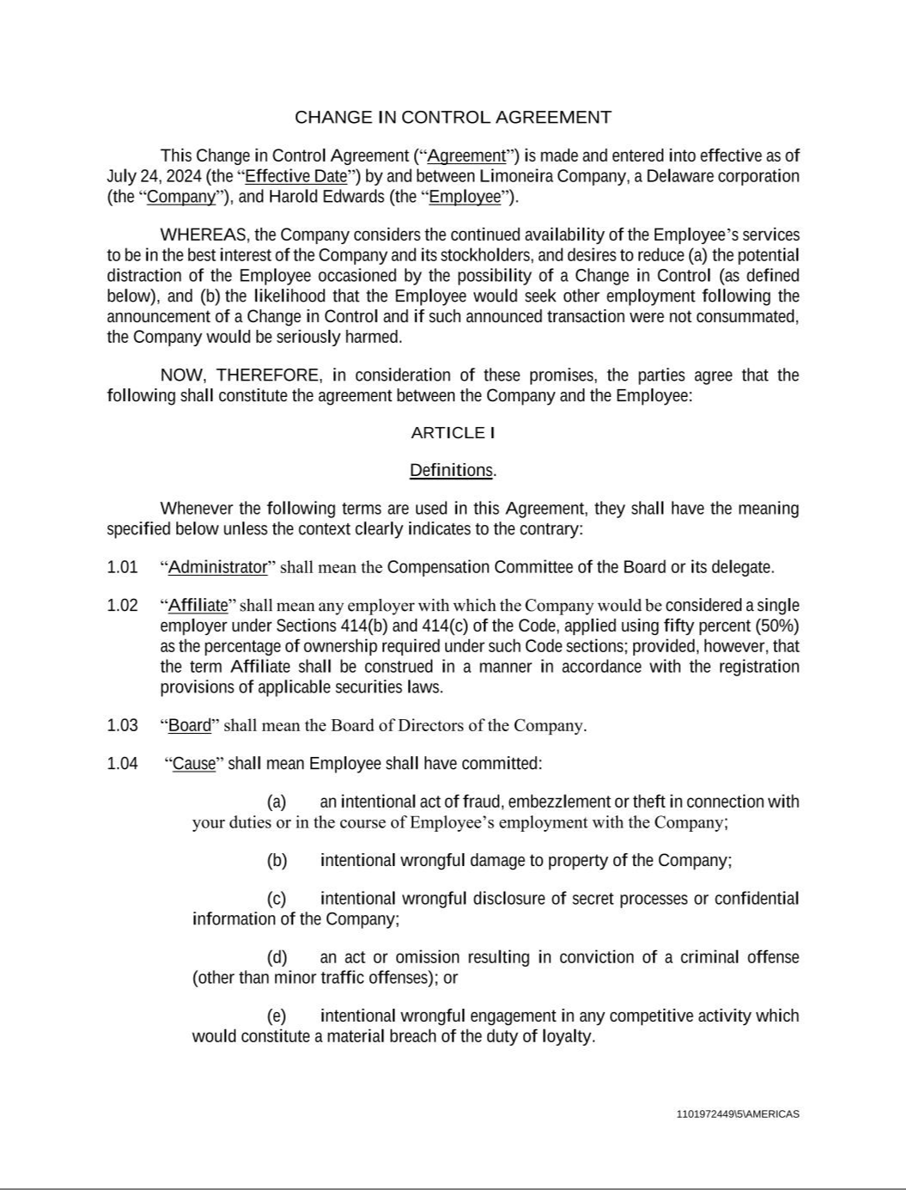

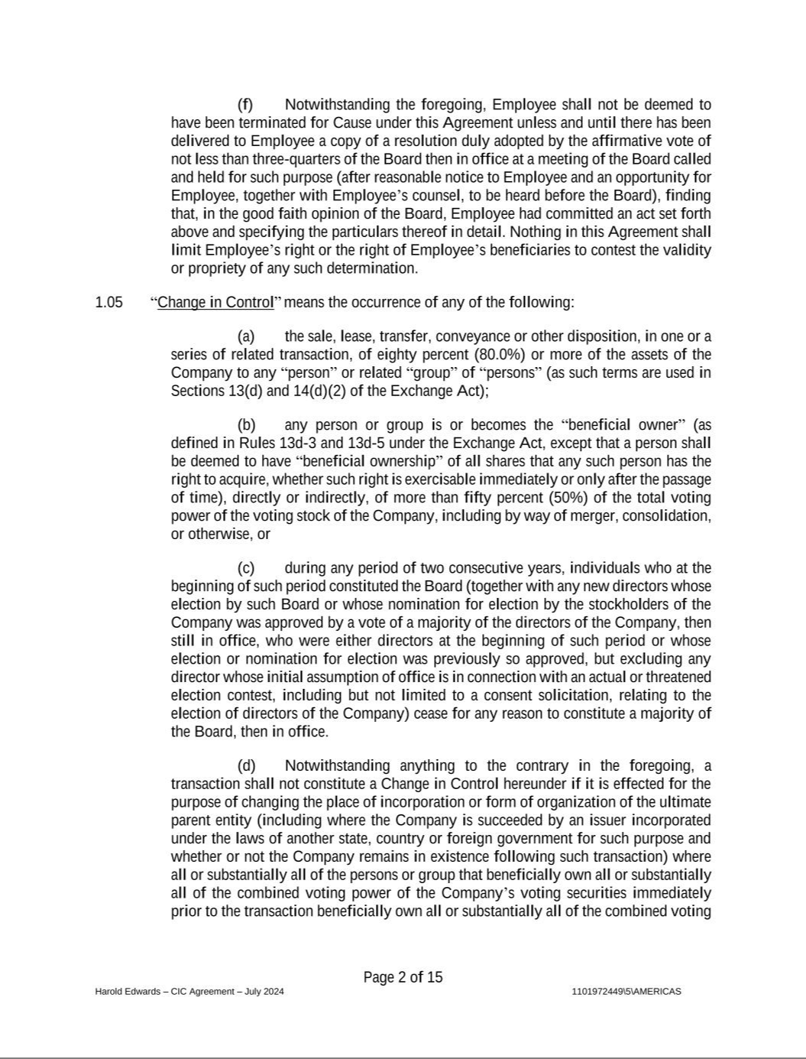

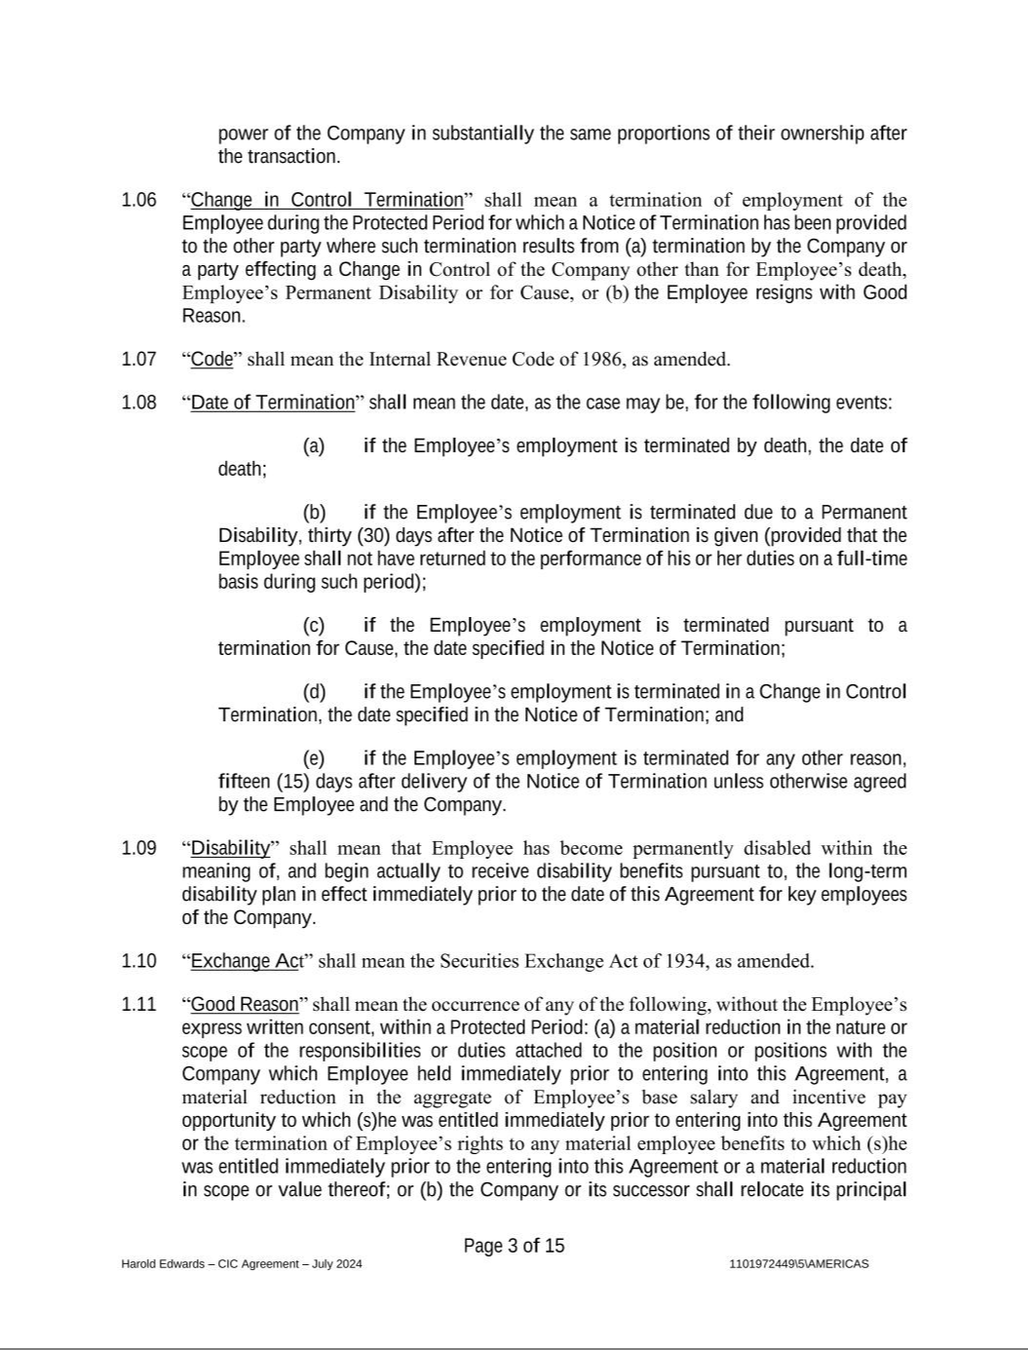

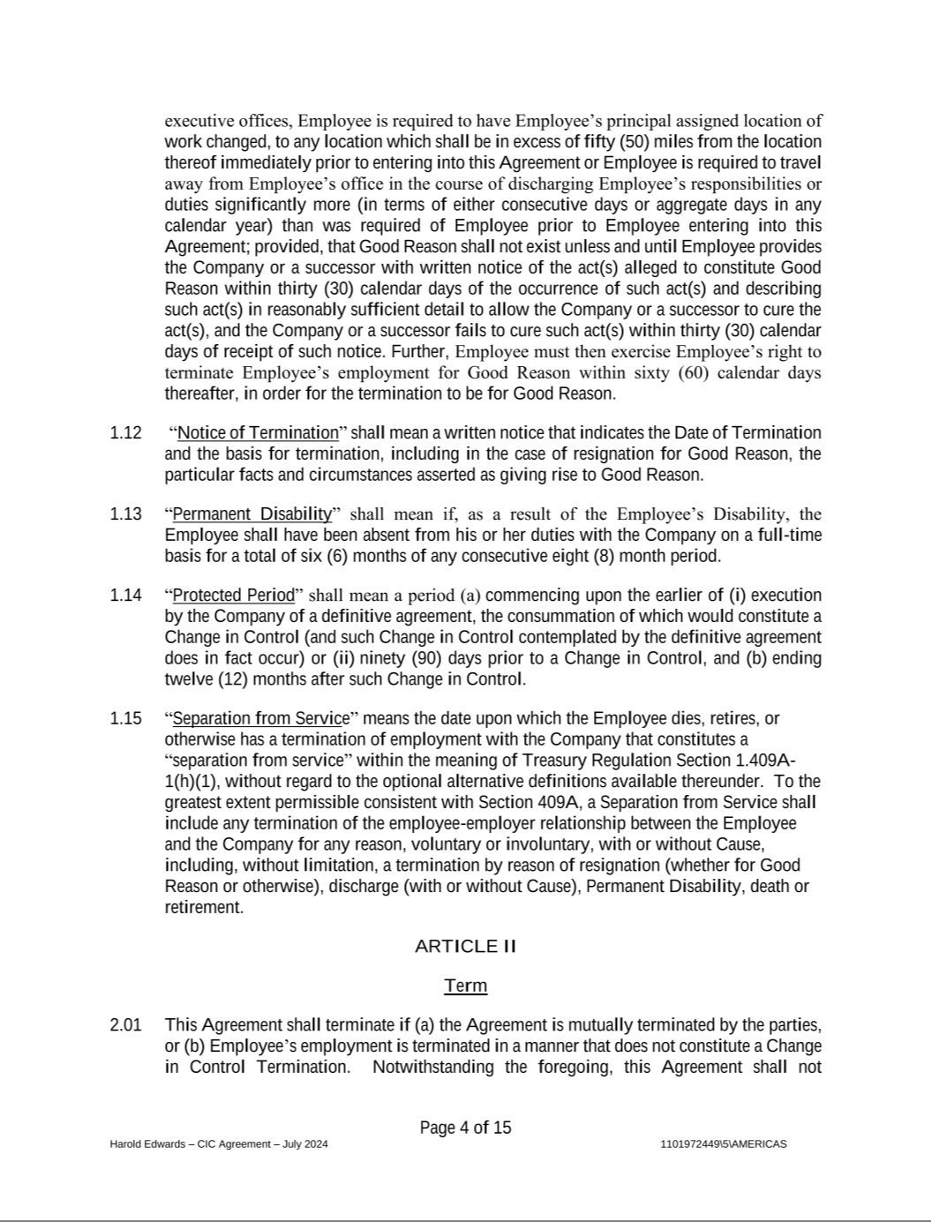

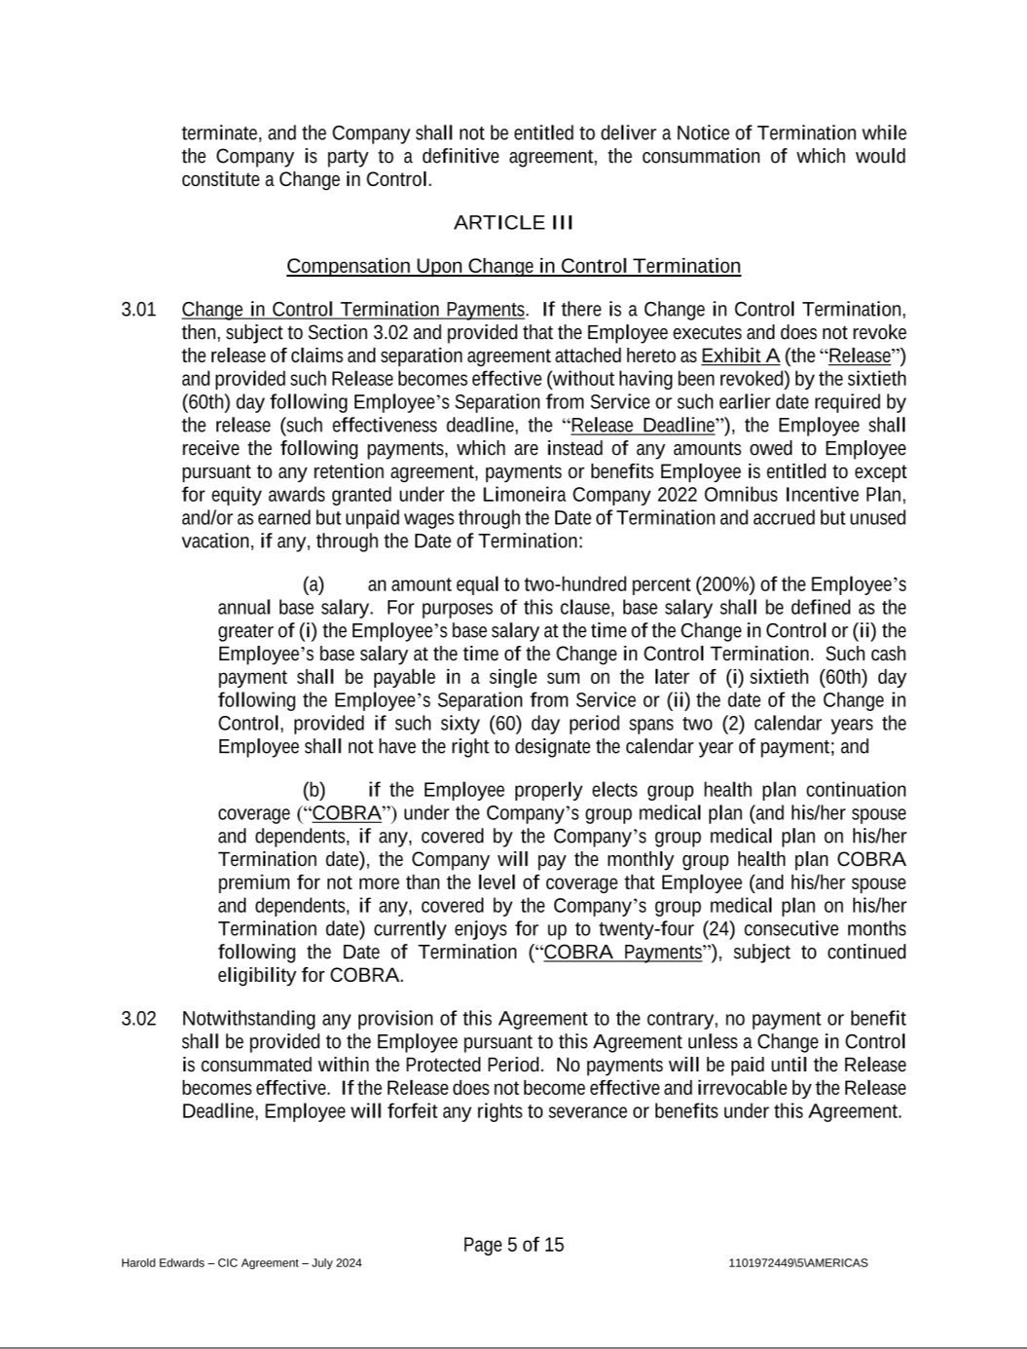

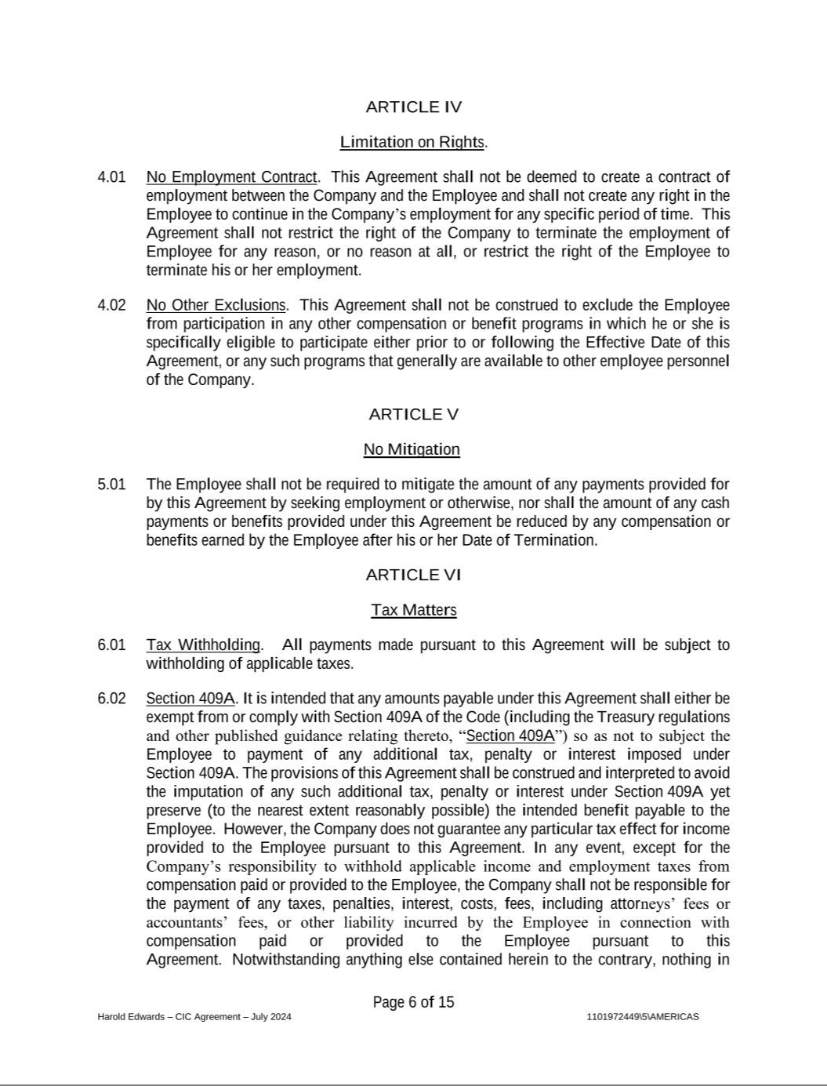

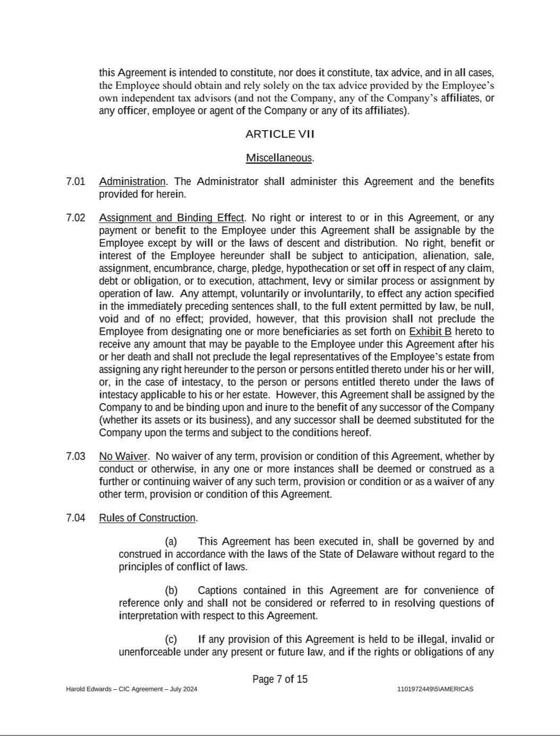

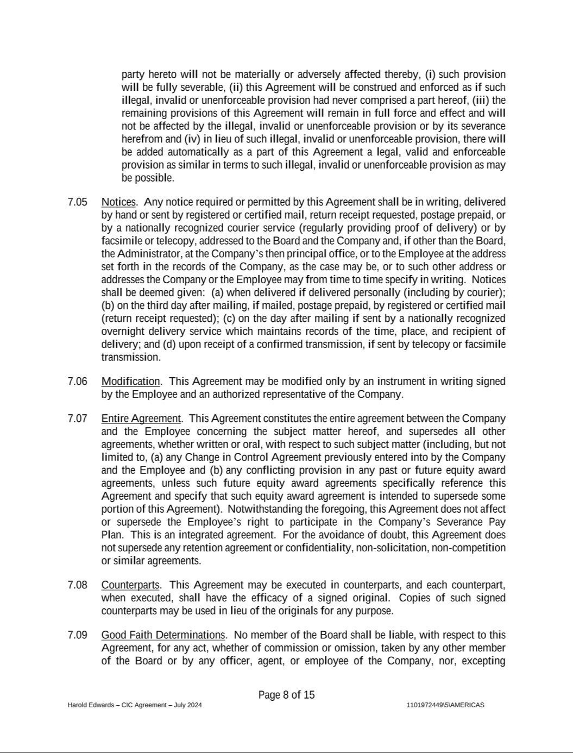

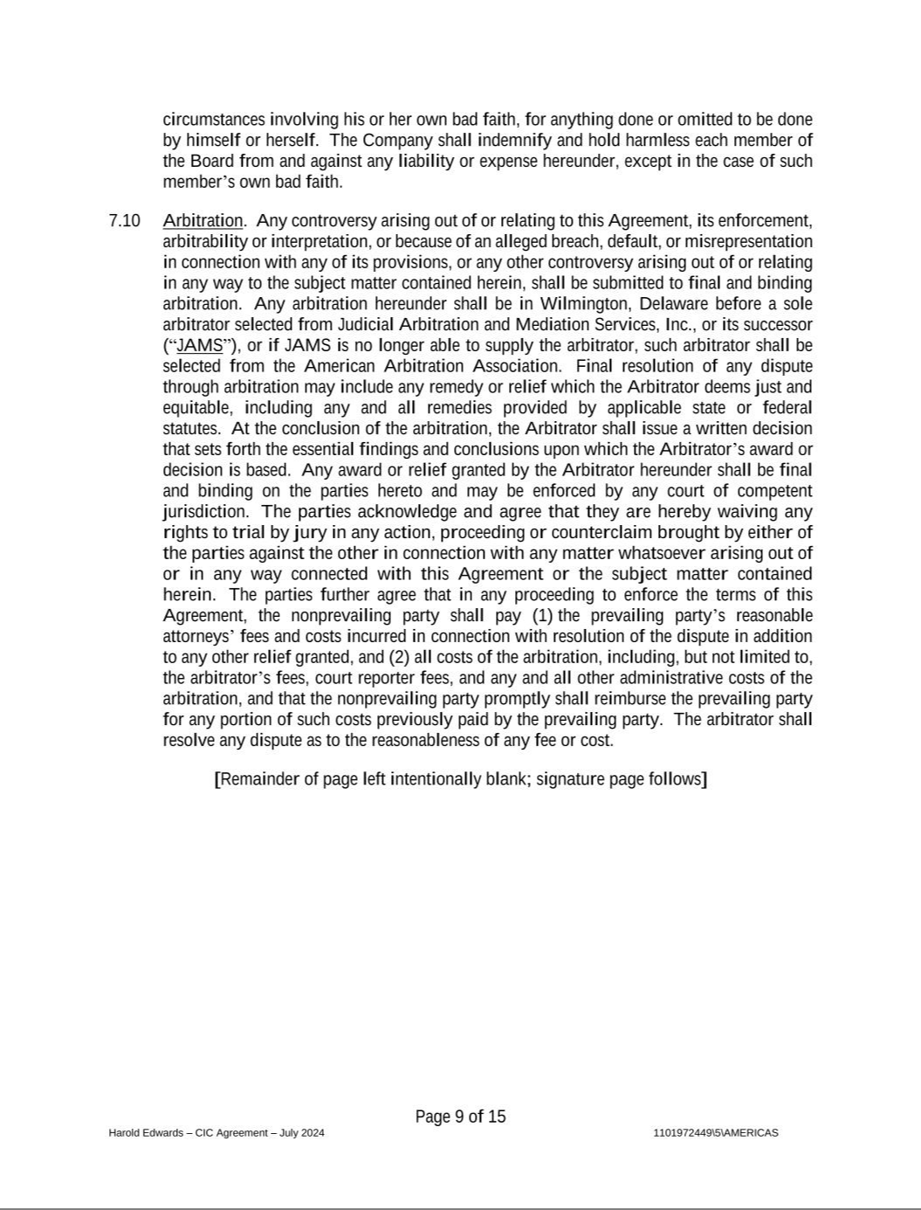

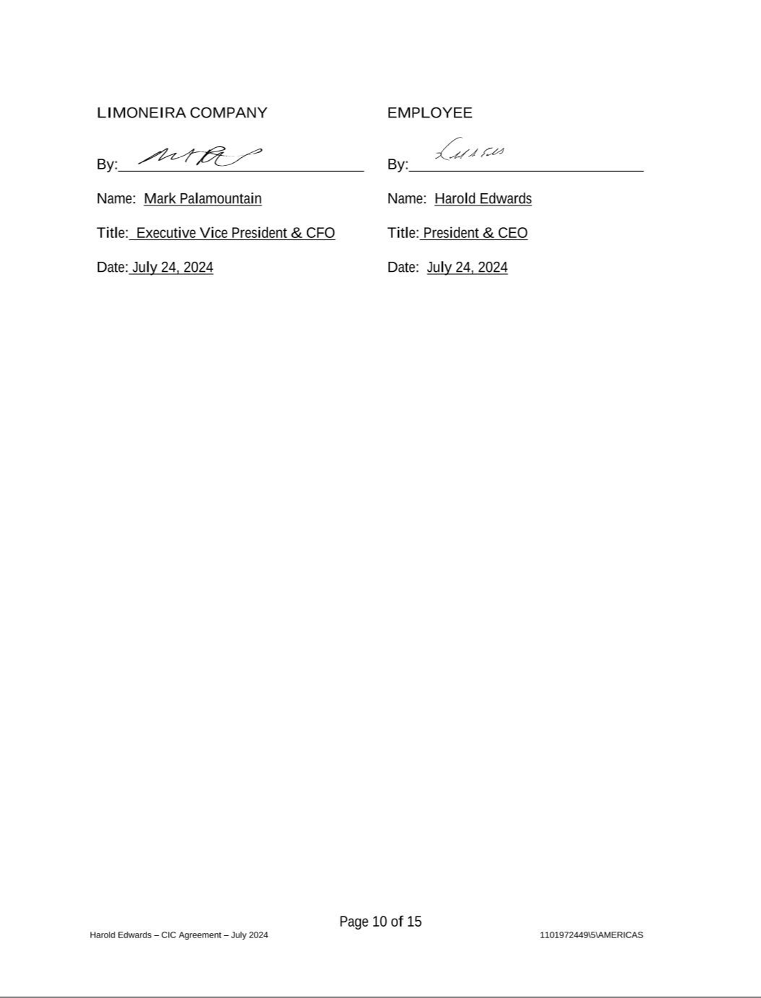

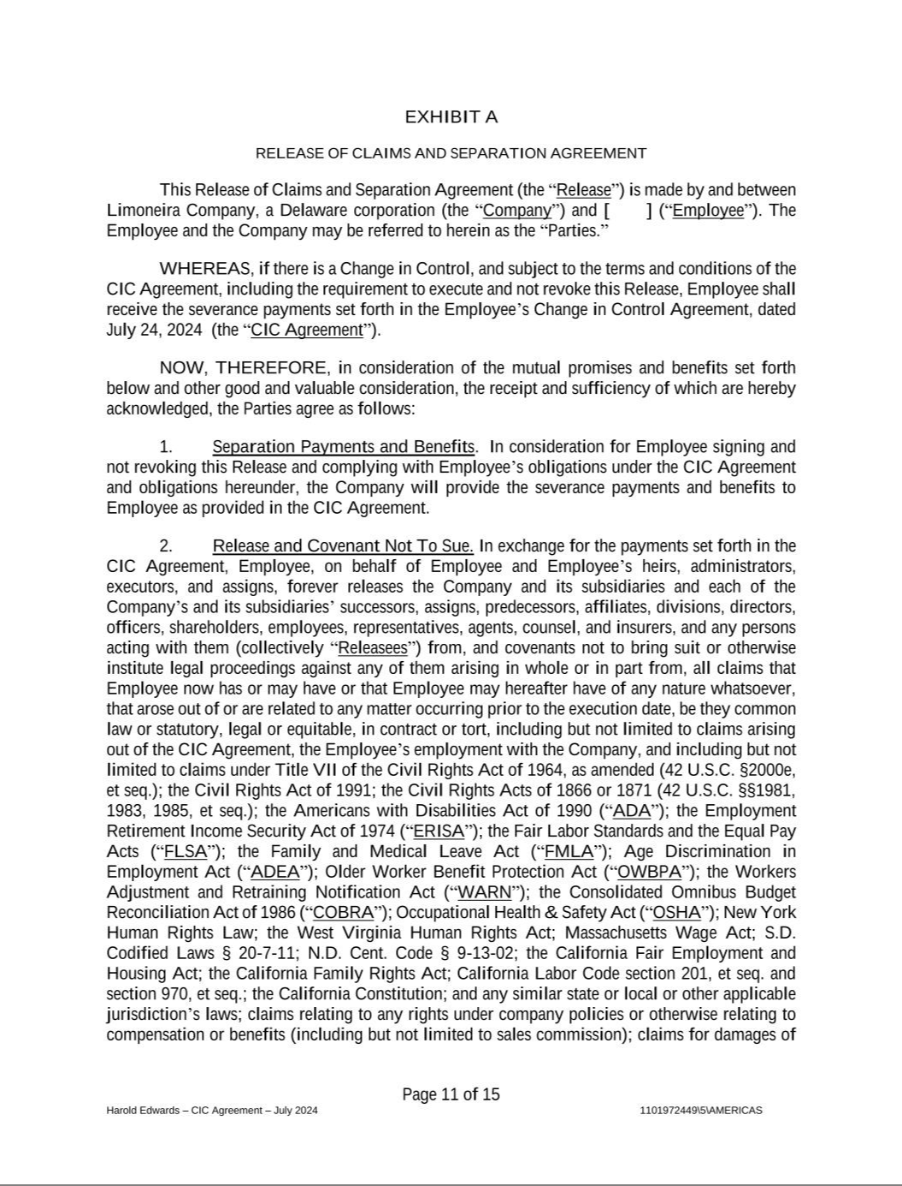

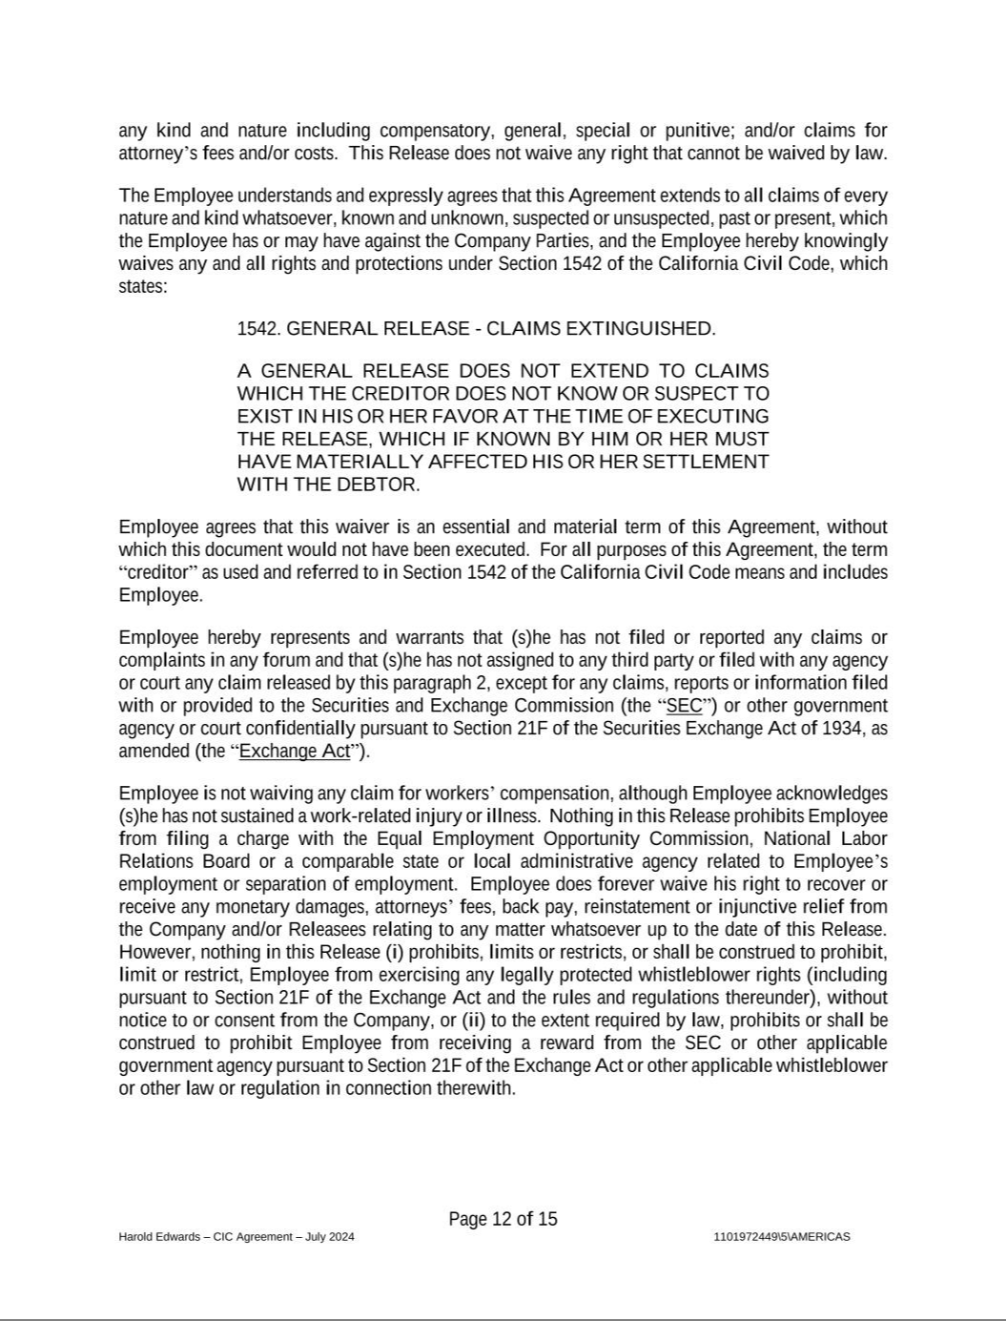

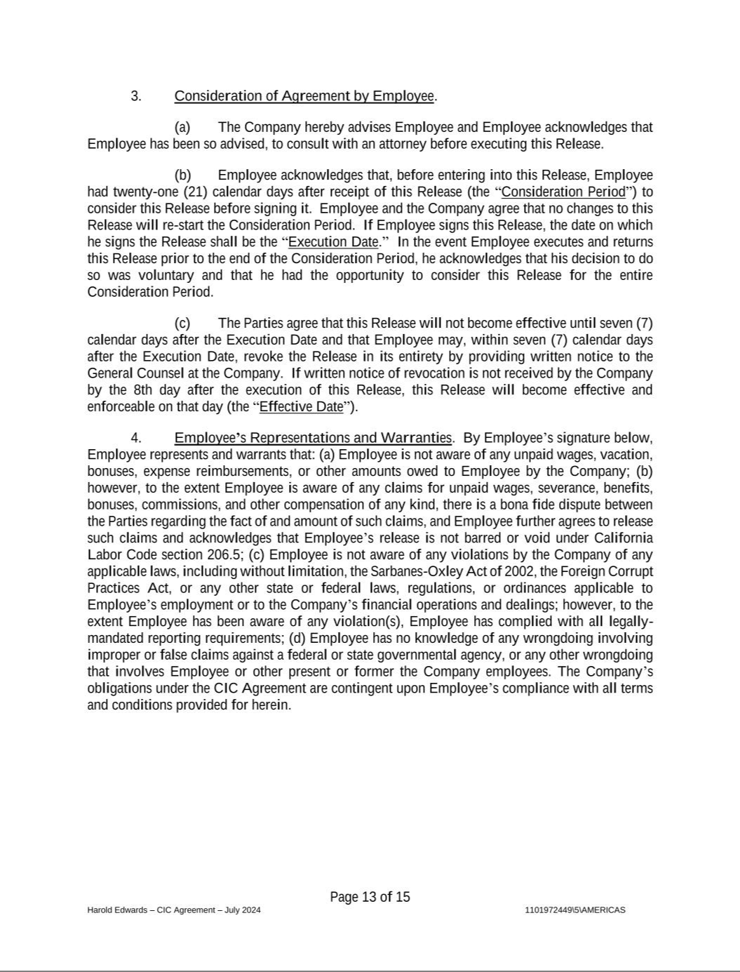

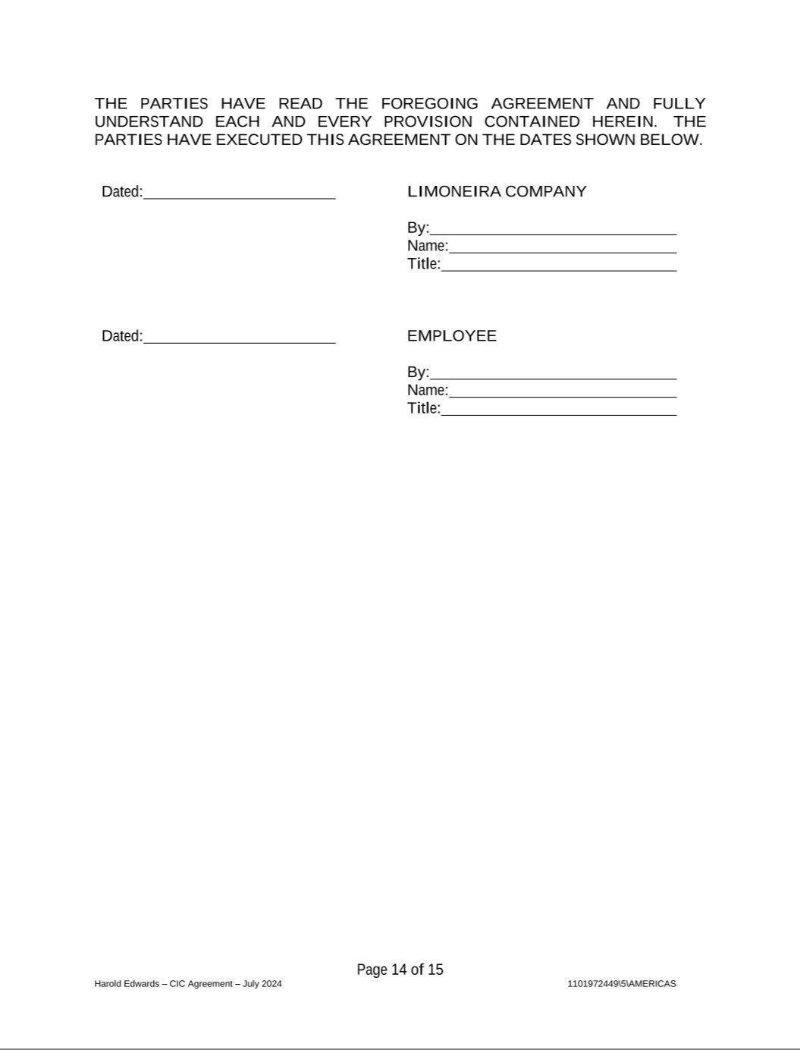



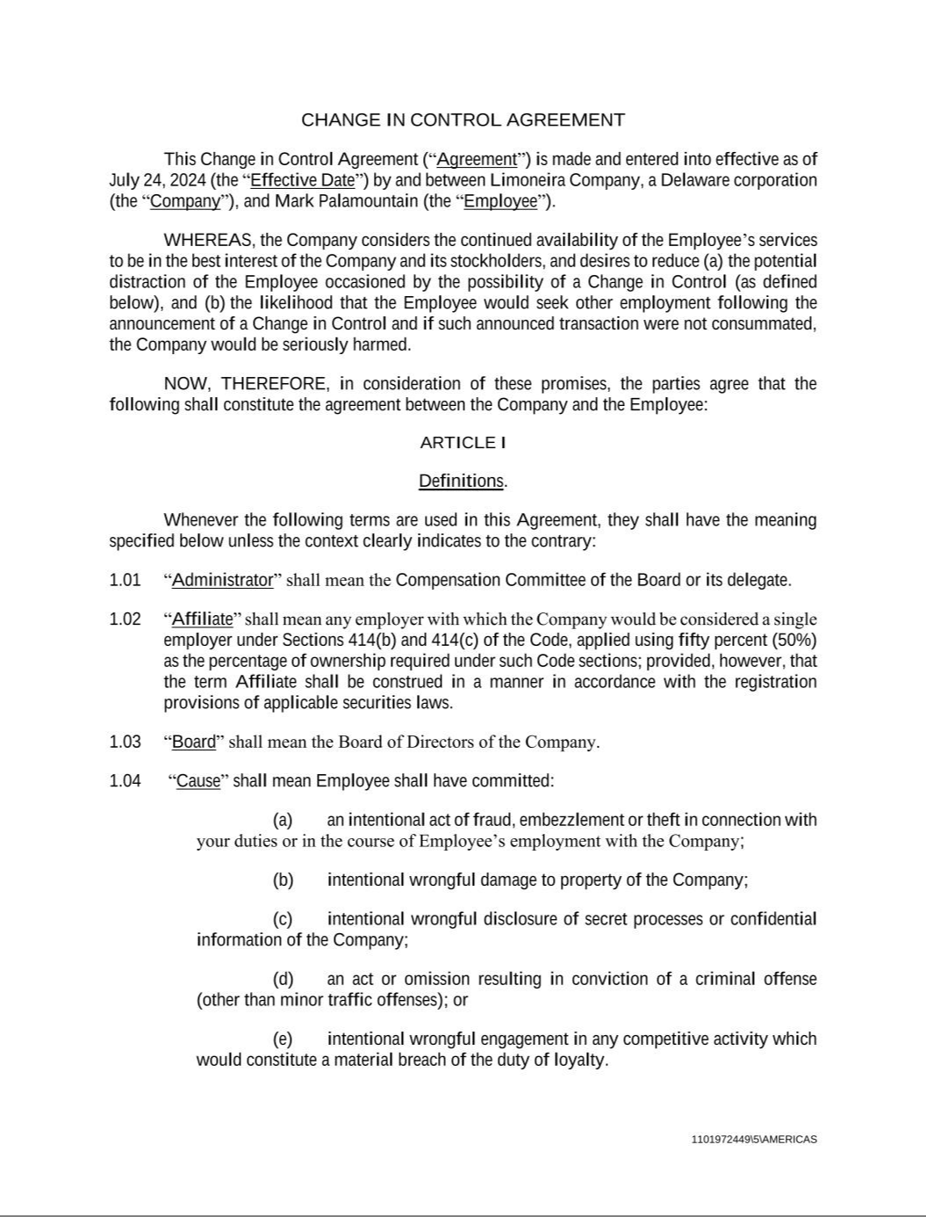

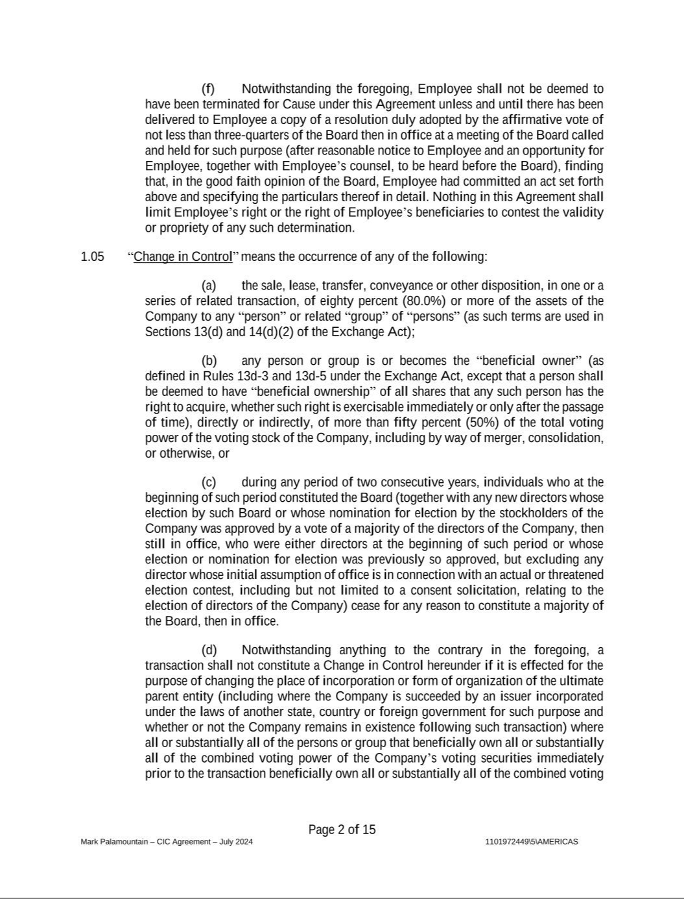

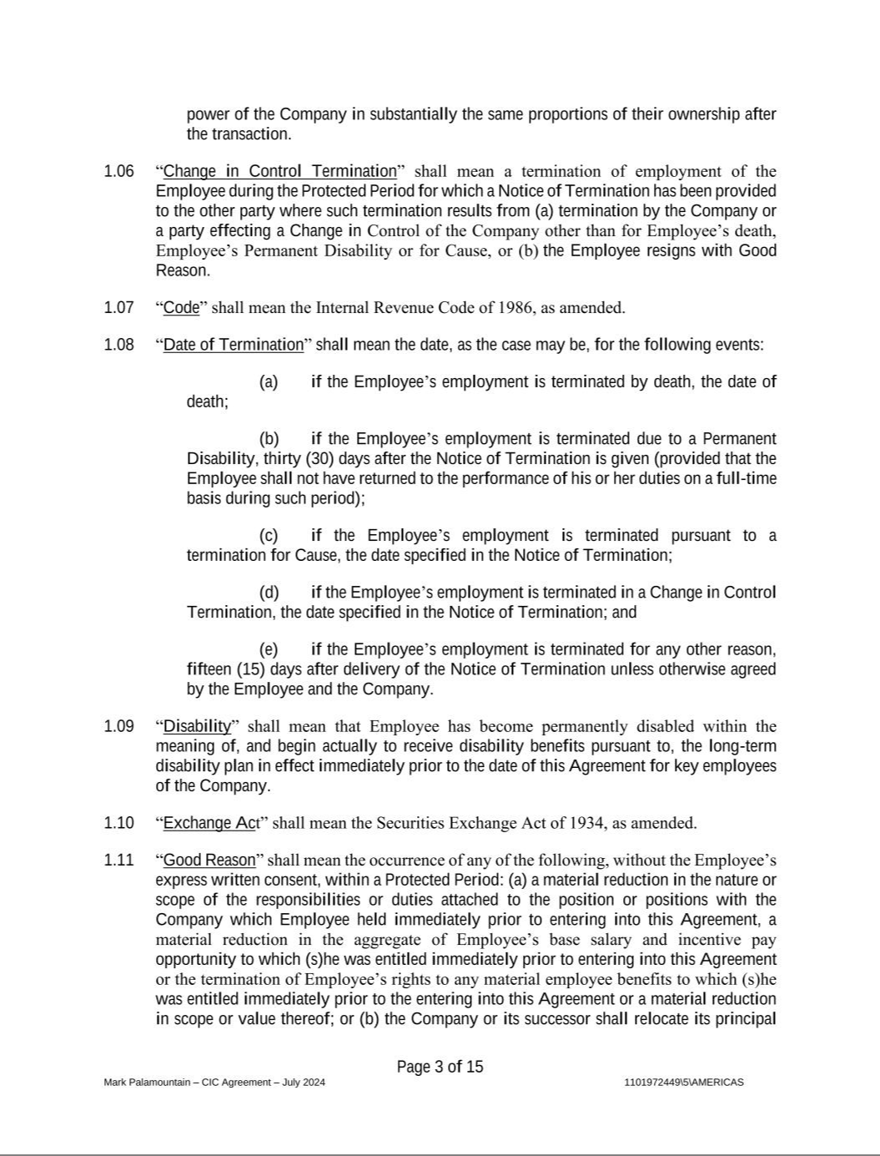

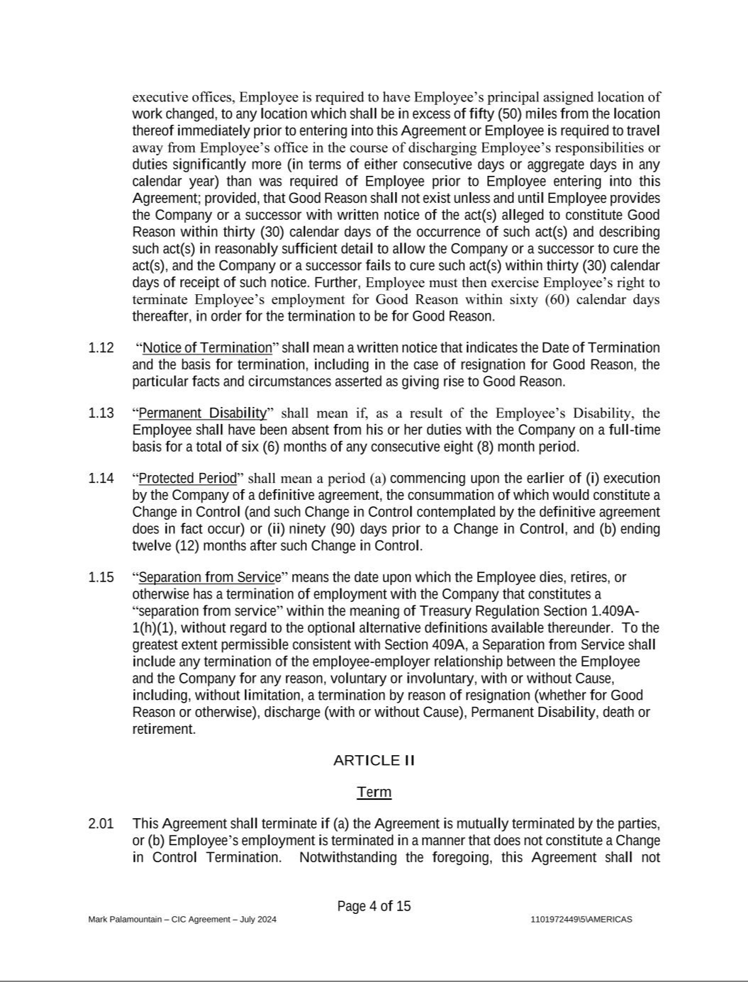

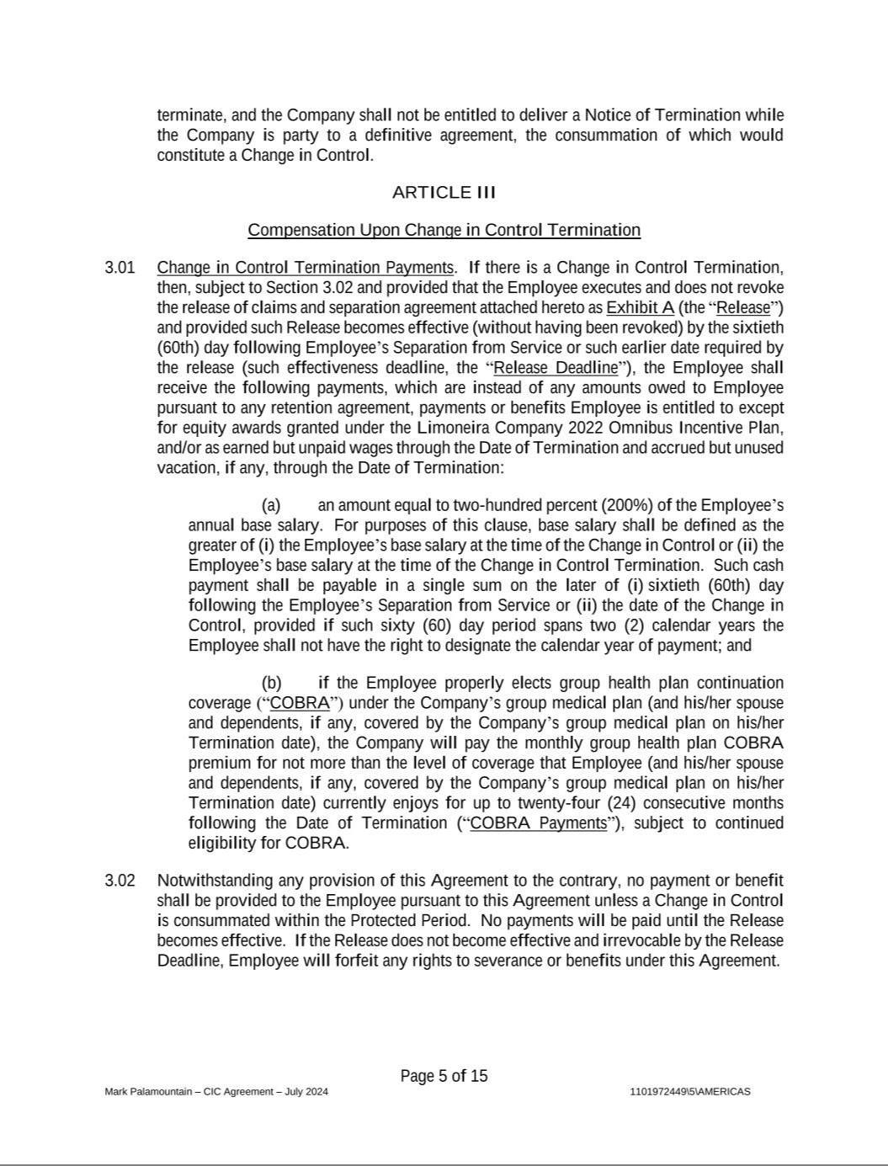

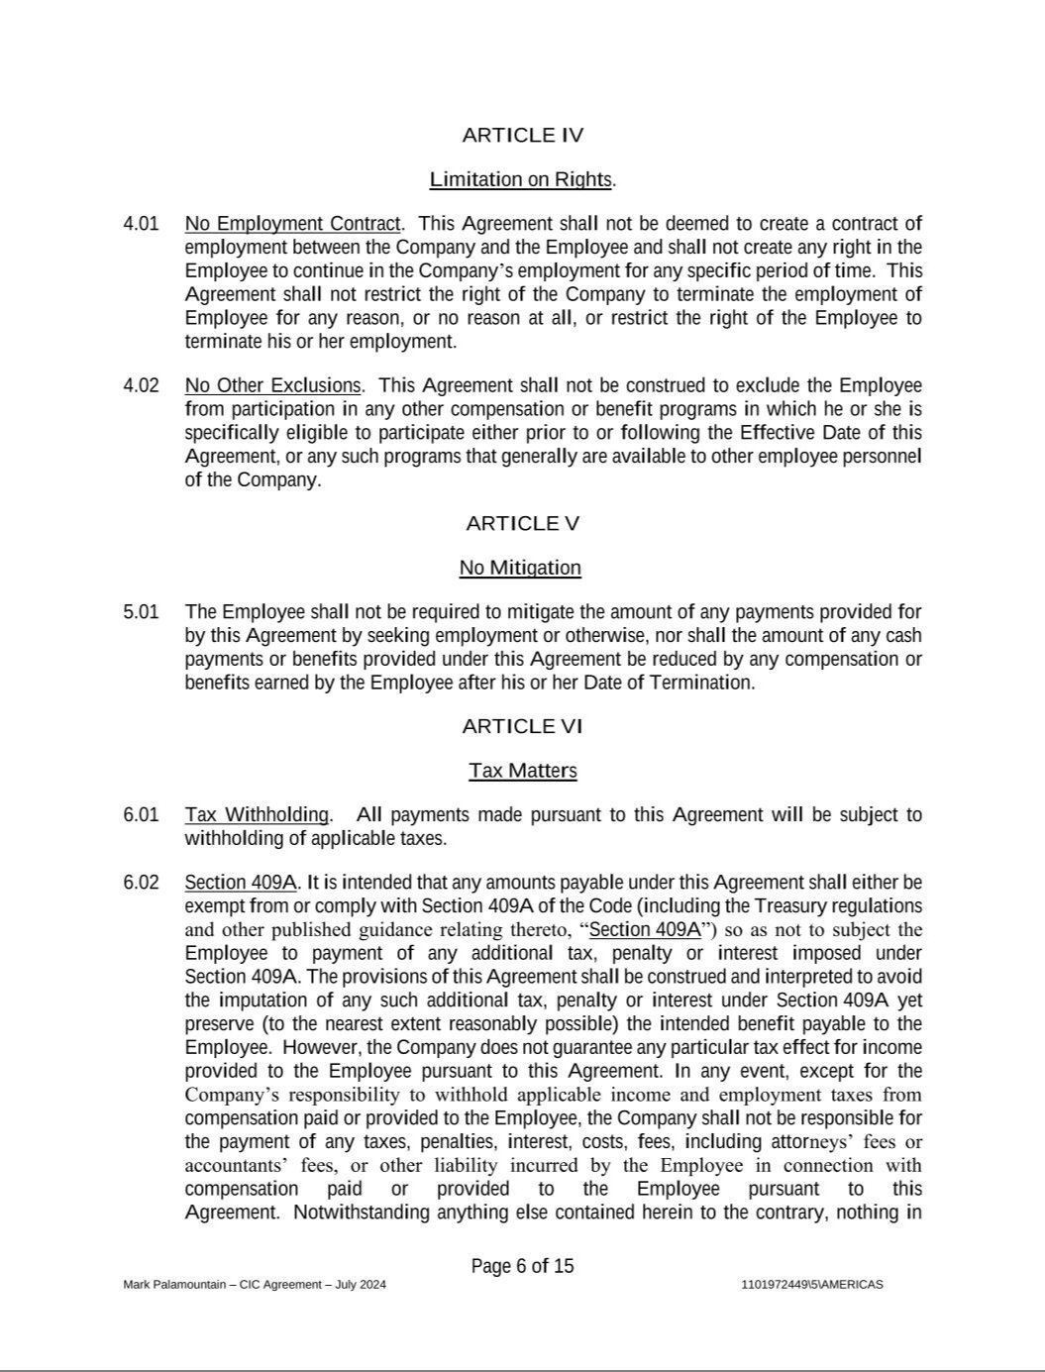

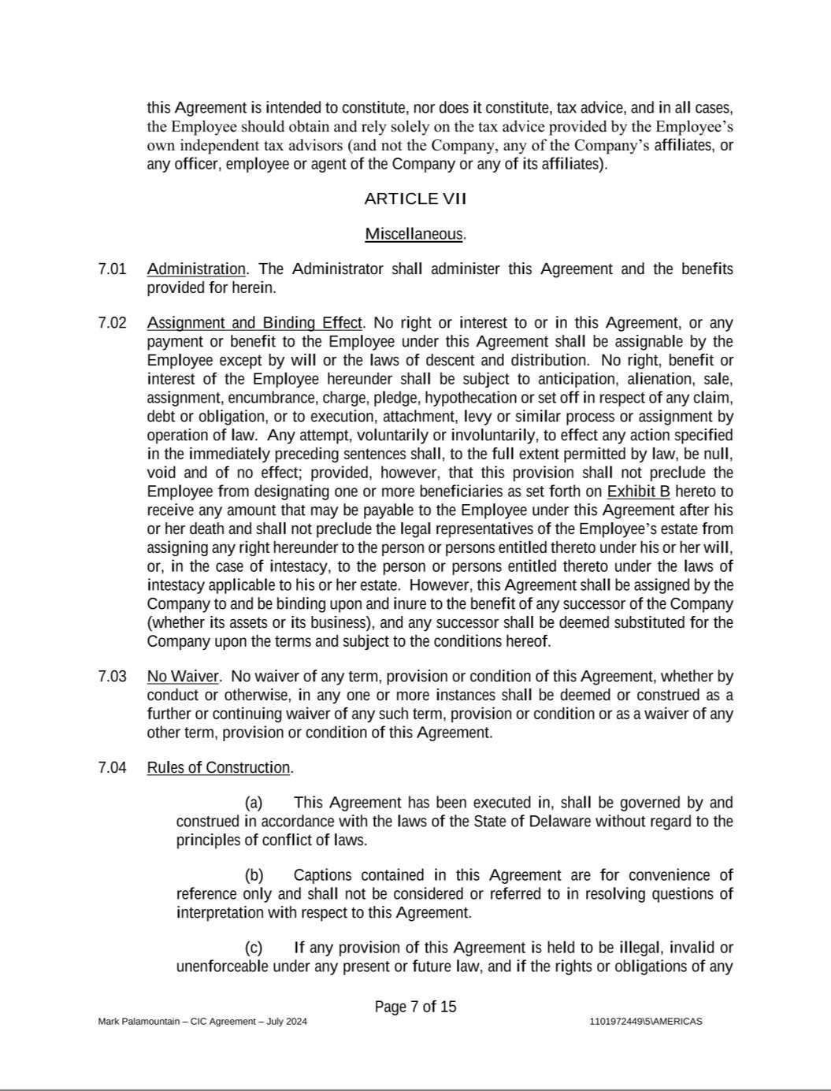

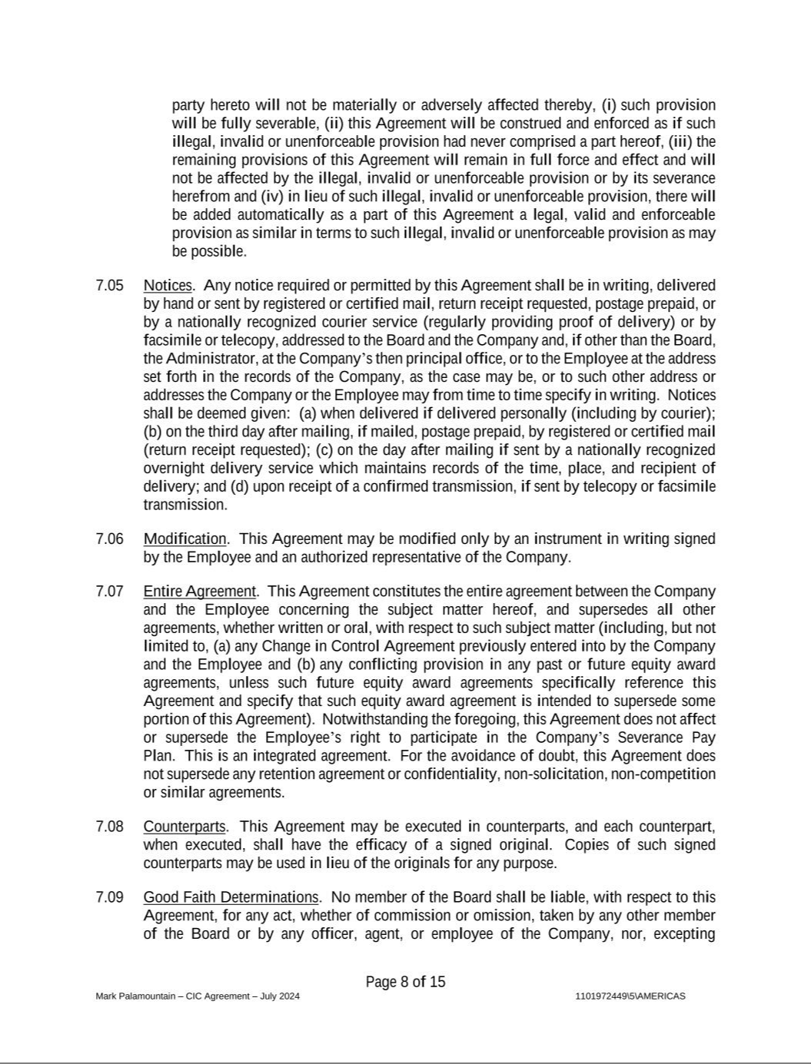

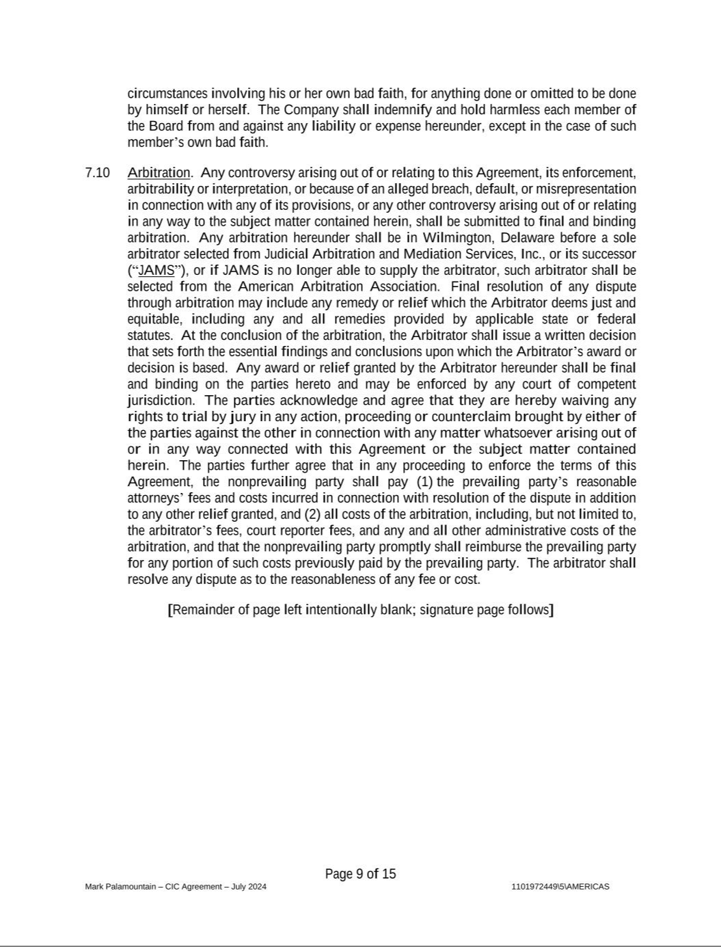

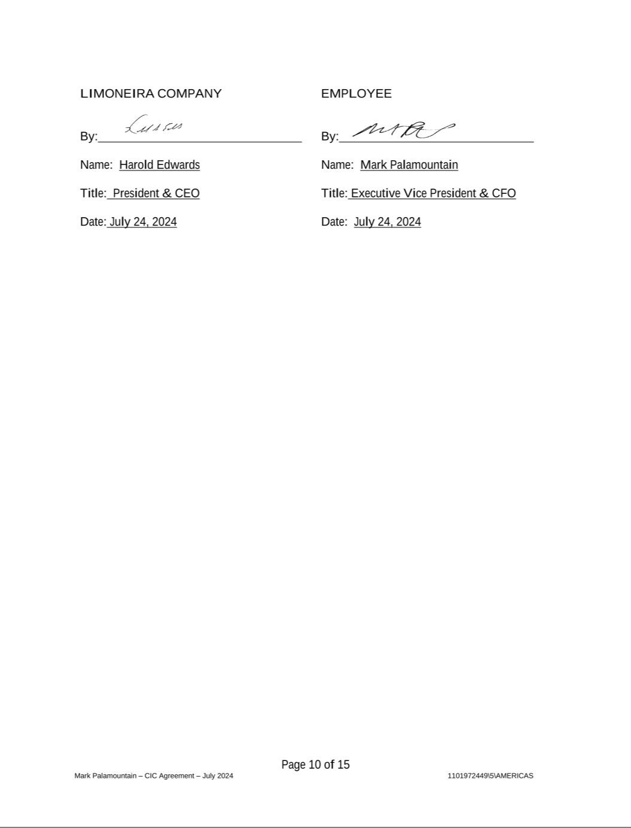

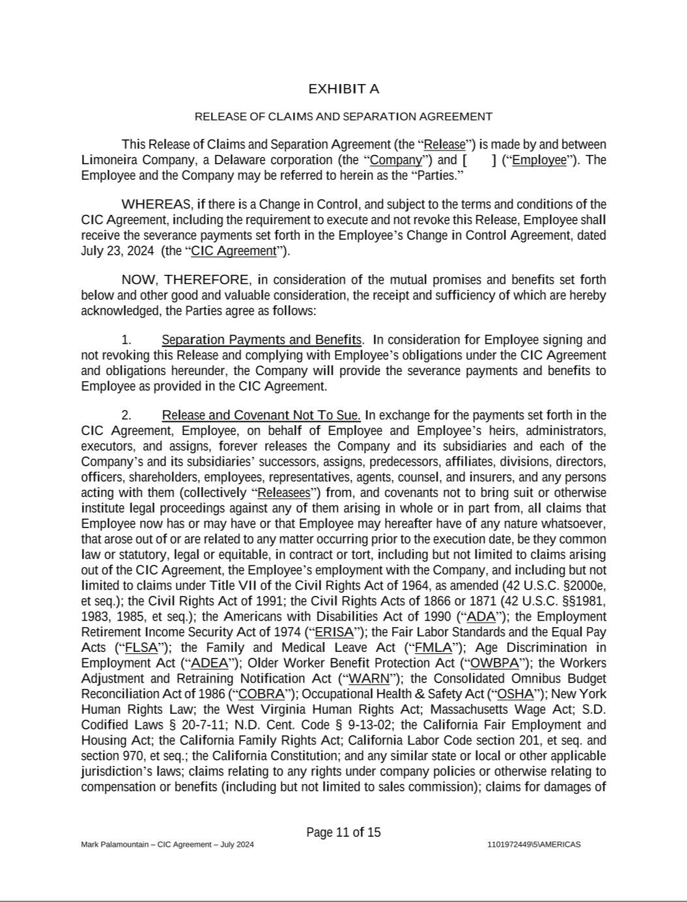

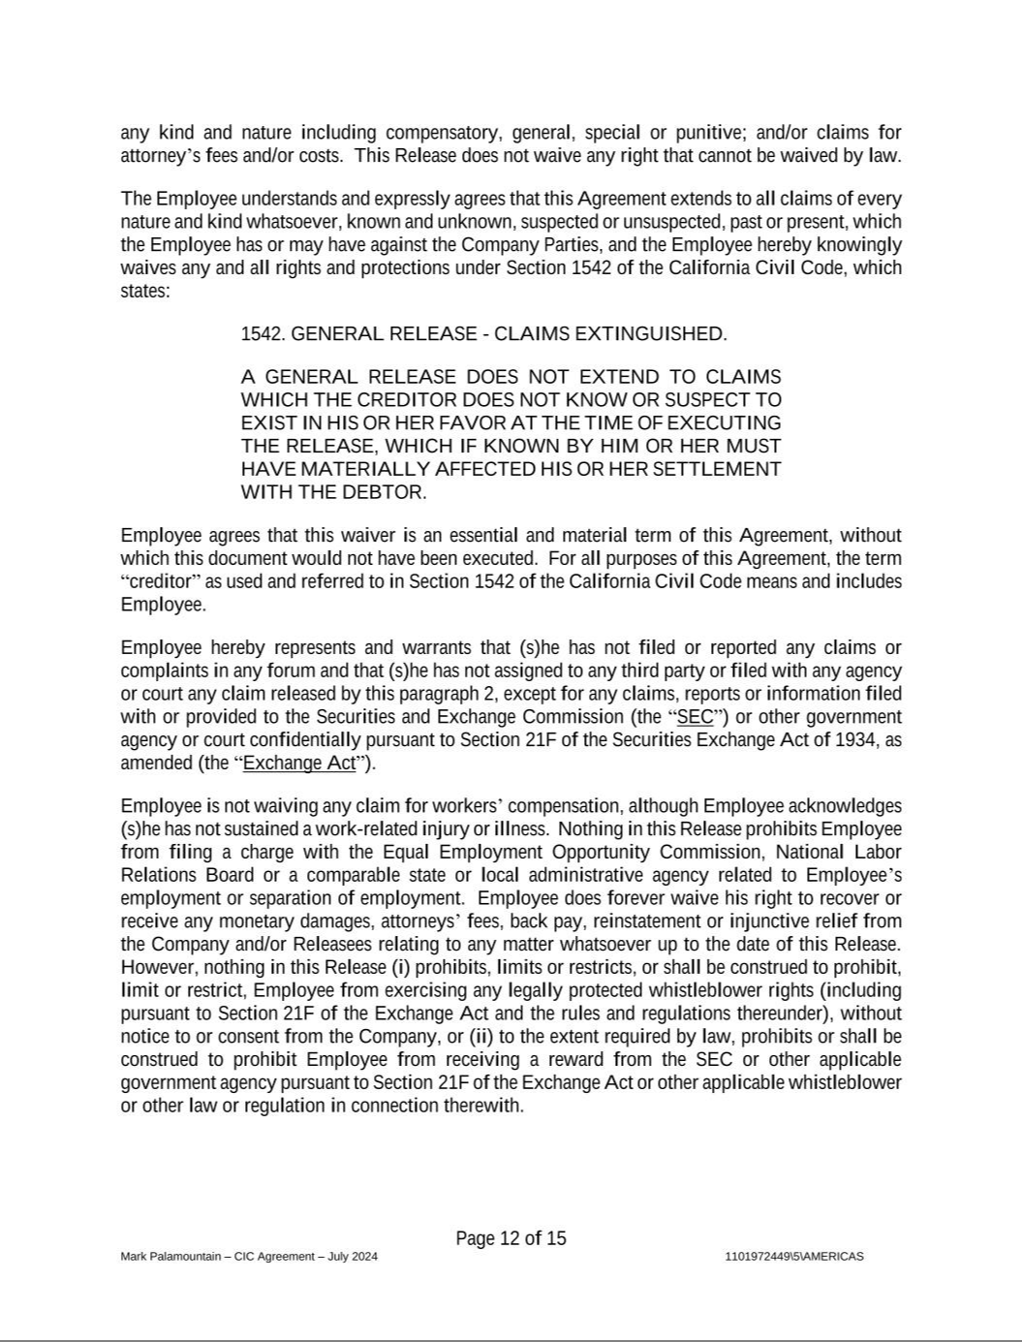

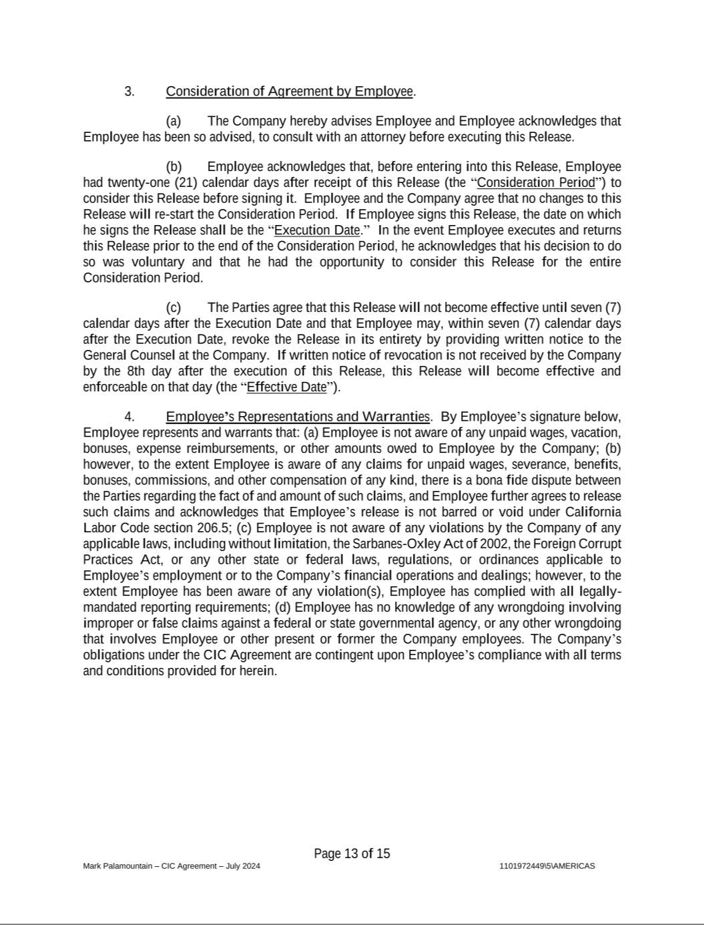

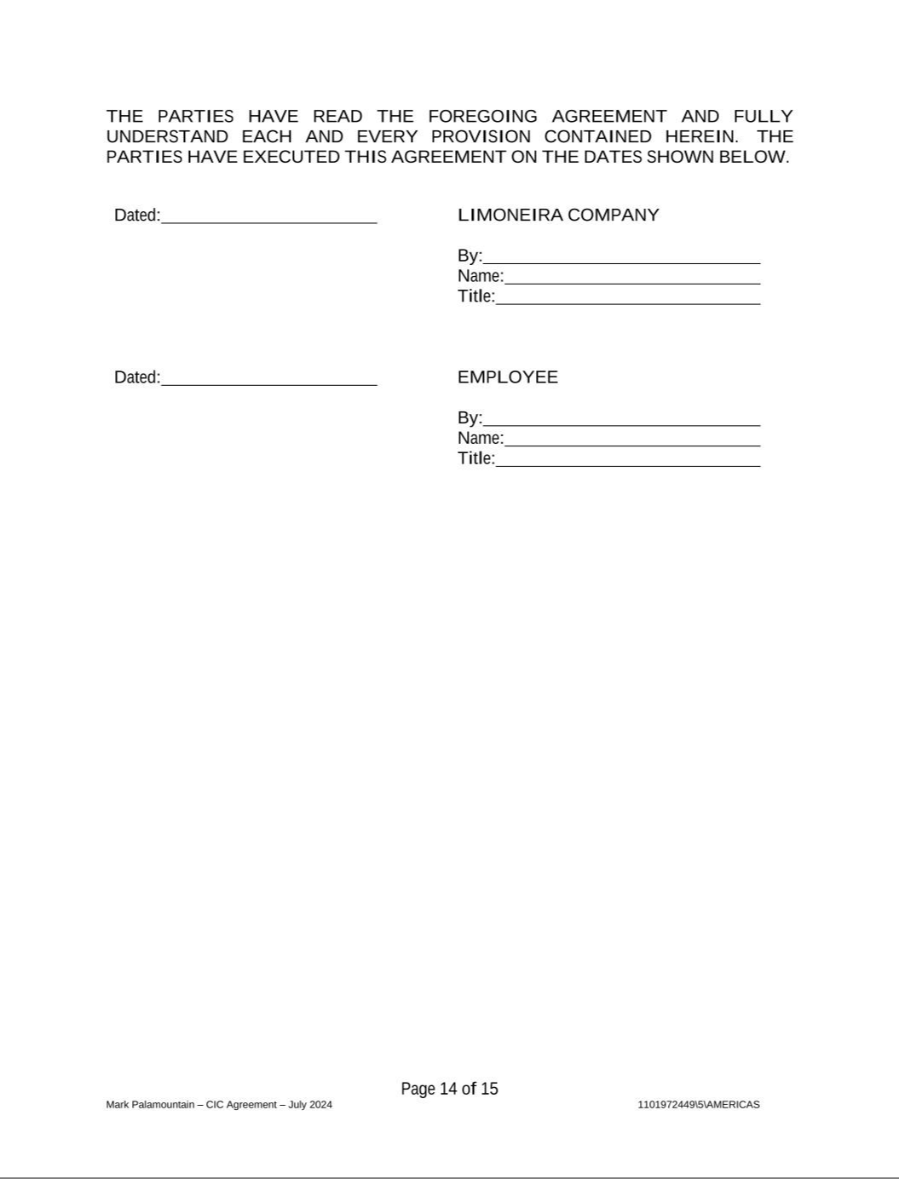



Exhibit 31.1

Certification of the Principal Executive Officer

Pursuant to Exchange Act Rule 13a-14(a) and 15d-14(a)

I, Harold S. Edwards, certify that:

- I have reviewed this Quarterly Report on Form 10-Q of Limoneira Company (the “Registrant”);

- Based on my knowledge, this report does not contain any untrue statement of a material fact or omit to state a material fact necessary to make the statements made, in light of the circumstances under which such statements were made, not misleading with respect to the period covered by this report;

- Based on my knowledge, the financial statements, and other financial information included in this report, fairly present in all material respects the financial condition, results of operations and cash flows of the Registrant as of, and for, the periods presented in this report;

- The Registrant’s other certifying officer and I are responsible for establishing and maintaining disclosure controls and procedures (as defined in Exchange Act Rules 13a-15(e) and 15d-15(e)) and internal control over financial reporting (as defined in Exchange Act Rules 13a-15(f) and 15d- 15(f)) for the Registrant and have:

  - designed such disclosure controls and procedures, or caused such disclosure controls and procedures to be designed under our supervision, to ensure that material information relating to the Registrant, including its consolidated subsidiaries, is made known to us by others within those entities, particularly during the period in which this report is being prepared;

  - designed such internal control over financial reporting, or caused such internal control over financial reporting to be designed under our supervision, to provide reasonable assurance regarding the reliability of financial reporting and the preparation of financial statements for external purposes in accordance with generally accepted accounting principles;

  - evaluated the effectiveness of the Registrant’s disclosure controls and procedures and presented in this report our conclusions about the effectiveness of the disclosure controls and procedures, as of the end of the period covered by this report based on such evaluation; and

  - disclosed in this report any change in the Registrant’s internal control over financial reporting that occurred during the Registrant’s most recent fiscal quarter that has materially affected, or is reasonably likely to materially affect, the Registrant’s internal control over financial reporting; and

- The Registrant’s other certifying officer and I have disclosed, based on our most recent evaluation of internal control over financial reporting, to the Registrant’s auditors and the audit committee of the Registrant’s board of directors (or persons performing the equivalent functions):

  - all significant deficiencies and material weaknesses in the design or operation of internal control over financial reporting which are reasonably likely to adversely affect the Registrant’s ability to record, process, summarize and report financial information; and

  - any fraud, whether or not material, that involves management or other employees who have a significant role in the Registrant’s internal control over financial reporting.

September 9, 2024 /s/ Harold S. Edwards

Harold S. Edwards,

Director, President and Chief Executive Officer

(Principal Executive Officer)

Exhibit 31.2

Certification of the Principal Financial Officer

Pursuant to Exchange Act Rule 13a-14(a) and 15d-14(a)

I, Mark Palamountain, certify that:

- I have reviewed this Quarterly Report on Form 10-Q of Limoneira Company (the “Registrant”);

- Based on my knowledge, this report does not contain any untrue statement of a material fact or omit to state a material fact necessary to make the statements made, in light of the circumstances under which such statements were made, not misleading with respect to the period covered by this report;

- Based on my knowledge, the financial statements, and other financial information included in this report, fairly present in all material respects the financial condition, results of operations and cash flows of the Registrant as of, and for, the periods presented in this report;

- The Registrant’s other certifying officer and I are responsible for establishing and maintaining disclosure controls and procedures (as defined in Exchange Act Rules 13a-15(e) and 15d-15(e)) and internal control over financial reporting (as defined in Exchange Act Rules 13a-15(f) and 15d- 15(f)) for the Registrant and have:

  - designed such disclosure controls and procedures, or caused such disclosure controls and procedures to be designed under our supervision, to ensure that material information relating to the Registrant, including its consolidated subsidiaries, is made known to us by others within those entities, particularly during the period in which this report is being prepared;

  - designed such internal control over financial reporting, or caused such internal control over financial reporting to be designed under our supervision, to provide reasonable assurance regarding the reliability of financial reporting and the preparation of financial statements for external purposes in accordance with generally accepted accounting principles;

  - evaluated the effectiveness of the Registrant’s disclosure controls and procedures and presented in this report our conclusions about the effectiveness of the disclosure controls and procedures, as of the end of the period covered by this report based on such evaluation; and

  - disclosed in this report any change in the Registrant’s internal control over financial reporting that occurred during the Registrant’s most recent fiscal quarter that has materially affected, or is reasonably likely to materially affect, the Registrant’s internal control over financial reporting; and
- The Registrant’s other certifying officer and I have disclosed, based on our most recent evaluation of internal control over financial reporting, to the Registrant’s auditors and the audit committee of the Registrant’s board of directors (or persons performing the equivalent functions):

  - all significant deficiencies and material weaknesses in the design or operation of internal control over financial reporting which are reasonably likely to adversely affect the Registrant’s ability to record, process, summarize and report financial information; and

  - any fraud, whether or not material, that involves management or other employees who have a significant role in the Registrant’s internal control over financial reporting.

September 9, 2024 /s/ Mark Palamountain

Mark Palamountain,

Executive Vice President, Chief Financial Officer and Treasurer

(Principal Financial and Accounting Officer)

Exhibit 32.1

Certification of the Principal Executive Officer

Pursuant to Section 906 of the Sarbanes-Oxley Act of 2002 (18 U.S.C. 1350)

In connection with the Quarterly Report on Form 10-Q for the quarter ended July 31, 2024 (the “Report”) of Limoneira Company (the “Registrant”), as filed with the Securities and Exchange Commission on the date hereof, I, Harold S. Edwards, Director, President and Chief Executive Officer of the Registrant, hereby certify that:

- The Report fully complies with the requirements of Section 13(a) or 15(d) of the Securities Exchange Act of 1934, as amended; and

- The information contained in the Report fairly presents, in all material respects, the financial condition and results of operations of the Registrant.

September 9, 2024 /s/ Harold S. Edwards

Harold S. Edwards,

Director, President and Chief Executive Officer

(Principal Executive Officer)

Exhibit 32.2

Certification of the Principal Financial Officer

Pursuant to Section 906 of the Sarbanes-Oxley Act of 2002 (18 U.S.C. 1350)

In connection with the Quarterly Report on Form 10-Q for the quarter ended July 31, 2024 (the “Report”) of Limoneira Company (the “Registrant”), as filed with the Securities and Exchange Commission on the date hereof, I, Mark Palamountain, Executive Vice President, Chief Financial Officer and Treasurer of the Registrant, hereby certify that:

- The Report fully complies with the requirements of Section 13(a) or 15(d) of the Securities Exchange Act of 1934, as amended; and

- The information contained in the Report fairly presents, in all material respects, the financial condition and results of operations of the Registrant.

September 9, 2024 /s/ Mark Palamountain

Mark Palamountain,

Executive Vice President, Chief Financial Officer and Treasurer

(Principal Financial and Accounting Officer)

