UNITED STATES
SECURITIES AND EXCHANGE COMMISSION
Washington, D.C. 20549
FORM 10-K
(Mark One)
☒ |  |  | ANNUAL REPORT PURSUANT TO SECTION 13 OR 15(d) OF THE SECURITIES EXCHANGE ACT OF 1934
For The Fiscal Year Ended October 31, 2024
OR
☐ |  |  | TRANSITION REPORT PURSUANT TO SECTION 13 OR 15(d) OF THE SECURITIES EXCHANGE ACT OF 1934
For The Transition Period From To
Commission File Number: 001-34755
LIMONEIRA COMPANY
(Exact name of registrant as specified in its charter)
Delaware |  |  | 77-0260692
(State or other jurisdiction of incorporation or organization) |  |  | (I.R.S. Employer Identification Number)
1141 Cummings Road
Santa Paula, CA 93060
(Address of principal executive offices and zip code)
Registrant’s telephone number, including area code: (805) 525-5541
Securities registered pursuant to Section 12(b) of the Act:
Title of each class |  |  | Trading symbol |  |  | Name of each exchange on which registered
Common Stock, par value $0.01 |  |  | LMNR |  |  | The NASDAQ Stock Market LLC  (NASDAQ Global Select Market)
Securities registered pursuant to Section 12(g) of the Act: None
Indicate by check mark if the registrant is a well-known seasoned issuer, as defined in Rule 405 of the Securities Act. Yes ☐ No ☒
Indicate by check mark if the registrant is not required to file reports pursuant to Section 13 or Section 15(d) of the Act. Yes ☐ No ☒
Indicate by check mark whether the registrant: (1) has filed all reports required to be filed by Section 13 or 15(d) of the Securities Exchange Act of 1934 during the preceding 12 months (or for such shorter period that the registrant was required to file such reports), and (2) has been subject to such filing requirements for the past 90 days. Yes ☒ No ☐
Indicate by check mark whether the registrant has submitted electronically every Interactive Data File required to be submitted pursuant to Rule 405 of Regulation S-T (§232.405 of this chapter) during the preceding 12 months (or for such shorter period that the registrant was required to submit such files). Yes ☒ No ☐
Indicate by check mark whether the registrant is a large accelerated filer, an accelerated filer, a non-accelerated filer, smaller reporting company or an emerging growth company. See the definitions of “large accelerated filer,” “accelerated filer,” “smaller reporting company” and “emerging growth company” in Rule 12b-2 of the Exchange Act.
Large accelerated filer ☐ |  |  | Accelerated filer ☒ |  |  | Non-accelerated filer ☐ |  |  | Smaller reporting  company ☐ |  |  | Emerging growth  company ☐
If an emerging growth company, indicate by check mark if the registrant has elected not to use the extended transition period for complying with any new or revised financial accounting standards provided pursuant to Section 13(a) of the Exchange Act. ☐
Indicate by check mark whether the registrant has filed a report on and attestation to its management’s assessment of the effectiveness of its internal control over financial reporting under Section 404(b) of the Sarbanes-Oxley Act (15 U.S.C. 7262(b)) by the registered public accounting firm that prepared or issued its audit report. ☒
Indicate by check mark whether the registrant is a shell company (as defined in Rule 12b-2 of the Act). Yes ☐ No ☒
1

If securities are registered pursuant to Section 12(b) of the Act, indicate by check mark whether the financial statements of the registrant included in the filing reflect the correction of an error to previously issued financial statements. ☐
Indicate by check mark whether any of those error corrections are restatements that required a recovery analysis of incentive-based compensation received by any of the registrant’s executive officers during the relevant recovery period pursuant to §240.10D-1(b). ☐
Based on the closing price as reported on the NASDAQ Global Market, the aggregate market value of the registrant’s Common Stock held by non-affiliates on April 30, 2024 (the last business day of the registrant’s most recently completed second fiscal quarter) was approximately $324.1 million. Shares of Common Stock held by each executive officer and director and by each stockholder affiliated with a director or an executive officer have been excluded from this calculation because such persons may be deemed to be affiliates. This determination of affiliate status is not necessarily a conclusive determination for other purposes. The number of outstanding shares of the registrant’s Common Stock as of November 30, 2024 was 18,083,092.
DOCUMENTS INCORPORATED BY REFERENCE
Portions of the registrant’s Proxy Statement for the 2025 Annual Meeting of Stockholders, which we intend to hold on April 9, 2025, are incorporated by reference into Part III of this Annual Report on Form 10-K. The definitive Proxy Statement will be filed within 120 days after October 31, 2024.

2

LIMONEIRA COMPANY
TABLE OF CONTENTS
PART I |  |  | 5
Item 1. Business |  |  | 5
Item 1A. Risk Factors |  |  | 15
Item 1B. Unresolved Staff Comments |  |  | 27
Item 1C. Cybersecurity |  |  | 27
Item 2. Properties |  |  | 28
Item 3. Legal Proceedings |  |  | 29
Item 4. Mine Safety Disclosures |  |  | 29
PART II |  |  | 30
Item 5. Market for Registrant’s Common Equity, Related Stockholder Matters and Issuer Purchases of Equity Securities |  |  | 30
Item 6. Reserved |  |  | 32
Item 7. Management’s Discussion and Analysis of Financial Condition and Results of Operations |  |  | 32
Item 7A. Quantitative and Qualitative Disclosures about Market Risk |  |  | 42
Item 8. Financial Statements and Supplementary Data |  |  | 43
Item 9. Changes in and Disagreements with Accountants on Accounting and Financial Disclosure |  |  | 82
Item 9A. Controls and Procedures |  |  | 82
Item 9B. Other Information |  |  | 84
Item 9C. Disclosure Regarding Foreign Jurisdictions that Prevent Inspections |  |  | 84
PART III |  |  | 85
Item 10. Directors, Executive Officers and Corporate Governance |  |  | 85
Item 11. Executive Compensation |  |  | 85
Item 12. Security Ownership of Certain Beneficial Owners and Management and Related Stockholder Matters |  |  | 85
Item 13. Certain Relationships and Related Transactions and Director Independence |  |  | 85
Item 14. Principal Accounting Fees and Services |  |  | 85
Part IV |  |  | 86
Item 15. Exhibits and Financial Statement Schedules |  |  | 86
Item 16. Form 10-K Summary |  |  | 86
SIGNATURES |  |  | 91

3

FORWARD-LOOKING STATEMENTS
This Annual Report on Form 10-K (this “Annual Report”) contains statements which, to the extent that they do not recite historical fact, constitute forward-looking statements. These statements can be identified by the fact that they do not relate strictly to historical or current facts and may include the words “may,” “will,” “could,” “should,” “would,” “believe,” “expect,” “anticipate,” “estimate,” “intend,” “plan” or other words or expressions of similar meaning. We based these forward-looking statements on our current expectations about future events. The forward-looking statements include statements that reflect management’s beliefs, plans, objectives, goals, expectations, anticipations and intentions with respect to our financial condition, results of operations, future performance and business, including statements relating to our business strategy and our current and future development plans.
The potential risks and uncertainties that could cause our actual financial condition, results of operations and future performance to differ materially from those expressed or implied in this Annual Report include, but are not limited to:

•success in executing the Company’s business plans and strategies and managing the risks involved in the foregoing;
•changes in laws, regulations, rules, quotas, tariffs and import laws;
•adverse weather conditions, natural disasters and other adverse natural conditions, including freezes, rains, fires, winds and droughts that affect the production, transportation, storage, import and export of fresh produce;
•market responses to industry volume pressures;
•increased pressure from disease, insects and other pests;
•disruption of water supplies or changes in water allocations;
•disruption in the global supply chain;
•negative impacts related to the COVID-19 pandemic and our Company's responses to the pandemic;
•product and raw materials supply and pricing;
•energy supply and pricing;
•changes in interest rates and the impact of inflation;
•availability of financing for development activities;
•general economic conditions for residential and commercial real estate development;
•political changes and economic crises;
•international conflict;
•acts of terrorism;
•labor disruptions, strikes, shortages or work stoppages;
•the impact of foreign exchange rate movements;
•ability to maintain compliance with covenants under our loan agreements;
•loss of important intellectual property rights; and
•other factors disclosed in our public filings with the Securities and Exchange Commission (the “SEC”).

In addition, this Annual Report contains industry data related to our business and the markets in which we operate. This data includes projections that are based on a number of assumptions. If these assumptions turn out to be incorrect, actual results could differ from the projections or estimates. We urge you to carefully review this Annual Report, particularly the section entitled “Risk Factors,” for a complete discussion of the risks of an investment in our common stock.
Although we believe that the expectations reflected in the forward-looking statements are reasonable, we cannot guarantee future results, level of activity, performance or achievements. Many factors discussed in this Annual Report, some of which are beyond our control, will be important in determining our future performance. Consequently, actual results may differ materially from those that might be anticipated from forward-looking statements. In light of these and other uncertainties, you should not regard the inclusion of a forward-looking statement in this Annual Report as a representation by us that our plans and objectives will be achieved, and you should not place undue reliance on such forward-looking statements. We undertake no obligation to publicly update or revise any forward-looking statements, whether as a result of new information, future events or otherwise, except as required by law.
All references to “we,” “us,” “our,” “our Company,” “the Company,” or “Limoneira” in this Annual Report mean Limoneira Company, a Delaware corporation, and its consolidated subsidiaries.

4

PART I

Item 1. Business
Limoneira Company, a Delaware corporation, is the successor to several businesses with operations in California since 1893. Our business and operations are described below. For detailed financial information with respect to our business and our operations, see our consolidated financial statements and the related notes to consolidated financial statements, which are included in Item 8 in this Annual Report. In addition, general information concerning our Company can be found on our website at www.limoneira.com. All of our filings with the SEC, including but not limited to, Annual Reports on Form 10-K, Quarterly Reports on Form 10-Q, Current Reports on Form 8-K, and any amendments thereto, are available free of charge on our website as soon as reasonably practicable after such material is electronically filed with or furnished to the SEC. The contents of our website referred to above are not incorporated into this Annual Report. Further, any references to our website are intended to be interactive textual references only.
Overview
We are primarily an agribusiness company founded and based in Santa Paula, California, committed to responsibly using and managing our approximately 10,500 acres of land, water resources and other assets to maximize long-term stockholder value. Our current operations consist of fruit production, sales and marketing, rental operations, real estate and capital investment activities.
Agribusiness activities are performed through these four reporting segments:
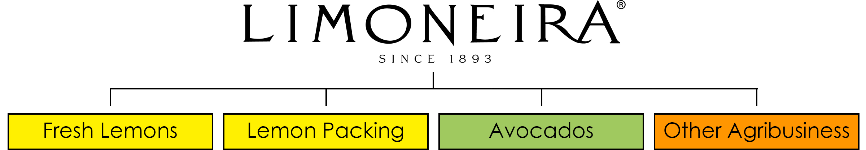

We are one of California’s oldest citrus growers and are one of the largest growers of lemons in the United States. According to the California Avocado Commission, we are one of the largest growers of avocados in the United States. In addition to growing lemons and avocados, we grow oranges and wine grapes. We have agricultural plantings throughout Ventura and San Luis Obispo Counties in California, Yuma County in Arizona, La Serena, Chile and Jujuy, Argentina, which collectively consist of approximately 3,400 acres of lemons, 1,400 acres of avocados, 100 acres of oranges and 400 acres of wine grapes. We also operate our own packinghouses in Santa Paula, California and Yuma, Arizona, where we process, pack and sell lemons that we grow, as well as lemons grown by others. We have a 47% interest in Rosales S.A. (“Rosales”), a citrus packing, marketing and sales business, a 90% interest in Fruticola Pan de Azucar S.A. (“PDA”), a lemon and orange orchard and a 100% interest in Agricola San Pablo, SpA (“San Pablo”), a lemon and orange orchard, all of which are located near La Serena, Chile. We have a 51% interest in a joint venture, Trapani Fresh Consorcio de Cooperacion (“Trapani Fresh”), a lemon orchard in Argentina.
Our water resources include water rights, usage rights and pumping rights to the water in aquifers under, and canals that run through, the land we own. Water for our farming operations is sourced from the existing water resources associated with our land, which includes rights to water in the adjudicated Santa Paula Basin (aquifer) and the un-adjudicated Fillmore and Paso Robles Basins (aquifers). We also use surface water in Arizona from the Colorado River through the Yuma Mesa Irrigation and Drainage District (“YMIDD”). We use ground water provided by wells and surface water for our PDA and San Pablo farming operations in Chile and our Trapani Fresh farming operations in Argentina.

For more than 100 years, we have been making strategic investments in California agriculture and real estate. We currently have an interest in two real estate development projects in California. These projects include multi-family housing, single-family homes and apartments of approximately 800 units in various stages of planning and development.

5

Fiscal Year 2024 Highlights and Recent Developments

On December 1, 2023, we announced the commencement of a strategic review process to explore potential alternatives aimed at maximizing stockholder value. Potential strategic alternatives could include, but not be limited to, a sale of all or parts of the Company and its assets, a merger or other transaction. The Board has not set a timetable for completion of the review and no transaction or other outcome is guaranteed to take place. At this time, we cannot predict the impact that such strategic alternatives might have on our business, operations or financial condition.
In December 2023, we sold 12 acres of real property located in Yuma, Arizona for a sales price of $0.8 million. After transaction and closing costs, we recorded a gain on sale of approximately $0.2 million.
In April 2024, the Company conducted an organization restructuring resulting in severance benefit costs of approximately $1.2 million.
On April 30, 2024, our real estate development joint venture with The Lewis Group of Companies (“Lewis”) closed an additional 554 residential homesites at the Harvest at Limoneira master planned community in Santa Paula, CA (“Harvest”) and we recorded equity in earnings of investments of $16.6 million in the second quarter of fiscal year 2024. On June 5, 2024, we received a cash distribution of $15.0 million from the joint venture.
On May 7, 2024, it was announced that the Santa Paula City Council approved the proposal brought by the Company’s real estate development joint venture with Lewis to increase the number of entitled lots at Harvest from 1,500 dwelling units to 2,050 dwelling units. The Santa Paula City Council approved an amendment allowing for the 550-unit increase on April 3, 2024. The 550-unit increase will provide 250 additional single family for-sale homesites within Phase 3 of Harvest. Additionally, the Company in partnership with Lewis plans to construct 300 multi-family rental homes on a mixed-use portion of the project.
On December 17, 2024, we declared a cash dividend of $0.075 per common share payable on January 15, 2025, in the aggregate amount of approximately $1.4 million to common stockholders of record as of December 30, 2024.

COVID-19 Pandemic
The COVID-19 pandemic had an adverse impact on the industries and markets in which we conduct business. In particular, the export market for fresh produce significantly declined due to the COVID-19 pandemic impacts.

The decline in demand for our products beginning the second quarter of fiscal year 2020 negatively impacted our sales and profitability and may impact our sales and profitability in future periods. The duration of these trends and the magnitude of such impacts cannot be estimated at this time, as they are influenced by a number of factors, many of which are outside management’s control, including, but not limited, to those presented in Item 1A. Risk Factors of this Annual Report.

Business Division Summary
We have three business divisions: agribusiness, rental operations and real estate development. The agribusiness division is comprised of four reportable operating segments: fresh lemons, lemon packing, avocados and other agribusiness, which primarily includes oranges, specialty citrus, other crops and farm management services. The agribusiness division includes our core operations of farming, harvesting, lemon packing and lemon sales operations. The rental operations division includes our residential and commercial rentals, leased land operations and organic recycling. The real estate development division includes our investments in real estate development projects. Financial information and discussion of our four reportable segments are contained in the notes to the accompanying consolidated financial statements of this Annual Report.

6

Agribusiness Summary
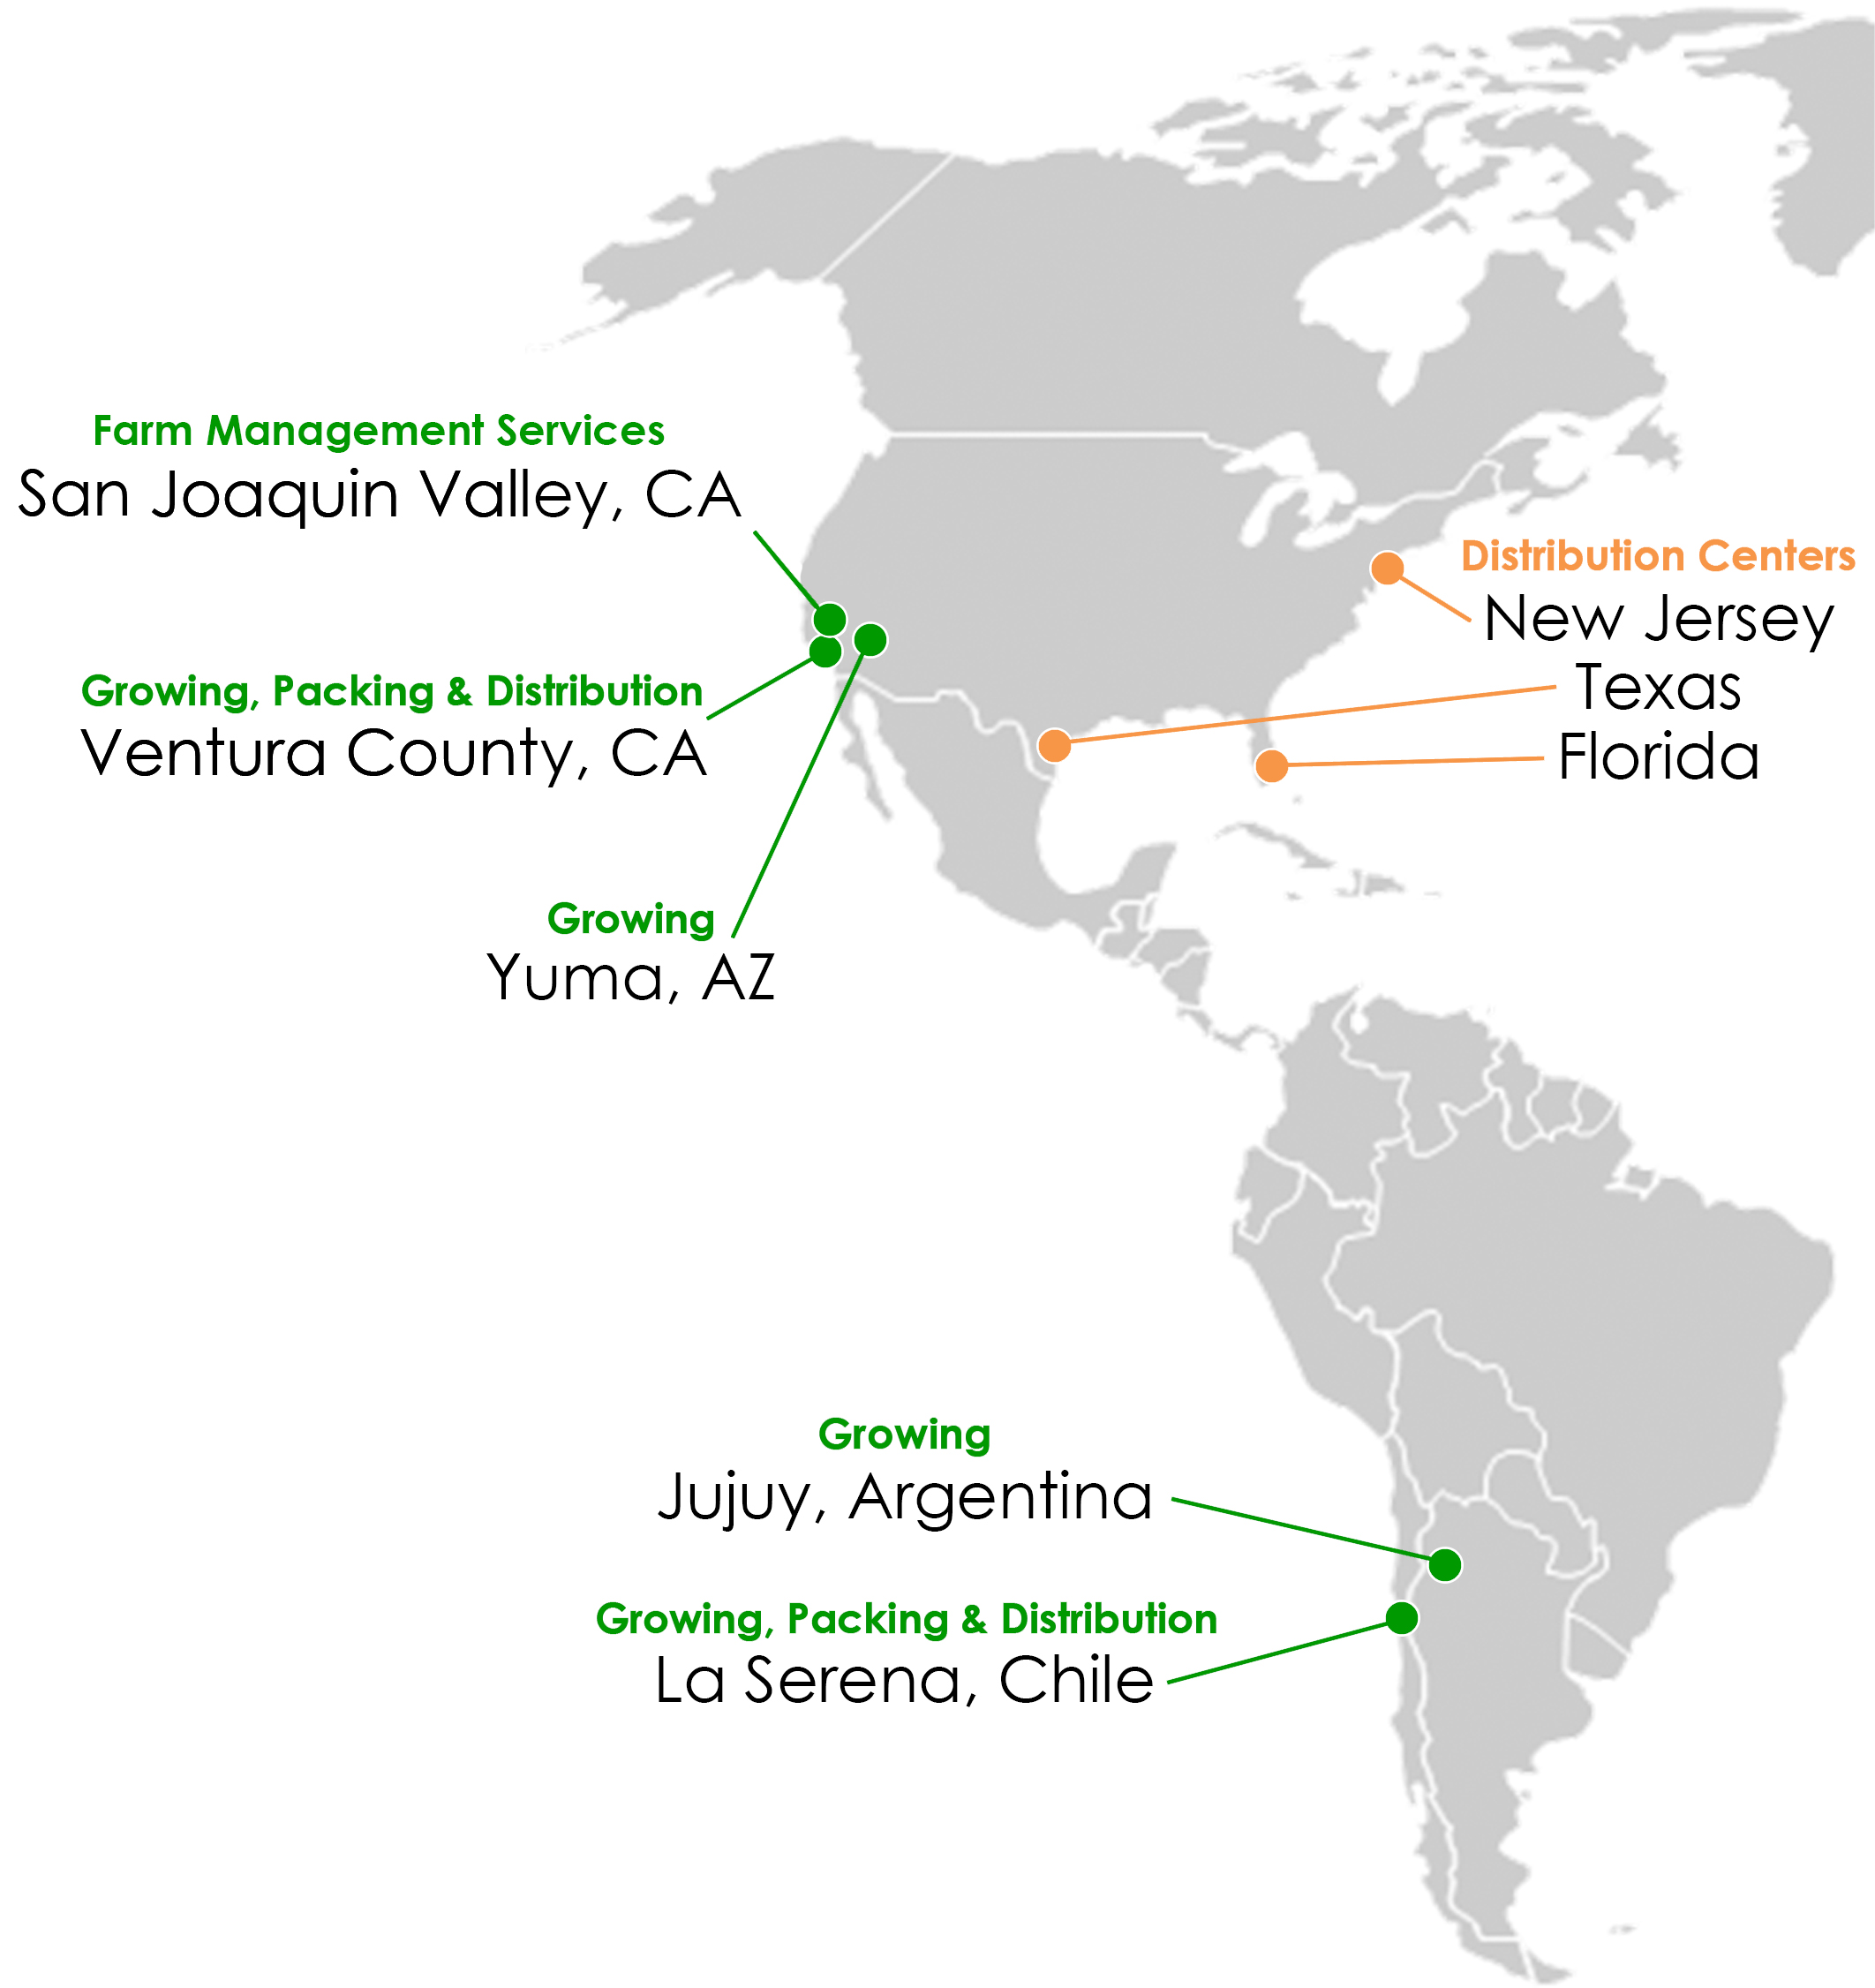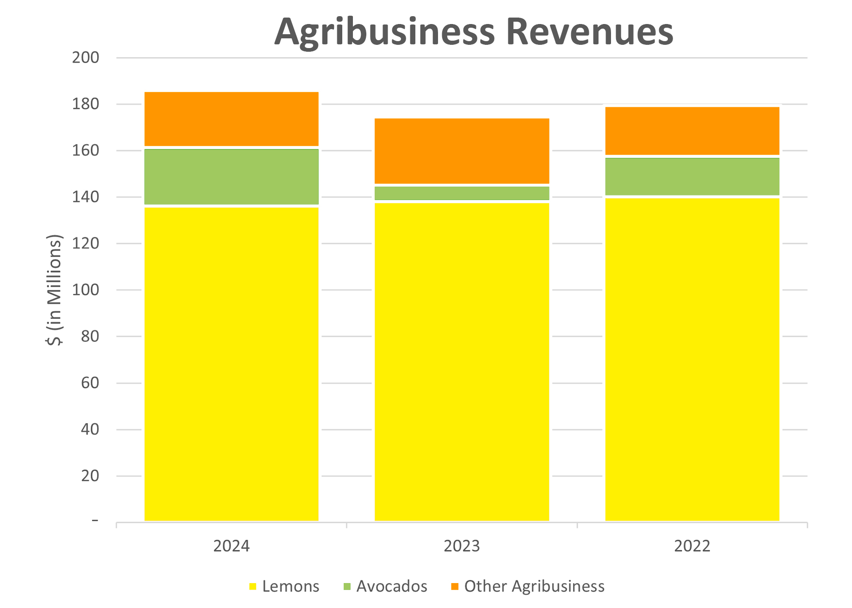
7

Farming
Lemons. We market and sell lemons directly to our food service, wholesale and retail customers throughout the United States, Canada, Asia, and certain other international markets. We are one of the largest lemon growers in the United States with approximately 3,400 acres of lemons planted primarily in Ventura County, California and in Yuma County, Arizona. Ventura County is California’s top lemon producing county.
There are many varieties of lemons, with the Lisbon, Eureka and Genoa varieties being the predominant varieties marketed on a worldwide basis. Approximately 99% of our lemon plantings are of the Lisbon, Eureka and Genoa varieties and approximately 1% are of other varieties such as sweet Meyer lemons and Proprietary Seedless lemons. California-grown lemons are available throughout the year, with peak production periods occurring from January through August. The storage life of fresh lemons generally ranges from one to 18 weeks, depending upon the maturity of the fruit, the growing methods used and the handling conditions in the distribution chain.
Avocados. We are one of the largest avocado growers in the United States with approximately 1,400 acres of avocados planted throughout Ventura County.
California-grown avocados have peak production periods occurring between February and July. Because of superior eating quality, the Hass avocado has contributed greatly to the avocado’s growing popularity through its retail, restaurant and other food service uses. Approximately 95% of our avocado plantings are of the Hass variety. The storage life of fresh avocados generally ranges from one to four weeks, depending upon the maturity of the fruit, the growing methods used and the handling conditions in the distribution chain.
Primarily related to differing soil conditions, the care of avocado trees is intensive. The need for more production per acre to compete with foreign sources of supply has required us to take an important lead in the practice of dense planting (typically four times the number of avocado trees per acre versus traditional avocado plantings) and mulching composition to help trees acclimate under conditions that more closely resemble those found in the tropics, a better climate for avocado growth.
Other Agribusiness. We have approximately 100 acres of oranges planted near La Serena, Chile, and 400 acres of wine grapes planted in San Luis Obispo County, California. We currently market our wine grapes utilizing processors that are not members of agricultural cooperatives. Our wine grapes are harvested and sold to various wine producers. Additionally, we provide farm management services, which include farming, management and operations services mainly related to the Northern Properties.
Plantings
We have agricultural plantings on properties located in the United States, Chile and Argentina. The following is a description of our agriculture properties:
Ranch Name |  |  |  |  |  | County / State or Country |  |  |  |  |  | Total  Acres |  |  |  |  |  | Lemons |  |  |  |  |  | Avocados |  |  |  |  |  | Oranges |  |  |  |  |  | Wine Grapes |  |  |  |  |  | Other
Limoneira/Olivelands |  |  |  |  |  | Ventura, CA |  |  |  |  |  | 1,700 |  |  |  |  |  | 400 |  |  |  |  |  | 900 |  |  |  |  |  | — |  |  |  |  |  | — |  |  |  |  |  | 400
La Campana |  |  |  |  |  | Ventura, CA |  |  |  |  |  | 300 |  |  |  |  |  | — |  |  |  |  |  | 300 |  |  |  |  |  | — |  |  |  |  |  | — |  |  |  |  |  | —
Orchard Farm |  |  |  |  |  | Ventura, CA |  |  |  |  |  | 1,100 |  |  |  |  |  | 700 |  |  |  |  |  | — |  |  |  |  |  | — |  |  |  |  |  | — |  |  |  |  |  | 400
Rancho La Cuesta |  |  |  |  |  | Ventura, CA |  |  |  |  |  | 200 |  |  |  |  |  | — |  |  |  |  |  | — |  |  |  |  |  | — |  |  |  |  |  | — |  |  |  |  |  | 200
Limco Del Mar |  |  |  |  |  | Ventura, CA |  |  |  |  |  | 200 |  |  |  |  |  | 100 |  |  |  |  |  | 100 |  |  |  |  |  | — |  |  |  |  |  | — |  |  |  |  |  | —
Windfall Farms |  |  |  |  |  | San Luis Obispo, CA |  |  |  |  |  | 700 |  |  |  |  |  | — |  |  |  |  |  | — |  |  |  |  |  | — |  |  |  |  |  | 400 |  |  |  |  |  | 300
Associated Citrus Packers |  |  |  |  |  | Yuma, AZ |  |  |  |  |  | 1,300 |  |  |  |  |  | 600 |  |  |  |  |  | — |  |  |  |  |  | — |  |  |  |  |  | — |  |  |  |  |  | 700
Pan de Azucar & San Pablo |  |  |  |  |  | La Serena, Chile |  |  |  |  |  | 3,500 |  |  |  |  |  | 500 |  |  |  |  |  | — |  |  |  |  |  | 100 |  |  |  |  |  | — |  |  |  |  |  | 2,900
Santa Clara |  |  |  |  |  | Jujuy, Argentina |  |  |  |  |  | 1,200 |  |  |  |  |  | 1,000 |  |  |  |  |  | — |  |  |  |  |  | — |  |  |  |  |  | — |  |  |  |  |  | 200
Other agribusiness land |  |  |  |  |  | Various Counties, CA |  |  |  |  |  | 300 |  |  |  |  |  | 100 |  |  |  |  |  | 100 |  |  |  |  |  | — |  |  |  |  |  | — |  |  |  |  |  | 100
Total |  |  |  |  |  |  |  |  |  |  |  | 10,500 |  |  |  |  |  | 3,400 |  |  |  |  |  | 1,400 |  |  |  |  |  | 100 |  |  |  |  |  | 400 |  |  |  |  |  | 5,200
The Limoneira/Olivelands Ranch is the original site of our Company. Our headquarters, lemon packing operations and storage facilities are located on this property.
Other acres in the table above includes corporate and lemon packing facilities, land leased to other agricultural businesses, rental units, roads, creeks, hillsides and other open land.
8

Our orchards can maintain production for many years. For financial reporting purposes, we depreciate our orchards from 20 to 30 years depending on the fruit variety. We regularly evaluate our orchards’ production and growing costs and based on these and other factors, we may decide to redevelop certain orchards. In addition, we may acquire agricultural property with existing productive orchards or without productive orchards, which would require new orchard plantings. The fruit varieties that we grow are typically non-producing for approximately the first four to five years after the year of planting. Orchards may continue producing fruit longer than their depreciable lives. The following table presents the number of acres planted by fruit variety and approximate age of our orchards:
 |  |  |  |  |  | Age of Orchards
 |  |  |  |  |  | 0-5 Years |  |  |  |  |  | 6-25 Years |  |  |  |  |  | Over 25 Years |  |  |  |  |  | Total
Lemons |  |  |  |  |  | 400 |  |  |  |  |  | 2,200 |  |  |  |  |  | 800 |  |  |  |  |  | 3,400
Avocados |  |  |  |  |  | 600 |  |  |  |  |  | 300 |  |  |  |  |  | 500 |  |  |  |  |  | 1,400
Oranges |  |  |  |  |  | — |  |  |  |  |  | 100 |  |  |  |  |  | — |  |  |  |  |  | 100
Wine grapes |  |  |  |  |  | 100 |  |  |  |  |  | 300 |  |  |  |  |  | — |  |  |  |  |  | 400
Total |  |  |  |  |  | 1,100 |  |  |  |  |  | 2,900 |  |  |  |  |  | 1,300 |  |  |  |  |  | 5,300
Lemon Packing and Sales
We are one of the oldest continuous lemon packing operations in North America. We pack and sell lemons grown by us as well as lemons grown by others, the operations of which are included in our financial statements under the lemon packing segment. Lemons delivered to our packinghouses in Santa Paula, California and Yuma, Arizona are sized, graded, cooled, ripened and packed for delivery to customers. Our ability to accurately estimate the size, grade and timing of the delivery of the annual lemon crop has a substantial impact on both our costs and the sales price we receive for the fruit.
A significant portion of the costs related to our lemon packing operation is fixed. We invest considerable time and research into refining and improving our lemon packing through innovation and are continuously searching for new techniques to refine how premium lemons are delivered to our consumers. Our strategy for growing the profitability of our lemon packing operations calls for optimizing the percentage of a crop that goes to the fresh market, or fresh utilization, and procuring a larger percentage of the California and Arizona lemon crop.
Rental Operations Summary
Our rental operations include our residential and commercial rentals, leased land operations and organic recycling.
We own and maintain 240 residential housing units located in Ventura County in California that we lease to employees, former employees and outside tenants. We also own several commercial office buildings. These properties generate reliable cash flows that we use to partially fund the operating costs of our business. As of October 31, 2024, we lease approximately 300 acres of our land to third-party agricultural tenants who grow a variety of row crops. Our leased land business provides us with a profitable method to diversify the use of our land. We also partner with one of our tenants and have an organic recycling facility on our land in Ventura County. Effective November 1, 2021, we lease our 1,200-acre Santa Clara ranch in Argentina.
Real Estate Development Summary

We invest in real estate investment projects and recognize that long-term strategies are required for successful real estate development activities. Our goal is to redeploy real estate earnings and cash flow into the expansion of our agribusiness and other income producing real estate. For real estate development projects and joint ventures, it is not unusual for the timing and amounts of revenues and costs, partner contributions and distributions, project loans, other financing assumptions and project cash flows to be impacted by government approvals, project revenue and cost estimates and assumptions, economic conditions, financing sources and product demand as well as other factors. Such factors could affect our results of operations, cash flows and liquidity.

9

For more than 100 years, we have been making strategic real estate investments in California agricultural and developable real estate. Our current real estate developments include developable land parcels, multi-family housing and single-family homes with approximately 800 units in various stages of planning and development. The following is a summary of each of the strategic real estate investment properties in which we own an interest:
East Area I - Santa Paula, California. East Area I consists of approximately 500 acres that we historically used as agricultural land and is located in Santa Paula approximately ten miles from the City of Ventura and the Pacific Ocean. East Area I is the location for our master planned community of commercial and residential properties, named Harvest at Limoneira, designed to satisfy expected demand in a region that we believe will have few other developments in this coming decade.
In November 2015, we entered into a joint venture with the Lewis Group of Companies (“Lewis”) for the residential development of our East Area I real estate development project. To consummate the transaction, we formed LLCB as the development entity, contributed our East Area I property to the joint venture and sold a 50% interest in the joint venture to Lewis for $20.0 million. The first phase of the project broke ground to commence mass grading in November 2017. Approved project plans include approximately 2,050 residential units and site improvements. A total of 1,261 residential units have closed from the project’s inception to October 31, 2024.
In October 2022, we entered into another joint venture with Lewis for the development of our 17-acre East Area I Retained Property (“Retained Property”), which is located within the East Area I property. We formed LLCB II, LLC as the development entity, contributed our Retained Property to the joint venture and sold a 50% interest to Lewis for approximately $8.0 million.
The joint venture partners will share in capital contributions to fund project costs until loan proceeds and/or revenues are sufficient to fund the projects. Since inception, each partner has made funding contributions of $21.4 million to LLCB and $1.0 million to LLCB II. In June 2024, we received a cash distribution of $15.0 million from LLCB and we expect to receive approximately $165.0 million from LLCB, LLCB II and East Area II over the next six years of the projects.

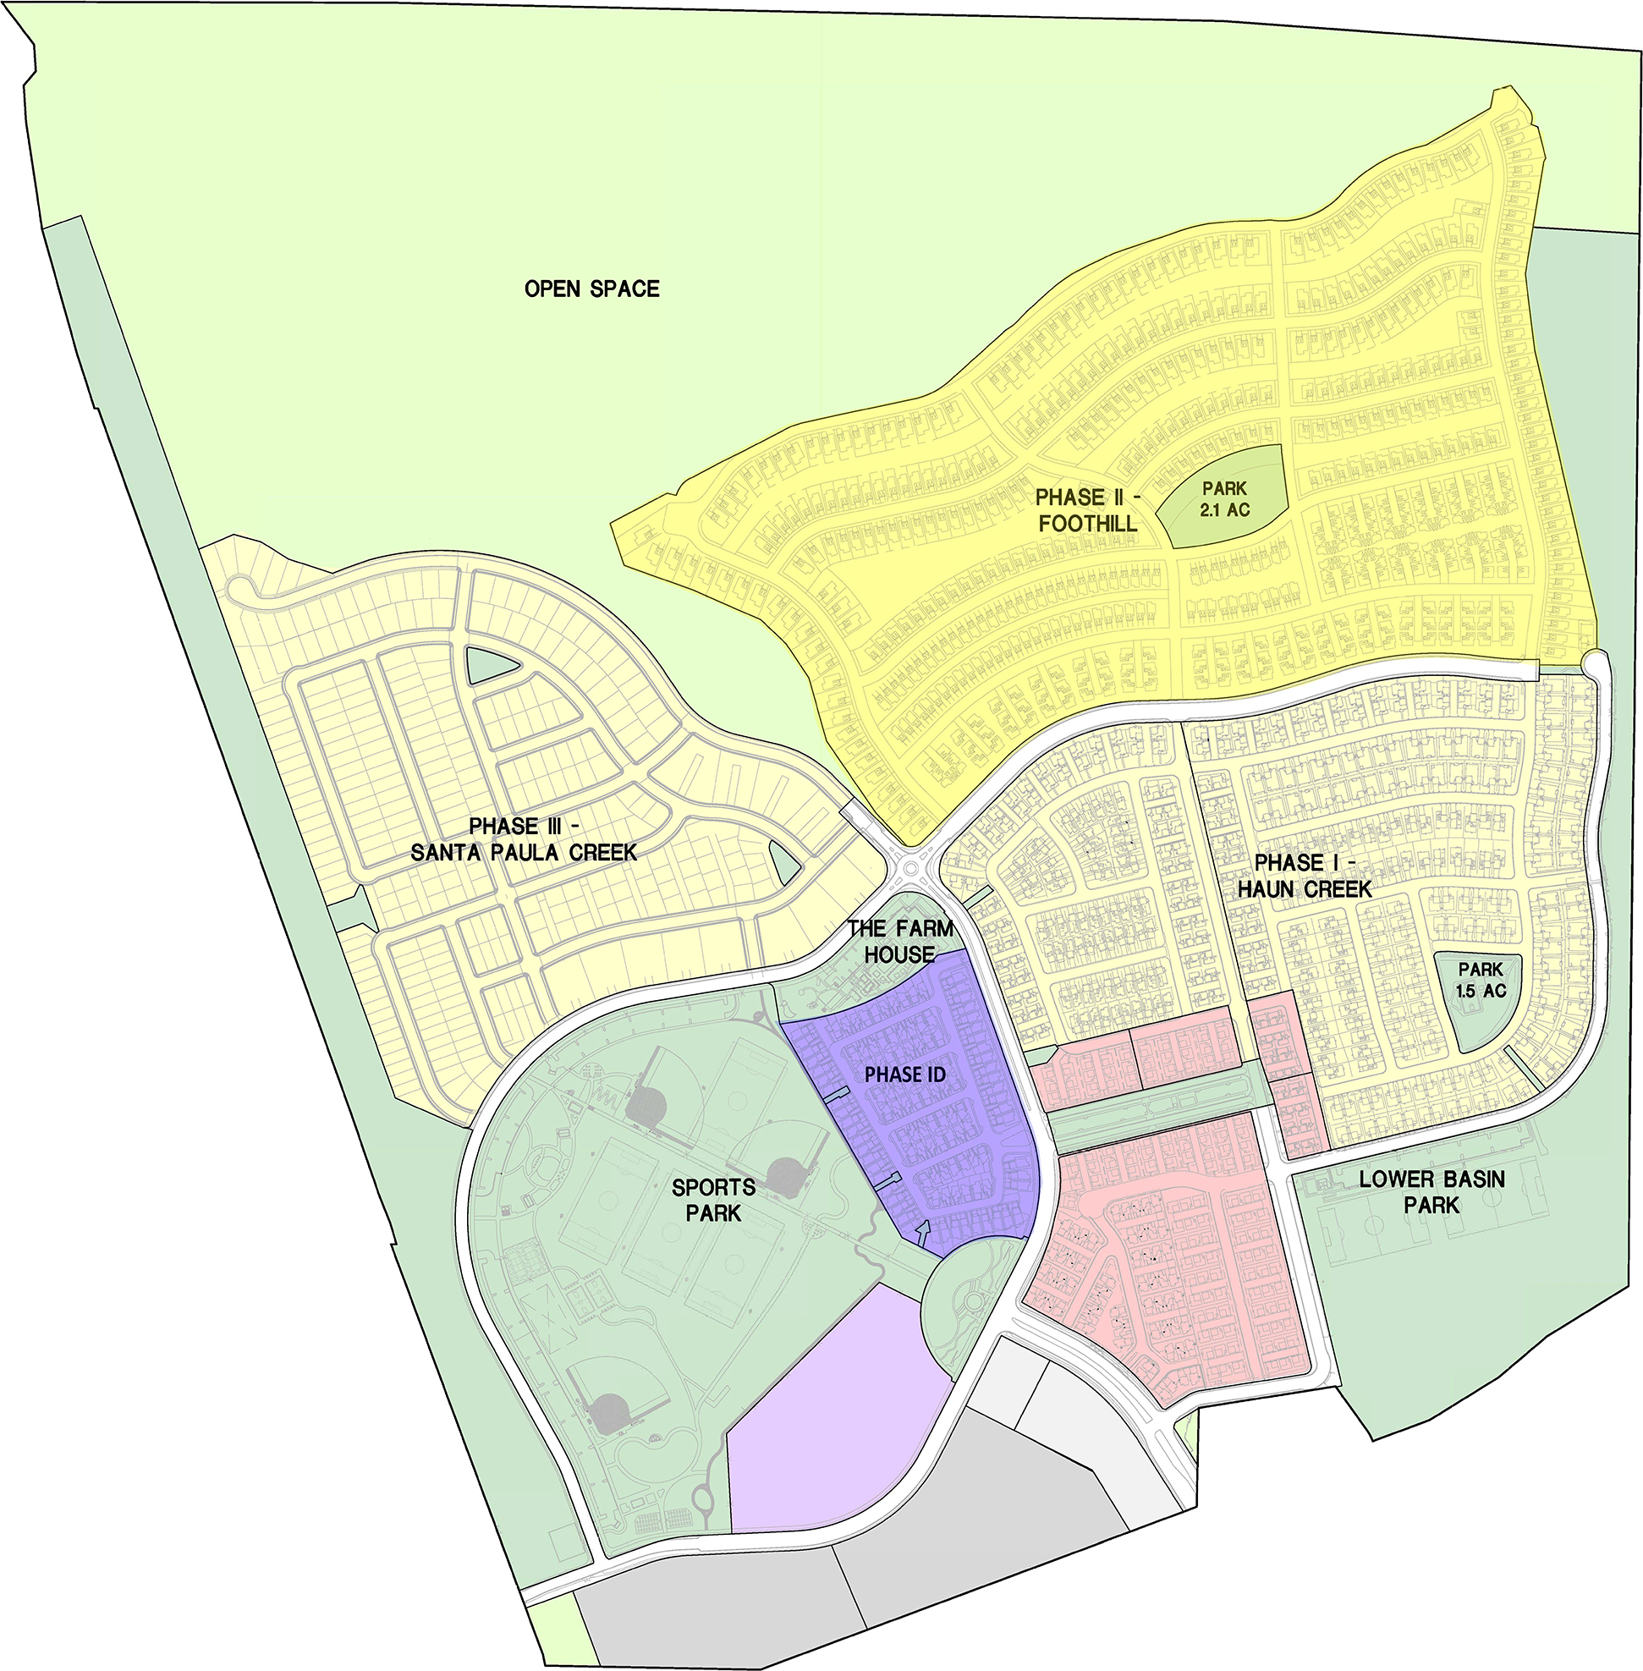

10

East Area II - Santa Paula, California. Our design associates and we are in the process of formulating plans for East Area II, a parcel of approximately 30 acres adjacent to East Area I. In July 2021, we entered into a non-binding letter of intent to sell approximately 25 acres of our East Area II property in five staged purchases to an investment company for the purpose of constructing a medical campus consisting of medical office buildings and an acute care hospital. Completion of the transaction is subject to the execution of a purchase and sale agreement and resolution of certain contingencies.
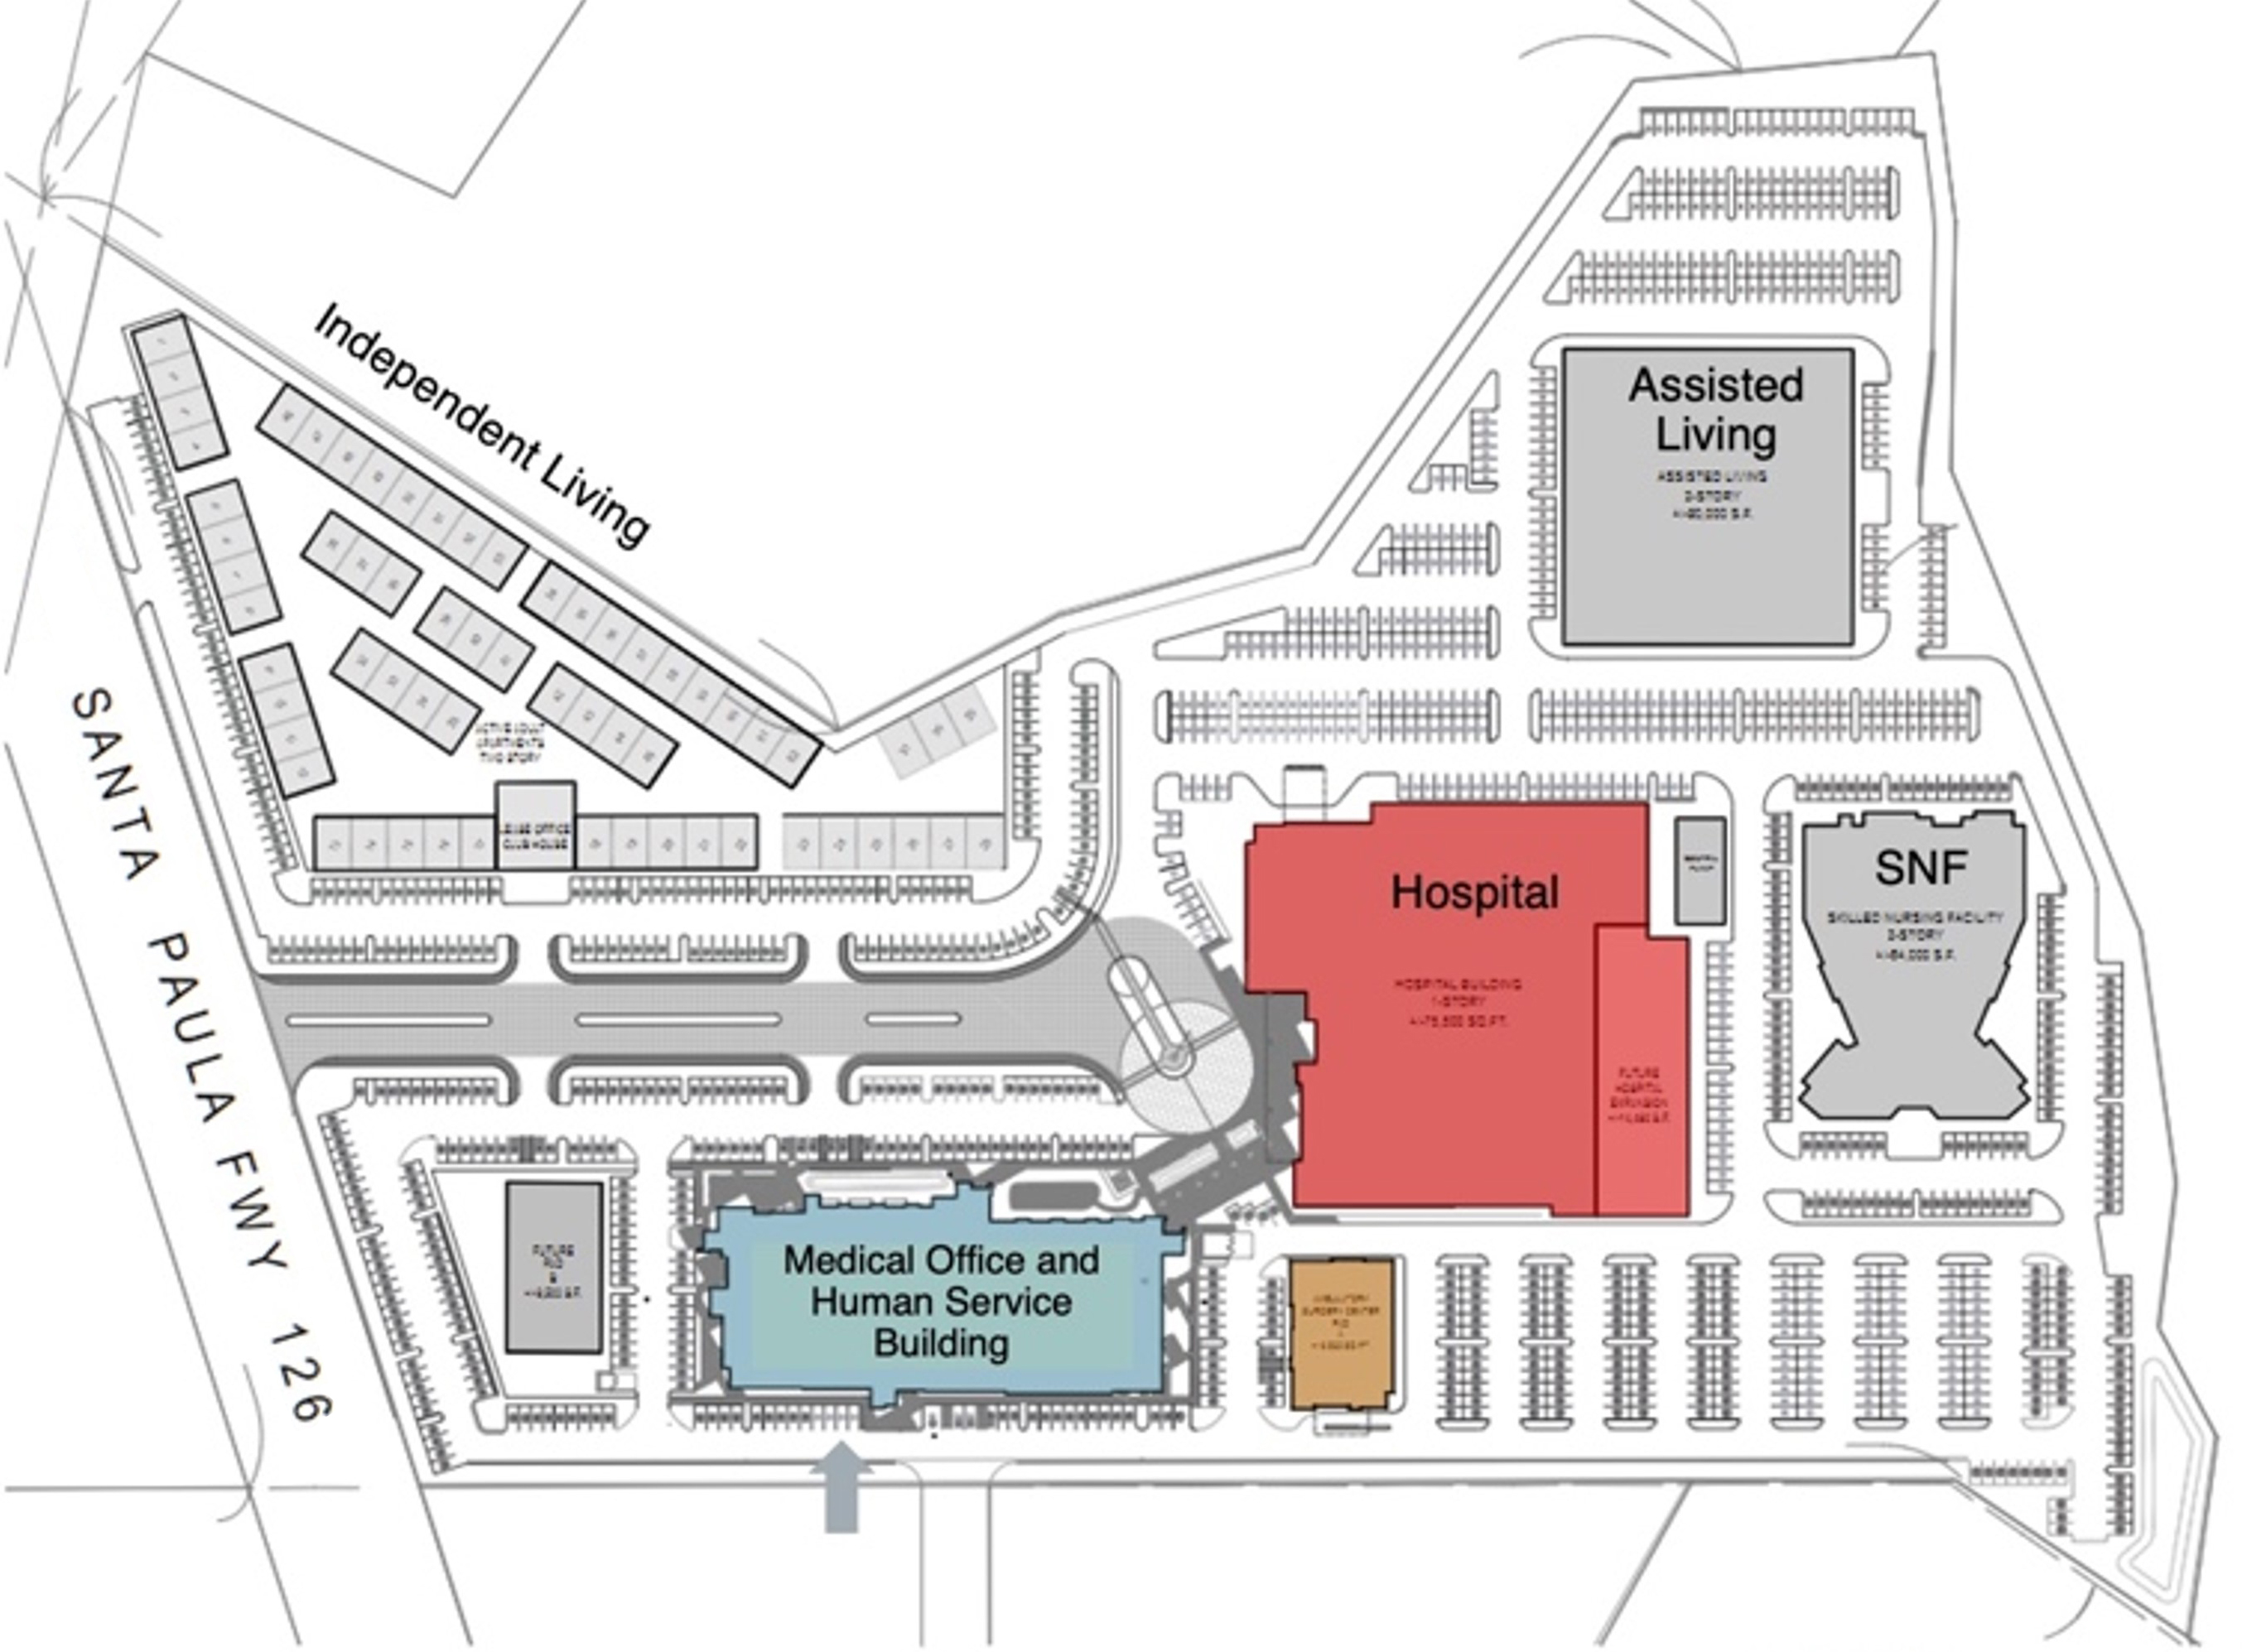
Santa Maria - Santa Barbara County, California. In fiscal year 2020, we entered into an agreement to sell our Sevilla property for $2.7 million, which closed in the first quarter of fiscal year 2023.
Markets and Competitive Strengths
Agribusiness Operations
With agricultural operations dating back to 1893, we are one of California’s oldest citrus growers and one of the largest growers of lemons and avocados in the United States. Consequently, we have developed significant experience with a variety of crops, mainly lemons and avocados. The following is a brief list of what we believe are our significant competitive strengths with respect to our agribusiness operations:
•Our agricultural properties in Ventura County are located near the Pacific Ocean, which provides an ideal environment for growing lemons and avocados. Our agricultural properties in Yuma, Arizona, are also located in an area that is well-suited for growing citrus crops.
•Historically, a higher percentage of our crops goes to the fresh market, which is commonly referred to as fresh utilization, than that of other growers and packers with which we compete.
•We have contiguous and nearby land resources that permit us to efficiently use our agricultural land and resources.
•We are not dependent on State or Federal water projects for our agribusiness or real estate development operations in California.
•We own a majority of our agricultural land and take a long view on our fruit production practices.
•A significant amount of our agribusiness property was acquired many years ago, which results in a low-cost basis and associated expenses.
•In our fresh lemons and lemon packing segments, our integrated business model with respect to growing, packing, marketing and selling citrus allows us to better serve our customers.
•Our lemon packing operations provide marketing opportunities with other citrus companies and their respective products.
11

•We made investments in ground-based solar projects that provide us with tangible and intangible non-revenue generating benefits. The electricity generated by these investments provides us with a significant portion of the electricity required to operate our packinghouse and cold storage facilities located in Santa Paula, California. Additionally, these investments support our sustainable agricultural practices, reduce our dependence on fossil-based electricity generation and lower our carbon footprint. Moreover, electricity that we generate and do not use is conveyed back to the utility companies. Finally, over time, we expect that our customers and the end consumers of our fruit will value the investments that we made in renewable energy as a part of our packing operations, which we believe may help us differentiate our products from similar commodities.
•We made various other investments in water rights and mutual water companies. We own shares in the following mutual water companies: Farmers Irrigation Co., Canyon Irrigation Co., San Cayetano Mutual Water Co. and Middle Road Mutual Water Co. Additionally, we acquired water rights in the adjudicated Santa Paula Basin (aquifer), the YMIDD and in Chile.
Real Estate Development Operations
With respect to our real estate development operations, we believe our competitive advantages are as follows:
•We have entitlements to build approximately 2,050 residential units in our East Area I development.
•We partnered with an experienced and financially strong land developer for our East Area I residential master plan development.
•Several of our agricultural and real estate investment properties are unique and carry longer-term development potential.
•Our East Area II property has approximately 30 acres of land commercially zoned, which is adjacent to our East Area I property.
Business Strategy
We are an agribusiness and real estate development company that generates revenue and annual cash flows to support investments in agricultural efficiencies and real estate development activities. As our agricultural and non-strategic real estate development investments are monetized, we intend to use the cash flow to reduce existing debt, invest in farming efficiencies and expand packing capacities through our One World of Citrus asset-lighter business model. We will also use more third-party grower and supplier fruit to reduce the impact of pricing volatility and rising farming costs.
We believe the asset-lighter model will enable us to achieve revenue and cash flow growth by reducing investment risk in North and South America, generating more stable and higher growth in cash flow and earnings, and improving our annual return on invested capital.
The following describes the key elements of our business strategy.
Agribusiness
With respect to our agribusiness operations, key elements of our strategy are:
•Expand our One World of Citrus asset-lighter business model in three main channels:
◦Growing, packing, marketing and distributing fruit grown on our properties;
◦Utilizing third-party grower fruit by packing, marketing and distributing their fruit through Limoneira channels; and
◦Marketing and distributing brokered fruit.
We intend to continue to strategically sell certain assets to reduce existing debt, increase farming efficiencies and expand packing capabilities. Increased volume of fruit sales is expected to be fueled by sourcing from third-party growers and suppliers, thus mitigating the volatility that commodity pricing has on growers.
•Expand our Sources of Lemon Supply. Peak lemon production occurs at different times of the year depending on geographic region. In addition to our lemon production in California and Arizona and lemons we acquire from domestic third-party growers and suppliers, we have expanded our lemon supply sources to international markets such as Mexico, Chile and Argentina. Increases in lemons procured from third-party growers and suppliers and international sources improve our ability to provide our customers with fresh lemons throughout the year.
12

•Increase the Volume of our Lemon Packing Operations. We regularly monitor our costs for redundancies and opportunities for cost reductions. In this regard, cost per carton is a function of throughput. We continually seek to acquire additional lemons from third-party growers and suppliers to pack through our packing facilities. Third-party growers and suppliers are only added if we determine their fruit is of good quality and can be cost effective for both the grower and us. Of most importance is the overall fresh utilization rate for our fruit, which is directly related to quality.
•Expand our Plantings of Avocados. Our plantings of avocados have been profitable and historically have been pursued to diversify our product line. We plan to expand our avocado production by 1,000 acres through fiscal year 2027 to capitalize on robust consumer demand trends.
•Expand International Sales and Marketing of Lemons. We estimate that we currently have approximately 15% of the fresh lemon market in the United States and a larger share of the United States lemon export market. We intend to explore opportunities to expand our international sales and marketing of lemons. We have the ability to supply a wide range of customers and markets and, because we produce high quality lemons, we can export our lemons to international customers, which many of our competitors are unable to supply.
Other Operations
With respect to our rental operations and real estate development activities, key elements of our strategy include the following:
•Rental and Housing Units. Our housing, commercial and land rental operations provide us with a consistent, dependable source of cash flow that helps to fund our overall activities. Additionally, we believe our housing rental operation allows us to offer a unique benefit to our employees.
•Opportunistically Lease Land to Third-Party Crop Farmers. We regularly monitor the profitability of our fruit-producing acreage to ensure acceptable per acre returns. When we determine that leasing the land to third-party row crop farmers would be more profitable than farming the land, we intend to seek third-party row crop tenants.
•Selectively and Responsibly Develop our Agricultural Land. We recognize that long-term strategies are required for successful real estate development activities. We thus intend to maintain our position as a responsible agricultural landowner and major employer in Ventura County while focusing our real estate development activities on those agricultural land parcels that we believe offer the best opportunities to demonstrate our long-term vision for our community.
Customers
We market and sell our lemons directly to our food service, wholesale and retail customers in the United States, Canada, Asia, and certain other international markets. We sold lemons and other citrus to 194 U.S. and international customers during fiscal year 2024. We sell our avocados to third-party packinghouses and our wine grapes to wine producers.
Competition
The agribusiness crop markets are intensely competitive, but no single producer has any significant market power over any market segments, as is consistent with the production of most agricultural commodities. Generally, there are a large number of global producers that sell through joint marketing organizations and cooperatives. Fruit is also sold to independent packers, both public and private, who then sell to their own customer base. Customers are typically large retail chains, food service companies, industrial manufacturers and distributors who sell and deliver to smaller customers in local markets throughout the world. In the purest sense, our largest competitors in our agribusiness segments are other citrus and avocado producers in California, Mexico, Chile, Argentina and Florida, a number of which are members of cooperatives such as Sunkist or have selling relationships with third-party packinghouses similar to that of Limoneira. Our lemons and other citrus also compete with other fruits and vegetables for the share of consumer expenditures devoted to fresh fruit and vegetables: apples, pears, melons, pineapples and other tropical fruit. Avocado products compete in the supermarket with hummus products and other dips and salsas. For our specific crops, the size of the 2023 U.S. market was approximately $615 million for lemons, both fresh and juice, approximately $250 million for avocados, and approximately $985 million for oranges, both fresh and juice. Competition in the various agribusiness markets is affected by reliability of supply, product quality, brand recognition and perception, price and the ability to satisfy changing customer preferences through innovative product offerings.
The sale and leasing of residential, commercial and industrial real estate is very competitive, with competition coming from numerous and varied sources throughout California. Our greatest direct competition for each of our current real estate development properties in Ventura County comes from other residential and commercial developments in nearby areas.
13

Resources and Raw Materials
In our fresh lemons and lemon packing segments, paper is considered a material raw product for our business because most of our products are packed in cardboard cartons for shipment. Paper is readily available, and we have numerous suppliers for such material. In our agribusiness division, petroleum-based products such as herbicides and pesticides are considered raw materials, and we have numerous suppliers for these products.
Intellectual Property
We have numerous trademarks and brands under which we market and sell our fruits, particularly lemons, domestically and internationally, many of which have been owned for decades. The material brands of Limoneira lemons include, but are not limited to, One World of Citrus®, Santa®, Paula®, Bridal Veil®, Fountain®, Golden Bowl® and Level®. These trademarks are owned by us and registered with the United States Patent and Trademark Office. We also acquired certain lemon brands with acquisitions, including Kiva®, Kachina®, Oxnard Lemon and Trapani Fresh.
Seasonal Nature of Business
As with any agribusiness enterprise, our agribusiness operations are predominantly seasonal in nature. The harvest and sale of our lemons, avocados and oranges occurs in all quarters, but is generally more concentrated during our third quarter. Our lemons are generally grown and marketed throughout the year, our avocados are primarily sold from January through August and our wine grapes are primarily sold in September and October.
Environmental and Regulatory Matters
Our agribusiness and real estate development divisions are subject to a broad range of evolving federal, state and local environmental laws and regulations. For example, the growing, packing, storing and distributing of our products is extensively regulated by various federal and state agencies. The California State Department of Food and Agriculture oversees our packing and processing of lemons and conducts tests for fruit quality and packaging standards. We are also subject to laws and regulations that govern the use of pesticides and other potentially hazardous substances and the treatment, handling, storage and disposal of materials and waste and the remediation of contaminated properties. Advertising of our products is subject to regulation by the Federal Trade Commission and our operations are subject to certain health and safety regulations, including those issued under the Occupational Safety and Health Act.
We seek to comply at all times with all such laws and regulations and to obtain any necessary permits and licenses, and we are not aware of any instances of material non-compliance. We believe our facilities and practices are sufficient to maintain compliance with applicable governmental laws, regulations, permits and licenses. Nevertheless, there is no guarantee that we will be able to comply with any future laws and regulations for necessary permits and licenses. Our failure to comply with applicable laws and regulations or obtain any necessary permits and licenses could subject us to civil remedies including fines, injunctions, recalls or seizures, as well as potential criminal sanctions. These remedies can increase costs, decrease revenues and lead to additional charges to earnings, which may have a material adverse effect on our business, results of operations and financial condition.
For a discussion of the various risks we face from regulation and compliance matters, see Item 1A. Risk Factors of this Annual Report.
Human Capital Resources
As of October 31, 2024, we had 241 employees, of which 90 were salaried and 151 were hourly. None of our employees are subject to a collective bargaining agreement. We believe that our relations with our employees are good.
We believe that an environment of diversity, inclusion and belonging fosters innovation, strengthens our global workforce, and drives our ability to serve customers. Our global presence is strengthened by having a workforce that reflects the diversity of the customers we serve and by maintaining an environment in which such diversity contributes to our mission.
Limoneira is committed to protecting the human rights, safety and dignity of the people who contribute to the success of our business. We are committed to improving the lives of all our stakeholders by helping to provide access to our products and increasing the diversity of our workforce. We also seek to support the welfare of the people who produce, process and harvest the products we sell. We have several diversity, inclusion and belonging efforts and programs to better ensure that we are supporting our employees.
14

Limoneira’s overall culture emphasizes the health and safety of our employees and the customers we serve. Limoneira has an Illness and Injury Prevention Plan (IIPP), a Safety Guide and conforms to and follows regulations and guidelines set forth by OSHA in all facilities and operations. Where a particular jurisdiction’s guidelines, such as Cal/OSHA, are different from the OSHA standard, Limoneira adheres to the most extensive guidelines. We have excellent results from our safety programs compared to similar companies within our industry.
We strive to be a great place for our employees to work and live. We offer competitive pay and best-in-class benefits, including a 401k plan with matching contribution opportunities, comprehensive paid healthcare plans, wellness programs and tuition reimbursement.
We own and maintain 240 residential housing units located in Ventura County, California. We lease these housing units to employees, former employees and outside tenants. Our residential units provide affordable housing to many of our employees, including our agribusiness employees. Employees live close to their work, which reduces traffic and commuting times. This unique employment benefit helps us maintain a dependable, long-term employee base. We partner with some local schools to provide transportation for residents.

Item 1A. Risk Factors
Risks Related to Our Business Approach
We cannot assure you that our evaluation of potential strategic alternatives to enhance value for stockholders will be successful; and there may be negative impacts on our business and stock price as a result of the process of exploring strategic alternatives.
On December 1, 2023, the Company announced the commencement of a process to explore strategic alternatives, which could include, but not be limited to, a sale of all or parts of the Company, merger or other transaction. The Board has not set a timetable for the completion of this review process and there can be no assurance that it will result in any transaction or outcome. Whether the process will result in any additional transactions, our ability to complete any transaction, and if our Board decides to pursue one or more transactions, will depend on numerous factors, some of which are beyond our control. Such factors include the interest of potential acquirers or strategic partners in a potential transaction, the value potential acquirers or strategic partners attribute to our businesses and their respective prospects, market conditions, interest rates and industry trends.
Our stock price may be adversely affected if the evaluation does not result in additional transactions or if one or more transactions are consummated on terms that investors view as unfavorable to us. Even if one or more additional transactions are completed, there can be no assurance that any such transactions will be successful or have a positive effect on stockholder value. Our Board may also determine that no additional transaction is in the best interest of our stockholders. In addition, our financial results and operations could be adversely affected by the strategic process and by the uncertainty regarding its outcome.
The attention of management and our Board could be diverted from our core business operations. We have diverted capital and other resources to the process that otherwise could have been used in our business operations, and we will continue to do so until the process is completed.
We could incur substantial expenses associated with identifying and evaluating potential strategic alternatives, including those related to employee retention payments, equity compensation, severance pay and legal, accounting and financial advisor fees. In addition, the process could lead us to lose or fail to attract, retain and motivate key employees, and to lose or fail to attract customers or business partners. Furthermore, it could expose us to litigation. The public announcement of a strategic alternative may also yield a negative impact on operating results if prospective or existing service providers are reluctant to commit to new or renewal contracts or if existing customers decide to move their business to a competitor.
We do not intend to disclose developments or provide updates on the progress or status of the strategic process until our Board deems further disclosure is appropriate or required. Accordingly, speculation regarding any developments related to the review of strategic alternatives and perceived uncertainties related to the future of the Company could cause our stock price to fluctuate significantly.
15

Risks Related to Our Agribusiness Operations
Adverse weather conditions, natural disasters, including earthquakes and wildfires, and other natural conditions, including the effects of climate change, could impose significant costs and losses on our business.
Fresh produce is vulnerable to adverse weather conditions, including windstorms, floods, drought and temperature extremes, which are quite common and may occur with higher frequency or be less predictable in the future due to the effects of climate change. Unfavorable growing conditions can reduce both crop size and crop quality. In extreme cases, entire harvests may be lost in some geographic areas. We purchase crop insurance for certain crops which partially mitigates our exposure.
All of our crops are subject to damage from frosts and freezes, and this has happened periodically in the past. In some cases, the fruit is damaged or ruined; in the case of extended periods of cold, the trees can also be damaged or killed.
Additionally, a significant portion of our agricultural plantings and our corporate headquarters are located in a region of California that is prone to natural disasters such as earthquakes and wildfires. For example, in December 2017, high winds and the related Southern California wildfires caused a brief power outage at our Santa Paula, California packinghouse and destroyed 14 of our farm worker housing units. While our orchards did not suffer significant damage in the wildfire, the potential for significant damage to a substantial amount of our plantings from a natural disaster in the future continues to exist. Furthermore, if a natural disaster or other event occurs that prevents us from using all or a significant portion of our corporate headquarters, as a result of a power outage or otherwise, or that damages critical infrastructure, it may be difficult or, in certain cases, impossible for us to continue our business for a substantial amount of time.
For the foregoing reasons, adverse weather conditions, natural disasters, including earthquakes and wildfires, or other natural conditions, including the effects of climate change, could severely disrupt our operations, and have a material adverse effect on our business, results of operations, financial condition and prospects.
Our agricultural plantings are potentially subject to damage from disease and pests, which could impose losses on our business and the prevention of which could impose significant additional costs on us.
Fresh produce is vulnerable to crop disease and to pests (e.g., Mediterranean Fruit Fly and the Asian Citrus Psyllid (“ACP”)), which may vary in severity and effect, depending on the stage of production at the time of infection or infestation, the type of treatment applied and climatic conditions.
ACP is an aphid-like insect that is a serious pest to all citrus plants because it can transmit the disease Huanglongbing (“HLB”) when it feeds on the plants’ leaves and trees. ACP is a federal action quarantine pest subject to interstate and international quarantine restrictions by the United States Department of Agriculture (“USDA”), including a prohibition on the movement of nursery stock out of quarantine areas and a requirement that all citrus fruit be cleaned of leaves and stems prior to movement out of the quarantine area. Due to the discovery of ACP in our orchards, we have experienced costs related to the quarantine and treatment of ACP.
In September 2023, two HLB-positive citrus trees were detected on a residential property in the City of Santa Paula, California. Following this detection, the California Department of Food and Agriculture established a mandatory five-mile-radius quarantine area, encompassing approximately 1,100 acres of Limoneira-owned lemon orchards. In July 2024, an additional 75 HLB-positive trees were detected on residential properties in the City of Santa Paula. In response, the quarantine area was expanded in September 2024 to account for the new detections. The quarantine restricts the movement of citrus fruit, trees, and related plant materials, subject to specific protocols. The estimated additional costs to spray insecticides on our orchards within the quarantine area are $0.3 million to $0.4 million for fiscal year 2025. There is no assurance that HLB will not be detected on Limoneira orchards in the future.
The costs to control these diseases and other infestations vary depending on the severity of the damage and the extent of the plantings affected. Moreover, there can be no assurance that available technologies to control such infestations will continue to be effective. These infestations can increase costs, decrease revenues and lead to additional charges to earnings, which may have a material adverse effect on our business, results of operations and financial condition.
16

Our strategy of marketing and selling our lemons directly to our food service, wholesale and retail customers may not continue to be successful.
Directly obtaining and retaining customers, particularly chain stores and other large customers, is highly competitive, and the prices or other terms of our sales arrangements may not be sufficient to retain existing business, maintain current levels of profitability or obtain new business. Industry consolidation (horizontally and vertically) and other factors have increased the buying leverage of the major grocery retailers in our markets, which may put further downward pressure on our pricing and volume and could adversely affect our results of operations.
Our earnings are sensitive to fluctuations in market supply and prices and demand for our products.
Excess supply often causes severe price competition in our industry and the worldwide lemon market is currently in an over-supplied position. Growing conditions in various parts of the world, particularly weather conditions such as windstorms, floods, droughts and freezes, as well as diseases and pests, are primary factors affecting market prices because of their influence on the supply and quality of product. The COVID-19 pandemic also reduced the demand for our products resulting in excess supply.
Fresh produce is highly perishable and generally must be brought to market and sold soon after harvest. Some items, such as avocados and oranges, must be sold more quickly, while other items, such as lemons, can be held in cold storage for longer periods of time. The selling price received for each type of produce depends on all of these factors, including the availability and quality of the produce item in the market and the availability and quality of competing types of produce.
In addition, general public perceptions regarding the quality, safety or health risks associated with particular food products could reduce demand and prices for some of our products. To the extent that consumer preferences evolve away from products that we produce for health or other reasons, and we are unable to modify our products or to develop products that satisfy new consumer preferences, there will be a decreased demand for our products. However, even if market prices are unfavorable, produce items which are ready to be, or have been, harvested must be brought to market promptly. A decrease in the selling price received for our products due to the factors described above could have a material adverse effect on our business, results of operations and financial condition.
Our earnings may be subject to seasonal variability.
Our earnings may be affected by seasonal factors, including:
•the seasonality of our supplies and consumer demand;
•the ability to process products during critical harvest periods; and
•the timing and effects of ripening and perishability.
Increases in commodity or raw product costs, such as fuel and paper, could adversely affect our operating results.
Many factors may affect the cost and supply of fresh produce, including external conditions, commodity market fluctuations, currency fluctuations, changes in governmental laws and regulations, agricultural programs, severe and prolonged weather conditions and natural disasters. Increased costs for purchased fruit have negatively impacted our operating results in the past, and there can be no assurance that they will not adversely affect our operating results in the future.
The price of various commodities can significantly affect our costs. The cost of petroleum-based products is volatile and there can be no assurance that there will not be further increases in such costs in the future. If the price of oil rises, the costs of our herbicides and pesticides can be significantly impacted.
The cost of paper is also significant to us because many of our products are packed in cardboard boxes for shipment. If the price of paper increases and we are not able to effectively pass these price increases along to our customers, then our operating income will decrease. Increased costs for paper have negatively impacted our operating income in the past, and there can be no assurance that these increased costs will not adversely affect our operating results in the future.
Increases in labor, personnel and benefits costs could adversely affect our operating results.
We primarily utilize labor contractors to grow, harvest and deliver our fruit to our lemon packinghouse or outside packing facilities. We utilize a combination of employees and labor contractors to process our lemons in our lemon packing facility. Our employees and contractors are in demand by other agribusinesses and other industries. Shortages of labor could delay our harvesting or lemon processing activities or could result in increases in labor costs.
17

Our labor contractors and we are subject to government mandated wage and benefit laws and regulations. For example, the State of California, where a substantial number of our labor contractors are located, passed regulations that will increase minimum wage rates to $16.50 per hour effective January 1, 2025 due to a cost-of-living increase provision in the state’s minimum wage law. The State of Arizona minimum wage rates also rise each year based on the annual cost of living and will increase to $14.70 per hour effective January 1, 2025. In addition, current or future federal or state healthcare legislation and regulation, including the Affordable Care Act, may increase our medical costs or the medical costs of our labor contractors that could be passed on to us.
Changes in immigration laws could impact the ability of Limoneira to harvest its crops.
We engage third parties to provide personnel for our harvesting operations. The availability and number of such workers is subject to decrease if there are changes in U.S. immigration laws. The states in which we operate are considering or have already adopted new immigration laws or enforcement programs, and the U.S. Congress and the Department of Homeland Security from time to time consider and may implement changes to federal immigration laws, regulations or enforcement programs. Immigration laws have recently been an area of considerable focus by the Department of Homeland Security, with enforcement operations taking place across the country, resulting in arrests and detentions of unauthorized workers. Termination of a significant number of personnel who are found to be unauthorized workers or the scarcity of available personnel to harvest our agricultural products could cause harvesting costs to increase or could lead to the loss of product that is not timely harvested, which could have a material adverse effect to our citrus and avocado operations, financial position, results of operations and cash flows.
The lack of sufficient water would severely impact our ability to produce crops or develop real estate.
The average rainfall in Ventura and San Luis Obispo Counties in California is substantially below amounts required to grow crops and therefore we are dependent on our surface water rights and rights to pump water from underground aquifers. Extended periods of drought in California may put additional pressure on the use and availability of water for agricultural uses, and in some cases, governmental authorities have diverted water to other uses. As California has grown in population, there are increasing and multiple pressures on the use and distribution of water, which many view as a finite resource. Lack of available potable water can also limit real estate development.
Our water resources include water rights, usage rights and pumping rights to the water in aquifers under, and canals that run through, the land we own. Water for our farming operations is sourced from the existing water resources associated with our land, which includes rights to water in the adjudicated Santa Paula Basin (aquifer) and the un-adjudicated Fillmore and Paso Robles Basins (aquifers). We use federal project water in Arizona from the Colorado River through the YMIDD. We also acquired water rights in Chile.

California received above average precipitation during the 2022 - 2023 and 2023 - 2024 rainfall seasons, after experiencing three years of below average precipitation and drought conditions. The above average precipitation helped to alleviate the drought conditions in California. As of October 31, 2024, the state was free from extreme drought conditions and Ventura County was free from any drought conditions. We continue to assess the impact drought conditions may have on our California orchards.
In August 2023 and August 2024, the U.S. Bureau of Reclamation announced that Lake Mead will operate in a Tier 1 shortage in 2024 and 2025, respectively, which requires Arizona to forfeit approximately 18% of the state’s yearly allotment of water from Lake Mead. In response to this and prior years’ water shortages, we entered into fallowing agreements during fiscal years 2023 and 2022 and continue to assess the impact these ongoing reductions may have on our Arizona orchards.

For fiscal year 2024, irrigation costs for our agricultural operations were similar compared to fiscal year 2023. Costs may increase as we pump more water than our historical averages and federal, state and local water delivery infrastructure costs may increase to access these limited water supplies. We have an ongoing plan for irrigation improvements continuing for fiscal year 2025 that includes drilling new wells and upgrading existing wells and irrigation systems.
We believe we have access to adequate supplies of water for our agricultural operations as well as our real estate development and rental operations and currently do not anticipate that future drought conditions will have a material impact on our operating results. However, if future drought conditions are worse than prior drought conditions or if regulatory responses to such conditions limit our access to water, our business could be negatively impacted by these conditions and responses in terms of access to water and/or cost of water.
18

The use of herbicides, pesticides and other potentially hazardous substances in our operations may lead to environmental damage and result in increased costs to us.
We use herbicides, pesticides and other potentially hazardous substances in the operation of our business. We may have to pay for the costs or damages associated with the improper application, accidental release or use or misuse of such substances. Our insurance may not be adequate to cover such costs or damages or may not continue to be available at a price or under terms that are satisfactory to us. In such cases, payment of such costs or damages could have a material adverse effect on our business, results of operations and financial condition.
Environmental and other regulation of our business, including potential climate change regulation, could adversely impact us by increasing our production cost or restricting our ability to import certain products into the United States.
Our business depends on the use of fertilizers, pesticides and other agricultural products. The use and disposal of these products in some jurisdictions are subject to regulation by various agencies. A decision by a regulatory agency to significantly restrict the use of such products that have traditionally been used in the cultivation of one of our principal products could have an adverse impact on us. Under the Federal Insecticide, Fungicide and Rodenticide Act, the Federal Food, Drug and Cosmetic Act and the Food Quality Protection Act of 1996, the EPA is undertaking a series of regulatory actions relating to the evaluation and use of pesticides in the food industry. Similarly, in the EU, regulation (EC) No. 1107/2009 fundamentally changed the pesticide approval process to hazard criteria based on the intrinsic properties of the substance. These actions and future actions regarding the availability and use of pesticides could have an adverse effect on us. In addition, if a regulatory agency were to determine that we are not in compliance with a regulation in that agency’s jurisdiction, this could result in substantial penalties and a ban on the sale of part or all of our products in that jurisdiction.
A global economic downturn may have an adverse impact on participants in our industry, which cannot be fully predicted.
The full impact of a global economic downturn on customers, vendors and other business partners, such as that seen with the COVID-19 pandemic, cannot be anticipated. For example, major customers or vendors may have financial challenges unrelated to us that could result in a decrease in their business with us or, in extreme cases, cause them to file for bankruptcy protection. Similarly, parties to contracts may be forced to breach their obligations under those contracts. Although we exercise prudent oversight of the credit ratings and financial strength of our major business partners and seek to diversify our risk to any single business partner, there can be no assurance that there will not be a bank, insurance company, supplier, customer or other financial partner that is unable to meet its contractual commitments to us. Similarly, stresses and pressures in the industry may result in impacts on our business partners and competitors, which could have wide-ranging impacts on the future of the industry.
We are subject to the risk of product contamination and product liability claims.
The sale of food products for human consumption involves the risk of injury to consumers. Such injuries may result from tampering by unauthorized third parties, product contamination or spoilage, including the presence of foreign objects, substances, chemicals, other agents, or residues introduced during the growing, storage, handling or transportation phases. While we are subject to governmental inspection and regulations and believe our facilities comply in all material respects with all applicable laws and regulations, we cannot be sure that consumption of our products will not cause a health-related illness in the future or that we will not be subject to claims or lawsuits relating to such matters. Even if a product liability claim is unsuccessful or is not fully pursued, the negative publicity surrounding any assertion that our products caused illness or injury could adversely affect our reputation with existing and potential customers and our corporate and brand image. Moreover, claims or liabilities of this sort might not be covered by our insurance or by any rights of indemnity or contribution that we may have against others. We maintain product liability insurance; however, we cannot be sure that we will not incur claims or liabilities for which we are not insured or that exceed the amount of our insurance coverage.
We are subject to transportation risks.
An extended interruption in our ability to ship our products could have a material adverse effect on our business, financial condition and results of operations. Similarly, any extended disruption in the distribution of our products or supply chain issues could have a material adverse effect on our business, financial condition and results of operations. While we believe we are adequately insured and would attempt to transport our products by alternative means if we were to experience an interruption due to strike, natural disasters or otherwise, we cannot be sure that we would be able to do so or be successful in doing so in a timely and cost-effective manner.
19

Events or rumors relating to LIMONEIRA or our other trademarks and related brands could significantly impact our business.
Consumer and institutional recognition of the LIMONEIRA, One World of Citrus®, Santa®, Paula®, Bridal Veil®, Fountain®, Golden Bowl®, Level®, Kiva®, Kachina®, Oxnard Lemon and Trapani Fresh trademarks and related brands and the association of these brands with high quality and safe food products are an integral part of our business. The occurrence of any events or rumors that cause consumers and/or institutions to no longer associate these brands with high quality and safe food products may materially adversely affect the value of our brand names and demand for our products.
Government regulation could increase our costs of production and increase legal and regulatory expenses.
Growing, packaging, storing and distributing food products are activities subject to extensive federal, state and local regulation, as well as foreign regulation. The U.S. Food and Drug Administration (the “FDA”), the USDA and various state and local public health and agricultural agencies regulate these aspects of our operations. Our business is subject to the FDA Food Safety Modernization Act to ensure food safety. This Act provides direct recall authority to the FDA and includes a number of other provisions designed to enhance food safety, including increased inspections by the FDA of food facilities. The Federal Perishable Agricultural Commodities Act, which specifies standards for the sale, shipment, inspection and rejection of agricultural products, governs our relationships with our fresh food suppliers with respect to the grading and commercial acceptance of product shipments. Import and export controls and similar laws and regulations, in both the United States and elsewhere affect our business. Issues such as health and safety, which may slow or otherwise restrict imports and exports, could adversely affect our business. In addition, the modification of existing laws or regulations or the introduction of new laws or regulations could require us to make material expenditures or otherwise adversely affect the way that we historically operated our business.
Our strategy to expand international supply and marketing may not be successful and may subject us to risks associated with doing business in corrupt environments.
While we intend to expand our lemon supply sources to international markets and explore opportunities to expand our marketing of lemons, we may not be successful in implementing this strategy. Additionally, in many countries outside of the United States, particularly in those with developing economies, it may be common for others to engage in business practices prohibited by laws and regulations applicable to us, such as the Foreign Corrupt Practices Act or similar local anti-bribery laws. These laws generally prohibit companies and their employees, contractors or agents from making improper payments to government officials for the purpose of obtaining or retaining business. Failure to comply with these laws could subject us to civil and criminal penalties that could materially and adversely affect our financial condition and results of operations.
We depend on our infrastructure to have sufficient capacity to handle our annual lemon production needs.
Our infrastructure has sufficient capacity for our lemon production needs, but if we lose machinery or facilities due to natural disasters or mechanical failure, we may not be able to operate at a sufficient capacity to meet our lemon production needs. This could have a material adverse effect on our business, which could impact our results of operations and our financial condition.
Risks Related to Our Indebtedness
We may be unable to generate sufficient cash flow to service our debt obligations.
To service our debt, we require a certain amount of cash. Our ability to generate cash, make scheduled payments or refinance our obligations depends on our successful financial and operating performance. Our financial and operating performance, cash flow and capital resources depend upon prevailing economic conditions and various financial, business and other factors, many of which are beyond our control. These factors include among others:
•economic and competitive conditions;
•changes in laws and regulations;
•operating difficulties, increased operating costs or pricing pressures we may experience; and
•delays in implementing any strategic projects.
20

If our cash flow and capital resources are insufficient to fund our debt service obligations, we may be forced to reduce or delay capital expenditures, sell material assets or operations, obtain additional capital or restructure our debt. If we are required to take any actions referred to above, it could have a material adverse effect on our business, financial condition and results of operations. In addition, we cannot assure you that we would be able to take any of these actions on terms acceptable to us, or at all, or that these actions would enable us to continue to satisfy our capital requirements or that these actions would be permitted under the terms of our various debt agreements.
Restrictive covenants in our debt instruments restrict or prohibit our ability to engage in or enter into a variety of transactions, which could adversely restrict our financial and operating flexibility and subject us to other risks.
Our revolving and non-revolving credit and term loan facilities contain various restrictive covenants that limit our ability to take certain actions. In particular, these agreements limit our ability to, among other things:
•incur additional indebtedness;
•make certain investments or acquisitions;
•create certain liens on our assets;
•engage in certain types of transactions with affiliates;
•merge, consolidate or transfer substantially all our assets; and
•transfer and sell assets.
Our revolving and non-revolving credit facility with the AgWest Farm Credit Facility contain a financial covenant that requires us to maintain compliance with a specific debt service coverage ratio on an annual basis. At October 31, 2024 we were in compliance with the debt service coverage ratio of 1.25:1.0. Our failure to comply with this covenant in the future may result in the declaration of an event of default under our AgWest Farm Credit Facility.
Any or all of these covenants could have a material adverse effect on our business by limiting our ability to take advantage of financing, merger and acquisition or other corporate opportunities and to fund our operations. Any future debt could also contain financial and other covenants more restrictive than those imposed under our line of credit and term loan facilities. A breach of a covenant or other provision in any credit facility governing our current and future indebtedness could result in a default under that facility and, due to cross-default and cross-acceleration provisions, could result in a default under our other credit facilities. Upon the occurrence of an event of default under any of our credit facilities, the applicable lender(s) could elect to declare all amounts outstanding to be immediately due and payable and, with respect to our revolving credit facility, terminate all commitments to extend further credit. If we were unable to repay those amounts, our lenders could proceed against the collateral granted to them to secure the indebtedness. If the lenders under our current or future indebtedness were to accelerate the payment of the indebtedness, we cannot assure you that our assets or cash flow would be sufficient to repay in full our outstanding indebtedness.
Despite our current indebtedness levels and the restrictive covenants set forth in agreements governing our indebtedness, we may still incur significant additional indebtedness, including secured and guaranteed indebtedness. Incurring more indebtedness could increase the risks associated with our overall indebtedness.
Subject to the restrictions in our credit facilities, we may incur significant additional indebtedness. If new debt is added to our current debt levels, the related risks that we now face could increase.
In January 2018, LLCB entered into a $45.0 million unsecured Line of Credit Loan Agreement and Promissory Note (the “Loan”) with Bank of America, N.A. to fund early development activities. Effective as of February 22, 2023, the maximum borrowing amount was reduced to $35.0 million. The obligations under the Loan were guaranteed by certain principals from Lewis and us. In May 2024, the Loan and corresponding guarantee were cancelled. Our real estate development activities could require future loans that may result in future guarantees.
Some of our debt is based on variable rates of interest, which could result in higher interest expenses in the event of an increase in the interest rates.
Our AgWest Farm Credit Facility is subject to variable rates, which generally change as interest rates change. We bear the risk that the rates we are charged by our lender will increase faster than the earnings and cash flow of our business, which could reduce profitability, adversely affect our ability to service our debt, cause us to breach covenants contained in our AgWest Farm Credit Facility, which could materially adversely affect our business, financial condition and results of operations. Our Company’s debt agreement with AgWest Farm Credit used LIBOR as a reference rate, which was converted to the Secure Overnight Financing Rate (“SOFR”) on January 1, 2023.
21

Global capital and credit market issues affect our liquidity, increase our borrowing costs and may affect the operations of our suppliers and customers.
The global capital and credit markets experienced increased volatility and disruption over the past several years, making it more difficult for companies to access those markets. We depend in part on stable, liquid and well-functioning capital and credit markets to fund our operations. Although we believe that our operating cash flows and existing credit facilities will permit us to meet our financing needs for the foreseeable future, there can be no assurance that continued or increased volatility and disruption in the capital and credit markets will not impair our liquidity or increase our costs of borrowing. Our business could also be negatively impacted if our suppliers or customers experience disruptions resulting from tighter capital and credit markets or a slowdown in the general economy.
Risks Related to Our Real Estate Development Operations
We are involved in a cyclical industry and are affected by changes in general and local economic conditions.
The real estate development industry is cyclical and is affected by changes in general and local economic conditions, including:
•employment levels;
•availability of financing;
•interest rates;
•consumer confidence;
•demand for the developed product, whether residential or industrial;
•supply of similar product, whether residential or industrial; and
•local, state and federal government regulation, including eminent domain laws, which may result in taking for less compensation than the owner believes the property is worth.
The process of project development and the commitment of financial and other resources occur long before a real estate project comes to market. A real estate project could come to market at a time when the real estate market is depressed. It is also possible in a rural area like ours that no market for the project will develop as projected.
A recession in the global economy, or a downturn in national or regional economic conditions, could adversely impact our real estate development business.
Future economic instability or tightening in the credit markets could lead to another housing market collapse, which could adversely affect our real estate development operations and those of our equity method investments. Future real estate sales, revenues, financial condition, results of operations and equity in earnings of investments could suffer as a result. Our business is sensitive to economic conditions in California, where our real estate development properties are located.
Higher interest rates and lack of available financing can have significant impacts on the real estate industry.
Higher interest rates generally impact the real estate industry by making it harder for buyers to qualify for financing, which can lead to a decrease in the demand for residential, commercial or industrial sites. Any decrease in demand will negatively impact our proposed developments. During 2023 and 2022, the Board of Governors of the Federal Reserve System took actions in tightening the monetary policy that resulted in higher interest rates prevailing in the marketplace. During 2024, the Board of Governors of the Federal Reserve System took actions in easing the monetary policy by cutting interest rates. Market interest rates may increase in the future and the increase may materially and negatively affect us. Lack of available credit to finance real estate purchases can also negatively impact demand. Any downturn in the economy or consumer confidence can also be expected to result in reduced housing demand and slower industrial development, which would negatively impact the demand for land we are developing.
22

We are subject to various land use regulations and require governmental approvals for our developments that could be denied.
In planning and developing our land, we are subject to various local, state, and federal statutes, ordinances, rules and regulations concerning zoning, infrastructure design, subdivision of land and construction. All of our new developments require amending existing general plan and zoning designations, so it is possible that our entitlement applications could be denied. In addition, the zoning that ultimately is approved could include density provisions that would limit the number of homes and other structures that could be built within the boundaries of a particular area, which could adversely impact the financial returns from a given project. In addition, in the past, many states, cities and counties (including Ventura County) approved various “slow growth” or “urban limit line” measures.
If unforeseen regulatory challenges with East Areas I and II occur, we may not be able to develop these projects as planned.
Third-party litigation could increase the time and cost of our real estate development efforts.
The land use approval processes we must follow to ultimately develop our projects have become increasingly complex. Moreover, the statutes, regulations and ordinances governing the approval processes provide third parties the opportunity to challenge the proposed plans and approvals. As a result, the prospect of third-party challenges to planned real estate developments provides additional uncertainties in real estate development planning and entitlements. Third-party challenges in the form of litigation would, by their nature, adversely affect the length of time and the cost required to obtain the necessary approvals. In addition, adverse decisions arising from any litigation would increase the costs and length of time to obtain ultimate approval of a project and could adversely affect the design, scope, plans and profitability of a project.
We are subject to environmental regulations and opposition from environmental groups that could cause delays and increase the costs of our real estate development efforts or preclude such development entirely.
Environmental laws that apply to a given site can vary greatly according to the site’s location and condition, the present and former uses of the site, and the presence or absence of sensitive elements like wetlands and endangered species. Environmental laws and conditions may (i) result in delays, (ii) cause us to incur additional costs for compliance, mitigation and processing land use applications, or (iii) preclude development in specific areas. In addition, in California, third parties have the ability to file litigation challenging the approval of a project, which they usually do by alleging inadequate disclosure and mitigation of the environmental impacts of the project. While we have worked with representatives of various environmental interests and wildlife agencies to minimize and mitigate the impacts of our planned projects, certain groups opposed to development may oppose our projects vigorously, so litigation challenging their approval could occur. Recent concerns over the impact of development on water availability and global warming increases the breadth of potential obstacles that our developments face.
Our real estate development projects are concentrated entirely in California.
All of our real estate development projects are located in California, and our business is especially sensitive to the economic conditions within California. Any adverse change in the economic climate of California, and any adverse change in the political or regulatory climate of California or Ventura County, could adversely affect our real estate development activities. Ultimately, our ability to sell or lease lots may decline as a result of weak economic conditions or restrictive regulations.
If the real estate industry weakens or instability of the mortgage industry and commercial real estate financing exists, it could have an adverse effect on our real estate activities.
If the residential real estate market weakens or instability of the mortgage industry and commercial real estate financing exists, our residential real estate business could be adversely affected. An excess supply of homes available due to foreclosures or the expectation of deflation in house prices could also have a negative impact on our ability to sell our inventory when it becomes available.
We rely on contractual arrangements with third-party advisors to assist us in carrying out our real estate development projects and are subject to risks associated with such arrangements.
We utilize third-party contractor and consultant arrangements to assist us in operating our real estate development division. These contractual arrangements may not be as effective in providing direct control over this business division. For example, our third-party advisors could fail to take actions required for our real estate development businesses despite their contractual obligation to do so. If the third-party advisors fail to perform under their agreements with us, we may have to rely on legal remedies under the law, which may not be effective. In addition, we cannot assure you that our third-party advisors would always act in our best interests.
23

If we are unable to complete land development projects within forecasted time and budget expectations, if at all, our financial results may be negatively affected.
We intend to develop land and real estate properties as suitable opportunities arise, taking into consideration the general economic climate. New real estate development projects have a number of risks, including the following:
•construction delays or cost overruns that may increase project costs;
•receipt of zoning, occupancy and other required governmental permits and authorizations;
•development costs incurred for projects that are not pursued to completion;
•earthquakes, hurricanes, floods, fires or other natural disasters that could adversely affect a project;
•defects in design or construction that may result in additional costs to remedy or require all or a portion of a property to be closed during the period required to rectify the situation;
•our ability to raise capital;
•the impact of governmental assessments such as park fees or affordable housing requirements;
•governmental restrictions on the nature and size of a project or timing of completion; and
•the potential lack of adequate building/construction capacity for large development projects.
If any development project is not completed on time or within budget, our financial results may be negatively affected.
If we are unable to obtain required land use entitlements at reasonable costs, or at all, our operating results would be adversely affected.
The financial performance of our real estate development activities is closely related to our success in obtaining land use entitlements for proposed development projects. Obtaining all of the necessary entitlements to develop a parcel of land is often difficult, costly and may take several years, or more, to complete. In some situations, we may be unable to obtain the necessary entitlements to proceed with a real estate development or may be required to alter our plans for the development. Delays or failures to obtain these entitlements may have a material adverse effect on our financial results.
We could experience a reduction in net income or reduced cash flows if we are unable to obtain reasonably priced financing to support our real estate development projects and land development activities.
The real estate development industry is capital intensive, and development requires significant up-front expenditures to develop land and begin real estate construction. Accordingly, we have and may continue to incur substantial indebtedness to finance our real estate development and land development activities. Although we believe that internally generated funds and current and available borrowing capacity will be sufficient to fund our capital and other expenditures, including additional land acquisition, development and construction activities, and the amounts available from such sources, may not be adequate to meet our needs. If such sources were insufficient, we would seek additional capital in the form of debt from a variety of potential sources, including bank financing. The availability of borrowed funds to be used for additional land acquisition, development and construction may be greatly reduced, and the lending community may require increased amounts of equity to be invested in a project by borrowers in connection with new loans. The failure to obtain sufficient capital to fund our planned expenditures could have a material adverse effect on our business and operations and our results of operations in future periods.
We may encounter risks associated with the real estate joint ventures we entered into in November 2015 and October 2022 with the Lewis Group of Companies including:
•the joint ventures may not perform financially or operationally as expected;
•land values, project costs, sales absorption or other assumptions included in the development plans may cause the joint ventures’ operating results to be less than expected;
•the joint ventures may not be able to obtain project loans on acceptable terms;
•the joint venture partners may not be able to provide capital to the joint ventures in the event external financing or project cash flows are not sufficient to finance the joint ventures’ operations;
•the joint venture partners may not manage the project properly; and
•disagreements could occur between the joint venture partners that could affect the operating results of the joint ventures or could result in a sale of a partner’s interest or the joint ventures at undesirable values.
24

We may encounter other risks that could impact our ability to develop our land.
We may also encounter other difficulties in developing our land, including:
•natural risks, such as geological and soil problems, earthquakes, fire, heavy rains and flooding and heavy winds;
•shortages of qualified trades people;
•reliance on local contractors, who may be inadequately capitalized;
•shortages of materials;
•increases in the cost of certain materials; and
•environmental remediation costs.
General Risks and Risks Related to Our Common Stock
Our business is highly competitive, and we cannot assure you that we will maintain our current market share.
Many companies compete in our different businesses. However, only a few well-established companies operate on an international, national and regional basis with one or several product lines. We face strong competition from these and other companies in all our product lines.
Important factors with respect to our competitors include the following:
•Some of our competitors may have greater operating flexibility and, in certain cases, this may permit them to respond better or more quickly to changes in the industry or to introduce new products and packaging more quickly and with greater marketing support.
•We cannot predict the pricing or promotional actions of our competitors or whether those actions will have a negative effect on us.
There can be no assurance that we will continue to compete effectively with our present and future competitors, and our ability to compete could be materially adversely affected by our debt levels and debt service requirements.
Currency exchange fluctuation may impact the results of our operations.
We distribute our products both nationally and internationally and have foreign subsidiaries with functional currencies besides the U.S. dollar. Our international sales are primarily transacted in U.S. dollars. Our results of operations are affected by fluctuations in currency exchange rates in both sourcing and selling locations and our foreign subsidiaries. In the past, periods of a strong U.S. dollar relative to other currencies led international customers, particularly in Asia, to find alternative sources of fruit.
We are dependent on key personnel and the loss of one or more of those key personnel may materially and adversely affect our prospects.
We currently depend heavily on the services of our key management personnel. The loss of any key personnel could materially and adversely affect our results of operations or financial condition. Our success will also depend in part on our ability to attract and retain additional qualified management personnel.
Inflation can have a significant adverse effect on our operations.
Inflation can have a major impact on our agribusiness operations. The farming operations are most affected by escalating costs, unpredictable revenues (due to an oversupply of certain crops) and very high irrigation water costs. High fixed water costs related to our farm lands will continue to adversely affect earnings. Prices received for many of our products are dependent upon prevailing market conditions and commodity prices. Therefore, it is difficult for us to accurately predict revenue, and we cannot pass on cost increases caused by general inflation, except to the extent reflected in market conditions and commodity prices.
25

System security risks, data protection breaches, cyber-attacks and systems integration issues could disrupt our internal operations or services provided to customers, and any such disruption could reduce our expected revenue, increase our expenses, damage our reputation and adversely affect our stock price.
Computer programmers and hackers may be able to penetrate our network security and misappropriate or compromise our confidential information or that of third parties, create system disruptions or cause shutdowns. Computer programmers and hackers also may be able to develop and deploy viruses, worms, and other malicious software programs that attack our products or otherwise exploit any security vulnerabilities of our products. In addition, sophisticated hardware and operating system software and applications that we produce or procure from third parties may contain defects in design or manufacture, including “bugs” and other problems that could unexpectedly interfere with the operation of the system. The costs to us to eliminate or alleviate cyber or other security problems, bugs, viruses, worms, malicious software programs and security vulnerabilities could be significant, and our efforts to address these problems may not be successful and could result in interruptions, delays, cessation of service and loss of existing or potential customers that may impede our sales, packing, distribution or other critical functions.
Portions of our IT infrastructure also may experience interruptions, delays or cessations of service or produce errors in connection with systems integration or migration work that takes place from time to time. We may not be successful in implementing new systems and transitioning data, which could cause business disruptions and be more expensive, time consuming, disruptive and resource-intensive. Such disruptions could adversely impact our ability to fulfill orders and interrupt other processes. Delayed sales, lower margins or lost customers resulting from these disruptions could adversely affect our financial results, stock price and reputation.
The acquisition of other businesses could pose risks to our operating income.
We intend to continue to consider acquisition prospects that complement our business. While we are not currently a party to any agreement with respect to any acquisitions, we may acquire other businesses in the future. Future acquisitions by us could result in accounting charges, potentially dilutive issuances of equity securities, and increased debt and contingent liabilities, any of which could have a material adverse effect on our business and the market price of our common stock. Acquisitions entail numerous risks, including the integration of the acquired operations, diversion of management’s attention to other business concerns, risks of entering markets in which we have limited prior experience, and potential loss of key employees of acquired organizations. We may be unable to successfully integrate businesses or the personnel of any business that might be acquired in the future, and our failure to do so could have a material adverse effect on our business and on the market price of our common stock. Additionally, in fiscal year 2024 we recorded an impairment charge on our most recently acquired foreign subsidiary, and we may incur further impairment charges on this or other foreign subsidiaries in the future.
The value of our common stock could be volatile.
Investing in our common stock involves a high degree of risk. There are numerous and varied risks, known and unknown, that may prevent us from achieving our goals. The risks described here are not the only ones we will face. If any of these risks or other risks actually occurs, our business, financial condition, results of operations or future prospects could be materially and adversely affected. In such event, the trading price of our common stock could decline and investors in our common stock could lose all or part of their investment.
The overall market and the price of our common stock may fluctuate greatly and we cannot assure you that you will be able to resell shares at or above market price. The trading price of our common stock may be significantly affected by various factors, including:
•quarterly fluctuations in our operating results;
•changes in investors’ and analysts’ perception of the business risks and conditions of our business;
•our ability to meet the earnings estimates and other performance expectations of financial analysts or investors;
•unfavorable commentary or downgrades of our stock by equity research analysts;
•fluctuations in the stock prices of our peer companies or in stock markets in general; and
•general economic or political conditions.
26

Concentrated ownership of our common stock creates a risk of sudden change in our share price.
As of October 31, 2024, directors and members of our executive management team beneficially owned or controlled approximately 8.9% of our common stock. Investors who purchase our common stock may be subject to certain risks due to the concentrated ownership of our common stock. The sale by any of our large stockholders of a significant portion of that stockholder’s holdings could have a material adverse effect on the market price of our common stock. In addition, the registration of any significant amount of additional shares of our common stock will have the immediate effect of increasing the public float of our common stock and any such increase may cause the market price of our common stock to decline or fluctuate significantly.
Our charter documents contain provisions that may delay, defer or prevent a change of control.
Provisions of our certificate of incorporation and bylaws could make it more difficult for a third-party to acquire control of us, even if the change in control would be beneficial to stockholders. These provisions include the following:
•division of our board of directors into three classes, with each class serving a staggered three-year term;
•removal of directors by stockholders by a supermajority of two-thirds of the outstanding shares;
•ability of the board of directors to authorize the issuance of preferred stock in series without stockholder approval; and
•prohibitions on our stockholders that prevent them from acting by written consent and limitations on calling special meetings.
We incur increased costs as a result of being a publicly traded company.
As a company with publicly traded securities, we incur, and will continue to incur, significant legal, accounting and other expenses. In addition, the Sarbanes-Oxley Act of 2002, as well as rules promulgated by the SEC and NASDAQ, require us to adopt corporate governance practices applicable to U.S. public companies. These rules and regulations may increase our legal and financial compliance costs, which could adversely affect the trading price of our common stock.

Item 1B. Unresolved Staff Comments
None.

Item 1C. Cybersecurity
Cybersecurity Risk Management & Strategy
Cybersecurity is an on-going risk to our business. We rely on complex information technology systems and networks to conduct business, including communicating with employees and our packing facilities, sourcing citrus from third-party growers and suppliers, selling and shipping our products and reporting results of operations. While we employ resources to monitor and protect our technology infrastructure and sensitive information, these security measures or those of our third-party vendors may not prevent all attempted security breaches or cyber-attacks. A substantial disruption to our or our third-party vendors' information technology systems, whether caused by a significant cyber incident or other unforeseen events, could adversely affect our operations.
The Company is committed to managing cybersecurity risks through ongoing vigilance and enhancement of our cybersecurity policies, procedures, and practices, extending to the safeguarding of sensitive information belonging to the Company, our growers and suppliers, customers, and employees. Through the execution of a leading-practice, risk-based strategy, we are enhancing capabilities to further protect our critical assets by implementing preventive and detective controls and performing continuous security monitoring and active threat response activities. The enhancement of the Company's cybersecurity risk management strategy and related procedures is a continuous activity to ensure the appropriate identification, assessment, and response to risks from cybersecurity threats that may adversely impact our operations. This includes our development and operationalizing of third-party security requirements, incident response procedures, and employee training and awareness programs to improve cybersecurity hygiene throughout our organization. Additionally, we proactively seek input from third-party cybersecurity consultants to independently evaluate our systems and processes, further identify risks and aid us in strengthening our defenses and improve our overall security posture.

27

Material Cybersecurity Threat Risks
In fiscal year 2024, the Company experienced no cybersecurity incidents that materially impacted our business strategy, operations or financial condition. We maintain cybersecurity insurance coverage to supplement our cybersecurity program, however, this insurance may not be sufficient to cover all potential losses, including reputational damage or costs incurred to improve or strengthen systems against future threats. Recognizing the increasing sophistication of cyber threats, we are actively enhancing our cybersecurity risk management efforts to minimize the likelihood and impact of such incidents.
Cybersecurity Governance
Our Board of Directors, through its Risk Committee with members having extensive experience in finance, asset management and agribusiness operations, oversees the cybersecurity risk management program and is provided quarterly updates by the Vice President of Packing & Technology and third-party security consultants to address our cybersecurity risk mitigation efforts. These updates include the progress of our risk mitigation efforts, cybersecurity strategies and investments. The frequency of these updates allows for informed decision-making and ensures that our Board of Directors is briefed on cybersecurity risks.
Our Vice President of Packing & Technology and our Information Security team are also responsible for identifying, assessing, and mitigating cybersecurity risks across the Company. All information security managers have attained a bachelor’s degree in a related field of study, with several also having industry-leading certifications in cybersecurity. This collective team has experience in information security and cybersecurity risk management and performs detection and monitoring of cybersecurity threats and incidents on an ongoing basis through a combination of security tooling, alerting mechanisms, automated systems and manual processes to continue to preserve the confidentiality, availability and integrity of our business operations.

Item 2. Properties
Real Estate
We own our corporate headquarters in Santa Paula, California. We own approximately 4,300 acres of farm land in California, 1,300 acres in Yuma, Arizona, 3,500 acres in La Serena, Chile and 1,200 acres in Jujuy, Argentina. We also have an interest in a partnership that owns approximately 200 acres of land. The land used for agricultural plantings consists of approximately 3,400 acres of lemons, approximately 1,400 acres of avocados, approximately 100 acres of oranges and approximately 400 acres of wine grapes. We believe that our properties are generally suitable to meet our production needs for the foreseeable future. Our agribusiness land holdings are summarized below as of October 31, 2024 ($ in thousands):
Ranch Name |  |  |  |  |  | Acres |  |  |  |  |  | Book Value |  |  |  |  |  | Acquisition Date |  |  |  |  |  | Book Value  per Acre
Limoneira/Olivelands Ranch |  |  |  |  |  | 1,700 |  |  |  |  |  | $ | 767 |  |  |  |  | 1907, 1913, 1920 |  |  |  |  |  | $ | 451
La Campana Ranch |  |  |  |  |  | 300 |  |  |  |  |  | 758 |  |  |  |  |  | 1964 |  |  |  |  |  | $ | 2,527
Orchard Farm Ranch |  |  |  |  |  | 1,100 |  |  |  |  |  | 3,240 |  |  |  |  |  | 1990 |  |  |  |  |  | $ | 2,945
Rancho La Cuesta Ranch |  |  |  |  |  | 200 |  |  |  |  |  | 2,899 |  |  |  |  |  | 1994 |  |  |  |  |  | $ | 14,495
Windfall Farms |  |  |  |  |  | 700 |  |  |  |  |  | 16,162 |  |  |  |  |  | 2009 |  |  |  |  |  | $ | 23,089
Associated Citrus Packers |  |  |  |  |  | 1,300 |  |  |  |  |  | 14,500 |  |  |  |  |  | 2013 |  |  |  |  |  | $ | 11,154
Pan de Azucar |  |  |  |  |  | 200 |  |  |  |  |  | 2,249 |  |  |  |  |  | 2017 |  |  |  |  |  | $ | 11,244
San Pablo |  |  |  |  |  | 3,300 |  |  |  |  |  | 5,480 |  |  |  |  |  | 2018 |  |  |  |  |  | $ | 1,661
Santa Clara |  |  |  |  |  | 1,200 |  |  |  |  |  | 8,600 |  |  |  |  |  | 2019 |  |  |  |  |  | $ | 7,167
Other land |  |  |  |  |  | 500 |  |  |  |  |  | 816 |  |  |  |  |  | various |  |  |  |  |  | $ | 1,632
Total land holdings |  |  |  |  |  | 10,500 |  |  |  |  |  | $ | 55,471
We own our packing facilities located in Santa Paula, California and Yuma, Arizona, where we process and pack our lemons as well as lemons for other growers. We have a 5.5 acre, one-megawatt ground-based photovoltaic solar generator and one-megawatt roof array, which provide the majority of the power to operate our packing facility.
We own and maintain 240 residential units in Ventura County that we lease to our employees, former employees and outside tenants and we own several commercial office buildings and properties that are leased to various tenants.
We own and have equity investments in real estate development property in Ventura County, California. These properties are in various stages of development for up to approximately 800 residential units.

28

Water and Mineral Rights
Our water resources include water rights, usage rights and pumping rights to the water in aquifers under, and canals that run through, the land we own. We believe we have adequate supplies of water for our agribusiness segments as well as our rental and real estate development activities. Water for our farming operations located in Ventura County, California is sourced from the existing water resources associated with our land, which includes approximately 8,600 acre-feet of adjudicated water rights in the Santa Paula Basin (aquifer) and the un-adjudicated Fillmore Basin (aquifer). Our Windfall Farms property located in San Luis Obispo County, California obtains water from wells that derive water from the Paso Robles Basin (aquifer). Our farming operations in Yuma, Arizona source water from the Colorado River through the YMIDD, where we have access to approximately 11,700 acre-feet of Class 3 Colorado River water rights. We use ground water provided by wells and surface water for our PDA and San Pablo farming operations in La Serena, Chile and our Trapani Fresh farming operations in Argentina.

Our rights to extract groundwater from the Santa Paula Basin are governed by the Santa Paula Basin Judgment (the “Judgment”). The Judgment was entered into in 1996 by stipulation among the United Water Conservation District, the City of Ventura and various members of the Santa Paula Basin Pumpers Association (the “Association”). The Association is a not-for-profit, mutual benefit corporation, which represents the interests of all overlying landowners with rights to extract groundwater from the Santa Paula Basin and the City of Santa Paula. We are a member of the Association and membership is governed by the Association’s Bylaws.
Our California water resources include approximately 11,400 acre-feet of water affiliated with our owned properties, of which approximately 8,600 acre-feet are adjudicated. Our Yuma, Arizona water resources include approximately 11,700 acre-feet of water sourced from the Colorado River. We own shares in various not-for-profit mutual benefit water companies. Our investments in these water companies provide us with the right to receive a proportionate share of water from each of the water companies.
We believe water is a natural resource that is critical to economic growth in the western United States and firm, reliable water rights are essential to our sustainable business practices. Consequently, we have long been a private steward and advocate of prudent and efficient water management. We have made substantial investments in securing water and water rights in quantities that are sufficient to support and, we believe will exceed, our long-term business objectives. We strive to follow best management practices for the diversion, conveyance, distribution and use of water. In the future, we intend to continue to provide leadership in the area of, and seek innovation opportunities that promote, increased water use efficiency and the development of new sources of supply for our neighboring communities.

Item 3. Legal Proceedings
From time to time, we are a party to various lawsuits, arbitrations or mediations that arise in the ordinary course of business. The disclosure called for by Part I, Item 3 regarding our legal proceedings is incorporated by reference herein from Note 18 – Commitments and Contingencies of the Notes to Consolidated Financial Statements in this Annual Report.

Item 4. Mine Safety Disclosures
Not applicable.

29

PART II

Item 5. Market for Registrant’s Common Equity, Related Stockholder Matters and Issuer Purchases of Equity Securities
Market Information
Our common stock is traded on The NASDAQ Stock Market LLC (“NASDAQ”) under the symbol “LMNR.” There is no assurance that our common stock will continue to be traded on NASDAQ or that any liquidity will exist for our stockholders.
Holders
On November 30, 2024, there were approximately 220 registered holders of our common stock. The number of registered holders includes banks and brokers who act as nominees, each of whom may represent more than one stockholder.
Dividends
The following table presents cash dividends per common share declared and paid in the periods shown.
 |  |  | Dividend
2024
Fourth Quarter Ended October 31, 2024 |  |  | $ | 0.075
Third Quarter Ended July 31, 2024 |  |  | $ | 0.075
Second Quarter Ended April 30, 2024 |  |  | $ | 0.075
First Quarter Ended January 31, 2024 |  |  | $ | 0.075
2023
Fourth Quarter Ended October 31, 2023 |  |  | $ | 0.075
Third Quarter Ended July 31, 2023 |  |  | $ | 0.075
Second Quarter Ended April 30, 2023 |  |  | $ | 0.075
First Quarter Ended January 31, 2023 |  |  | $ | 0.075
In December 2024, we declared our quarterly dividend of $0.075 per common share and we expect to continue to pay quarterly dividends at a similar rate to the extent permitted by the financial results of our business and other factors beyond management’s control.

30

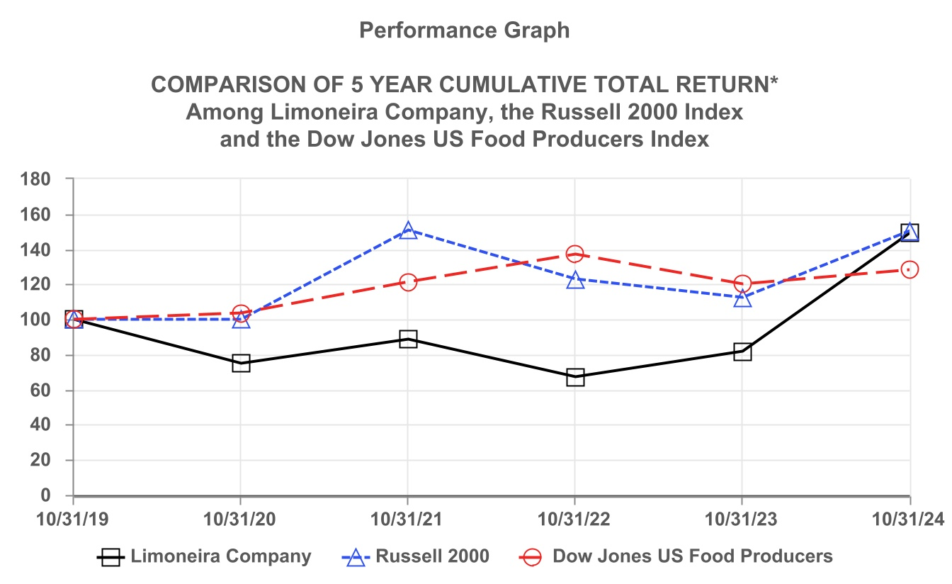
*$100 invested on 10/31/19 in stock or index, including reinvestment of dividends.
Fiscal year ending October 31.
Copyright© 2024 S&P Dow Jones Indices LLC, a division of S&P Global. All rights reserved.
Copyright© 2024 Russell Investment Group. All rights reserved.
The line graph above compares the percentage change in cumulative total stockholder return of our common stock registered under Section 12 of the Securities Exchange Act of 1934, as amended (the “Exchange Act”) with (i) the cumulative total return of the Russell 2000 Index, assuming reinvestment of dividends, and (ii) the cumulative total return of Dow Jones U.S. Food Producers Index, assuming reinvestment of dividends.
Recent Sales of Unregistered Securities
None.
Purchases of Equity Securities by Issuer and Affiliated Purchasers

Period |  |  | Total Number of Shares Purchased (1) |  |  | Weighted Average Price Paid per Share |  |  | Total Number of Shares Purchased as Part of Publicly Announced Plans or Programs |  |  | Maximum Number (or Approximate Dollar Value) of Shares that May Yet Be Purchased Under the Plans or Programs
August 1, 2024 - August 31, 2024 |  |  | — |  |  | $ | — |  | — |  |  | —
September 1, 2024 - September 30, 2024 |  |  | — |  |  | $ | — |  | — |  |  | —
October 1, 2024 - October 31, 2024 |  |  | 18,730 |  |  | $ | 25.64 |  | — |  |  | —
Total |  |  | 18,730 |  |  |  |  |  | — |  |  | —
(1) Shares were acquired from employees in accordance with our stock-based compensation plan as a result of share withholdings to pay income tax related to the vesting and distribution of restricted stock awards.

31

Item 6. Reserved

Item 7. Management’s Discussion and Analysis of Financial Condition and Results of Operations
The following Management’s Discussion and Analysis of Financial Condition and Results of Operations (MD&A) is intended to promote understanding of the results of operations and financial condition. MD&A is provided as a supplement to, and should be read in conjunction with, our consolidated financial statements and the accompanying Notes to Consolidated Financial Statements (Part II, Item 8 of this Form 10-K). This discussion and analysis contains forward-looking statements that involve risks, uncertainties and assumptions. Actual results may differ materially from those anticipated in these forward-looking statements as a result of various factors, including, but not limited to, those presented under “Risk Factors” included in Item 1A and elsewhere in this Annual Report on Form 10-K. This section generally discusses the results of operations for fiscal year 2024 compared to fiscal year 2023. For discussion related to the results of operations and changes in financial condition for fiscal year 2023 compared to fiscal year 2022 refer to Part II, Item 7, Management’s Discussion and Analysis of Financial Condition and Results of Operations in our fiscal year 2023 Form 10-K, which was filed with the United States Securities and Exchange Commission (SEC) on December 21, 2023.

Overview
Limoneira Company, a Delaware corporation, is the successor to several businesses with operations in California since 1893. We are primarily an agribusiness company founded and based in Santa Paula, California, committed to responsibly using and managing our approximately 10,500 acres of land, water resources and other assets to maximize long-term stockholder value. Our current operations consist of fruit production, sales and marketing, rental operations, real estate and capital investment activities.

We have three business divisions: agribusiness, rental operations and real estate development. The agribusiness division is comprised of four reportable operating segments: fresh lemons, lemon packing, avocados and other agribusiness, which primarily includes oranges, specialty citrus, other crops and farm management services. The agribusiness division includes our core operations of farming, harvesting, lemon packing and lemon sales operations. The rental operations division includes our residential and commercial rentals comprised of 240 completed rental units, leased land operations and organic recycling. The real estate development division includes our investments in real estate development projects. Generally, we see our Company as a land and farming company that generates annual cash flows to support our progress into diversified real estate development activities. As real estate developments are monetized, our agriculture business will then be able to expand more rapidly into new regions and markets.
Recent Developments – Refer to Part I, Item 1 “Fiscal Year 2024 Highlights and Recent Developments”

32

Results of Operations
The following table shows the results of operations ($ in thousands):
 |  |  |  |  |  |  | Years Ended October 31,
 |  |  |  |  |  |  | 2024 |  |  |  |  |  |  |  |  |  |  |  | 2023 |  |  |  |  |  |  |  |  |  |  |  | 2022
Net revenues:
Agribusiness |  |  |  |  |  |  | $ | 185,923 |  |  |  |  | 97 |  | % |  |  |  | $ | 174,381 |  |  |  |  | 97 |  | % |  |  |  | $ | 179,281 |  |  |  |  | 97 |  | %
Other operations |  |  |  |  |  |  | 5,580 |  |  |  |  |  | 3 |  | % |  |  |  | 5,520 |  |  |  |  |  | 3 |  | % |  |  |  | 5,324 |  |  |  |  |  | 3 |  | %
Total net revenues |  |  |  |  |  |  | 191,503 |  |  |  |  |  | 100 |  | % |  |  |  | 179,901 |  |  |  |  |  | 100 |  | % |  |  |  | 184,605 |  |  |  |  |  | 100 |  | %
Costs and expenses:
Agribusiness |  |  |  |  |  |  | 164,807 |  |  |  |  |  | 83 |  | % |  |  |  | 169,169 |  |  |  |  |  | 99 |  | % |  |  |  | 160,651 |  |  |  |  |  | 88 |  | %
Other operations |  |  |  |  |  |  | 5,274 |  |  |  |  |  | 3 |  | % |  |  |  | 4,612 |  |  |  |  |  | 3 |  | % |  |  |  | 4,438 |  |  |  |  |  | 2 |  | %
Impairment of intangible asset |  |  |  |  |  |  | 643 |  |  |  |  |  | 1 |  | % |  |  |  | — |  |  |  |  |  | — |  | % |  |  |  | — |  |  |  |  |  | — |  | %
Gain on disposal of assets, net |  |  |  |  |  |  | (507) |  |  |  |  |  | (1) |  | % |  |  |  | (28,849) |  |  |  |  |  | (17) |  | % |  |  |  | (4,500) |  |  |  |  |  | (2) |  | %
Gain on legal settlement |  |  |  |  |  |  | — |  |  |  |  |  | — |  | % |  |  |  | (2,269) |  |  |  |  |  | (1) |  | % |  |  |  | — |  |  |  |  |  | — |  | %
Selling, general and administrative |  |  |  |  |  |  | 27,464 |  |  |  |  |  | 14 |  | % |  |  |  | 26,455 |  |  |  |  |  | 16 |  | % |  |  |  | 21,815 |  |  |  |  |  | 12 |  | %
Total costs and expenses |  |  |  |  |  |  | 197,681 |  |  |  |  |  | 100 |  | % |  |  |  | 169,118 |  |  |  |  |  | 100 |  | % |  |  |  | 182,404 |  |  |  |  |  | 100 |  | %
Operating (loss) income:
Agribusiness |  |  |  |  |  |  | 21,116 |  |  |  |  |  |  |  |  |  |  |  | 5,212 |  |  |  |  |  |  |  |  |  |  |  | 18,630
Other operations |  |  |  |  |  |  | 306 |  |  |  |  |  |  |  |  |  |  |  | 908 |  |  |  |  |  |  |  |  |  |  |  | 886
Impairment of intangible asset |  |  |  |  |  |  | (643) |  |  |  |  |  |  |  |  |  |  |  | — |  |  |  |  |  |  |  |  |  |  |  | —
Gain on disposal of assets, net |  |  |  |  |  |  | 507 |  |  |  |  |  |  |  |  |  |  |  | 28,849 |  |  |  |  |  |  |  |  |  |  |  | 4,500
Gain on legal settlement |  |  |  |  |  |  | — |  |  |  |  |  |  |  |  |  |  |  | 2,269 |  |  |  |  |  |  |  |  |  |  |  | —
Selling, general and administrative |  |  |  |  |  |  | (27,464) |  |  |  |  |  |  |  |  |  |  |  | (26,455) |  |  |  |  |  |  |  |  |  |  |  | (21,815)
Operating (loss) income |  |  |  |  |  |  | (6,178) |  |  |  |  |  |  |  |  |  |  |  | 10,783 |  |  |  |  |  |  |  |  |  |  |  | 2,201
Other income (expense):
Interest income |  |  |  |  |  |  | 118 |  |  |  |  |  |  |  |  |  |  |  | 364 |  |  |  |  |  |  |  |  |  |  |  | 53
Interest expense, net of patronage dividends |  |  |  |  |  |  | (961) |  |  |  |  |  |  |  |  |  |  |  | (494) |  |  |  |  |  |  |  |  |  |  |  | (2,291)
Equity in earnings of investments, net |  |  |  |  |  |  | 18,356 |  |  |  |  |  |  |  |  |  |  |  | 5,322 |  |  |  |  |  |  |  |  |  |  |  | 1,341
Other income (expense), net |  |  |  |  |  |  | 212 |  |  |  |  |  |  |  |  |  |  |  | (2,611) |  |  |  |  |  |  |  |  |  |  |  | (955)
Total other income (expense) |  |  |  |  |  |  | 17,725 |  |  |  |  |  |  |  |  |  |  |  | 2,581 |  |  |  |  |  |  |  |  |  |  |  | (1,852)
Income before income tax provision |  |  |  |  |  |  | 11,547 |  |  |  |  |  |  |  |  |  |  |  | 13,364 |  |  |  |  |  |  |  |  |  |  |  | 349
Income tax provision |  |  |  |  |  |  | (4,373) |  |  |  |  |  |  |  |  |  |  |  | (4,247) |  |  |  |  |  |  |  |  |  |  |  | (823)
Net income (loss) |  |  |  |  |  |  | 7,174 |  |  |  |  |  |  |  |  |  |  |  | 9,117 |  |  |  |  |  |  |  |  |  |  |  | (474)
Net loss attributable to noncontrolling interest |  |  |  |  |  |  | 542 |  |  |  |  |  |  |  |  |  |  |  | 283 |  |  |  |  |  |  |  |  |  |  |  | 238
Net income (loss) attributable to Limoneira Company |  |  |  |  |  |  | $ | 7,716 |  |  |  |  |  |  |  |  |  |  | $ | 9,400 |  |  |  |  |  |  |  |  |  |  | $ | (236)

Non-GAAP Financial Measures
Due to significant depreciable assets associated with the nature of our operations and interest costs associated with our capital structure, management believes that earnings before interest, income taxes, depreciation and amortization (“EBITDA”) and adjusted EBITDA, which excludes stock-based compensation, named executive officer cash severance, pension settlement cost, impairment of intangible asset, gain on disposal of assets, net, cash bonus related to sale of assets, gain on legal settlement and severance benefits are important measures to evaluate our results of operations between periods on a more comparable basis. Such measurements are not prepared in accordance with U.S. generally accepted accounting principles (“GAAP”) and should not be construed as an alternative to reported results determined in accordance with GAAP. The non-GAAP information provided is unique to us and may not be consistent with methodologies used by other companies.
33

EBITDA and adjusted EBITDA are summarized and reconciled to net income (loss) attributable to Limoneira Company which management considers to be the most directly comparable financial measure calculated and presented in accordance with GAAP, as follows (in thousands):
 |  |  |  |  |  |  | Years Ended October 31,
 |  |  |  |  |  |  | 2024 |  |  |  |  |  | 2023 |  |  |  |  |  | 2022
Net income (loss) attributable to Limoneira Company |  |  |  |  |  |  | $ | 7,716 |  |  |  |  | $ | 9,400 |  |  |  |  | $ | (236)
Interest income |  |  |  |  |  |  | (118) |  |  |  |  |  | (364) |  |  |  |  |  | (53)
Interest expense, net of patronage dividends |  |  |  |  |  |  | 961 |  |  |  |  |  | 494 |  |  |  |  |  | 2,291
Income tax provision |  |  |  |  |  |  | 4,373 |  |  |  |  |  | 4,247 |  |  |  |  |  | 823
Depreciation and amortization |  |  |  |  |  |  | 8,374 |  |  |  |  |  | 8,576 |  |  |  |  |  | 9,798
EBITDA |  |  |  |  |  |  | $ | 21,306 |  |  |  |  | $ | 22,353 |  |  |  |  | $ | 12,623
Stock-based compensation |  |  |  |  |  |  | 4,116 |  |  |  |  |  | 3,841 |  |  |  |  |  | 2,732
Named executive officer cash severance |  |  |  |  |  |  | — |  |  |  |  |  | — |  |  |  |  |  | 432
Pension settlement cost |  |  |  |  |  |  | — |  |  |  |  |  | 2,700 |  |  |  |  |  | 607
Impairment of intangible asset |  |  |  |  |  |  | 643 |  |  |  |  |  | — |  |  |  |  |  | —
Gain on disposal of assets, net |  |  |  |  |  |  | (507) |  |  |  |  |  | (28,849) |  |  |  |  |  | (4,500)
Cash bonus related to sale of assets |  |  |  |  |  |  | — |  |  |  |  |  | 2,000 |  |  |  |  |  | —
Gain on legal settlement |  |  |  |  |  |  | — |  |  |  |  |  | (2,269) |  |  |  |  |  | —
Severance benefits |  |  |  |  |  |  | 1,160 |  |  |  |  |  | — |  |  |  |  |  | —
Adjusted EBITDA |  |  |  |  |  |  | $ | 26,718 |  |  |  |  | $ | (224) |  |  |  |  | $ | 11,894

Fiscal Year 2024 Compared to Fiscal Year 2023
Revenues
Total net revenues for fiscal year 2024 were $191.5 million compared to $179.9 million for fiscal year 2023. The 6% increase of $11.6 million was primarily due to increased agribusiness revenues from avocados, partially offset by decreased agribusiness revenues from lemons and specialty citrus and other crops, as detailed below ($ in thousands):

 |  |  | Years Ended October 31,
 |  |  | 2024 |  |  |  |  |  | 2023 |  |  |  |  |  | Change
Lemons |  |  | $ | 136,175 |  |  |  |  | $ | 138,018 |  |  |  |  | $ | (1,843) |  | (1)%
Avocados |  |  | 25,114 |  |  |  |  |  | 7,046 |  |  |  |  |  | 18,068 |  |  | 256%
Oranges |  |  | 5,189 |  |  |  |  |  | 5,779 |  |  |  |  |  | (590) |  |  | (10)%
Specialty citrus and other crops |  |  | 5,089 |  |  |  |  |  | 9,515 |  |  |  |  |  | (4,426) |  |  | (47)%
Farm management |  |  | 10,212 |  |  |  |  |  | 9,931 |  |  |  |  |  | 281 |  |  | 3%
Other |  |  | 4,144 |  |  |  |  |  | 4,092 |  |  |  |  |  | 52 |  |  | 1%
Agribusiness revenues |  |  | $ | 185,923 |  |  |  |  | $ | 174,381 |  |  |  |  | $ | 11,542 |  | 7%

•Lemons: The decrease for fiscal year 2024, compared to fiscal year 2023, was primarily due to decreased volume, partially offset by higher prices of fresh lemons sold. Fresh lemon sales were $84.0 million and $86.8 million, in aggregate, on 4.5 million and 4.8 million cartons of lemons sold at average per carton prices of $18.87 and $18.24 for fiscal years 2024 and 2023, respectively. Lemon revenues included brokered lemons and other lemon sales of $32.0 million and $26.2 million, lemon packing of $17.1 million and $20.6 million, and lemon by-product sales of $3.0 million and $3.0 million, respectively, for fiscal years 2024 and 2023. Fiscal year 2023 revenues included settlement proceeds of $1.4 million allocated to lemons.
•Avocados: The increase for fiscal year 2024, compared to fiscal year 2023 was due to increased volume and higher prices of avocados sold. The California avocado crop typically experiences alternating years of high and low production due to plant physiology. We sold 15.1 million and 3.8 million pounds of avocados at an average price per pound of $1.67 and $1.06 for fiscal years 2024 and 2023, respectively. Fiscal year 2023 revenues included settlement proceeds of $2.4 million allocated to avocados and crop insurance proceeds of $0.7 million.
34

•Oranges: The decrease for fiscal year 2024, compared to fiscal year 2023, was primarily due to decreased volume and lower prices of oranges sold. We sold 280,000 and 292,000 cartons of oranges at an average price per carton of $18.53 and $19.79 for fiscal years 2024 and 2023, respectively.
•Specialty citrus and other crops: The decrease for fiscal year 2024, compared to fiscal year 2023, was primarily due to decreased volume, partially offset by higher prices of specialty citrus sold. We sold 79,000 and 240,000 40-pound carton equivalents of specialty citrus at an average price per carton of $28.23 and $27.18 for fiscal years 2024 and 2023, respectively. Additionally, we sold $2.9 million of wine grapes for both fiscal years 2024 and 2023.
•Farm management: Farm management revenue is comprised primarily of Northern Properties farming, management and operations services. The increase in farm management revenue for fiscal year 2024, compared to fiscal year 2023, was primarily due to twelve months of activity in fiscal year 2024 compared to nine months of activity in fiscal year 2023.
•Other: Other revenue is comprised primarily of fallowing and freight revenue. Other revenue for fiscal year 2024 was similar compared to fiscal year 2023.
Other operations revenue for fiscal year 2024 was $5.6 million compared to $5.5 million for fiscal year 2023.
Costs and Expenses
Total costs and expenses for fiscal year 2024 were $197.7 million compared to $169.1 million for fiscal year 2023. The 17% increase of $28.6 million was primarily due to the 2023 net gain on disposal of assets, the 2023 gain on legal settlement and an increase in selling, general and administrative expenses, partially offset by a decrease in agribusiness costs and expenses. Agribusiness costs and expenses are detailed below ($ in thousands):

 |  |  | Years Ended October 31,
 |  |  | 2024 |  |  |  |  |  | 2023 |  |  |  |  |  | Change
Packing costs |  |  | $ | 42,751 |  |  |  |  | $ | 45,689 |  |  |  |  | $ | (2,938) |  | (6)%
Harvest costs |  |  | 12,585 |  |  |  |  |  | 18,613 |  |  |  |  |  | (6,028) |  |  | (32)%
Growing costs |  |  | 27,577 |  |  |  |  |  | 33,379 |  |  |  |  |  | (5,802) |  |  | (17)%
Third-party grower and supplier costs |  |  | 72,176 |  |  |  |  |  | 61,273 |  |  |  |  |  | 10,903 |  |  | 18%
Other costs |  |  | 2,601 |  |  |  |  |  | 2,892 |  |  |  |  |  | (291) |  |  | (10)%
Depreciation and amortization |  |  | 7,117 |  |  |  |  |  | 7,323 |  |  |  |  |  | (206) |  |  | (3)%
Agribusiness costs and expenses |  |  | $ | 164,807 |  |  |  |  | $ | 169,169 |  |  |  |  | $ | (4,362) |  | (3)%

•Packing costs: Packing costs consist primarily of the costs to pack lemons for sale such as labor and benefits, cardboard cartons, fruit treatments, packing and shipping supplies and facility operating costs. The decrease for fiscal year 2024, compared to fiscal year 2023, was primarily due to decreased volume. We packed and sold 4.5 million and 4.8 million cartons of lemons at average per carton costs of $9.60 and $9.61 for fiscal years 2024 and 2023, respectively.
•Harvest costs: The decrease in harvest costs for fiscal year 2024 compared to fiscal year 2023 was primarily due to decreased volume of lemons harvested related to the sale of the Northern Properties, partially offset by increased volume of avocados harvested.
•Growing costs: Growing costs, also referred to as cultural costs, consist of orchard maintenance costs such as cultivation, fertilization and soil amendments, pest control, pruning and irrigation. The decrease for fiscal year 2024, compared to fiscal year 2023, was primarily due to farm management decisions based on weather, harvest timing and crop conditions.
•Third-party grower and supplier costs: We sell fruit that we grow and fruit that we procure from other growers and suppliers. The cost of procuring fruit from other growers and suppliers is referred to as third-party grower and supplier costs. The increase for fiscal year 2024, compared to fiscal year 2023, was primarily due to increased volume and higher prices of third-party grower fruit sold. We incurred costs for third-party grower fruit of $40.9 million and $31.9 million for fiscal years 2024 and 2023, respectively. Of the 4.5 million and 4.8 million cartons of lemons packed and sold, 3.2 million (72%) and 2.6 million (54%), were procured from third-party growers at average per carton prices of $12.76 and $12.44 for fiscal years 2024 and 2023, respectively. The increased volume for third-party grower fruit was primarily due to the sale of the Northern Properties and the related marketing agreement. Additionally, we incurred costs for supplier costs and purchased, packed fruit for resale of $31.3 million and $29.4 million for fiscal years 2024 and 2023, respectively.
•Other costs: The decrease in other costs for fiscal year 2024 compared to fiscal year 2023 was primarily due to a decrease in shipping costs, mainly related to a decrease in volume of lemons sold.
35

•Depreciation and amortization: Depreciation and amortization expenses for fiscal year 2024 were similar to fiscal year 2023.
Other operations expenses for fiscal year 2024 were $5.3 million compared to $4.6 million for fiscal year 2023. The increase in other operations expenses was primarily due to severance benefits paid in fiscal year 2024 and increased residential and commercial rental expenses.
Gain on disposal of assets, net for fiscal year 2024 was $0.5 million compared to $28.8 million for fiscal year 2023. The decrease was primarily due to the 2023 gain on the sale of the Northern Properties, partially offset by the 2023 loss on disposal of Cadiz Ranch assets.
Gain on legal settlement was $2.3 million for fiscal year 2023 due to the Settlement Agreement related to the Thomas fire.
Selling, general and administrative expenses for fiscal year 2024 were $27.5 million compared to $26.5 million for fiscal year 2023. The $1.0 million increase was primarily due to:

•$0.9 million increase in selling expenses;
•$0.7 million increase in legal and consulting fees associated with our strategic initiatives;
•$0.1 million net increase in salaries, benefits and incentive compensation; and
•$0.7 million net decrease in other selling, general and administrative expenses.
Other Income

Total other income for fiscal year 2024 was $17.7 million compared to $2.6 million for fiscal year 2023. The $15.1 million increase in total other income was primarily due to:

•$13.0 million increase of equity in earnings of investments, net, primarily due to LLCB’s closing of 554 residential homesites in fiscal year 2024;
•$2.8 million increase of other income, net primarily due to pension settlement cost in fiscal year 2023; and
•$0.5 million increase of interest expense, net of patronage dividends, primarily due to decreased patronage dividends.

Income Taxes
We recorded an income tax provision of $4.4 million and $4.2 million on pre-tax income of $11.5 million and $13.4 million for fiscal years 2024 and 2023, respectively. The tax provision recorded for fiscal year 2024 differs from the U.S. federal statutory tax rate of 21.0% primarily due to foreign jurisdictions that are taxed at different rates, state taxes, tax impact of stock-based compensation, executive compensation, nondeductible tax items and valuation allowances on certain deferred tax assets of foreign subsidiaries. Our effective tax rate for fiscal years 2024 and 2023 was 37.9% and 31.8%, respectively.
Net Loss Attributable to Noncontrolling Interest
Net loss attributable to noncontrolling interest represents 10% and 49% of the net loss of PDA and Trapani Fresh, respectively, for fiscal years 2024 and 2023.

Segment Results of Operations
We operate in four reportable operating segments: fresh lemons, lemon packing, avocados and other agribusiness. Our reportable operating segments are strategic business units with different products and services, distribution processes and customer bases. We evaluate the performance of our operating segments separately to monitor the different factors affecting financial results. Each segment is subject to review and evaluations related to current market conditions, market opportunities and available resources. During fiscal year 2024, the Company changed its reporting of other revenue and other costs and includes these items in the other agribusiness segment instead of the fresh lemons segment. Prior years’ information has been restated to conform to the current year’s presentation. See Note 21 - Segment Information for additional information regarding our operating segments.

36

Segment information for fiscal year 2024 (in thousands):

 |  |  | Fresh  Lemons |  |  | Lemon  Packing |  |  | Eliminations |  |  | Avocados |  |  | Other  Agribusiness |  |  | Total  Agribusiness |  |  | Corporate  and Other |  |  | Total
Revenues from external customers |  |  | $ | 119,044 |  | $ | 17,131 |  | $ | — |  | $ | 25,114 |  | $ | 24,634 |  | $ | 185,923 |  | $ | 5,580 |  | $ | 191,503
Intersegment revenue |  |  | — |  |  | 32,127 |  |  | (32,127) |  |  | — |  |  | — |  |  | — |  |  | — |  |  | —
Total net revenues |  |  | 119,044 |  |  | 49,258 |  |  | (32,127) |  |  | 25,114 |  |  | 24,634 |  |  | 185,923 |  |  | 5,580 |  |  | 191,503
Costs and expenses |  |  | 116,308 |  |  | 42,751 |  |  | (32,127) |  |  | 7,334 |  |  | 23,424 |  |  | 157,690 |  |  | 31,617 |  |  | 189,307
Depreciation and amortization |  |  | — |  |  | — |  |  | — |  |  | — |  |  | — |  |  | 7,117 |  |  | 1,257 |  |  | 8,374
Operating (loss) income |  |  | $ | 2,736 |  | $ | 6,507 |  | $ | — |  | $ | 17,780 |  | $ | 1,210 |  | $ | 21,116 |  | $ | (27,294) |  | $ | (6,178)

Segment information for fiscal year 2023 (in thousands):

 |  |  | Fresh  Lemons |  |  | Lemon  Packing |  |  | Eliminations |  |  | Avocados |  |  | Other  Agribusiness |  |  | Total  Agribusiness |  |  | Corporate  and Other |  |  | Total
Revenues from external customers |  |  | $ | 117,445 |  | $ | 20,573 |  | $ | — |  | $ | 7,046 |  | $ | 29,317 |  | $ | 174,381 |  | $ | 5,520 |  | $ | 179,901
Intersegment revenue |  |  | — |  |  | 31,081 |  |  | (31,081) |  |  | — |  |  | — |  |  | — |  |  | — |  |  | —
Total net revenues |  |  | 117,445 |  |  | 51,654 |  |  | (31,081) |  |  | 7,046 |  |  | 29,317 |  |  | 174,381 |  |  | 5,520 |  |  | 179,901
Costs and expenses (gains) |  |  | 117,602 |  |  | 45,689 |  |  | (31,081) |  |  | 4,034 |  |  | 25,602 |  |  | 161,846 |  |  | (1,304) |  |  | 160,542
Depreciation and amortization |  |  | — |  |  | — |  |  | — |  |  | — |  |  | — |  |  | 7,323 |  |  | 1,253 |  |  | 8,576
Operating income (loss) |  |  | $ | (157) |  | $ | 5,965 |  | $ | — |  | $ | 3,012 |  | $ | 3,715 |  | $ | 5,212 |  | $ | 5,571 |  | $ | 10,783

Fiscal Year 2024 Segment Information Compared to Fiscal Year 2023 Segment Information
The following analysis should be read in conjunction with the previous section “Results of Operations.”
Fresh Lemons
Fresh lemons segment revenue is comprised of sales of fresh lemons, lemon by-products, brokered lemons and other lemon revenue. Our fresh lemons segment total net revenues for fiscal year 2024 were $119.0 million compared to $117.4 million for fiscal year 2023. The 1% increase of $1.6 million was primarily due to:

•Brokered lemons and other lemon sales increase of $5.8 million;
•Fresh lemon sales decrease of $2.8 million; and
•Legal settlement proceeds of $1.4 million allocated to fresh lemons in fiscal year 2023.

Costs and expenses associated with our fresh lemons segment include growing costs, harvest costs, cost of lemons we procure from third-party growers and suppliers. Our fresh lemons segment costs and expenses for fiscal year 2024 were $116.3 million compared to $117.6 million for fiscal year 2023. The 1% decrease of $1.3 million was primarily due to:

•Harvest costs decrease of $8.5 million;
•Growing costs decrease of $7.7 million;
•Third-party grower and supplier costs increase of $13.9 million; and
•Intersegment costs and expenses increase of $1.0 million.

Lemon Packing
Lemon packing segment revenue is comprised of packing revenue and intersegment packing revenue. Our lemon packing segment total net revenues for fiscal year 2024 were $49.3 million compared to $51.7 million for fiscal year 2023. The 5% decrease of $2.4 million was primarily due to decreased volume of lemons packed and sold.
Costs and expenses associated with our lemon packing segment consist of the costs to pack lemons for sale such as labor and benefits, cardboard cartons, fruit treatments, packing and shipping supplies, subcontracted and facility operating costs. Our lemon packing costs and expenses for fiscal year 2024 were $42.8 million compared to $45.7 million for fiscal year 2023. The 6% decrease of $2.9 million was primarily due to decreased volume of lemons packed and sold, partially offset by increased subcontracted costs.
Lemon packing segment operating income per carton sold for fiscal year 2024 was $1.46 compared to $1.25 for fiscal year 2023.
37

The lemon packing segment included intersegment revenues for fiscal year 2024 of $32.1 million compared to $31.1 million for fiscal year 2023, that were charged to the fresh lemons segment to pack lemons for sale. Such intersegment revenues and expenses are eliminated in our consolidated financial statements.
Avocados
Our avocados segment revenues for fiscal year 2024 were $25.1 million compared to $7.0 million for fiscal year 2023. The 256% increase of $18.1 million was primarily due to alternating years of high and low production due to plant physiology and higher pricing.
Costs and expenses associated with our avocados segment include growing and harvest costs. Our avocados segment costs and expenses for fiscal year 2024 were $7.3 million compared to $4.0 million for fiscal year 2023. The 82% increase of $3.3 million primarily consisted of the following:

•Harvest costs increase of $2.3 million; and
•Growing costs increase of $1.0 million.

Other Agribusiness
Our other agribusiness segment total net revenues for fiscal year 2024 were $24.6 million compared to $29.3 million for fiscal year 2023. The 16% decrease of $4.7 million was primarily due to:

•Specialty citrus and other crops revenues decrease of $4.4 million;
•Orange revenues decrease of $0.6 million; and
•Farm management revenues increase of $0.3 million.

Costs and expenses associated with our other agribusiness segment include growing costs, harvest costs, purchased fruit costs and shipping costs. Our other agribusiness costs and expenses for fiscal year 2024 were $23.4 million compared to $25.6 million for fiscal year 2023. The 9% decrease of $2.2 million was primarily due to:

•Purchased and supplier fruit costs decrease of $3.0 million;
•Shipping costs decrease of $0.3 million;
•Growing costs increase of $0.9 million; and
•Harvest costs increase of $0.2 million.

Total agribusiness depreciation and amortization expenses for fiscal year 2024 were $7.1 million compared to $7.3 million for fiscal year 2023.
Corporate and Other
Our corporate and other operations revenues for fiscal year 2024 were $5.6 million compared to $5.5 million for fiscal year 2023.
Costs and expenses (gains) in our corporate and other operations for fiscal years 2024 and 2023 were $31.6 million and $(1.3) million, respectively, and include selling, general and administrative costs and expenses, impairment of intangible asset, gain on disposal of assets, net and gain on legal settlement not allocated to the operating segments. Depreciation and amortization expenses for were $1.3 million for both fiscal years 2024 and 2023.

38

Liquidity and Capital Resources
Overview
Our primary sources of liquidity are cash and cash flows generated from our operations, use of our revolving credit facility, sales of assets and distributions from our equity investments. Our liquidity and capital position fluctuates during the year depending on seasonal production cycles, weather events and demand for our products. Typically, our first and last fiscal quarters coincide with the fall and winter months during which we are growing crops that are harvested and sold in the spring and summer, which are our second and third quarters. To meet working capital demand and investment requirements of our agribusiness and real estate development projects and to supplement operating cash flows, we utilize our revolving credit facility to fund agricultural inputs and farm management practices until sufficient returns from crops allow us to repay amounts borrowed. Raw materials needed to propagate the various crops grown by us consist primarily of fertilizer, herbicides, insecticides, fuel and water, all of which are readily available from local sources.

Material contractual obligations arising in the normal course of business consist primarily of purchase obligations, long-term fixed rate and variable rate debt and related interest payments and operating and finance leases. See Note 11 - Long-Term Debt and Note 13 - Leases for amounts outstanding as of October 31, 2024, related to debt and leases. Purchase obligations consist of contracts primarily related to packing supplies, the majority of which are due in the next three years.

We believe that the cash flows from operations and available borrowing capacity from our existing credit facilities will be sufficient to satisfy our capital expenditures, debt service, working capital needs and other contractual obligations for the next 12 months. We believe our revenue generating operations, distributions from equity investments and credit facilities will generate sufficient cash needed to operate beyond the next 12 months. In addition, we have the ability to control a portion of our investing cash flows to the extent necessary based on our liquidity demands.

Cash Flows from Operating Activities
Net cash provided by (used in) operating activities was $17.9 million and $(15.9) million for fiscal years 2024 and 2023, respectively. The significant components of our cash flows provided by (used in) operating activities were as follows:
•Net income was $7.2 million and $9.1 million for fiscal years 2024 and 2023, respectively. The components of net income for fiscal year 2024, compared to net income for fiscal year 2023, primarily consists of a decrease in operating income of $17.0 million and an increase in total other income of $15.1 million.
•Adjustments to reconcile net income to net cash provided by (used in) operating activities:
◦Adjustments provided (used) $9.0 million and $(22.5) million for fiscal years 2024 and 2023, respectively, primarily related to depreciation and amortization, gain on disposal of assets, net, stock compensation expense, equity in earnings of investments, net and cash distributions from equity investments.
◦Changes in operating assets and liabilities provided by (used in) $1.7 million and $(2.5) million of operating cash for fiscal years 2024 and 2023, respectively, primarily related to cultural costs, accounts payable/growers and suppliers payable, accrued liabilities/payables to related parties, and other long-term liabilities.
Cash Flows from Investing Activities
▪The $9.2 million of net cash used in investing activities for fiscal year 2024 was comprised primarily of capital expenditures of $9.4 million related to orchard and vineyard development.
▪The $90.6 million of net cash provided by investing activities for fiscal year 2023 was comprised primarily of net proceeds from sale of assets of $98.5 million, net proceeds from the sale of real estate development assets of $2.6 million, partially offset by capital expenditures of $10.3 million related to orchard and vineyard development.
Cash Flows from Financing Activities
•The $9.3 million of net cash used in financing activities for fiscal year 2024 was comprised primarily of common and preferred stock dividends of $5.9 million and exchange of common stock of $2.3 million.
•The $71.9 million of net cash used in financing activities for fiscal year 2023 was comprised primarily of net repayments of long-term debt of $65.0 million and common and preferred stock dividends of $5.9 million.

39

Transactions Affecting Liquidity and Capital Resources
Credit Facilities and Long-Term Debt
We finance our working capital and other liquidity requirements primarily through cash from operations, distributions from equity investments and from our Credit Facility with AgWest Farm Credit, formerly known as Farm Credit West, (the "Lender"), which includes the Master Loan Agreement (the “MLA”), a revolving credit facility supplement (the “Revolving Credit Supplement”), a non-revolving credit facility supplement (the “Non-Revolving Credit Supplement” and, together with the Revolving Credit Supplement, the “Supplements”), and a Fixed Interest Rate Agreement, which extends principal repayment to July 1, 2026. The MLA governs the terms of the Supplements. In addition, we have Banco de Chile term and COVID-19 loans. Additional information regarding these loans can be found in Note 11- Long-Term Debt.

The Supplements provide aggregate borrowing capacity of $115.0 million, comprised of $75.0 million under the Revolving Credit Supplement and $40.0 million under the Non-Revolving Credit Supplement. As of October 31, 2024, our outstanding borrowings under the AgWest Farm Credit Facility were $40.0 million and we had $75.0 million of availability.
On January 31, 2023, we sold the Northern Properties which resulted in total net proceeds of $98.4 million. The proceeds were used to pay down all of our domestic debt except the Non-Revolving Credit Supplement.
The MLA subjects us to affirmative and restrictive covenants including, among other customary covenants, financial reporting requirements, requirements to maintain and repair any collateral, restrictions on the sale of assets, restrictions on the use of proceeds, prohibitions on the incurrence of additional debt and restrictions on the purchase or sale of major assets of our business. We are also subject to a financial covenant that requires us to maintain compliance with a specific debt service coverage ratio of 1.25:1.0 on an annual basis. We were in compliance as of October 31, 2024.

We received annual patronage dividends from the Lender of $0.6 million and $1.4 million for fiscal years 2024 and 2023, respectively.
Real Estate Development Joint Venture
On April 30, 2024, our real estate development joint venture with Lewis closed an additional 554 residential homesites at the Harvest at Limoneira master planned community in Santa Paula, CA, and we recorded equity in earnings of investments of $17.8 million for LLCB for fiscal year 2024. On June 5, 2024, we received a cash distribution of $15.0 million from the joint venture which we used to pay down debt. As of October 31, 2024, the 50%-owned unconsolidated joint venture had $66.9 million of cash and cash equivalents on hand.
Dividends
The holders of the Series B Convertible Preferred Stock (the “Series B Stock”) and the Series B-2 Preferred Stock (the “Series B-2 Preferred Stock”) are entitled to receive cumulative cash dividends. Such preferred dividends paid totaled $0.5 million in each of the fiscal years 2024 and 2023.
Cash dividends declared in each of the fiscal years 2024 and 2023 totaled $0.30 per common share and such dividends paid totaled $5.4 million for both fiscal years 2024 and 2023.
Income Taxes
We paid income taxes of $5.2 million and $7.2 million for fiscal years 2024 and 2023, respectively.
Real Estate Development Activities and Related Capital Resources
As noted under “Transactions Affecting Liquidity and Capital Resources,” we have the ability to control a portion of our investing cash flows to the extent necessary based upon our liquidity demands. In order for our real estate development operations to reach their maximum potential benefit to us, however, we will need to be successful over time in identifying other third-party sources of capital to collaborate with us to move those development projects forward. While we are frequently in discussions with potential external sources of capital in respect to all of our development projects, current market conditions for California real estate projects make it difficult to predict the timing and amounts of future capital that will be required to complete the development of our projects.
40

In November 2015, we entered into a joint venture with Lewis for the residential development of our East Area I real estate development project. To consummate the transaction, we formed LLCB as the development entity, contributed our East Area I property to the joint venture and sold a 50% interest in the joint venture to Lewis for $20.0 million. The first phase of the project broke ground to commence mass grading in November 2017. Approved project plans currently include approximately 2,050 residential units and site improvements. A total of 1,261 residential units have closed from the project’s inception to October 31, 2024.
In October 2022, we entered into a joint venture with Lewis for the development of our 17-acre East Area I Retained Property. We formed LLCB II as the development entity, contributed our Retained Property to the joint venture and sold a 50% interest to Lewis for approximately $8.0 million. We recorded a gain on the transaction of approximately $4.7 million, of which $0.5 million was deferred and recognized in fiscal year 2024.
The joint venture partners will share in the capital contributions to fund project costs until loan proceeds and/or revenues are sufficient to fund the projects. Since inception each partner has made funding contributions of $21.4 million to LLCB and $1.0 million to LLCB II. We expect to receive approximately $165.0 million from LLCB, LLCB II and East Area II over the next six years of the projects.
Trend Information
The commodity pricing for our fresh produce, and therefore our revenues and margins, is significantly impacted by consumer demand. The worldwide fresh produce industry has historically enjoyed consistent underlying demand and favorable growth dynamics. In recent years, the market for fresh produce has increased faster than the rate of population growth, supported by ongoing trends including greater consumer demand for healthy, fresh and convenient foods, increased retailer square footage devoted to fresh produce, and greater emphasis on fresh produce as a differentiating factor in attracting customers. Health-conscious consumers are driving much of the growth in demand for fresh produce. Over the past several decades, the benefits of natural, preservative-free and organic foods have become an increasingly significant element of the public dialogue on health and nutrition. As a result, consumption of fresh fruits and vegetables markedly increased. Conversely, a decrease in demand, as was seen during the COVID-19 pandemic as a result of restaurant closures, had the impact of reducing our pricing and therefore our revenues and margins.
Critical Accounting Estimates
The preparation of our consolidated financial statements in accordance with GAAP requires us to develop critical accounting policies and make certain estimates, assumptions and judgments that may affect the reported amounts of assets, liabilities, revenues and expenses. We base our estimates and judgments on historical experience, available relevant data and other information that we believe to be reasonable under the circumstances, and we continue to review and evaluate these estimates. Actual results may materially differ from these estimates under different assumptions or conditions as new or additional information becomes available in future periods. For further information on significant accounting policies, see discussion in Note 2 - Summary of Significant Accounting Policies.
Impairment of Real Estate Development Projects – We evaluate our real estate development projects, held either by us or as included specifically within our investments in LLCB and LLCB II, for impairment on an ongoing basis. Our evaluation for impairment involves an initial assessment of each real estate development project to determine whether events or changes in circumstances exist that may indicate that the carrying amounts of, or investment in, real estate development projects are no longer recoverable. Possible indications of impairment may include events or changes in circumstances affecting the entitlement process, litigation, zoning, government regulation, geographical demand for new housing or commercial property, and market conditions related to residential or commercial land lots. When events or changes in circumstances exist, we further evaluate the real estate development projects for impairment by a) comparing undiscounted future cash flows expected to be generated over the life of the real estate development projects to the respective carrying amount for our real estate development or b) determining if our equity in investment incurred an other-than-temporary decline in value.
We make significant judgments in evaluating each real estate development project, as held by us or within our investments in LLCB and LLCB II, for possible indications of impairment. These judgments may relate to the identification of appropriate and comparable market prices, the consideration of changes to legal factors or the business climate, the likelihood of successfully completing the entitlement process, changes in zoning or government regulation, and demand for new housing. Changes in these judgments could have a significant impact on real estate development or equity in investments. No impairment loss has been recognized on any real estate development and no other-than-temporary-impairment has been recognized on our equity in LLCB or LLCB II, for fiscal years 2024, 2023 and 2022.
41

The impairment calculation for real estate developments held by us compares the carrying value of the asset to the asset’s estimated future cash flows (undiscounted). If the estimated future cash flows are less than the carrying value of the asset, we calculate an impairment loss. The impairment loss calculation compares the carrying value of the asset to the asset’s estimated fair value, which may be based on estimated future cash flows (discounted). We recognize an impairment loss equal to the amount by which the asset’s carrying value exceeds the asset’s estimated fair value. If we recognize an impairment loss, the adjusted carrying amount of the asset will be its new cost basis. Restoration of a previously recognized impairment loss is prohibited. If actual results are not consistent with our assumptions and judgments used in estimating future cash flows and asset fair values, we may be exposed to impairment losses that could be material to our results of operations.
Whenever events or changes in circumstances indicate that the carrying amount of our equity investments in LLCB and LLCB II might not be recoverable, then we determine whether an impairment is other-than-temporary. If we conclude the impairment is other-than-temporary, we determine the estimated fair value of the investment by performing a discounted cash flow or market approach analysis and recognize an other-than-temporary impairment to reduce the investment to its estimated fair value.
We believe that the accounting estimate related to impairment of real estate development projects held by us, or other-than-temporary impairment of our equity investments in LLCB and LLCB II, is a critical accounting estimate because it is very susceptible to change from period to period; it requires management to make assumptions about future prices, production, and costs, and the potential impact of a loss from impairment could be material to our earnings. Management’s assumptions regarding future cash flows from real estate development projects or return on equity of our investments in LLCB and LLCB II have fluctuated in the past due to changes in prices, production and costs and are expected to continue to do so in the future as market conditions change.
Recent Accounting Pronouncements
See Note 2 - Summary of Significant Accounting Policies for information concerning recent accounting pronouncements.

Item 7A. Quantitative and Qualitative Disclosures about Market Risk
Interest Rate Risk
Borrowings under the AgWest Farm Credit Facility are subject to variable interest rates. These variable interest rates subject us to the risk of increased interest costs associated with any upward movements in interest rates. For the AgWest Farm Credit Facility, our borrowing interest rate is an internally calculated rate based on an AgWest Farm Credit internal method that follows the changing market interest rates and the cost to fund variable-rate loans. Rate changes are expected to be generally the same as the Federal Open Market Committee (the “FOMC”) recommended changes, however the changes may be marginally different than the FOMC’s recommendation. As of October 31, 2024, our total debt outstanding under the AgWest Farm Credit Facility was $40.0 million.
Based on our level of borrowings as of October 31, 2024, a 100 basis points increase in interest rates would not materially increase our interest expense for fiscal year 2025 or the three subsequent fiscal years. Additionally, a 100 basis points increase in the interest rate would not materially decrease our net income for fiscal year 2025 or the three subsequent fiscal years. We have strategies in place to manage our exposure to interest rate risk, including the potential early pay down of outstanding debt under the AgWest Farm Credit Facility. Refer to “Management’s Discussion and Analysis of Financial Condition and Results of Operations – Liquidity and Capital Resources” for additional information.

42

Item 8. Financial Statements and Supplementary Data
Limoneira Company
Index to Consolidated Financial Statements
Report of Independent Registered Public Accounting Firm |  |  | 44
Consolidated Financial Statements of Limoneira Company
Consolidated Balance Sheets as of October 31, 2024 and 2023 |  |  | 46
Consolidated Statements of Operations for the years ended October 31, 2024, 2023 and 2022 |  |  | 47
Consolidated Statements of Comprehensive Income (Loss) for the years ended October 31, 2024, 2023 and 2022 |  |  | 48
Consolidated Statements of Stockholders’ Equity and Temporary Equity for the years ended October 31, 2024, 2023 and 2022 |  |  | 49
Consolidated Statements of Cash Flows for the years ended October 31, 2024, 2023 and 2022 |  |  | 50
Notes to Consolidated Financial Statements |  |  | 52
All schedules are omitted for the reason that they are not applicable or the required information is included in the Consolidated Financial Statements or the notes thereto.

43

REPORT OF INDEPENDENT REGISTERED PUBLIC ACCOUNTING FIRM
To the Stockholders and the Board of Directors of Limoneira Company
Opinion on the Financial Statements
We have audited the accompanying consolidated balance sheets of Limoneira Company and subsidiaries (the “Company”) as of October 31, 2024 and 2023, the related consolidated statements of operations, comprehensive income (loss), stockholders' equity and temporary equity, and cash flows, for each of the three years in the period ended October 31, 2024, and the related notes (collectively referred to as the “financial statements”). In our opinion, based on our audits and the report of the other auditors, the financial statements present fairly, in all material respects, the financial position of the Company as of October 31, 2024 and 2023, and the results of its operations and its cash flows for each of the three years in the period ended October 31, 2024, in conformity with accounting principles generally accepted in the United States of America.
We did not audit the financial statements of Limoneira Lewis Community Builders, LLC (“LLCB”), the Company's investment in which is accounted for by use of the equity method. The accompanying consolidated financial statements of the Company include, before the basis difference and related amortization discussed in Note 7, its equity in investment in LLCB of $63,581,000 and $58,282,000 as of October 31, 2024 and 2023, respectively, and its equity earnings in LLCB of $20,304,000, $5,851,000, and $1,015,000 for the years ended October 31, 2024, 2023, and 2022, respectively. The financial statements of LLCB were audited by other auditors whose report has been furnished to us, and our opinion, insofar as it relates to the amounts included for the Company’s equity in investment and equity earnings in LLCB, is based solely on the report of the other auditors.
We have also audited, in accordance with the standards of the Public Company Accounting Oversight Board (United States) (PCAOB), the Company’s internal control over financial reporting as of October 31, 2024, based on the criteria established in Internal Control — Integrated Framework (2013) issued by the Committee of Sponsoring Organizations of the Treadway Commission and our report dated December 23, 2024, expressed an unqualified opinion on the Company’s internal control over financial reporting based on our audit.
Basis for Opinion
These financial statements are the responsibility of the Company’s management. Our responsibility is to express an opinion on the Company’s financial statements based on our audits. We are a public accounting firm registered with the PCAOB and are required to be independent with respect to the Company in accordance with the U.S. federal securities laws and the applicable rules and regulations of the Securities and Exchange Commission and the PCAOB.
We conducted our audits in accordance with the standards of the PCAOB. Those standards require that we plan and perform the audit to obtain reasonable assurance about whether the financial statements are free of material misstatement, whether due to error or fraud. Our audits included performing procedures to assess the risks of material misstatement of the financial statements, whether due to error or fraud, and performing procedures that respond to those risks. Such procedures included examining, on a test basis, evidence regarding the amounts and disclosures in the financial statements. Our audits also included evaluating the accounting principles used and significant estimates made by management, as well as evaluating the overall presentation of the financial statements. We believe that our audits and the report of the other auditors provide a reasonable basis for our opinion.
Critical Audit Matter
The critical audit matter communicated below is a matter arising from the current-period audit of the financial statements that was communicated or required to be communicated to the audit committee and that (1) relates to accounts or disclosures that are material to the financial statements and (2) involved our especially challenging, subjective, or complex judgments. The communication of critical audit matters does not alter in any way our opinion on the financial statements, taken as a whole, and we are not, by communicating the critical audit matter below, providing a separate opinion on the critical audit matter or on the accounts or disclosures to which it relates.
Real estate development assets held by the Company and equity in investment in LLCB – Impairment Indicators – Refer to Notes 2, 6, and 7 to the financial statements

44

Critical Audit Matter Description
The Company’s evaluation of real estate development projects, held either by the Company or as included specifically within its investment in LLCB, for impairment involves an initial assessment of each real estate development project to determine whether events or changes in circumstances exist that may indicate that the carrying amounts of, or investment in, real estate development projects are no longer recoverable. Possible indications of impairment may include events or changes in circumstances affecting the entitlement process, litigation, zoning, government regulation, geographical demand for new housing or commercial property, and market conditions related to residential or commercial land lots. When events or changes in circumstances exist, the Company further evaluates the real estate development projects for impairment by a) comparing undiscounted future cash flows expected to be generated over the life of the real estate development projects to the respective carrying amount for its real estate development or b) determining if its equity in investment has incurred an other-than-temporary decline in value.
The Company makes significant judgments in evaluating each real estate development project as held by them or within its investment in LLCB, for possible indications of impairment. These judgments may relate to the identification of appropriate and comparable market prices, the consideration of changes to legal factors or the business climate, the likelihood of successfully completing the entitlement process, changes in zoning or government regulation, and demand for new housing. Changes in these judgments could have a significant impact on real estate development or equity in investments. Real estate development assets held by the Company were $10,201,000, and equity in investments was $81,546,000 as of October 31, 2024 of which $67,962,000 was related to LLCB. For the year ended October 31, 2024, no impairment loss has been recognized on any real estate development and no other-than-temporary-impairment has been recognized on the Company’s equity in LLCB.
We identified the significant judgments made by management in evaluating real estate development assets held by the Company and equity in investment in LLCB, for possible indicators of impairment, as a critical audit matter. This required a high degree of auditor judgment and an increased extent of effort, including the need to involve our fair value specialists, when performing audit procedures to evaluate the reasonableness of management’s estimates and assumptions when determining whether events or changes in circumstances have occurred indicating that the carrying amount of real estate development assets held by the Company and equity in investment in LLCB may not be recoverable and whether management appropriately identified impairment indicators.
How the Critical Audit Matter Was Addressed in the Audit
Our audit procedures related to the evaluation of real estate development assets held by the Company and equity in investment in LLCB for possible indications of impairment included the following, among others:
•We tested the effectiveness of the controls over management’s identification of possible circumstances that may indicate that real estate development assets held by the Company or equity in investment in LLCB is no longer recoverable, including controls over management’s evaluation of the entitlement process, litigation, zoning, government regulation, geographical demand and market conditions.
•We evaluated management’s impairment analysis by:
–Searching for adverse asset-specific and/or market conditions by reviewing publicly available information on land values in the surrounding regions of the development, periodicals and news information relating to the Southern California real estate market
–Obtaining information from legal counsel and performing inquiries with management in order to evaluate any changes in the status of litigation matters affecting the real estate development assets and the potential impact on the ability to recover the accumulated costs, including any relevant government regulations and/or other matters impacting the entitlement process
–Obtaining comparable land sales in the area and comparing such data to information used by management with the assistance of our fair value specialists
–Developing an independent expectation of impairment indicators and comparing such expectation to management’s analysis
/s/ Deloitte & Touche LLP
Los Angeles, California
December 23, 2024
We have served as the Company’s auditor since 2019.

45

LIMONEIRA COMPANY
CONSOLIDATED BALANCE SHEETS
(in thousands, except share and per share data)
 |  |  | October 31,
 |  |  | 2024 |  |  |  |  |  | 2023
Assets
Current assets:
Cash |  |  | $ | 2,996 |  |  |  |  | $ | 3,631
Accounts receivable, net |  |  | 14,734 |  |  |  |  |  | 14,458
Cultural costs |  |  | 1,877 |  |  |  |  |  | 2,334
Prepaid expenses and other current assets |  |  | 3,849 |  |  |  |  |  | 5,588
Receivables/other from related parties |  |  | 2,390 |  |  |  |  |  | 4,214
Total current assets |  |  | 25,846 |  |  |  |  |  | 30,225
Property, plant and equipment, net |  |  | 162,046 |  |  |  |  |  | 160,631
Real estate development |  |  | 10,201 |  |  |  |  |  | 9,987
Equity in investments |  |  | 81,546 |  |  |  |  |  | 78,816
Goodwill |  |  | 1,504 |  |  |  |  |  | 1,512
Intangible assets, net |  |  | 5,221 |  |  |  |  |  | 6,657
Other assets |  |  | 12,451 |  |  |  |  |  | 13,382
Total assets |  |  | $ | 298,815 |  |  |  |  | $ | 301,210
Liabilities, Convertible Preferred Stock and Stockholders’ Equity
Current liabilities:
Accounts payable |  |  | $ | 7,260 |  |  |  |  | $ | 9,892
Growers and suppliers payable |  |  | 8,960 |  |  |  |  |  | 9,629
Accrued liabilities |  |  | 12,483 |  |  |  |  |  | 8,651
Payables to related parties |  |  | 5,542 |  |  |  |  |  | 4,805
Current portion of long-term debt |  |  | 559 |  |  |  |  |  | 381
Total current liabilities |  |  | 34,804 |  |  |  |  |  | 33,358
Long-term liabilities:
Long-term debt, less current portion |  |  | 40,031 |  |  |  |  |  | 40,628
Deferred income taxes |  |  | 20,084 |  |  |  |  |  | 22,172
Other long-term liabilities |  |  | 1,395 |  |  |  |  |  | 4,555
Total liabilities |  |  | 96,314 |  |  |  |  |  | 100,713
Commitments and contingencies |  |  | — |  |  |  |  |  | —
Series B Convertible Preferred Stock – $100.00 par value (50,000 shares authorized: 14,790 shares issued and outstanding at October 31, 2024 and October 31, 2023) (8.75% coupon rate) |  |  | 1,479 |  |  |  |  |  | 1,479
Series B-2 Convertible Preferred Stock – $100.00 par value (10,000 shares authorized: 9,300 shares issued and outstanding at October 31, 2024 and October 31, 2023) (4% dividend rate on liquidation value of $1,000 per share) |  |  | 9,331 |  |  |  |  |  | 9,331
Stockholders’ equity:
Series A Junior Participating Preferred Stock – $0.01 par value (20,000 shares authorized: zero issued or outstanding at October 31, 2024 and October 31, 2023) |  |  | — |  |  |  |  |  | —
Common Stock – $0.01 par value (39,000,000 shares authorized: 18,284,148 and 18,192,009 shares issued and 18,033,171 and 17,941,032 shares outstanding at October 31, 2024 and October 31, 2023, respectively) |  |  | 180 |  |  |  |  |  | 179
Additional paid-in capital |  |  | 170,243 |  |  |  |  |  | 168,441
Retained earnings |  |  | 20,826 |  |  |  |  |  | 19,017
Accumulated other comprehensive loss |  |  | (6,614) |  |  |  |  |  | (5,666)
Treasury stock, at cost, 250,977 shares at October 31, 2024 and October 31, 2023 |  |  | (3,493) |  |  |  |  |  | (3,493)
Noncontrolling interest |  |  | 10,549 |  |  |  |  |  | 11,209
Total stockholders’ equity |  |  | 191,691 |  |  |  |  |  | 189,687
Total liabilities, convertible preferred stock and stockholders’ equity |  |  | $ | 298,815 |  |  |  |  | $ | 301,210
See Notes to Consolidated Financial Statements.

46

LIMONEIRA COMPANY
CONSOLIDATED STATEMENTS OF OPERATIONS
(in thousands, except per share data)
 |  |  |  |  | Years Ended October 31,
 |  |  |  |  |  |  | 2024 |  |  |  |  |  | 2023 |  |  |  |  |  | 2022
Net revenues:
Agribusiness |  |  |  |  |  |  | $ | 185,923 |  |  |  |  | $ | 174,381 |  |  |  |  | $ | 179,281
Other operations |  |  |  |  |  |  | 5,580 |  |  |  |  |  | 5,520 |  |  |  |  |  | 5,324
Total net revenues |  |  |  |  |  |  | 191,503 |  |  |  |  |  | 179,901 |  |  |  |  |  | 184,605
Costs and expenses:
Agribusiness |  |  |  |  |  |  | 164,807 |  |  |  |  |  | 169,169 |  |  |  |  |  | 160,651
Other operations |  |  |  |  |  |  | 5,274 |  |  |  |  |  | 4,612 |  |  |  |  |  | 4,438
Impairment of intangible asset |  |  |  |  |  |  | 643 |  |  |  |  |  | — |  |  |  |  |  | —
Gain on disposal of assets, net |  |  |  |  |  |  | (507) |  |  |  |  |  | (28,849) |  |  |  |  |  | (4,500)
Gain on legal settlement |  |  |  |  |  |  | — |  |  |  |  |  | (2,269) |  |  |  |  |  | —
Selling, general and administrative |  |  |  |  |  |  | 27,464 |  |  |  |  |  | 26,455 |  |  |  |  |  | 21,815
Total costs and expenses |  |  |  |  |  |  | 197,681 |  |  |  |  |  | 169,118 |  |  |  |  |  | 182,404
Operating (loss) income |  |  |  |  |  |  | (6,178) |  |  |  |  |  | 10,783 |  |  |  |  |  | 2,201
Other income (expense):
Interest income |  |  |  |  |  |  | 118 |  |  |  |  |  | 364 |  |  |  |  |  | 53
Interest expense, net of patronage dividends |  |  |  |  |  |  | (961) |  |  |  |  |  | (494) |  |  |  |  |  | (2,291)
Equity in earnings of investments, net |  |  |  |  |  |  | 18,356 |  |  |  |  |  | 5,322 |  |  |  |  |  | 1,341
Other income (expense), net |  |  |  |  |  |  | 212 |  |  |  |  |  | (2,611) |  |  |  |  |  | (955)
Total other income (expense) |  |  |  |  |  |  | 17,725 |  |  |  |  |  | 2,581 |  |  |  |  |  | (1,852)
Income before income tax provision |  |  |  |  |  |  | 11,547 |  |  |  |  |  | 13,364 |  |  |  |  |  | 349
Income tax provision |  |  |  |  |  |  | (4,373) |  |  |  |  |  | (4,247) |  |  |  |  |  | (823)
Net income (loss) |  |  |  |  |  |  | 7,174 |  |  |  |  |  | 9,117 |  |  |  |  |  | (474)
Net loss attributable to noncontrolling interest |  |  |  |  |  |  | 542 |  |  |  |  |  | 283 |  |  |  |  |  | 238
Net income (loss) attributable to Limoneira Company |  |  |  |  |  |  | 7,716 |  |  |  |  |  | 9,400 |  |  |  |  |  | (236)
Preferred dividends |  |  |  |  |  |  | (501) |  |  |  |  |  | (501) |  |  |  |  |  | (501)
Net income (loss) applicable to common stock |  |  |  |  |  |  | $ | 7,215 |  |  |  |  | $ | 8,899 |  |  |  |  | $ | (737)
Basic net income (loss) per common share |  |  |  |  |  |  | $ | 0.40 |  |  |  |  | $ | 0.50 |  |  |  |  | $ | (0.04)
Diluted net income (loss) per common share |  |  |  |  |  |  | $ | 0.40 |  |  |  |  | $ | 0.50 |  |  |  |  | $ | (0.04)
Weighted-average common shares outstanding-basic |  |  |  |  |  |  | 17,715 |  |  |  |  |  | 17,603 |  |  |  |  |  | 17,513
Weighted-average common shares outstanding-diluted |  |  |  |  |  |  | 17,715 |  |  |  |  |  | 17,603 |  |  |  |  |  | 17,513
See Notes to Consolidated Financial Statements.

47

LIMONEIRA COMPANY
CONSOLIDATED STATEMENTS OF COMPREHENSIVE INCOME (LOSS)
(in thousands)
 |  |  |  |  |  |  |  | Years Ended October 31,
 |  |  |  |  |  |  |  | 2024 |  |  |  |  |  | 2023 |  |  |  |  |  | 2022
Net income (loss) |  |  |  |  |  |  |  | $ | 7,174 |  |  |  |  | $ | 9,117 |  |  |  |  | $ | (474)
Other comprehensive (loss) income, net of tax:
Foreign currency translation adjustments |  |  |  |  |  |  |  | (948) |  |  |  |  |  | 518 |  |  |  |  |  | (2,430)
Minimum pension liability adjustments, net of tax of zero, $(135) and $(71) |  |  |  |  |  |  |  | — |  |  |  |  |  | (220) |  |  |  |  |  | (183)
Pension settlement cost, net of tax of zero, $756 and $169 |  |  |  |  |  |  |  | — |  |  |  |  |  | 1,944 |  |  |  |  |  | 438
Total other comprehensive (loss) income, net of tax |  |  |  |  |  |  |  | (948) |  |  |  |  |  | 2,242 |  |  |  |  |  | (2,175)
Comprehensive income (loss) |  |  |  |  |  |  |  | 6,226 |  |  |  |  |  | 11,359 |  |  |  |  |  | (2,649)
Comprehensive loss attributable to noncontrolling interest |  |  |  |  |  |  |  | 542 |  |  |  |  |  | 283 |  |  |  |  |  | 356
Comprehensive income (loss) attributable to Limoneira Company |  |  |  |  |  |  |  | $ | 6,768 |  |  |  |  | $ | 11,642 |  |  |  |  | $ | (2,293)
See Notes to Consolidated Financial Statements.

48

LIMONEIRA COMPANY

CONSOLIDATED STATEMENTS OF STOCKHOLDERS’ EQUITY AND TEMPORARY EQUITY
(in thousands, except share data)
 |  |  |  |  |  | Stockholders’ Equity |  |  |  |  |  |  |  |  |  |  |  |  |  |  |  |  |  |  |  |  |  |  |  |  |  |  |  |  |  |  |  |  |  |  |  |  |  |  |  |  |  |  |  |  |  |  |  | Temporary Equity
 |  |  |  |  |  | Common Stock |  |  |  |  |  |  |  |  |  |  |  | Additional  Paid-In |  |  |  |  |  | Retained |  |  |  |  |  | Accumulated  Other  Comprehensive |  |  |  |  |  | Treasury |  |  |  |  |  | Non-controlling |  |  |  |  |  | Total |  |  |  |  |  | Series B  Convertible  Preferred |  |  |  |  |  | Series B-2  Convertible  Preferred
 |  |  |  |  |  | Shares |  |  |  |  |  | Amount |  |  |  |  |  | Capital |  |  |  |  |  | Earnings |  |  |  |  |  | (Loss) Income |  |  |  |  |  | Stock |  |  |  |  |  | Interest |  |  |  |  |  | Equity |  |  |  |  |  | Stock |  |  |  |  |  | Stock
Balance at October 31, 2021 |  |  |  |  |  | 17,685,400 |  |  |  |  |  | $ | 179 |  |  |  |  | $ | 163,965 |  |  |  |  | $ | 21,552 |  |  |  |  | $ | (5,733) |  |  |  |  | $ | (3,493) |  |  |  |  | $ | 11,965 |  |  |  |  | $ | 188,435 |  |  |  |  | $ | 1,479 |  |  |  |  | $ | 9,331
Dividends - common ($0.30 per share) |  |  |  |  |  | — |  |  |  |  |  | — |  |  |  |  |  | — |  |  |  |  |  | (5,315) |  |  |  |  |  | — |  |  |  |  |  | — |  |  |  |  |  | — |  |  |  |  |  | (5,315) |  |  |  |  |  | — |  |  |  |  |  | —
Dividends - Series B ($8.75 per share) |  |  |  |  |  | — |  |  |  |  |  | — |  |  |  |  |  | — |  |  |  |  |  | (129) |  |  |  |  |  | — |  |  |  |  |  | — |  |  |  |  |  | — |  |  |  |  |  | (129) |  |  |  |  |  | — |  |  |  |  |  | —
Dividends - Series B-2 ($40 per share) |  |  |  |  |  | — |  |  |  |  |  | — |  |  |  |  |  | — |  |  |  |  |  | (372) |  |  |  |  |  |  |  |  |  |  |  | — |  |  |  |  |  | — |  |  |  |  |  | (372) |  |  |  |  |  | — |  |  |  |  |  | —
Stock compensation |  |  |  |  |  | 104,231 |  |  |  |  |  | 1 |  |  |  |  |  | 2,731 |  |  |  |  |  | — |  |  |  |  |  | — |  |  |  |  |  | — |  |  |  |  |  | — |  |  |  |  |  | 2,732 |  |  |  |  |  | — |  |  |  |  |  | —
Exchange of common stock |  |  |  |  |  | (105,316) |  |  |  |  |  | (3) |  |  |  |  |  | (1,527) |  |  |  |  |  | — |  |  |  |  |  | — |  |  |  |  |  | — |  |  |  |  |  | — |  |  |  |  |  | (1,530) |  |  |  |  |  | — |  |  |  |  |  | —
Net loss |  |  |  |  |  | — |  |  |  |  |  | — |  |  |  |  |  | — |  |  |  |  |  | (236) |  |  |  |  |  | — |  |  |  |  |  | — |  |  |  |  |  | (238) |  |  |  |  |  | (474) |  |  |  |  |  | — |  |  |  |  |  | —
Other comprehensive loss, net of tax |  |  |  |  |  | — |  |  |  |  |  | — |  |  |  |  |  | — |  |  |  |  |  | — |  |  |  |  |  | (2,175) |  |  |  |  |  | — |  |  |  |  |  | (118) |  |  |  |  |  | (2,293) |  |  |  |  |  | — |  |  |  |  |  | —
Balance at October 31, 2022 |  |  |  |  |  | 17,684,315 |  |  |  |  |  | 177 |  |  |  |  |  | 165,169 |  |  |  |  |  | 15,500 |  |  |  |  |  | (7,908) |  |  |  |  |  | (3,493) |  |  |  |  |  | 11,609 |  |  |  |  |  | 181,054 |  |  |  |  |  | 1,479 |  |  |  |  |  | 9,331
Dividends - common ($0.30 per share) |  |  |  |  |  | — |  |  |  |  |  | — |  |  |  |  |  | — |  |  |  |  |  | (5,382) |  |  |  |  |  | — |  |  |  |  |  | — |  |  |  |  |  | — |  |  |  |  |  | (5,382) |  |  |  |  |  | — |  |  |  |  |  | —
Dividends - Series B ($8.75 per share) |  |  |  |  |  | — |  |  |  |  |  | — |  |  |  |  |  | — |  |  |  |  |  | (129) |  |  |  |  |  | — |  |  |  |  |  | — |  |  |  |  |  | — |  |  |  |  |  | (129) |  |  |  |  |  | — |  |  |  |  |  | —
Dividends - Series B-2 ($40 per share) |  |  |  |  |  | — |  |  |  |  |  | — |  |  |  |  |  | — |  |  |  |  |  | (372) |  |  |  |  |  | — |  |  |  |  |  | — |  |  |  |  |  | — |  |  |  |  |  | (372) |  |  |  |  |  | — |  |  |  |  |  | —
Stock compensation |  |  |  |  |  | 296,189 |  |  |  |  |  | 3 |  |  |  |  |  | 3,838 |  |  |  |  |  | — |  |  |  |  |  | — |  |  |  |  |  | — |  |  |  |  |  | — |  |  |  |  |  | 3,841 |  |  |  |  |  | — |  |  |  |  |  | —
Exchange of common stock |  |  |  |  |  | (39,472) |  |  |  |  |  | (1) |  |  |  |  |  | (566) |  |  |  |  |  | — |  |  |  |  |  | — |  |  |  |  |  | — |  |  |  |  |  | — |  |  |  |  |  | (567) |  |  |  |  |  | — |  |  |  |  |  | —
Noncontrolling interest adjustment |  |  |  |  |  | — |  |  |  |  |  | — |  |  |  |  |  | — |  |  |  |  |  | — |  |  |  |  |  | — |  |  |  |  |  | — |  |  |  |  |  | (117) |  |  |  |  |  | (117) |  |  |  |  |  | — |  |  |  |  |  | —
Net income (loss) |  |  |  |  |  | — |  |  |  |  |  | — |  |  |  |  |  | — |  |  |  |  |  | 9,400 |  |  |  |  |  | — |  |  |  |  |  | — |  |  |  |  |  | (283) |  |  |  |  |  | 9,117 |  |  |  |  |  | — |  |  |  |  |  | —
Other comprehensive income, net of tax |  |  |  |  |  | — |  |  |  |  |  | — |  |  |  |  |  | — |  |  |  |  |  | — |  |  |  |  |  | 2,242 |  |  |  |  |  | — |  |  |  |  |  | — |  |  |  |  |  | 2,242 |  |  |  |  |  | — |  |  |  |  |  | —
Balance at October 31, 2023 |  |  |  |  |  | 17,941,032 |  |  |  |  |  | 179 |  |  |  |  |  | 168,441 |  |  |  |  |  | 19,017 |  |  |  |  |  | (5,666) |  |  |  |  |  | (3,493) |  |  |  |  |  | 11,209 |  |  |  |  |  | 189,687 |  |  |  |  |  | 1,479 |  |  |  |  |  | 9,331
Dividends - common ($0.30 per share) |  |  |  |  |  | — |  |  |  |  |  | — |  |  |  |  |  | — |  |  |  |  |  | (5,406) |  |  |  |  |  | — |  |  |  |  |  | — |  |  |  |  |  | — |  |  |  |  |  | (5,406) |  |  |  |  |  | — |  |  |  |  |  | —
Dividends - Series B ($8.75 per share) |  |  |  |  |  | — |  |  |  |  |  | — |  |  |  |  |  | — |  |  |  |  |  | (129) |  |  |  |  |  | — |  |  |  |  |  | — |  |  |  |  |  | — |  |  |  |  |  | (129) |  |  |  |  |  | — |  |  |  |  |  | —
Dividends - Series B-2 ($40 per share) |  |  |  |  |  | — |  |  |  |  |  | — |  |  |  |  |  | — |  |  |  |  |  | (372) |  |  |  |  |  | — |  |  |  |  |  | — |  |  |  |  |  | — |  |  |  |  |  | (372) |  |  |  |  |  | — |  |  |  |  |  | —
Stock compensation |  |  |  |  |  | 210,036 |  |  |  |  |  | 2 |  |  |  |  |  | 4,114 |  |  |  |  |  | — |  |  |  |  |  | — |  |  |  |  |  | — |  |  |  |  |  | — |  |  |  |  |  | 4,116 |  |  |  |  |  | — |  |  |  |  |  | —
Exchange of common stock |  |  |  |  |  | (117,897) |  |  |  |  |  | (1) |  |  |  |  |  | (2,312) |  |  |  |  |  | — |  |  |  |  |  | — |  |  |  |  |  | — |  |  |  |  |  | — |  |  |  |  |  | (2,313) |  |  |  |  |  | — |  |  |  |  |  | —
Noncontrolling interest adjustment |  |  |  |  |  | — |  |  |  |  |  | — |  |  |  |  |  | — |  |  |  |  |  | — |  |  |  |  |  | — |  |  |  |  |  | — |  |  |  |  |  | (118) |  |  |  |  |  | (118) |  |  |  |  |  | — |  |  |  |  |  | —
Net income (loss) |  |  |  |  |  | — |  |  |  |  |  | — |  |  |  |  |  | — |  |  |  |  |  | 7,716 |  |  |  |  |  | — |  |  |  |  |  | — |  |  |  |  |  | (542) |  |  |  |  |  | 7,174 |  |  |  |  |  | — |  |  |  |  |  | —
Other comprehensive loss |  |  |  |  |  | — |  |  |  |  |  | — |  |  |  |  |  | — |  |  |  |  |  | — |  |  |  |  |  | (948) |  |  |  |  |  | — |  |  |  |  |  | — |  |  |  |  |  | (948) |  |  |  |  |  | — |  |  |  |  |  | —
Balance at October 31, 2024 |  |  |  |  |  | 18,033,171 |  |  |  |  |  | $ | 180 |  |  |  |  | $ | 170,243 |  |  |  |  | $ | 20,826 |  |  |  |  | $ | (6,614) |  |  |  |  | $ | (3,493) |  |  |  |  | $ | 10,549 |  |  |  |  | $ | 191,691 |  |  |  |  | $ | 1,479 |  |  |  |  | $ | 9,331
See Notes to Consolidated Financial Statements.

49

LIMONEIRA COMPANY
CONSOLIDATED STATEMENTS OF CASH FLOWS
(in thousands)
 |  |  | Years Ended October 31,
 |  |  | 2024 |  |  |  |  |  | 2023 |  |  |  |  |  | 2022
Operating activities
Net income (loss) |  |  | $ | 7,174 |  |  |  |  | $ | 9,117 |  |  |  |  | $ | (474)
Adjustments to reconcile net income (loss) to net cash provided by (used in) operating activities:
Depreciation and amortization |  |  | 8,374 |  |  |  |  |  | 8,576 |  |  |  |  |  | 9,798
Impairment of intangible asset |  |  | 643 |  |  |  |  |  | — |  |  |  |  |  | —
Gain on disposal of assets, net |  |  | (507) |  |  |  |  |  | (28,849) |  |  |  |  |  | (4,500)
Gain on legal settlement |  |  | — |  |  |  |  |  | (853) |  |  |  |  |  | —
Stock compensation expense |  |  | 4,116 |  |  |  |  |  | 3,841 |  |  |  |  |  | 2,732
Non-cash lease expense |  |  | 1,831 |  |  |  |  |  | 1,647 |  |  |  |  |  | 442
Equity in earnings of investments, net |  |  | (18,356) |  |  |  |  |  | (5,322) |  |  |  |  |  | (1,341)
Cash distributions from equity investments |  |  | 15,005 |  |  |  |  |  | 220 |  |  |  |  |  | 483
Deferred income taxes |  |  | (2,087) |  |  |  |  |  | (1,947) |  |  |  |  |  | 548
Other, net |  |  | 1 |  |  |  |  |  | 168 |  |  |  |  |  | 1,831
Changes in operating assets and liabilities:
Accounts receivable and receivables/other from related parties |  |  | 1,105 |  |  |  |  |  | 815 |  |  |  |  |  | 1,845
Cultural costs |  |  | 454 |  |  |  |  |  | 2,455 |  |  |  |  |  | (1,148)
Prepaid expenses and other current assets |  |  | 353 |  |  |  |  |  | 1,487 |  |  |  |  |  | (325)
Other assets |  |  | (160) |  |  |  |  |  | 1,230 |  |  |  |  |  | (134)
Accounts payable and growers and suppliers payable |  |  | (3,343) |  |  |  |  |  | (1,772) |  |  |  |  |  | 1,853
Accrued liabilities and payables to related parties |  |  | 3,780 |  |  |  |  |  | (2,921) |  |  |  |  |  | 3,269
Income taxes payable |  |  | 1,272 |  |  |  |  |  | (1,035) |  |  |  |  |  | —
Other long-term liabilities |  |  | (1,802) |  |  |  |  |  | (2,727) |  |  |  |  |  | (49)
Net cash provided by (used in) operating activities |  |  | 17,853 |  |  |  |  |  | (15,870) |  |  |  |  |  | 14,830
Investing activities
Capital expenditures |  |  | (9,413) |  |  |  |  |  | (10,305) |  |  |  |  |  | (10,066)
Net proceeds from sales of assets |  |  | 1,043 |  |  |  |  |  | 98,545 |  |  |  |  |  | 19,259
Net proceeds from legal settlement |  |  | — |  |  |  |  |  | 853 |  |  |  |  |  | —
Net proceeds from sale of real estate development assets |  |  | — |  |  |  |  |  | 2,577 |  |  |  |  |  | 7,917
Cash distributions from Trapani Fresh |  |  | 122 |  |  |  |  |  | 122 |  |  |  |  |  | 122
Cash distributions from equity investment |  |  | 148 |  |  |  |  |  | — |  |  |  |  |  | —
Collection on notes receivable |  |  | 132 |  |  |  |  |  | 155 |  |  |  |  |  | 2,755
Equity investment contributions and capitalized interest |  |  | (693) |  |  |  |  |  | (847) |  |  |  |  |  | (48)
Investments in mutual water companies and water rights |  |  | (526) |  |  |  |  |  | (523) |  |  |  |  |  | (506)
Net cash (used in) provided by investing activities |  |  | (9,187) |  |  |  |  |  | 90,577 |  |  |  |  |  | 19,433
Financing activities
Borrowings of long-term debt |  |  | 175,685 |  |  |  |  |  | 57,940 |  |  |  |  |  | 146,941
Repayments of long-term debt |  |  | (176,057) |  |  |  |  |  | (122,921) |  |  |  |  |  | (173,755)
Proceeds from equipment financings |  |  | — |  |  |  |  |  | — |  |  |  |  |  | 1,020
Principal paid on finance leases and equipment financings |  |  | (698) |  |  |  |  |  | (491) |  |  |  |  |  | (377)
Dividends paid – common |  |  | (5,406) |  |  |  |  |  | (5,382) |  |  |  |  |  | (5,315)
Dividends paid – preferred |  |  | (501) |  |  |  |  |  | (501) |  |  |  |  |  | (501)
Exchange of common stock |  |  | (2,313) |  |  |  |  |  | (567) |  |  |  |  |  | (1,530)
Net cash used in financing activities |  |  | (9,290) |  |  |  |  |  | (71,922) |  |  |  |  |  | (33,517)
Effect of exchange rate changes on cash |  |  | (11) |  |  |  |  |  | (11) |  |  |  |  |  | (328)
Net (decrease) increase in cash |  |  | (635) |  |  |  |  |  | 2,774 |  |  |  |  |  | 418
Cash at beginning of period |  |  | 3,631 |  |  |  |  |  | 857 |  |  |  |  |  | 439
Cash at end of period |  |  | $ | 2,996 |  |  |  |  | $ | 3,631 |  |  |  |  | $ | 857
50

LIMONEIRA COMPANY

CONSOLIDATED STATEMENTS OF CASH FLOWS (CONTINUED)
(in thousands)
 |  |  | Years Ended October 31,
 |  |  | 2024 |  |  |  |  |  | 2023 |  |  |  |  |  | 2022
Supplemental disclosures of cash flow information
Cash paid during the period for interest (net of amounts capitalized) |  |  | $ | 971 |  |  |  |  | $ | 652 |  |  |  |  | $ | 2,064
Cash paid during the period for income taxes, net |  |  | $ | 5,194 |  |  |  |  | $ | 7,229 |  |  |  |  | $ | 83
Non-cash investing and financing activities:
Contribution of real estate development to equity investment |  |  | $ | — |  |  |  |  | $ | — |  |  |  |  | $ | 7,975
Reduction of net payables to related parties |  |  | $ | — |  |  |  |  | $ | — |  |  |  |  | $ | 2,392
Reduction of note receivable |  |  | $ | — |  |  |  |  | $ | — |  |  |  |  | $ | 388
Capital expenditures accrued but not paid at period-end |  |  | $ | 382 |  |  |  |  | $ | 309 |  |  |  |  | $ | 430
Cancellation of loan guarantee related to equity investment |  |  | $ | 1,080 |  |  |  |  | $ | — |  |  |  |  | $ | —
See Notes to Consolidated Financial Statements.

51
LIMONEIRA COMPANY
NOTES TO CONSOLIDATED FINANCIAL STATEMENTS

1. Business

Limoneira Company (together with its consolidated subsidiaries, the “Company”) engages primarily in growing citrus and avocados, harvesting citrus, and packing, marketing and selling citrus. The Company is also engaged in residential rentals and other rental operations and real estate development activities.
The Company markets and sells citrus directly to food service, wholesale and retail customers throughout the United States, Canada, Asia, and certain other international markets. Through fiscal year 2023, the Company was a member of Sunkist Growers, Inc., an agricultural marketing cooperative, and sold a portion of its oranges, specialty citrus and other crops to Sunkist-licensed and other third-party packinghouses.

2. Summary of Significant Accounting Policies

Principles of Consolidation
The consolidated financial statements include the accounts of the Company and the accounts of all the subsidiaries and investments in which the Company holds a controlling interest. The consolidated financial statements represent the consolidated balance sheets, statements of operations, statements of comprehensive income (loss), statements of stockholders’ equity and temporary equity and statements of cash flows of Limoneira Company and consolidated subsidiaries. Intercompany balances and transactions have been eliminated in consolidation. The Company considers the criteria established under the Financial Accounting Standards Board (“FASB”) – Accounting Standards Code (“ASC”) 810, Consolidations, and the effect of variable interest entities, in its consolidation process.
Use of Estimates
The preparation of financial statements in conformity with U.S. generally accepted accounting principles (“GAAP”) requires management to make estimates and assumptions that affect the reported amounts of assets and liabilities and disclosure of contingent assets and liabilities at the date of the financial statements and the reported amounts of revenues and expenses during the reporting period. Actual results could differ from those estimates.
Accounts Receivable
The Company grants credit in the course of its operations to cooperatives, companies and lessees of the Company’s facilities. The Company performs periodic credit evaluations of its customers’ financial condition and generally does not require collateral. The Company provides allowances on its receivables as required based on accounts receivable aging and other factors. As of October 31, 2024 and 2023 the allowances totaled $355,000 and $260,000, respectively. Credit losses were $235,000 for fiscal year 2024 and immaterial for fiscal years 2023 and 2022.
Concentrations and Geographic Information
Concentrations of credit risk with respect to revenues and accounts receivable are limited due to a large, diverse customer base. One individual customer represented 14% of revenue for fiscal year 2024. One individual customer represented 20% of accounts receivable, net as of October 31, 2024.
No individual supplier represented 10% of accounts payable as of October 31, 2024.
Lemons procured from third-party growers were 72%, 54% and 52% of the Company's domestic lemon supply for fiscal years 2024, 2023 and 2022, respectively. Four third-party growers and suppliers were 27%, 14%, 11%, and 11% of growers and suppliers payable as of October 31, 2024.

The Company maintains its cash in federally insured financial institutions. The account balances at these institutions periodically exceed Federal Deposit Insurance Corporation (“FDIC”) insurance coverage and, as a result, there is a concentration of risk related to amounts on deposit in excess of FDIC insurance coverage.

Cultural Costs
Growing costs, also referred to as cultural costs, consist of orchard maintenance costs such as cultivation, fertilization and soil amendments, pest control, pruning and irrigation. Harvest costs are comprised of labor and equipment expenses incurred to harvest and deliver crops to the packinghouses.

52
LIMONEIRA COMPANY
NOTES TO CONSOLIDATED FINANCIAL STATEMENTS (CONTINUED)
2. Summary of Significant Accounting Policies (continued)
Cultural Costs (continued)
Certain of the Company’s crops have distinct growing periods and distinct harvest and selling periods, each of which lasts approximately four to eight months. During the growing period, cultural costs are capitalized as they are associated with benefiting and preparing the crops for the harvest and selling period. During the harvest and selling period, harvest costs and cultural costs are expensed when incurred and capitalized cultural costs are amortized as components of agribusiness costs and expenses.
Due to climate, growing conditions and the types of crops grown, certain of the Company’s other crops may be harvested and sold on a year-round basis. Accordingly, the Company does not capitalize cultural costs associated with these crops and therefore such costs, as well as harvest costs associated with these crops, are expensed to operations when incurred as components of agribusiness costs and expenses.
Most cultural costs, including amortization of capitalized cultural costs, and harvest costs are associated with and charged to specific crops. Certain other costs, such as property taxes, indirect labor, including farm supervision and management, and irrigation that benefit multiple crops are allocated to crops on a per acre basis.
Income Taxes
Deferred income tax assets and liabilities are computed annually for differences between the financial statement and income tax bases of assets and liabilities that will result in taxable or deductible amounts in the future. Such deferred income tax asset and liability computations are based on enacted tax laws and rates applicable to periods in which the differences are expected to affect taxable income. A valuation allowance is established, when necessary, to reduce deferred income tax assets to the amount expected to be realized.
Tax benefits from an uncertain tax position are only recognized if it is more likely than not that the tax position will be sustained upon examination by the taxing authorities, based on the technical merits of the position. The tax benefits recognized in the financial statements from such a position are measured based on the largest benefit that has a greater than 50% likelihood of being realized upon ultimate settlement.
Property, Plant and Equipment
Property, plant and equipment is stated at original cost, net of accumulated depreciation. Depreciation is computed using the straight-line method at rates based upon the estimated useful lives of the related assets as follows (in years):
Land improvements |  |  | 10 – 30
Buildings and building improvements |  |  | 10 – 50
Equipment |  |  | 5 – 20
Orchards and vineyards |  |  | 20 – 30
Costs of planting and developing orchards are capitalized until the orchards become commercially productive. Planting costs consist primarily of the costs to purchase and plant nursery stock. Orchard development costs consist primarily of maintenance costs of orchards such as cultivation, pruning, irrigation, labor, pest control and fertilization, and interest costs during the development period. The Company ceases the capitalization of costs and commences depreciation when the orchards become commercially productive and orchard maintenance costs are accounted for as cultural costs as described above.
Capitalized Interest
Interest is capitalized on real estate development projects and significant construction in progress using the weighted average interest rate during the fiscal year. Capitalized interest is included in property, plant, and equipment, equity in investments and real estate development assets in the Company’s consolidated balance sheets.
53
LIMONEIRA COMPANY
NOTES TO CONSOLIDATED FINANCIAL STATEMENTS (CONTINUED)
2. Summary of Significant Accounting Policies (continued)
Real Estate Development Costs
The Company capitalizes the planning, entitlement, construction, development costs and interest associated with its various real estate projects. Costs that are not capitalized, which include property maintenance and repairs, general and administrative and marketing expenses, are expensed as incurred. A real estate development project is considered substantially complete upon the cessation of construction and development activities. Once a project is substantially completed, future costs are expensed as incurred. The Company capitalized costs related to its real estate projects of $214,000 and $281,000 for fiscal years 2024 and 2023, respectively.
Equity in Investments
Investments in unconsolidated joint ventures in which the Company has significant influence but less than a controlling interest, or is not the primary beneficiary if the joint venture is determined to be a Variable Interest Entity (“VIE”), are accounted for under the equity method of accounting and, accordingly, are adjusted for capital contributions, distributions, capitalized interest and the Company’s equity in net earnings or loss of the respective joint venture. The Company evaluates equity method investments for impairment whenever events or changes in circumstances exist that may indicate the investments are no longer recoverable or have incurred an other-than-temporary decline in value.
Long-Lived and Intangible Assets
Intangible assets consist primarily of customer relationships, trade names and trademarks and a non-competition agreement. The Company’s definite-life intangible assets are being amortized on a straight-line basis over their estimated lives of eight years. Acquired water and mineral rights are indefinite-life assets not subject to amortization. Assets held for sale are carried at the lower of cost or fair value less estimated cost to sell.
The Company evaluates long-lived assets, including its property and equipment, real estate development projects and definite-life intangible assets, for impairment whenever events or changes in circumstances indicate that the carrying value of an asset may not be recoverable. If the estimated fair value or undiscounted future cash flows from the use of an asset are less than the carrying value of that asset, a write-down is recorded to reduce the carrying value of the asset to its estimated fair value. The Company evaluates its indefinite-life intangible assets annually or whenever events or changes in circumstances indicate an impairment of the assets’ value may exist.

Goodwill
Goodwill is tested for impairment on an annual basis or when an event or changes in circumstances indicate that its carrying value may not be recoverable. Goodwill impairment is tested at the reporting unit level, which is defined as an operating segment or one level below the operating segment. The annual, or interim, goodwill impairment test is performed by comparing the fair value of a reporting unit with its carrying amount. An impairment charge is recognized for the amount by which the carrying amount exceeds the reporting unit’s fair value; however, the loss recognized should not exceed the total amount of goodwill allocated to that reporting unit. An entity still has the option to perform the qualitative assessment for a reporting unit to determine if the quantitative impairment test is necessary. Goodwill impairment testing involves significant judgment and estimates.
Fair Values of Financial Instruments
Accounts receivable, accounts payable, growers and suppliers payable and accrued liabilities reported on the Company’s consolidated balance sheets approximate their fair values due to the short-term nature of the instruments.
Based on the borrowing rates currently available to the Company for bank loans with similar terms and maturities, the fair value of long-term debt is approximately equal to its carrying amount as of October 31, 2024 and 2023.
Reclassifications
Certain reclassifications have been made to the prior years’ consolidated financial statements to conform to the current presentation. The Company reclassified shipping and other revenue and shipping costs from the lemon packing reportable segment to the other agribusiness reportable segment.

54
LIMONEIRA COMPANY
NOTES TO CONSOLIDATED FINANCIAL STATEMENTS (CONTINUED)
2. Summary of Significant Accounting Policies (continued)
Comprehensive Income (Loss)
Comprehensive income (loss) represents all changes in a company’s net assets, except changes resulting from transactions with stockholders. Other comprehensive income or loss includes foreign currency translation items and defined benefit pension items. Accumulated other comprehensive loss is reported as a component of the Company’s stockholders’ equity.

The following table summarizes the changes in other comprehensive (loss) income by component at October 31(in thousands):
 |  |  | 2024 |  |  |  |  |  |  |  |  |  |  |  |  |  |  |  |  |  | 2023 |  |  |  |  |  |  |  |  |  |  |  |  |  |  |  |  |  | 2022
 |  |  | Pre-tax Amount |  |  |  |  |  | Tax Expense |  |  |  |  |  | Net Amount |  |  |  |  |  | Pre-tax Amount |  |  |  |  |  | Tax Benefit (Expense) |  |  |  |  |  | Net Amount |  |  |  |  |  | Pre-tax Amount |  |  |  |  |  | Tax Benefit (Expense) |  |  |  |  |  | Net Amount
Foreign currency translation adjustments |  |  | $ | (948) |  |  |  |  | $ | — |  |  |  |  | $ | (948) |  |  |  |  | $ | 518 |  |  |  |  | $ | — |  |  |  |  | $ | 518 |  |  |  |  | $ | (2,430) |  |  |  |  | $ | — |  |  |  |  | $ | (2,430)
Minimum pension liability adjustments:
Other comprehensive (loss) income before reclassifications |  |  | — |  |  |  |  |  | — |  |  |  |  |  | — |  |  |  |  |  | (355) |  |  |  |  |  | 135 |  |  |  |  |  | (220) |  |  |  |  |  | (254) |  |  |  |  |  | 71 |  |  |  |  |  | (183)
Amounts reclassified to earnings included in “Other income (expense), net” |  |  | — |  |  |  |  |  | — |  |  |  |  |  | — |  |  |  |  |  | 2,700 |  |  |  |  |  | (756) |  |  |  |  |  | 1,944 |  |  |  |  |  | 607 |  |  |  |  |  | (169) |  |  |  |  |  | 438
Other comprehensive (loss) income |  |  | $ | (948) |  |  |  |  | $ | — |  |  |  |  | $ | (948) |  |  |  |  | $ | 2,863 |  |  |  |  | $ | (621) |  |  |  |  | $ | 2,242 |  |  |  |  | $ | (2,077) |  |  |  |  | $ | (98) |  |  |  |  | $ | (2,175)
The following table summarizes the changes in accumulated other comprehensive (loss) income by component (in thousands):
 |  |  | Foreign Currency Translation Loss |  |  |  |  |  | Defined Benefit Pension Plan |  |  |  |  |  |  |  | Accumulated Other Comprehensive (Loss) Income
Balance as of October 31, 2021 |  |  | $ | (3,754) |  |  |  |  | $ | (1,979) |  |  |  |  |  |  | $ | (5,733)
Other comprehensive (loss) income |  |  | (2,430) |  |  |  |  |  | 255 |  |  |  |  |  |  |  | (2,175)
Balance as of October 31, 2022 |  |  | (6,184) |  |  |  |  |  | (1,724) |  |  |  |  |  |  |  | (7,908)
Other comprehensive income |  |  | 518 |  |  |  |  |  | 1,724 |  |  |  |  |  |  |  | 2,242
Balance as of October 31, 2023 |  |  | (5,666) |  |  |  |  |  | — |  |  |  |  |  |  |  | (5,666)
Other comprehensive loss |  |  | (948) |  |  |  |  |  | — |  |  |  |  |  |  |  | (948)
Balance as of October 31, 2024 |  |  | $ | (6,614) |  |  |  |  | $ | — |  |  |  |  |  |  | $ | (6,614)

Foreign Currency
The Company has foreign subsidiaries whose functional currencies are the Chilean Peso. Their balance sheets are translated to U.S. dollars at exchange rates in effect at the balance sheet date and their income statements are translated at average exchange rates during the reporting period. The resulting foreign currency translation adjustments are recorded as a separate component of accumulated other comprehensive (loss) income.
The Company’s foreign subsidiaries incurred aggregate foreign exchange transaction losses of approximately $123,000 for fiscal year 2024 and $204,000 for both fiscal years 2023 and 2022. These losses are included in selling, general and administrative expenses in the consolidated statements of operations.
55
LIMONEIRA COMPANY
NOTES TO CONSOLIDATED FINANCIAL STATEMENTS (CONTINUED)
2. Summary of Significant Accounting Policies (continued)
Revenue Recognition
The Company recognizes revenue in accordance with ASC 606, Revenue from contracts with customers, and recognizes revenue to depict the transfer of promised goods or services to customers in an amount that reflects the consideration to which the Company expects to be entitled in exchange for those goods or services. To achieve that core principle, the Company applies the following steps:
•Identify the contract(s) with a customer;
•Identify the performance obligations in the contract;
•Determine the transaction price;
•Allocate the transaction price to the performance obligations in the contract;
•Recognize revenue when (or as) the entity satisfies a performance obligation.
The Company determines the appropriate method by which it recognizes revenue by analyzing the nature of the products or services being provided as well as the terms and conditions of contracts or arrangements entered into with its customers. The Company accounts for a contract when it has approval and commitment from both parties, the rights of the parties are identified, payment terms are identified, the contract has commercial substance and collectability of consideration is probable. A contract’s transaction price is allocated to each distinct good or service (i.e., performance obligation) identified in the contract and each performance obligation is valued based on its estimated relative standalone selling price.
The Company recognizes the majority of its revenue at a point in time when it satisfies a performance obligation and transfers control of the product to the respective customer. The amount of revenue that is recognized is based on the transaction price, which represents the invoiced amount and includes estimates of variable consideration such as allowances for estimated customer discounts or concessions, where applicable. The amount of variable consideration included in the transaction price may be constrained and is included only to the extent that it is probable that a significant reversal in the amount of the cumulative revenue recognized under the contract will not occur in a future period.
Agribusiness revenue - Revenue from lemon sales is generally recognized at a point in time when the customer takes control of the fruit from the Company’s packinghouse, which aligns with the transfer of title to the customer. The Company has elected to treat any shipping and handling costs incurred after control of the goods has been transferred to the customer as agribusiness costs.
The Company’s avocados are packed and sold by third-party packinghouses. The Company’s arrangements with its third-party packinghouses are such that the Company is the producer and supplier of the product, and the third-party packinghouses are the Company’s customers. The Company controls the product until it is delivered to the third-party packinghouses at which time control of the product is transferred to the third-party packinghouses and revenue is recognized.
Farm management revenue is recorded when services are provided for farming, management, orchard development, accounting and operations. Revenue is recorded gross for all expense reimbursements plus a fee for the services provided.
Revenue from crop insurance proceeds is recorded when the amount can be reasonably determined and upon establishment of the present right to payment. There were no agribusiness revenues from crop insurance proceeds for fiscal year 2024. The Company recorded agribusiness revenues from crop insurance proceeds of $769,000 and $449,000 for fiscal years 2023 and 2022, respectively.
Advertising Expense
Advertising costs are expensed as incurred. Advertising costs were immaterial for fiscal years 2024 and 2023 and $165,000 for fiscal year 2022.

56
LIMONEIRA COMPANY
NOTES TO CONSOLIDATED FINANCIAL STATEMENTS (CONTINUED)
2. Summary of Significant Accounting Policies (continued)
Leases
Accounting for Leases as a Lessee - The Company enters into leases as a lessee generally for agricultural land, packinghouse facilities, equipment and vehicles. The Company determines if an arrangement is a lease or contains a lease at inception. Operating and finance leases are included in other assets, accrued liabilities and other long-term liabilities on its consolidated balance sheets. Lease right-of-use (“ROU”) assets represent the right to use an underlying asset for the lease term and lease liabilities represent the obligation to make lease payments arising from the lease, measured on a discounted basis. Lease ROU assets and lease liabilities are recognized based on the present value of the future minimum lease payments over the lease term at commencement date. The Company uses either its incremental borrowing rate based on the information available at commencement date, or the rate implicit in the lease, if known, in determining the present value of future payments.
Operating lease expense for minimum lease payments is recognized on a straight-line basis over the lease term. Leases with an initial term of 12 months or less are not recorded on the balance sheet as the Company has elected to recognize lease expense for these leases on a straight-line basis over the lease term. The Company had material leases with related parties which are further described in Note 15 - Related-Party Transactions.
Certain of the Company’s agricultural land agreements contain variable costs based on a percentage of the operating results of the leased property. Such variable lease costs are expensed as incurred. These land agreements also contain costs for non-lease components, such as water usage, which the Company accounts for separately from the lease components. For all other agreements, the Company generally combines lease and non-lease components in calculating the ROU assets and lease liabilities. See Note 13 - Leases for additional information.
Accounting for Leases as a Lessor - Leases in which the Company acts as the lessor include land, residential and commercial units and are all classified as operating leases. Certain of the Company’s contracts contain variable income based on a percentage of the operating results of the leased asset. Certain of the Company’s contracts contain non-lease components such as water, utilities and common area services. The Company has elected to not separate lease and non-lease components for its lessor arrangements and the combined component is accounted for entirely under ASC 842, Leases. The underlying asset in an operating lease arrangement is carried at depreciated cost within property, plant, and equipment, net on the consolidated balance sheets. Depreciation is calculated using the straight-line method over the useful life of the underlying asset. The Company recognizes operating lease revenue on a straight-line basis over the lease term.
Basic and Diluted Net Income (Loss) per Share
Basic net income (loss) per common share is calculated using the weighted-average number of common shares outstanding during the period without consideration of the dilutive effect of conversion of preferred stock. Diluted net income (loss) per common share is calculated using the weighted-average number of common shares outstanding during the period plus the dilutive effect of conversion of unvested, restricted stock and preferred stock.
Diluted net income (loss) per common share is calculated using the more dilutive method of either the two-class method or the treasury stock method. Unvested stock-based compensation awards that contain non-forfeitable rights to dividends as participating shares are included in computing earnings per share. The Company’s unvested, restricted stock awards qualify as participating shares.

Defined Benefit Retirement Plan
The Company sponsored a defined benefit retirement plan (the “Plan”) that was frozen in June 2004, and no future benefits accrued to participants subsequent to that time. In fiscal year 2021, the Company terminated the Plan effective December 31, 2021. On November 4, 2022, the Company entered into an agreement with Principal Life Insurance Company for the purchase of an annuity contract in connection with the Plan termination. On November 10, 2022, the annuity contract was purchased for $12,617,000, payable with Plan assets and a $2,500,000 cash payment from the Company.

57
LIMONEIRA COMPANY
NOTES TO CONSOLIDATED FINANCIAL STATEMENTS (CONTINUED)
2. Summary of Significant Accounting Policies (continued)
Recent Accounting Pronouncements
FASB Accounting Standards Update (“ASU”) 2023-07, Segment Reporting (Topic 280): Improvements to Reportable Segment Disclosures
ASU 2023-07 is intended to improve reportable segment disclosure requirements primarily through enhanced disclosures about significant segment expenses, the chief operating decision maker (“CODM”), and how the CODM uses the reported measure(s) of segment profit or loss. This amendment also requires that a public entity provide all annual disclosures about a reportable segment’s profit or loss and assets currently required by FASB Accounting Standards Codification Topic 280, Segment Reporting, in interim periods.
The ASU is effective for fiscal years beginning after December 15, 2023, and interim periods within fiscal years beginning after December 15, 2024. Early adoption is permitted. A public entity should apply the amendments retrospectively to all prior periods presented in the financial statements. The Company is currently evaluating the impact of this guidance on its consolidated financial statements.
ASU 2023-09, Income Taxes (Topic 740): Improvements to Income Tax Disclosures
ASU 2023-09 requires disaggregated information about a reporting entity’s effective tax rate reconciliation as well as information on income taxes paid. The ASU is effective for public business entities with annual periods beginning after December 15, 2024, with early adoption permitted. The Company is currently evaluating the impact of this guidance on its consolidated financial statements.
SEC Release No. 33-11275: The Enhancement and Standardization of Climate-Related Disclosures for Investors
In March 2024, the SEC adopted final rules under SEC Release No. 33-11275: The Enhancement and Standardization of Climate-Related Disclosures for Investors, which requires registrants to provide certain climate-related information in their registration statements and annual reports. The rules require information about a registrant’s climate-related risks that are reasonably likely to have a material impact on its business, results of operations, or financial condition. These requirements are effective for the Company in various fiscal years, starting with its fiscal year beginning November 1, 2026. On April 4, 2024, the SEC determined to voluntarily stay the final rules pending certain legal challenges. The Company is currently evaluating the impact of these final rules on its consolidated financial statements and disclosures.
ASU 2024-03, Income Statement – Reporting Comprehensive Income – Expense Disaggregation Disclosures (Subtopic 220-40): Disaggregation of Income Statement Expenses
ASU 2024-03 requires public companies to disclose, in the notes to financial statements, specified information about certain costs and expenses at each interim and annual reporting period. Specific disclosures include the amounts of (a) purchases of inventory; (b) employee compensation; (c) depreciation; (d) intangible asset amortization; and (e) depreciation, depletion, and amortization recognized as part of oil- and gas-producing activities (or other amounts of depletion expense) included in each relevant expense caption, as well as a qualitative description of the amounts remaining in relevant expense captions that are not separately disaggregated quantitatively. Additionally, companies will need to disclose the total amount of selling expenses and, in annual reporting periods, an entity’s definition of selling expenses.
This ASU is effective for public business entities for annual reporting periods beginning after December 15, 2026, and interim reporting periods beginning after December 15, 2027. Early adoption is permitted. A public business entity should apply ASU 2024-03 prospectively to financial statements issued for reporting periods beginning after the effective date but may elect to apply the ASU retrospectively to any or all prior periods presented in the financial statements. The Company is currently evaluating the impact of this guidance on its consolidated financial statements.

58
LIMONEIRA COMPANY
NOTES TO CONSOLIDATED FINANCIAL STATEMENTS (CONTINUED)
3. Asset Sales and Disposals
Northern Properties
In October 2022, the Company entered into a Purchase and Sale Agreement, as amended, (the “Agreement”) with PGIM Real Estate Finance, LLC (“PGIM”) to sell 3,537 acres of land and citrus orchards in Tulare County, California (the “Northern Properties”) for a purchase price of approximately $100,405,000. On January 25, 2023, the Board approved the Agreement creating a binding agreement of the Company to sell the Northern Properties and the transaction closed on January 31, 2023. During the quarter ended April 30, 2023, the purchase price was decreased by $397,000 for reimbursement of certain cultural costs and prepaid expenses, resulting in a final purchase price of $100,008,000. After transaction costs the Company received net proceeds of $98,411,000.
The following is a summary of the transaction (in thousands):
Net cash proceeds received |  |  | $ | 85,494
Debt directly repaid through the transaction |  |  | 12,917
Total net proceeds received |  |  | 98,411
Less: net book value of assets sold
Cultural costs |  |  | 3,853
Prepaid expenses and other current assets |  |  | 155
Property, plant and equipment, net |  |  | 53,144
Intangible assets, net |  |  | 12
Other assets |  |  | 1,320
Accrued liabilities |  |  | (68)
 |  |  | 58,416
Gain on disposal of assets |  |  | $ | 39,995

The proceeds were used to pay down all of the Company’s domestic debt except the AgWest Farm Credit $40,000,000 non-revolving line of credit. The Northern Properties component, including an allocation of interest expense related to the debt directly repaid through the transaction, had a pretax loss of $1,667,000 and $1,236,000 for fiscal years 2023 and 2022, respectively.

On January 31, 2023, the Company entered into a Farm Management Agreement (“FMA”) with an affiliate of PGIM to provide farming, management and operations services related to the Northern Properties. The FMA had an initial term expiring March 31, 2024, and thereafter continues from year to year unless earlier terminated under the terms of the FMA. Further, on January 31, 2023, the Company entered into a Grower Packing and Marketing Agreement to provide packing, marketing and selling services for lemons harvested on the Northern Properties for a minimum five-year term, subject to certain benchmarking standards.
Yuma Property
In December 2023, the Company sold 12 acres of real property located in Yuma, Arizona for a sales price of $775,000. After transaction and closing costs, the Company recorded a gain on disposal of assets of approximately $187,000 during fiscal year 2024.

Cadiz Ranch
In April 2023, the Company determined that citrus farming operations were economically unviable on 670 acres of leased agricultural land at the Cadiz Ranch. As a result, the Company ceased farming operations at the Cadiz Ranch, disposed of the related property, plant and equipment and recorded a loss on disposal of assets of $9,012,000 during fiscal year 2023.

Oxnard Lemon
In October 2022, the Company sold the Oxnard Lemon property and packing facility located in Ventura County, California. The Company received net proceeds of $19,144,000 and recognized a gain of approximately $846,000 during fiscal year 2022. Concurrent with the closing of the sale, the Company entered into a lease agreement to continue use of the property as a lessee for a period of 36 months from the closing date, with extension options for an additional 24 months.

59
LIMONEIRA COMPANY
NOTES TO CONSOLIDATED FINANCIAL STATEMENTS (CONTINUED)
4. Prepaid Expenses and Other Current Assets
Prepaid expenses and other current assets consist of the following as of October 31 (in thousands):

 |  |  | 2024 |  |  |  |  |  | 2023
Prepaid supplies and insurance |  |  | $ | 1,986 |  |  |  |  | $ | 1,667
Assets held for sale |  |  | — |  |  |  |  |  | 535
Sales tax receivable |  |  | 312 |  |  |  |  |  | 490
Income taxes receivable |  |  | — |  |  |  |  |  | 816
Lemon supplier advances |  |  | 295 |  |  |  |  |  | 791
Other |  |  | 1,256 |  |  |  |  |  | 1,289
 |  |  | $ | 3,849 |  |  |  |  | $ | 5,588

5. Property, Plant and Equipment
Property, plant and equipment consist of the following as of October 31 (in thousands):
 |  |  | 2024 |  |  |  |  |  | 2023
Land |  |  | $ | 55,471 |  |  |  |  | $ | 55,974
Land improvements |  |  | 30,715 |  |  |  |  |  | 29,925
Buildings and building improvements |  |  | 37,105 |  |  |  |  |  | 36,983
Equipment |  |  | 61,561 |  |  |  |  |  | 58,574
Orchards and vineyards |  |  | 47,921 |  |  |  |  |  | 43,258
Construction in progress |  |  | 15,832 |  |  |  |  |  | 16,977
 |  |  | 248,605 |  |  |  |  |  | 241,691
Less accumulated depreciation |  |  | (86,559) |  |  |  |  |  | (81,060)
 |  |  | $ | 162,046 |  |  |  |  | $ | 160,631
Depreciation expense was $7,474,000, $7,701,000 and $9,075,000 for fiscal years 2024, 2023 and 2022, respectively.
Refer to Note 3 - Asset Sales and Disposals for discussion on the Company’s significant property, plant and equipment transactions.

6. Real Estate Development
Real estate development assets are comprised of land and land development costs for the East Area II property in the amount of $10,201,000 and $9,987,000 as of October 31, 2024 and 2023, respectively.

East Area I, Retained Property and East Area II
In fiscal year 2005, the Company began capitalizing the costs of two real estate development projects east of Santa Paula, California, for the development of 550 acres of land into residential units, commercial buildings and civic facilities. In November 2015 (the “Transaction Date”), the Company entered into a joint venture with The Lewis Group of Companies (“Lewis”) for the residential development of its East Area I real estate development project. To consummate the transaction, the Company formed Limoneira Lewis Community Builders, LLC (“LLCB”) as the development entity, contributed its East Area I property to LLCB, and sold a 50% interest to Lewis for $20,000,000.

The Company and LLCB also entered into a Retained Property Development Agreement on the Transaction Date (the “Retained Property Agreement”). Under the terms of the Retained Property Agreement, LLCB transferred certain contributed East Area I property, which was entitled for commercial development, back to the Company (the “Retained Property”) and arranged for the design and construction of certain improvements to the Retained Property, subject to certain reimbursements by the Company. The balance in East Area II includes estimated costs incurred by and reimbursable to LLCB of $3,444,000 as of October 31, 2024 and 2023, which is included in payables to related parties.

60
LIMONEIRA COMPANY
NOTES TO CONSOLIDATED FINANCIAL STATEMENTS (CONTINUED)
6. Real Estate Development (continued)
East Area I, Retained Property and East Area II (continued)
In January 2018, LLCB entered into a $45,000,000 unsecured Line of Credit Loan Agreement and Promissory Note (the “Loan”) with Bank of America, N.A. to fund early development activities. Effective as of February 22, 2023, the Loan maturity date was extended to February 22, 2024, and the maximum borrowing amount was reduced to $35,000,000. As of February 1, 2023, the interest rate on the Loan transitioned from the London Interbank Offered Rate (“LIBOR”) to the Bloomberg Short-Term Bank Yield Index rate (“BSBY”) plus 2.85% and was payable monthly. Effective as of February 22, 2024, the Loan maturity date was extended to August 22, 2024 and the interest rate transitioned from the BSBY to the Secured Overnight Financing Rate ("SOFR") plus 2.85%. As of May 3, 2024, the Loan had no outstanding balance and was cancelled. As of October 31, 2024, LLCB had cash and cash equivalents of $66,851,000.
In February 2018, the Company and certain principals from Lewis guaranteed the obligations under the Loan. The guarantors were jointly and severally liable for all Loan obligations in the event of default by LLCB. Additionally, a Reimbursement Agreement was executed between the Lewis guarantors and the Company, which provided for unpaid liabilities of LLCB to be shared pro-rata by the Lewis guarantors and the Company in proportion to their percentage interest in LLCB. The guarantee continued in effect until all of the Loan obligations were fully paid and the Loan terminated. The $1,080,000 estimated value of the guarantee was recorded in the Company’s consolidated balance sheets and, upon cancellation of the Loan in May 2024, was removed from other long-term liabilities and the corresponding value in equity in investments.

In October 2022, the Company entered into a joint venture with Lewis for the development of the Retained Property. The Company formed LLCB II, LLC (“LLCB II”) as the development entity, contributed the Retained Property to the joint venture and sold a 50% interest to Lewis for $7,975,000. After transaction costs, the Company received net proceeds of $7,917,000 and recorded a gain on the transaction of $4,652,000, of which $465,000 was deferred and recognized in fiscal year 2024 and $4,187,000 was recognized in fiscal year 2022. The joint venture partners will share in the capital contributions to fund project costs until loan proceeds and/or revenues are sufficient to fund the project. The Company made contributions of $480,000 and $525,000 to LLCB II in fiscal year 2024 and 2023, respectively.
In April 2024, the Santa Paula City Council approved an amendment to increase the number of entitled lots at LLCB and LLCB II from 1,500 residential units to 2,050 residential units.

Through October 31, 2024, LLCB closed on lot sales representing 1,261 residential units since inception, including 554 residential units in fiscal year 2024. In June 2024, the Company received a cash distribution of $15,005,000 from LLCB.

Other Real Estate Development Projects
In fiscal year 2020, the Company entered into an agreement to sell its Sevilla property for $2,700,000, which closed in November 2022. After transaction and other costs, the Company received cash proceeds of approximately $2,577,000 and recorded an immaterial loss on disposal of assets for fiscal year 2023.
In December 2017, the Company sold its Centennial property with a net book value of $2,983,000 for $3,250,000. The Company received cash and a $3,000,000 promissory note secured by the property for the balance of the purchase. In fiscal year 2022, the promissory note was paid in full and the deferred gain of $161,000 was recorded in gain on disposal of assets, net.

7. Equity in Investments
Limco Del Mar, Ltd.
The Company has a 1.3% interest in Limco Del Mar, Ltd. (“Del Mar”) as a general partner and a 26.8% interest as a limited partner. Based on the terms of the partnership agreement, the Company may be removed as general partner without cause from the partnership upon the vote of the limited partners owning an aggregate of 50% or more interest in the partnership. Since the Company has significant influence, but less than a controlling interest, the Company’s investment in Del Mar is accounted for using the equity method of accounting.

61
LIMONEIRA COMPANY
NOTES TO CONSOLIDATED FINANCIAL STATEMENTS (CONTINUED)
7. Equity in Investments (continued)
Limco Del Mar, Ltd. (continued)
The Company provides Del Mar with farm management, orchard land development and accounting services and received farm management revenue and expense reimbursements of $128,000, $206,000 and $202,000 for fiscal years 2024, 2023 and 2022, respectively. Del Mar markets lemons through the Company pursuant to its customary marketing agreements and the amount of lemons procured from Del Mar was $1,182,000, $1,161,000 and $1,568,000 for fiscal years 2024, 2023 and 2022, respectively. Fruit proceeds due to Del Mar were $527,000 and $347,000 as of October 31, 2024 and 2023, respectively, and are included in payables to related parties and growers and suppliers payable in the accompanying consolidated balance sheets, respectively.
Romney Property Partnership
In May 2007, the Company and an individual formed the Romney Property Partnership (“Romney”) for the purpose of owning and leasing an office building and adjacent lot in Santa Paula, California. The Company paid $489,000 in 2007 for 75% interest in Romney. The terms of the partnership agreement affirm the status of the Company as a noncontrolling investor in the partnership since the Company cannot exercise unilateral control over the partnership. Since the Company has significant influence, but less than a controlling interest, the Company’s investment in Romney is accounted for using the equity method of accounting. Net profits, losses and cash flows of Romney are shared by the Company, which receives 75% and the individual, who receives 25%.
Rosales S.A.
The Company currently has a 47% equity interest in Rosales S.A. (“Rosales”) of which 35% was acquired in fiscal year 2014 and an additional 12% interest was acquired with the purchase of Fruticola Pan de Azucar S.A. (“PDA”) in fiscal year 2017. Rosales is a citrus packing, marketing and sales business located in La Serena, Chile. In addition, the Company has the right to acquire the interest of the majority shareholder of Rosales upon death or disability of Rosales’ general manager for the fair value of the interest on the date of the event as defined in the shareholders’ agreement. Since the Company has significant influence, but less than a controlling interest, the Company’s investment in Rosales is accounted for using the equity method of accounting.
Rosales’ functional currency is the Chilean Peso. The following financial information has been translated to U.S. dollars. In addition, as a result of the Company’s acquisition of its equity interest, basis differences were identified between the historical cost of the net assets of Rosales and the proportionate fair value of the net assets acquired. Such basis differences aggregated to $1,683,000 on the acquisition date and are primarily comprised of intangible assets, including $343,000 of equity method goodwill. An additional $925,000 of basis differences were identified with the February 2017 PDA acquisition, including $143,000 of equity method goodwill. The $2,122,000 in basis differences exclusive of goodwill is being amortized over the estimated life of the underlying intangible assets as a reduction in the equity investment and an expense included in equity in earnings of investments. Amortization amounted to $76,000, $87,000 and $118,000 for fiscal years 2024, 2023 and 2022, respectively, and is estimated to be immaterial thereafter.
The Company recognized lemon and orange sales to Rosales of $4,541,000, $4,581,000 and $3,615,000 for fiscal years 2024, 2023 and 2022, respectively. The aggregate amount of lemons and oranges procured from Rosales was $5,387,000, $5,826,000 and $3,821,000 for fiscal years 2024, 2023 and 2022, respectively. Net amounts due (to) from Rosales were $(629,000) and $626,000 as of October 31, 2024 and 2023, respectively, and are included in payables to related parties and in receivables/other from related parties.
62
LIMONEIRA COMPANY
NOTES TO CONSOLIDATED FINANCIAL STATEMENTS (CONTINUED)
7. Equity in Investments (continued)
Limoneira Lewis Community Builders, LLC (“LLCB”)
As described in Note 6 – Real Estate Development, the Company has a joint venture with Lewis for the residential development of its East Area I real estate development project. In addition to the assessment performed by the Company of its investment in LLCB under the requirements of Regulation S-X Rule 4-08(g), the Company also assessed its investment in LLCB under the requirements of Regulation S-X Rule 3-09(b). LLCB was deemed significant for the years ended October 31, 2024 and 2023 but was not significant for the year ended October 31, 2022. Therefore, the audited financial statements of LLCB for the years ended October 31, 2024, 2023 and 2022 are provided as exhibits to this document to comply with this rule. Additionally, there is a basis difference between the Company’s historical investment in the project and the amount recorded in members’ capital by LLCB of $63,581,000 as of October 31, 2024. The basis difference of $4,381,000 as of October 31, 2024 was primarily comprised of capitalized interest and certain other costs incurred by Limoneira Company during the development period. This basis difference is being amortized as lots are sold utilizing the relative sales value method and the amount amortized totaled $2,545,000, $717,000 and $77,000 for fiscal years 2024, 2023 and 2022, respectively. The Company’s share of LLCB’s net income prior to basis amortization was $20,304,000, $5,851,000 and $1,015,000 for fiscal years 2024, 2023 and 2022, respectively.
LLCB II, LLC (“LLCB II”)
As described in Note 6 - Real Estate Development, in October 2022, the Company formed a joint venture with Lewis for the residential development of its Retained Property. Control is shared with Lewis, therefore the Company's investment in LLCB II is accounted for using the equity method of accounting.
The following is financial information of the equity method investees for fiscal years 2024, 2023 and 2022 (in thousands):
2024 |  |  | Del Mar |  |  |  |  |  | Romney |  |  |  |  |  | Rosales |  |  |  |  |  |  | LLCB |  |  |  |  |  | LLCB II
Current assets |  |  | $ | 1,299 |  |  |  |  | $ | 6 |  |  |  |  | $ | 5,289 |  |  |  |  |  | $ | 141,660 |  |  |  |  | $ | 18,061
Non-current assets |  |  | $ | 790 |  |  |  |  | $ | 602 |  |  |  |  | $ | 2,455 |  |  |  |  |  | $ | — |  |  |  |  | $ | —
Current liabilities |  |  | $ | — |  |  |  |  | $ | 3 |  |  |  |  | $ | 4,937 |  |  |  |  |  | $ | 15,461 |  |  |  |  | $ | —
Non-current liabilities |  |  | $ | — |  |  |  |  | $ | — |  |  |  |  | $ | 650 |  |  |  |  |  | $ | — |  |  |  |  | $ | —
Revenues |  |  | $ | 2,331 |  |  |  |  | $ | 26 |  |  |  |  | $ | 12,168 |  |  |  |  |  | $ | 87,100 |  |  |  |  | $ | —
Operating income (loss) |  |  | $ | 1,305 |  |  |  |  | $ | (2) |  |  |  |  | $ | 985 |  |  |  |  |  | $ | 38,364 |  |  |  |  | $ | 7
Net income (loss) |  |  | $ | 1,305 |  |  |  |  | $ | (2) |  |  |  |  | $ | 646 |  |  |  |  |  | $ | 38,364 |  |  |  |  | $ | 7
2023
Current assets |  |  | $ | — |  |  |  |  | $ | 13 |  |  |  |  | $ | 3,637 |  |  |  |  |  | $ | 124,939 |  |  |  |  | $ | 17,094
Non-current assets |  |  | $ | 797 |  |  |  |  | $ | 597 |  |  |  |  | $ | 2,547 |  |  |  |  |  | $ | — |  |  |  |  | $ | —
Current liabilities |  |  | $ | 13 |  |  |  |  | $ | 3 |  |  |  |  | $ | 3,032 |  |  |  |  |  | $ | 7,104 |  |  |  |  | $ | —
Non-current liabilities |  |  | $ | — |  |  |  |  | $ | — |  |  |  |  | $ | 1,085 |  |  |  |  |  | $ | — |  |  |  |  | $ | —
Revenues |  |  | $ | 1,434 |  |  |  |  | $ | 22 |  |  |  |  | $ | 10,903 |  |  |  |  |  | $ | 30,933 |  |  |  |  | $ | —
Operating income (loss) |  |  | $ | 100 |  |  |  |  | $ | (4) |  |  |  |  | $ | 738 |  |  |  |  |  | $ | 11,770 |  |  |  |  | $ | (2)
Net income (loss) |  |  | $ | 100 |  |  |  |  | $ | (4) |  |  |  |  | $ | 538 |  |  |  |  |  | $ | 11,770 |  |  |  |  | $ | (2)
2022
Revenues |  |  | $ | 2,882 |  |  |  |  | $ | 6 |  |  |  |  | $ | 7,177 |  |  |  |  |  | $ | 2,500 |  |  |  |  | $ | —
Operating income (loss) |  |  | $ | 1,823 |  |  |  |  | $ | (1) |  |  |  |  | $ | 272 |  |  |  |  |  | $ | 1,809 |  |  |  |  | $ | —
Net income (loss) |  |  | $ | 1,823 |  |  |  |  | $ | (1) |  |  |  |  | $ | 26 |  |  |  |  |  | $ | 1,809 |  |  |  |  | $ | —
63
LIMONEIRA COMPANY
NOTES TO CONSOLIDATED FINANCIAL STATEMENTS (CONTINUED)
7. Equity in Investments (continued)
The Company’s investment and equity in earnings (losses) of the equity method investees are as follows (in thousands):
 |  |  | Del Mar |  |  |  |  |  | Romney |  |  |  |  |  | Rosales |  |  |  |  |  | LLCB |  |  |  |  |  | LLCB II |  |  |  |  |  | Total
Investment balance October 31, 2021 |  |  | $ | 1,997 |  |  |  |  | $ | 508 |  |  |  |  | $ | 1,351 |  |  |  |  | $ | 60,216 |  |  |  |  | $ | — |  |  |  |  | $ | 64,072
Equity earnings (losses) |  |  | 510 |  |  |  |  |  | (1) |  |  |  |  |  | (106) |  |  |  |  |  | 938 |  |  |  |  |  | — |  |  |  |  |  | 1,341
Cash distributions |  |  | (483) |  |  |  |  |  | — |  |  |  |  |  | — |  |  |  |  |  | — |  |  |  |  |  | — |  |  |  |  |  | (483)
Investment contributions |  |  | — |  |  |  |  |  | — |  |  |  |  |  | — |  |  |  |  |  | — |  |  |  |  |  | 8,023 |  |  |  |  |  | 8,023
Foreign currency adjustments |  |  | — |  |  |  |  |  | — |  |  |  |  |  | (98) |  |  |  |  |  | — |  |  |  |  |  | — |  |  |  |  |  | (98)
Investment balance October 31, 2022 |  |  | 2,024 |  |  |  |  |  | 507 |  |  |  |  |  | 1,147 |  |  |  |  |  | 61,154 |  |  |  |  |  | 8,023 |  |  |  |  |  | 72,855
Equity earnings (losses) |  |  | 28 |  |  |  |  |  | (5) |  |  |  |  |  | 166 |  |  |  |  |  | 5,134 |  |  |  |  |  | (1) |  |  |  |  |  | 5,322
Cash distributions |  |  | (220) |  |  |  |  |  | — |  |  |  |  |  | — |  |  |  |  |  | — |  |  |  |  |  | — |  |  |  |  |  | (220)
Cash contributions |  |  | — |  |  |  |  |  | — |  |  |  |  |  | — |  |  |  |  |  | — |  |  |  |  |  | 525 |  |  |  |  |  | 525
Capitalized interest |  |  | — |  |  |  |  |  | — |  |  |  |  |  | — |  |  |  |  |  | — |  |  |  |  |  | 322 |  |  |  |  |  | 322
Foreign currency adjustments |  |  | — |  |  |  |  |  | — |  |  |  |  |  | 12 |  |  |  |  |  | — |  |  |  |  |  | — |  |  |  |  |  | 12
Investment balance October 31, 2023 |  |  | 1,832 |  |  |  |  |  | 502 |  |  |  |  |  | 1,325 |  |  |  |  |  | 66,288 |  |  |  |  |  | 8,869 |  |  |  |  |  | 78,816
Equity earnings (losses) |  |  | 366 |  |  |  |  |  | (1) |  |  |  |  |  | 228 |  |  |  |  |  | 17,759 |  |  |  |  |  | 4 |  |  |  |  |  | 18,356
Cash distributions |  |  | — |  |  |  |  |  | — |  |  |  |  |  | (148) |  |  |  |  |  | (15,005) |  |  |  |  |  | — |  |  |  |  |  | (15,153)
Cash contributions |  |  | — |  |  |  |  |  | — |  |  |  |  |  | — |  |  |  |  |  | — |  |  |  |  |  | 480 |  |  |  |  |  | 480
Capitalized interest |  |  | — |  |  |  |  |  | — |  |  |  |  |  | — |  |  |  |  |  | — |  |  |  |  |  | 213 |  |  |  |  |  | 213
Fair value of loan guarantee |  |  |  |  |  |  |  |  |  |  |  |  |  |  |  |  |  |  |  |  | (1,080) |  |  |  |  |  | — |  |  |  |  |  | (1,080)
Foreign currency adjustments |  |  | — |  |  |  |  |  | — |  |  |  |  |  | (86) |  |  |  |  |  | — |  |  |  |  |  | — |  |  |  |  |  | (86)
Investment balance October 31, 2024 |  |  | $ | 2,198 |  |  |  |  | $ | 501 |  |  |  |  | $ | 1,319 |  |  |  |  | $ | 67,962 |  |  |  |  | $ | 9,566 |  |  |  |  | $ | 81,546

8. Goodwill and Intangible Assets

A summary of the change in the carrying amount of goodwill is as follows (in thousands):
 |  |  | Goodwill Carrying Amount
Balance at October 31, 2022 |  |  | $ | 1,506
Foreign currency translation adjustment |  |  | 6
Balance at October 31, 2023 |  |  | $ | 1,512
Foreign currency translation adjustment |  |  | (8)
Balance at October 31, 2024 |  |  | $ | 1,504

Goodwill is tested for impairment on an annual basis or when an event or changes in circumstances indicate that its carrying value may not be recoverable. The Company concluded that no potential impairment indicators existed during any interim period and performed its annual assessment of goodwill impairment as of July 31, 2024 with no impairment noted. The Company did not incur any goodwill impairment losses for fiscal years 2024, 2023 or 2022, as the estimated fair values of its reporting units were in excess of their carrying values.
As of October 31, 2024, the Company allocated goodwill to its reportable segments as follows: Fresh Lemons $934,000 and Lemon Packing $570,000, respectively.

64
LIMONEIRA COMPANY
NOTES TO CONSOLIDATED FINANCIAL STATEMENTS (CONTINUED)
8. Goodwill and Intangible Assets (continued)
Intangible assets consist of the following as of October 31 (in thousands):

 |  |  | 2024 |  |  |  |  |  |  |  |  |  |  |  |  |  |  |  |  |  |  |  |  |  |  |  | 2023
 |  |  | Gross Carrying Amount |  |  |  |  |  | Accumulated Amortization |  |  |  |  |  | Net Carrying Amount |  |  |  |  |  | Weighted Average Useful Life in Years |  |  |  |  |  | Gross Carrying Amount |  |  |  |  |  | Accumulated Amortization |  |  |  |  |  | Net Carrying Amount |  |  |  |  |  | Weighted Average Useful Life in Years
Trade names and trademarks |  |  | $ | 2,108 |  |  |  |  | (1,308) |  |  |  |  |  | 800 |  |  |  |  |  | 8 |  |  |  |  |  | $ | 2,108 |  |  |  |  | $ | (1,104) |  |  |  |  | $ | 1,004 |  |  |  |  | 8
Customer relationships |  |  | 2,707 |  |  |  |  |  | (1,842) |  |  |  |  |  | 865 |  |  |  |  |  | 8 |  |  |  |  |  | 4,037 |  |  |  |  |  | (2,111) |  |  |  |  |  | 1,926 |  |  |  |  |  | 9
Non-competition agreement |  |  | 437 |  |  |  |  |  | (187) |  |  |  |  |  | 250 |  |  |  |  |  | 8 |  |  |  |  |  | 437 |  |  |  |  |  | (132) |  |  |  |  |  | 305 |  |  |  |  |  | 8
Acquired water and mineral rights |  |  | 3,306 |  |  |  |  |  | — |  |  |  |  |  | 3,306 |  |  |  |  |  | Indefinite |  |  |  |  |  | 3,422 |  |  |  |  |  | — |  |  |  |  |  | 3,422 |  |  |  |  |  | Indefinite
 |  |  | $ | 8,558 |  |  |  |  | $ | (3,337) |  |  |  |  | $ | 5,221 |  |  |  |  |  |  |  |  |  |  | $ | 10,004 |  |  |  |  | $ | (3,347) |  |  |  |  | $ | 6,657

Amortization expense totaled $677,000, $730,000, and $723,000 for fiscal years 2024, 2023 and 2022, respectively.
In July 2024, the Company determined that the carrying value of one of its customer relationships was not recoverable, recorded an impairment charge of $643,000 and wrote off the intangible asset.
Estimated future amortization expense of intangible assets are as follows (in thousands):

2025 |  |  | $ | 578
2026 |  |  | 578
2027 |  |  | 294
2028 |  |  | 294
2029 |  |  | 171
Thereafter |  |  | —
 |  |  | $ | 1,915

9. Other Assets
Investments in Mutual Water Companies
The Company’s investments in various not-for-profit mutual water companies provide it with the right to receive a proportionate share of water from each of the not-for-profit mutual water companies that have been invested in and do not constitute voting shares and/or rights. In January 2023, the Company sold an investment in a mutual water company with a net book value of $1,320,000 as part of the Northern Properties sale described in Note 3 - Asset Sales and Disposals. Amounts included in other assets in the consolidated balance sheets as of October 31, 2024 and 2023 were $6,229,000 and $5,703,000, respectively.

10. Accrued Liabilities
Accrued liabilities consist of the following as of October 31 (in thousands):

 |  |  | 2024 |  |  |  |  |  | 2023
Compensation |  |  | $ | 4,147 |  |  |  |  | $ | 2,858
Property taxes |  |  | 820 |  |  |  |  |  | 548
Operating expenses |  |  | 3,020 |  |  |  |  |  | 2,223
Leases |  |  | 2,295 |  |  |  |  |  | 2,150
Income taxes payable |  |  | 456 |  |  |  |  |  | —
Other |  |  | 1,745 |  |  |  |  |  | 872
 |  |  | $ | 12,483 |  |  |  |  | $ | 8,651

65
LIMONEIRA COMPANY
NOTES TO CONSOLIDATED FINANCIAL STATEMENTS (CONTINUED)
11. Long-Term Debt
Long-term debt is comprised of the following as of October 31 (in thousands):

 |  |  | 2024 |  |  |  |  |  | 2023
AgWest Farm Credit revolving and non-revolving lines of credit: the interest rate of the revolving line of credit is variable based on the one-month SOFR, which was 4.84% at October 31, 2024, plus 1.78%. The interest rate for the $40.0 million outstanding balance of the non-revolving line of credit is fixed at 3.57% through July 1, 2025 and variable thereafter. Interest is payable monthly and the principal is due in full on July 1, 2026. |  |  | $ | 40,000 |  |  |  |  | $ | 40,000
Banco de Chile term loan: The interest rate is fixed at 6.48%. The principal is due January 2025. |  |  | 433 |  |  |  |  |  | 583
Banco de Chile COVID-19 loans: The interest rates were fixed at 3.48%. The loans were payable in monthly installments through September 2024. |  |  | — |  |  |  |  |  | 112
Banco de Chile COVID-19 loans: The interest rates are fixed at 3.48% and 4.26%. The loans are payable in monthly installments through September 2026. |  |  | 157 |  |  |  |  |  | 314
Total long-term debt |  |  | 40,590 |  |  |  |  |  | 41,009
Less current portion |  |  | 559 |  |  |  |  |  | 381
Long-term debt, less current portion |  |  | $ | 40,031 |  |  |  |  | $ | 40,628
The Company entered into a Master Loan Agreement (the “MLA”) with AgWest Farm Credit, formerly known as Farm Credit West, (the “Lender”) dated June 1, 2021, together with a revolving credit facility supplement (the “Revolving Credit Supplement”), a non-revolving credit facility supplement (the “Non-Revolving Credit Supplement,” and together with the Revolving Credit Supplement, the “Supplements”) and an agreement to convert to a fixed interest rate for a period of time as described in the table above (“Fixed Interest Rate Agreement”). The MLA governs the terms of the Supplements.
In March 2020, the Company entered into a revolving equity line of credit promissory note and loan agreement with the Lender for a $15,000,000 Revolving Equity Line of Credit (the “RELOC”) secured by a first lien on the Windfall Investors, LLC property. The RELOC featured a 3-year draw period followed by 20 years of fully amortized loan payments. On March 31, 2023, the draw period expired and the RELOC was closed as there was no balance outstanding.
The Supplements provide aggregate borrowing capacity of $115,000,000 comprised of $75,000,000 under the Revolving Credit Supplement, and $40,000,000 under the Non-Revolving Credit Supplement. As of October 31, 2024, the Company’s outstanding borrowings under the Supplements were $40,000,000 and it had $75,000,000 available to borrow.
In January 2023, the Company used the proceeds from the Northern Properties sale as described in Note 3 - Asset Sales and Disposals to reduce the Company's long-term debt.
The interest rate in effect under the Revolving Credit Supplement automatically adjusts on the first day of each month. The interest rate for any amount outstanding under the Revolving Credit Supplement was based on the one-month LIBOR plus or minus an applicable margin. As of January 1, 2023, the rate transitioned from LIBOR to SOFR. The applicable margin ranges from 1.68% to 2.28% depending on the ratio of current assets, plus the remaining available commitment divided by current liabilities. On each anniversary of July 1, the Company has the option to convert the interest rate in use under the Revolving Credit Supplement from the preceding SOFR-based calculation to a variable interest rate. The Company may prepay any amounts outstanding under the Revolving Credit Supplement without penalty.
The interest rate in effect under the Non-Revolving Credit Supplement is a fixed interest rate of 3.57% per year until July 1, 2025 (the “Fixed Rate Term”). Thereafter, the interest rate will convert to a variable interest rate established by the Lender corresponding to the applicable interest rate group. The Company may not prepay any amounts under the outstanding Non-Revolving Credit Supplement during the Fixed Rate Term. Thereafter, the Company may prepay any amounts outstanding under the Non-Revolving Credit Supplement, provided that a fee equal to 0.50% of the amount prepaid and any other cost or loss suffered by the Lender must be paid with any prepayment.
66
LIMONEIRA COMPANY
NOTES TO CONSOLIDATED FINANCIAL STATEMENTS (CONTINUED)
11. Long-Term Debt (continued)
All indebtedness under the MLA, including any indebtedness under the Supplements, is secured by a first lien on Company-owned stock or participation certificates, Company funds maintained with the Lender, the Lender’s unallocated surplus, certain of the Company’s agricultural properties, certain of the Company’s building fixtures and improvements, and investments in mutual water companies associated with the pledged agricultural properties. The MLA includes customary default provisions. Should an event of default occur, the Lender, at its option, may declare all or any portion of the indebtedness under the MLA to be immediately due and payable without demand, notice of nonpayment, protest or prior recourse to collateral, and terminate or suspend the Company’s right to draw or request funds on any loan or line of credit.
The MLA subjects the Company to affirmative and restrictive covenants including, among other customary covenants, financial reporting requirements, requirements to maintain and repair any collateral, restrictions on the sale of assets, restrictions on the use of proceeds, prohibitions on the incurrence of additional debt and restrictions on the purchase or sale of major assets of the Company’s business. The Company is also subject to a financial covenant that requires it to maintain compliance with a specific debt service coverage ratio of 1.25:1.0 on an annual basis. The Company was in compliance as of October 31, 2024.

The Company received annual cash patronage dividends from the Lender of $558,000, $1,413,000 and $1,582,000 for fiscal years 2024, 2023 and 2022, respectively.
Interest is capitalized on non-bearing orchards, real estate development projects and significant construction in progress. The Company capitalized interest of $788,000, $864,000 and $582,000 for fiscal years ended 2024, 2023 and 2022, respectively. Capitalized interest is included in property, plant and equipment, real estate development assets and equity in investments in the Company’s consolidated balance sheets.
Principal payments on the Company’s long-term debt are due as follows (in thousands):
2025 |  |  | $ | 559
2026 |  |  | 40,031
 |  |  | $ | 40,590

12. Other Long-Term Liabilities
Other long-term liabilities consist of the following as of October 31 (in thousands):

 |  |  | 2024 |  |  |  |  |  | 2023
Loan guarantee |  |  | — |  |  |  |  |  | 1,080
Leases |  |  | 818 |  |  |  |  |  | 2,316
Other |  |  | 577 |  |  |  |  |  | 1,159
 |  |  | $ | 1,395 |  |  |  |  | $ | 4,555

13. Leases

Lessor Arrangements
The Company enters into leasing transactions in which it rents certain of its assets and the Company is the lessor. These lease contracts are typically classified as operating leases with remaining terms ranging from one month to 18 years with various renewal terms available. All of the residential rentals have month-to-month lease terms.

67
LIMONEIRA COMPANY
NOTES TO CONSOLIDATED FINANCIAL STATEMENTS (CONTINUED)
13. Leases (continued)
Lessor Arrangements (continued)
The following table presents the components of the Company’s operating lease portfolio included in property, plant and equipment, net as of October 31 (in thousands):
 |  |  | 2024 |  |  |  |  |  | 2023
Land and land improvements |  |  | $ | 12,219 |  |  |  |  | $ | 12,333
Buildings, equipment and building improvements |  |  | 20,671 |  |  |  |  |  | 20,729
Orchards |  |  | 8,410 |  |  |  |  |  | 8,410
Less: accumulated depreciation |  |  | (9,765) |  |  |  |  |  | (8,931)
Property, plant and equipment, net under operating leases |  |  | $ | 31,535 |  |  |  |  | $ | 32,541
Depreciation expense for assets under operating leases was approximately $962,000 and $1,005,000 for fiscal years 2024 and 2023, respectively.
The Company's rental operations revenue consists of the following for the fiscal years ended October 31 (in thousands):

 |  |  |  |  |  |  | 2024 |  |  |  |  |  | 2023
Operating lease revenue |  |  |  |  |  |  | $ | 5,255 |  |  |  |  | $ | 5,174
Variable lease revenue |  |  |  |  |  |  | 325 |  |  |  |  |  | 346
Total lease revenue |  |  |  |  |  |  | $ | 5,580 |  |  |  |  | $ | 5,520

The future minimum lease payments to be received by the Company related to these operating lease agreements as of October 31, 2024 are as follows (in thousands):
2025 |  |  | $ | 1,245
2026 |  |  | 316
2027 |  |  | 160
2028 |  |  | 104
2029 |  |  | 49
Thereafter |  |  | 641
Total |  |  | $ | 2,515

Lessee Arrangements
The Company enters into leasing transactions in which the Company is the lessee. These lease contracts are classified as either operating or finance leases. The Company’s lease contracts are generally for agricultural land, packinghouse facilities, equipment and vehicles with remaining lease terms ranging from one to four years, with various term extensions available. Leases with an initial term of 12 months or less are not recorded on the balance sheet and the Company recognizes lease expense for these leases on a straight-line basis over the lease term. Lease costs are primarily included in agribusiness costs and expenses in the Company's consolidated statements of operations.
68
LIMONEIRA COMPANY
NOTES TO CONSOLIDATED FINANCIAL STATEMENTS (CONTINUED)
13. Leases (continued)
Lessee Arrangements (continued)
Lease costs consist of the following for the fiscal years ended October 31 (in thousands):
 |  |  |  |  |  |  | 2024 |  |  |  |  |  | 2023
Operating lease costs |  |  |  |  |  |  | $ | 2,050 |  |  |  |  | $ | 2,000
Finance lease costs:
Amortization of lease assets |  |  |  |  |  |  | 223 |  |  |  |  |  | 145
Interest on lease liabilities |  |  |  |  |  |  | 43 |  |  |  |  |  | 32
Variable lease costs |  |  |  |  |  |  | 319 |  |  |  |  |  | —
Short-term lease costs |  |  |  |  |  |  | 208 |  |  |  |  |  | 600
Total lease costs |  |  |  |  |  |  | $ | 2,843 |  |  |  |  | $ | 2,777

Supplemental balance sheet information related to leases consists of the following as of October 31 (in thousands):

 |  |  | Classification |  |  |  |  |  | 2024 |  |  |  |  |  | 2023
Assets
Operating lease ROU assets |  |  | Other assets |  |  |  |  |  | $ | 2,416 |  |  |  |  | $ | 3,484
Finance lease assets |  |  | Other assets |  |  |  |  |  | 772 |  |  |  |  |  | 1,182
 |  |  |  |  |  |  |  |  | $ | 3,188 |  |  |  |  | $ | 4,666
Liabilities
Current operating lease liabilities |  |  | Accrued liabilities |  |  |  |  |  | $ | 2,075 |  |  |  |  | $ | 1,831
Current finance lease liabilities |  |  | Accrued liabilities |  |  |  |  |  | 220 |  |  |  |  |  | 319
Non-current operating lease liabilities |  |  | Other long-term liabilities |  |  |  |  |  | 400 |  |  |  |  |  | 1,714
Non-current finance lease liabilities |  |  | Other long-term liabilities |  |  |  |  |  | 418 |  |  |  |  |  | 602
 |  |  |  |  |  |  |  |  | $ | 3,113 |  |  |  |  | $ | 4,466
Weighted-average remaining lease term (in years):
Operating leases |  |  |  |  |  |  |  |  | 1.5 |  |  |  |  |  | 1.6
Finance leases |  |  |  |  |  |  |  |  | 3.3 |  |  |  |  |  | 3.1
Weighted-average discount rate:
Operating leases |  |  |  |  |  |  |  |  | 6.8 |  | % |  |  |  | 4.9 |  | %
Finance leases |  |  |  |  |  |  |  |  | 7.1 % |  |  |  |  |  | 4.2 |  | %

Supplemental cash flow information related to leases consists of the following for the fiscal years ended October 31 (in thousands):

 |  |  | 2024 |  |  |  |  |  | 2023
Cash paid for amounts included in the measurement of lease liabilities:
Operating cash outflows from operating leases |  |  | $ | 2,037 |  |  |  |  | $ | 1,931
Operating cash outflows from finance leases |  |  | $ | 43 |  |  |  |  | $ | 32
Financing cash outflows from finance leases |  |  | $ | 360 |  |  |  |  | $ | 297
ROU assets obtained in exchange for new operating lease liabilities |  |  | $ | 766 |  |  |  |  | $ | 138
Leased assets obtained in exchange for new finance lease liabilities |  |  | $ | 677 |  |  |  |  | $ | 235
Write off of ROU asset and operating lease liability |  |  | $ | — |  |  |  |  | $ | (1,206)

69
LIMONEIRA COMPANY
NOTES TO CONSOLIDATED FINANCIAL STATEMENTS (CONTINUED)
13. Leases (continued)
Future minimum lease payments under non-cancellable leases are as follows (in thousands), which excludes $1,315,000 of operating and finance lease payments for leases that have been signed but not commenced:
 |  |  | Operating |  |  |  |  |  | Finance |  |  |  |  |  | Total
2025 |  |  | $ | 2,075 |  |  |  |  | $ | 220 |  |  |  |  | $ | 2,295
2026 |  |  | 371 |  |  |  |  |  | 220 |  |  |  |  |  | 591
2027 |  |  | 138 |  |  |  |  |  | 196 |  |  |  |  |  | 334
2028 |  |  | 11 |  |  |  |  |  | 77 |  |  |  |  |  | 88
2029 |  |  | 3 |  |  |  |  |  | — |  |  |  |  |  | 3
Total lease payments |  |  | 2,598 |  |  |  |  |  | 713 |  |  |  |  |  | 3,311
Less: Imputed interest |  |  | (123) |  |  |  |  |  | (75) |  |  |  |  |  | (198)
Present value of lease liabilities |  |  | $ | 2,475 |  |  |  |  | $ | 638 |  |  |  |  | $ | 3,113
In addition to operating and finance lease commitments, the Company also has financing transactions which do not meet the definition of a lease, with minimum future payments of $473,000 for fiscal year 2025, $452,000 for fiscal year 2026 and $37,000 for fiscal year 2027.

14. Earnings Per Share
Basic net income (loss) per common share is calculated using the weighted-average number of common shares outstanding during the period without consideration of the dilutive effect of conversion of preferred stock. Diluted net income (loss) per common share is calculated using the weighted-average number of common shares outstanding during the period plus the dilutive effect of conversion of unvested, restricted stock and preferred stock. The Series B and Series B-2 convertible preferred shares were anti-dilutive for fiscal years 2024, 2023 and 2022. The computations for basic and diluted net income (loss) per common share are as follows for the fiscal years ended October 31 (in thousands, except per share data):

 |  |  |  |  |  |  | 2024 |  |  |  |  |  | 2023 |  |  |  |  |  | 2022
Basic net income (loss) per common share:
Net income (loss) applicable to common stock |  |  |  |  |  |  | $ | 7,215 |  |  |  |  | $ | 8,899 |  |  |  |  | $ | (737)
Effect of unvested, restricted stock |  |  |  |  |  |  | (119) |  |  |  |  |  | (146) |  |  |  |  |  | (50)
Numerator: Net income (loss) for basic EPS |  |  |  |  |  |  | 7,096 |  |  |  |  |  | 8,753 |  |  |  |  |  | (787)
Denominator: Weighted average common shares–basic |  |  |  |  |  |  | 17,715 |  |  |  |  |  | 17,603 |  |  |  |  |  | 17,513
Basic net income (loss) per common share |  |  |  |  |  |  | $ | 0.40 |  |  |  |  | $ | 0.50 |  |  |  |  | $ | (0.04)
Diluted net income (loss) per common share:
Net income (loss) for basic EPS |  |  |  |  |  |  | $ | 7,096 |  |  |  |  | $ | 8,753 |  |  |  |  | $ | (787)
Effect of dilutive preferred stock |  |  |  |  |  |  | — |  |  |  |  |  | — |  |  |  |  |  | —
Numerator: Net income (loss) for diluted EPS |  |  |  |  |  |  | 7,096 |  |  |  |  |  | 8,753 |  |  |  |  |  | (787)
Weighted average common shares–basic |  |  |  |  |  |  | 17,715 |  |  |  |  |  | 17,603 |  |  |  |  |  | 17,513
Effect of dilutive preferred stock |  |  |  |  |  |  | — |  |  |  |  |  | — |  |  |  |  |  | —
Denominator: Weighted average common shares–diluted |  |  |  |  |  |  | 17,715 |  |  |  |  |  | 17,603 |  |  |  |  |  | 17,513
Diluted net income (loss) per common share |  |  |  |  |  |  | $ | 0.40 |  |  |  |  | $ | 0.50 |  |  |  |  | $ | (0.04)

Diluted net income (loss) per common share is calculated using the more dilutive method of either the two-class method or the treasury stock method. Unvested stock-based compensation awards that contain non-forfeitable rights to dividends as participating shares are included in computing earnings per share. The Company’s unvested, restricted stock awards qualify as participating shares. Diluted net income (loss) per common share was calculated under the two-class method for fiscal years 2024, 2023 and 2022.

70
LIMONEIRA COMPANY
NOTES TO CONSOLIDATED FINANCIAL STATEMENTS (CONTINUED)
15. Related-Party Transactions
The Company has transactions with equity method investments and various related parties summarized in Note 6 - Real Estate Development, Note 7 - Equity in Investments and in the tables below (in thousands):

 |  |  |  |  |  |  |  |  |  |  |  | October 31, 2024 |  |  |  |  |  |  |  |  |  |  |  |  |  |  |  | October 31, 2023
 |  |  |  |  |  |  |  |  |  |  |  | Balance Sheet |  |  |  |  |  |  |  |  |  |  |  |  |  |  |  | Balance Sheet
Ref |  |  |  |  |  | Related-Party |  |  |  |  |  | Receivables/Other from Related Parties |  |  |  |  |  | Other Assets |  |  |  |  |  | Payables to Related Parties |  |  |  |  |  |  |  | Receivables/Other from Related Parties |  |  |  |  |  | Other Assets |  |  |  |  |  | Payables to Related Parties
2 |  |  |  |  |  | Mutual water companies |  |  |  |  |  | $ | — |  |  |  |  | $ | 526 |  |  |  |  | $ | 105 |  |  |  |  |  |  | $ | — |  |  |  |  | $ | 523 |  |  |  |  | $ | 48
5 |  |  |  |  |  | Cadiz / Fenner / WAM |  |  |  |  |  | $ | — |  |  |  |  | $ | — |  |  |  |  | $ | — |  |  |  |  |  |  | $ | — |  |  |  |  | $ | — |  |  |  |  | $ | 206
6 |  |  |  |  |  | YMIDD |  |  |  |  |  | $ | 206 |  |  |  |  | $ | — |  |  |  |  | $ | — |  |  |  |  |  |  | $ | 571 |  |  |  |  | $ | — |  |  |  |  | $ | —
7 |  |  |  |  |  | FGF |  |  |  |  |  | $ | 2,184 |  |  |  |  | $ | 2,383 |  |  |  |  | $ | 837 |  |  |  |  |  |  | $ | 2,681 |  |  |  |  | $ | 2,519 |  |  |  |  | $ | 837
8 |  |  |  |  |  | LLCB |  |  |  |  |  | $ | — |  |  |  |  | $ | — |  |  |  |  | $ | 3,444 |  |  |  |  |  |  | $ | 66 |  |  |  |  | $ | — |  |  |  |  | $ | 3,444
10 |  |  |  |  |  | Rosales |  |  |  |  |  | $ | — |  |  |  |  | $ | — |  |  |  |  | $ | 629 |  |  |  |  |  |  | $ | 896 |  |  |  |  | $ | — |  |  |  |  | $ | 270
11 |  |  |  |  |  | Del Mar |  |  |  |  |  | $ | — |  |  |  |  | $ | — |  |  |  |  | $ | 527 |  |  |  |  |  |  | $ | — |  |  |  |  | $ | — |  |  |  |  | $ | —

 |  |  |  |  |  |  |  |  |  |  |  | Year Ended October 31, 2024 |  |  |  |  |  |  |  |  |  |  |  |  |  |  |  |  |  |  |  | Year Ended October 31, 2023
 |  |  |  |  |  |  |  |  |  |  |  | Consolidated Statement of Operations |  |  |  |  |  |  |  |  |  |  |  |  |  |  |  |  |  |  |  |  |  |  |  |  |  | Consolidated Statement of Operations
Ref |  |  |  |  |  | Related-Party |  |  |  |  |  | Net Revenue Agribusiness |  |  |  |  |  | Net Revenue Other Operations |  |  |  |  |  | Agribusiness Expense and Other |  |  |  |  |  |  |  | Dividends Paid |  |  |  |  |  | Net Revenue Agribusiness |  |  |  |  |  | Net Revenue Other Operations |  |  |  |  |  | Agribusiness Expense and Other |  |  |  |  |  |  |  | Dividends Paid
1 |  |  |  |  |  | Employees |  |  |  |  |  | $ | — |  |  |  |  | $ | 920 |  |  |  |  | $ | — |  |  |  |  |  |  | $ | — |  |  |  |  | $ | — |  |  |  |  | $ | 888 |  |  |  |  | $ | — |  |  |  |  |  |  | $ | —
2 |  |  |  |  |  | Mutual water companies |  |  |  |  |  | $ | — |  |  |  |  | $ | — |  |  |  |  | $ | 1,032 |  |  |  |  |  |  | $ | — |  |  |  |  | $ | — |  |  |  |  | $ | — |  |  |  |  | $ | 1,306 |  |  |  |  |  |  | $ | —
3 |  |  |  |  |  | Cooperative association |  |  |  |  |  | $ | — |  |  |  |  | $ | — |  |  |  |  | $ | 576 |  |  |  |  |  |  | $ | — |  |  |  |  | $ | — |  |  |  |  | $ | — |  |  |  |  | $ | 1,689 |  |  |  |  |  |  | $ | —
5 |  |  |  |  |  | Cadiz / Fenner / WAM |  |  |  |  |  | $ | — |  |  |  |  | $ | — |  |  |  |  | $ | — |  |  |  |  |  |  | $ | 372 |  |  |  |  | $ | — |  |  |  |  | $ | — |  |  |  |  | $ | 2,074 |  |  |  |  |  |  | $ | —
6 |  |  |  |  |  | YMIDD |  |  |  |  |  | $ | 1,273 |  |  |  |  | $ | — |  |  |  |  | $ | 139 |  |  |  |  |  |  | $ | — |  |  |  |  | $ | 1,080 |  |  |  |  | $ | — |  |  |  |  | $ | 134 |  |  |  |  |  |  | $ | —
7 |  |  |  |  |  | FGF |  |  |  |  |  | $ | 330 |  |  |  |  | $ | 200 |  |  |  |  | $ | — |  |  |  |  |  |  | $ | — |  |  |  |  | $ | 330 |  |  |  |  | $ | 224 |  |  |  |  | $ | — |  |  |  |  |  |  | $ | —
9 |  |  |  |  |  | Principal Owner |  |  |  |  |  | $ | — |  |  |  |  | $ | — |  |  |  |  | $ | — |  |  |  |  |  |  | $ | 938 |  |  |  |  | $ | — |  |  |  |  | $ | — |  |  |  |  | $ | — |  |  |  |  |  |  | $ | 867
10 |  |  |  |  |  | Rosales |  |  |  |  |  | $ | 4,541 |  |  |  |  | $ | — |  |  |  |  | $ | 5,387 |  |  |  |  |  |  | $ | — |  |  |  |  | $ | 4,581 |  |  |  |  | $ | — |  |  |  |  | $ | 5,826 |  |  |  |  |  |  | $ | —
11 |  |  |  |  |  | Del Mar |  |  |  |  |  | $ | 128 |  |  |  |  | $ | — |  |  |  |  | $ | 1,182 |  |  |  |  |  |  | $ | — |  |  |  |  | $ | 206 |  |  |  |  | $ | — |  |  |  |  | $ | 1,161 |  |  |  |  |  |  | $ | —

 |  |  |  |  |  |  |  |  |  |  |  | Year Ended October 31, 2022
 |  |  |  |  |  |  |  |  |  |  |  | Consolidated Statement of Operations
Ref |  |  |  |  |  | Related-Party |  |  |  |  |  | Net Revenue Agribusiness |  |  |  |  |  | Net Revenue Other Operations |  |  |  |  |  | Agribusiness Expense and Other |  |  |  |  |  | Dividends Paid
1 |  |  |  |  |  | Employees |  |  |  |  |  | $ | — |  |  |  |  | $ | 869 |  |  |  |  | $ | — |  |  |  |  | $ | —
2 |  |  |  |  |  | Mutual water companies |  |  |  |  |  | $ | — |  |  |  |  | $ | — |  |  |  |  | $ | 1,454 |  |  |  |  | $ | —
3 |  |  |  |  |  | Cooperative association |  |  |  |  |  | $ | — |  |  |  |  | $ | — |  |  |  |  | $ | 1,834 |  |  |  |  | $ | —
4 |  |  |  |  |  | Calavo |  |  |  |  |  | $ | — |  |  |  |  | $ | 80 |  |  |  |  | $ | 2 |  |  |  |  | $ | 126
5 |  |  |  |  |  | Cadiz / Fenner / WAM |  |  |  |  |  | $ | — |  |  |  |  | $ | — |  |  |  |  | $ | 1,467 |  |  |  |  | $ | —
6 |  |  |  |  |  | YMIDD |  |  |  |  |  | $ | 225 |  |  |  |  | $ | — |  |  |  |  | $ | 142 |  |  |  |  | $ | —
7 |  |  |  |  |  | FGF |  |  |  |  |  | $ | 673 |  |  |  |  | $ | 343 |  |  |  |  | $ | 25 |  |  |  |  | $ | —
9 |  |  |  |  |  | Principal Owner |  |  |  |  |  | $ | — |  |  |  |  | $ | — |  |  |  |  | $ | — |  |  |  |  | $ | 593
10 |  |  |  |  |  | Rosales |  |  |  |  |  | $ | 3,615 |  |  |  |  | $ | — |  |  |  |  | $ | 3,821 |  |  |  |  | $ | —
11 |  |  |  |  |  | Del Mar |  |  |  |  |  | $ | 202 |  |  |  |  | $ | — |  |  |  |  | $ | 1,568 |  |  |  |  | $ | —
(1) Employees - The Company rents certain of its residential housing assets to employees on a month-to-month basis and recorded rental income from employees.
(2) Mutual water companies - The Company has representation on the boards of directors of the mutual water companies in which the Company has investments, as well as other water districts. Refer to Note 9 - Other Assets. The Company recorded capital contributions, purchased water and water delivery services and had water payments due to the mutual water companies and districts.

71
LIMONEIRA COMPANY
NOTES TO CONSOLIDATED FINANCIAL STATEMENTS (CONTINUED)
15. Related-Party Transactions (continued)
(3) Cooperative association - The Company has representation on the board of directors of a non-profit cooperative association that provides pest control services for the agricultural industry. The Company purchased services and supplies from and had immaterial payments due to the cooperative association.

(4) Calavo - Through January 2022, the Company had representation on the board of directors of Calavo. Calavo owned common stock of the Company, and the Company paid dividends on such common stock to Calavo. Additionally, the Company leases office space to Calavo. As of February 2022, Calavo is no longer a related-party.

(5) Cadiz / Fenner / WAM - A member of the Company’s board of directors served as the CEO, President and a member of the board of directors of Cadiz, Inc. through December 31, 2023. As of January 1, 2024, Cadiz, Inc. is no longer a related-party. In 2013, the Company entered a long-term lease agreement (the “Lease”) with Cadiz Real Estate, LLC (“Cadiz”), a wholly owned subsidiary of Cadiz, Inc., and leased 670 acres located in eastern San Bernardino County, California. In 2016, Cadiz assigned this lease to Fenner Valley Farms, LLC (“Fenner”), a subsidiary of Water Asset Management, LLC (“WAM”). As of the date of the lease assignment, the Company no longer had any related-party transactions with Cadiz. An affiliate of WAM is the holder of 9,300 shares of the Company’s Series B-2 convertible preferred stock and the Company paid dividends to such affiliate. The annual base rent was equal to the sum of $200 per planted acre and 20% of gross revenues from the sale of harvested lemons (less operating expenses), not to exceed $1,200 per acre per year. Upon the adoption of ASC 842, the Company recorded a ROU asset and corresponding lease liability, which were written off in fiscal year 2023 upon cessation of farming operations.
(6) Yuma Mesa Irrigation and Drainage District (“YMIDD”) - The Company has representation on the board of directors of YMIDD. The Company purchased water from YMIDD and had no amounts payable to them for such purchases. Additionally, the Company received fallowing revenue from YMIDD and has a receivable outstanding.
(7) FGF - The Company has a receivable from FGF for lemon sales and the sale of packing supplies and a payable due to FGF for fruit purchases and services. The Company records revenue related to the licensing of intangible assets to FGF. The Company leases the Santa Clara ranch to FGF and records rental revenue related to the leased land.

(8) LLCB - Refer to Note 6 - Real Estate Development.

(9) Principal owner - The Company has one principal owner with ownership shares over 10% and paid dividends to such owner.

(10) Rosales - The Company has an equity interest in Rosales as further described in Note 7 - Equity in Investments. The Company recognizes lemon and orange sales to Rosales, procures lemons and oranges from Rosales and has amounts due to and due from Rosales for such sales and purchases.
(11) Del Mar - The Company has an interest in Del Mar as a general partner and as a limited partner as further described in Note 7 - Equity in Investments. The Company provides Del Mar with farm management services and Del Mar markets lemons through the Company. The Company has a payable due to Del Mar for such lemon procurement.

16. Income Taxes
A reconciliation of income before income taxes for domestic and foreign locations for the fiscal years ended October 31 are as follows (in thousands):
 |  |  | 2024 |  |  |  |  |  | 2023 |  |  |  |  |  | 2022
United States |  |  | $ | 12,894 |  |  |  |  | $ | 14,395 |  |  |  |  | $ | 1,911
Foreign |  |  | (1,347) |  |  |  |  |  | (1,031) |  |  |  |  |  | (1,562)
Income before income taxes |  |  | $ | 11,547 |  |  |  |  | $ | 13,364 |  |  |  |  | $ | 349
72
LIMONEIRA COMPANY
NOTES TO CONSOLIDATED FINANCIAL STATEMENTS (CONTINUED)
16. Income Taxes (continued)
The components of the provision for income taxes for the fiscal years ended October 31 are as follows (in thousands):
 |  |  | 2024 |  |  |  |  |  | 2023 |  |  |  |  |  | 2022
Current:
Federal |  |  | $ | (4,493) |  |  |  |  | $ | (5,696) |  |  |  |  | $ | (178)
State |  |  | (1,972) |  |  |  |  |  | (498) |  |  |  |  |  | (93)
Foreign |  |  | 5 |  |  |  |  |  | — |  |  |  |  |  | (4)
Total current tax provision |  |  | (6,460) |  |  |  |  |  | (6,194) |  |  |  |  |  | (275)
Deferred:
Federal |  |  | 1,641 |  |  |  |  |  | 2,665 |  |  |  |  |  | (477)
State |  |  | 446 |  |  |  |  |  | (717) |  |  |  |  |  | (127)
Foreign |  |  | — |  |  |  |  |  | (1) |  |  |  |  |  | 56
Total deferred tax (provision) benefit |  |  | 2,087 |  |  |  |  |  | 1,947 |  |  |  |  |  | (548)
Total income tax provision |  |  | $ | (4,373) |  |  |  |  | $ | (4,247) |  |  |  |  | $ | (823)
Deferred income taxes reflect the net of temporary differences between the carrying amount of the assets and liabilities for financial reporting and income tax purposes. The components of deferred income tax assets as of October 31 are as follows (in thousands):
 |  |  | 2024 |  |  |  |  |  | 2023
Deferred income tax assets:
Reserves and other accruals |  |  | $ | 1,233 |  |  |  |  | $ | 698
Net operating losses |  |  | 1,645 |  |  |  |  |  | 1,970
Lease liabilities |  |  | 679 |  |  |  |  |  | 951
Other assets |  |  | 366 |  |  |  |  |  | 43
Stock-based compensation |  |  | 1,761 |  |  |  |  |  | 1,320
Total deferred income tax assets |  |  | 5,684 |  |  |  |  |  | 4,982
Valuation allowance |  |  | (1,973) |  |  |  |  |  | (2,299)
Total net deferred income tax assets |  |  | 3,711 |  |  |  |  |  | 2,683
Deferred income tax liabilities:
Property taxes |  |  | (193) |  |  |  |  |  | (19)
Depreciation |  |  | (13,182) |  |  |  |  |  | (13,335)
Amortization |  |  | (40) |  |  |  |  |  | (107)
Land and other indefinite life assets |  |  | (4,207) |  |  |  |  |  | (4,138)
Investment in joint ventures and other basis adjustments |  |  | (5,334) |  |  |  |  |  | (6,119)
Right-of-use assets |  |  | (663) |  |  |  |  |  | (935)
Prepaids and receivables |  |  | (174) |  |  |  |  |  | (178)
Other |  |  | (2) |  |  |  |  |  | (24)
Total deferred income tax liabilities |  |  | (23,795) |  |  |  |  |  | (24,855)
Net deferred income tax liabilities |  |  | $ | (20,084) |  |  |  |  | $ | (22,172)
Deferred income taxes — noncurrent assets |  |  | $ | — |  |  |  |  | $ | —
Deferred income taxes — noncurrent liabilities |  |  | $ | (20,084) |  |  |  |  | $ | (22,172)
73
LIMONEIRA COMPANY
NOTES TO CONSOLIDATED FINANCIAL STATEMENTS (CONTINUED)
16. Income Taxes (continued)
The Company periodically evaluates the recoverability of the deferred tax assets. The Company recognizes deferred tax assets to the extent that it believes that these assets are more likely than not to be realized. In making such a determination, the Company considers all available positive and negative evidence, including future reversals of existing taxable temporary differences, projected future taxable income, tax-planning strategies, and results of recent operations. The Company recorded a valuation allowance of $1,973,000 on the net deferred tax assets of its subsidiaries in Argentina, Chile and Holland as of October 31, 2024 as the Company does not believe it is more likely than not that these deferred tax assets will be realized due to the recent history of cumulative pre-tax book losses and lack of objectively verifiable future sources of taxable income.
As of October 31, 2024, the Company recorded a deferred tax asset of $1,645,000 related to its state and foreign net operating loss carryforwards. The net operating losses begin to expire as follows (in thousands):
Jurisdiction |  |  | Gross Amount |  |  |  |  |  | Begin to Expire
State |  |  | 866 |  |  |  |  |  | 10/31/2040
Chile |  |  | 3,292 |  |  |  |  |  | Indefinite
Holland |  |  | 171 |  |  |  |  |  | 10/31/2025
Argentina |  |  | 2,703 |  |  |  |  |  | 10/31/2025
The provision for income taxes differs from the amount of income tax determined by applying the U.S. statutory federal income tax rate to pretax income as a result of the following differences for the fiscal years ended October 31 (in thousands):
 |  |  | 2024 |  |  |  |  |  |  |  |  |  |  |  | 2023 |  |  |  |  |  |  |  |  |  |  |  | 2022
 |  |  | Amount |  |  |  |  |  | % |  |  |  |  |  | Amount |  |  |  |  |  | % |  |  |  |  |  | Amount |  |  |  |  |  | %
Provision at statutory rates |  |  | $ | (2,425) |  |  |  |  | (21.0) |  | % |  |  |  | $ | (2,806) |  |  |  |  | (21.0) |  | % |  |  |  | $ | (73) |  |  |  |  | (21.0) |  | %
State income tax, net of federal benefit |  |  | (1,201) |  |  |  |  |  | (10.4) |  | % |  |  |  | (814) |  |  |  |  |  | (6.2) |  | % |  |  |  | (74) |  |  |  |  |  | (21.1) |  | %
Share-based compensation |  |  | 243 |  |  |  |  |  | 2.1 |  | % |  |  |  | 20 |  |  |  |  |  | 0.2 |  | % |  |  |  | (110) |  |  |  |  |  | (31.2) |  | %
Executive compensation |  |  | (561) |  |  |  |  |  | (4.9) |  | % |  |  |  | (395) |  |  |  |  |  | (3.0) |  | % |  |  |  | (98) |  |  |  |  |  | (27.9) |  | %
Tax law change |  |  | — |  |  |  |  |  | — |  | % |  |  |  | 137 |  |  |  |  |  | 1.0 |  | % |  |  |  | — |  |  |  |  |  | — |  | %
State rate adjustment |  |  | (64) |  |  |  |  |  | (0.6) |  | % |  |  |  | (95) |  |  |  |  |  | (0.7) |  | % |  |  |  | (59) |  |  |  |  |  | (16.9) |  | %
Valuation allowance |  |  | (80) |  |  |  |  |  | (0.7) |  | % |  |  |  | (436) |  |  |  |  |  | (3.3) |  | % |  |  |  | (357) |  |  |  |  |  | (101.8) |  | %
Foreign rate differential |  |  | (85) |  |  |  |  |  | (0.7) |  | % |  |  |  | 66 |  |  |  |  |  | 0.5 |  | % |  |  |  | 74 |  |  |  |  |  | 21.1 |  | %
Noncontrolling interest |  |  | (114) |  |  |  |  |  | (1.0) |  | % |  |  |  | (48) |  |  |  |  |  | (0.4) |  | % |  |  |  | (41) |  |  |  |  |  | (11.8) |  | %
Other permanent items |  |  | (86) |  |  |  |  |  | (0.7) |  | % |  |  |  | 247 |  |  |  |  |  | 1.9 |  | % |  |  |  | (12) |  |  |  |  |  | (3.5) |  | %
Tax credit and others |  |  | — |  |  |  |  |  | — |  | % |  |  |  | (123) |  |  |  |  |  | (0.8) |  | % |  |  |  | (73) |  |  |  |  |  | (20.7) |  | %
Total income tax provision |  |  | $ | (4,373) |  |  |  |  | (37.9) |  | % |  |  |  | $ | (4,247) |  |  |  |  | (31.8) |  | % |  |  |  | $ | (823) |  |  |  |  | (234.8) |  | %
As of October 31, 2024 and 2023, the Company had no unrecognized tax benefits. The Company files income tax returns in the U.S., California, Arizona, Chile, Argentina and Holland. The Company is no longer subject to significant U.S., state and Chilean income tax examinations for years prior to the statutory periods of three years for federal, four years for state and three years for Chilean tax jurisdictions. The Company recognizes interest expense and penalties related to income tax matters as a component of income tax expense. There was no accrued interest or penalties associated with uncertain tax positions as of October 31, 2024.

17. Retirement Plans
The Limoneira Company Retirement Plan (the “Plan”) was a noncontributory, defined benefit, single employer pension plan, which provided retirement benefits for all eligible employees. Benefits paid by the Plan were calculated based on years of service, highest five-year average earnings, primary Social Security benefit and retirement age. Effective June 2004, the Company froze the Plan, and no additional benefits accrued to participants subsequent to that date. The Plan was administered by Principal Bank and Mercer Human Resource Consulting. In fiscal year 2021, the Company terminated the Plan effective December 31, 2021.

74
LIMONEIRA COMPANY
NOTES TO CONSOLIDATED FINANCIAL STATEMENTS (CONTINUED)
Retirement Plans (continued)
During fiscal year 2023, the Company made funding contributions of $2,500,000 to fully fund and settle the plan obligations. Lump sum payments were made to a portion of the active and vested terminated participants and annuities were purchased for all remaining participants from an insurance company. There are no remaining benefit obligations or plan assets, and the remaining accumulated other comprehensive loss was fully recognized.
The Plan was funded consistent with the funding requirements of federal law and regulations. Plan assets were invested in a group trust consisting primarily of cash.
The following tables set forth the Plan’s net periodic benefit cost, changes in benefit obligation and Plan assets, funded status, amounts recognized in the Company’s consolidated balance sheets, additional year-end information and assumptions used in determining the benefit obligations and net periodic benefit cost.
The components of net periodic benefit cost for the Plan consists of the following for the fiscal years ended October 31 (in thousands):

 |  |  |  |  |  |  | 2024 |  |  |  |  |  | 2023
Administrative expenses |  |  |  |  |  |  | $ | — |  |  |  |  | $ | 20
Interest cost |  |  |  |  |  |  | — |  |  |  |  |  | 34
Expected return on plan assets |  |  |  |  |  |  | — |  |  |  |  |  | (17)
Prior service cost |  |  |  |  |  |  | — |  |  |  |  |  | 4
Settlement loss recognized |  |  |  |  |  |  | — |  |  |  |  |  | 2,700
Net periodic benefit cost |  |  |  |  |  |  | $ | — |  |  |  |  | $ | 2,741

Following is a summary of the Plan’s funded status at October 31 (in thousands):
 |  |  | 2024 |  |  |  |  |  | 2023
Change in benefit obligation:
Benefit obligation at beginning of year |  |  | $ | — |  |  |  |  | $ | 14,607
Administrative expenses |  |  | — |  |  |  |  |  | 20
Plan settlements |  |  | — |  |  |  |  |  | (14,427)
Interest cost |  |  | — |  |  |  |  |  | 35
Benefits paid |  |  | — |  |  |  |  |  | (100)
Expenses paid |  |  | — |  |  |  |  |  | (220)
Benefits and expenses payable |  |  | — |  |  |  |  |  | (198)
Transfer in |  |  | — |  |  |  |  |  | 99
Actuarial loss (gain) |  |  | — |  |  |  |  |  | 184
Benefit obligation at end of year |  |  | $ | — |  |  |  |  | $ | —
Change in plan assets:
Fair value of plan assets at beginning of year |  |  | $ | — |  |  |  |  | $ | 12,335
Actual return on plan assets |  |  | — |  |  |  |  |  | 11
Plan settlements |  |  | — |  |  |  |  |  | (14,427)
Employer contributions |  |  | — |  |  |  |  |  | 2,500
Benefits paid |  |  | — |  |  |  |  |  | (100)
Expenses paid |  |  | — |  |  |  |  |  | (220)
Benefits and expenses payable |  |  | — |  |  |  |  |  | (198)
Transfer in |  |  | — |  |  |  |  |  | 99
Fair value of plan assets at end of year |  |  | $ | — |  |  |  |  | $ | —
75
LIMONEIRA COMPANY
NOTES TO CONSOLIDATED FINANCIAL STATEMENTS (CONTINUED)
17. Retirement Plans (continued)
Presented below are changes in accumulated other comprehensive income, before tax, in the Plan at October 31, (in thousands):
 |  |  | 2024 |  |  |  |  |  | 2023
Changes recognized in other comprehensive income:
Net loss arising during the year |  |  | $ | — |  |  |  |  | $ | 190
Amortization of prior service cost |  |  | — |  |  |  |  |  | (54)
Amortization of net loss |  |  | — |  |  |  |  |  | (2,649)
Total recognized in other comprehensive income |  |  | $ | — |  |  |  |  | $ | (2,513)
Total recognized in net periodic benefit and other comprehensive loss |  |  | $ | — |  |  |  |  | $ | 228
The Company has a 401(k) plan in which an employee can participate after one month of employment. Employees may elect to defer up to 100% of their annual earnings subject to Internal Revenue Code limits. The Company makes a matching contribution on these deferrals up to 4% of the employee’s annual earnings after one year of employment. Participants vest in any matching contribution at a rate of 20% per year beginning after one year of employment. In addition, for calendar year 2024 and 2023, the Company contributed a discretionary profit sharing of 2% of gross wages deposited into the 401(k) account of all eligible employees. During fiscal years 2024, 2023 and 2022, the Company contributed to the plan and recognized expenses of $915,000, $676,000 and $445,000, respectively.

18. Commitments and Contingencies
Litigation and Legal Proceedings

The Company is from time to time involved in various lawsuits and legal proceedings that arise in the ordinary course of business. At this time, the Company is not aware of any pending or threatened litigation against it that it expects will have a material adverse effect on its business, financial condition, liquidity or operating results. Legal claims are inherently uncertain, however, and it is possible that the Company’s business, financial condition, liquidity and/or operating results could be adversely affected in the future by legal proceedings.

The Company was party to a lawsuit, initiated on March 27, 2018, against Southern California Edison in Superior Court of the State of California, County of Los Angeles whereby the Company claimed unspecified damages, attorneys’ fees and other costs, as a result of the Thomas Fire in fiscal year 2018. On April 18, 2023, the Company entered into a Confidential Settlement Agreement and Release (the “Settlement Agreement”) with Southern California Edison Company and Edison International to formally resolve any and all claims related to the fire. Under the terms of the Settlement Agreement, the Company was awarded a total settlement of $9,000,000. On May 19, 2023, the Company received $6,109,000, net of legal and related costs, of which $3,840,000 was recorded in agribusiness revenues and $2,269,000 was recorded in gain on legal settlement.

19. Series B and Series B-2 Preferred Stock
Series B Convertible Preferred Stock
In 1997, in connection with the acquisition of Ronald Michaelis Ranches, Inc., the Company issued 30,000 shares of Series B Convertible Preferred Stock at $100.00 par value (the “Series B Stock”).
Dividends: The holders of shares of Series B Stock are entitled to receive cumulative cash dividends at an annual rate of 8.75% of par value. Such dividends are payable quarterly on the first day of January, April, July and October in each year.
Voting Rights: Each holder of Series B Stock is entitled to ten votes on all matters submitted to a vote of the stockholders of the Company.
Redemption: The Company, at the option of the Board of Directors, may redeem the Series B Stock, as a whole or in part, at any time or from time to time on or after August 1, 2017 and before July 31, 2027, at a redemption price equal to the par value thereof, plus accrued and unpaid dividends thereon to the date fixed for redemption. Redemption by the Company of a portion of the Series B Stock totaling 14,790 shares is subject to certain conditions agreed upon between the Company and the holders of this portion of the Series B Stock.

76
LIMONEIRA COMPANY
NOTES TO CONSOLIDATED FINANCIAL STATEMENTS (CONTINUED)
19. Series B and Series B-2 Preferred Stock (continued)
Series B Convertible Preferred Stock (continued)
Conversion: The holders of Series B Stock have the right, at their option, to convert such shares into shares of Common Stock of the Company at any time prior to redemption. The conversion price is $8.00 per share of Common Stock. Pursuant to the terms of the Certificate of Designation, Preferences and Rights of the Series B Stock, the conversion price shall be adjusted to reflect any dividends paid in Common Stock of the Company, the subdivision of the Common Stock of the Company into a greater number of shares of Common Stock of the Company or upon the advice of legal counsel.
Put: The holders of Series B Stock may at any time after July 1, 2017 and before June 30, 2027 cause the Company to repurchase such shares at a repurchase price equal to the par value thereof, plus accrued and unpaid dividends thereon to the date fixed for repurchase. The put features of a portion of the Series B Stock totaling 14,790 shares are subject to certain conditions agreed upon between the Company and the holders of this portion of the Series B Stock.
Because the Series B Stock may be redeemed by holders of the shares at their discretion beginning July 1, 2017, the redemption is outside the control of the Company and accordingly, the Series B Stock has been classified as temporary equity.
Series B-2 Convertible Preferred Stock
During March and April of 2014, pursuant to a Series B-2 Stock Purchase Agreement dated March 21, 2014, the Company issued an aggregate of 9,300 shares of Series B-2, 4% voting preferred stock with a par value of $100.00 per share (“Series B-2 Preferred Stock”) to WPI-ACP Holdings, LLC (“WPI”), an entity affiliated with WAM for total proceeds of $9,300,000. The transactions were exempt from the registration requirements of the Securities Act of 1933, as amended. The Series B-2 Preferred Stock has the following rights, preferences, privileges, and restrictions:
Conversion: Each share of Series B-2 Preferred Stock is convertible into common stock at a conversion price equal to the greater of (a) the then-market price of the Company’s common stock based upon the closing price of the Company’s common stock on The NASDAQ Stock Market, LLC or on such other principal market on which the Company’s common stock may be trading or (b) $15.00 per share of common stock. Shares of Series B-2 Preferred Stock may be converted into common stock (i) at any time prior to the redemption thereof, or (ii) in the event the Option Agreement (as defined below) is terminated without all of the shares of Series B-2 Preferred Stock having been redeemed, within 30 calendar days following such termination.
Dividends: The holder of shares of the Series B-2 Preferred Stock is entitled to receive cumulative cash dividends at an annual rate of 4% of the liquidation value of $1,000 per share. Such dividends are payable quarterly on the first day of January, April, July and October in each year.
Liquidation Rights: In the event of any voluntary or involuntary liquidation, dissolution or winding up of the Company, the holder of shares of the Series B-2 Preferred Stock is entitled to be paid out of the assets available for distribution, before any payment is made to the holders of the Company’s common stock or any other series or class of the Company’s shares ranking junior to the Series B-2 Preferred Stock, an amount equal to the liquidation value of $1,000 per share, plus an amount equal to all accrued and unpaid dividends.
Voting Rights: Each share of Series B-2 Preferred Stock is entitled to one vote on all matters submitted to a vote of the Company’s stockholders.
Redemption: The Company may redeem shares of Series B-2 Preferred Stock only (i) from WPI or its designee and (ii) upon, and to the extent of, an election to exercise the option pursuant to the Option Agreement, described below, at a redemption price equal to the liquidation value of $1,000 per share plus accrued and unpaid dividends.
Because the Series B-2 Preferred Stock may be redeemed by WPI at its discretion with the exercise of the Option Agreement, the redemption is outside the control of the Company and accordingly, the Series B-2 Preferred Stock has been classified as temporary equity.
In connection with the sale of the Series B-2 Preferred Stock, Associated Citrus Packers, Inc. (“Associated”) and another affiliate of WAM (“WPI-ACP”), entered into a series of agreements related to the future ownership and disposition of farmland with associated Colorado River water rights and other real estate that is held by Associated in Yuma, Arizona. The agreements allow the parties to explore strategies that will make the highest and best use of those assets, including but not limited to the sale or lease of assets or the expansion of a fallowing and water savings program in which a portion of Associated’s property is currently enrolled.

77
LIMONEIRA COMPANY
NOTES TO CONSOLIDATED FINANCIAL STATEMENTS (CONTINUED)
19. Series B and Series B-2 Preferred Stock (continued)
Series B-2 Convertible Preferred Stock (continued)
The net proceeds of any monetization event would be shared equally by the parties. The agreements entered into include a Water Development Agreement and an Option Agreement. Pursuant to the Water Development Agreement, Associated granted WPI-ACP exclusive rights to develop water assets attributable to the real estate owned by Associated for the mutual benefit of Associated and WAM. Pursuant to the Option Agreement, Associated granted WPI-ACP an option to purchase an undivided interest of up to one-half of the real estate owned by Associated in Yuma County, Arizona (the “Property”) and the water rights associated therewith until January 1, 2026. The purchase price for the Property subject to the Option Agreement will be paid via the redemption by the Company of a proportionate percentage of the Series B-2 Preferred Stock. Unless and until a definitive agreement or definitive agreements with respect to Associated’s real estate and water rights is entered into that would cause the cessation of farming operations, Associated expects to continue farming the Property and recognize all results of operations and retain all proceeds from such operations.

20. Stockholders’ Equity
Series A Junior Participating Preferred Stock
The Company has 20,000 shares of preferred stock authorized as Series A Junior Participating Preferred Stock at $0.01 par value (the “Series A Stock”). No shares are issued or outstanding.
Stock-based Compensation
The Company has a stock-based compensation plan that allows for the grant of common stock of the Company to members of management, key executives and non-employee directors. The fair value of such awards is based on the fair value of the Company’s stock on the date of grant, and all are classified as equity awards. In fiscal year 2022, the 2010 Stock Plan terminated and was replaced by the 2022 Stock Plan (the “Stock Plan” and together with the 2010 Stock Plan, the "Stock Plans") with 500,000 initial authorized shares. In fiscal year 2024 an additional 1,000,000 shares were authorized. The Stock Plan had 944,544 remaining shares available to be issued as of October 31, 2024.
Management Performance Awards
Certain restricted stock grants are made to management under the Stock Plans ("Performance Awards"). Historically, the Company granted awards to management each December based on the achievement of certain annual financial performance and other criteria achieved during the previous fiscal year. These grants were based on a percentage of the employee’s base salary divided by the stock price on the grant date once the performance criteria were met, and generally vested over a two-year period as service is provided. During December 2023, 36,127 shares of stock with a per share price of $19.57 were granted to management for fiscal year 2023 performance, resulting in total compensation expense of approximately $707,000, with $293,000 recognized in fiscal year 2023, and the balance recognized over the next two years as the shares vest.
During April 2024, 4,330 shares of stock with a weighted average per share price of $19.49 were granted to management and vested upon issuance. The related compensation expense of $84,000 was recognized upon vesting. During May 2024, 35,779 shares of stock with a per share price of $20.07 were granted to management. The related compensation expense of approximately $718,000 will be recognized over three years as the shares vest.
In May 2024, the Company entered into Performance Share-Based Agreements with members of management whereby the employees may be granted up to a maximum of 71,558 shares of common stock in the future based on the achievement of certain long-term performance goals over a three-year period. The Company recorded $306,000 of stock compensation expense, based on the awards probable of vesting, during fiscal year 2024.
Executive Awards
Certain restricted stock grants are made to key executives under the Stock Plans (“Executive Awards”). These grants generally vest over a three-year period as service is provided. During November 2023, the Company granted 53,078 shares of common stock with a per share price of $14.13 to key executives. The related compensation expense of approximately $750,000 will be recognized equally over the next three years as the shares vest.

78
LIMONEIRA COMPANY
NOTES TO CONSOLIDATED FINANCIAL STATEMENTS (CONTINUED)
20. Stockholders’ Equity (continued)
Stock-based Compensation (continued)
Executive Awards (continued)
In fiscal year 2022, the Company entered into Retention Bonus Agreements with key executives (collectively, the “Retention Bonus Agreements”) whereby the executives are eligible to receive cash and restricted stock grants. During December 2023, the Company granted 12,709 shares of common stock with a per share price of $19.57 to key executives related to the Retention Bonus Agreements. The related compensation expense of approximately $249,000 had $115,000 recognized for fiscal year 2023 and the balance recognized over the next year as the shares vest. During June 2024, the Company granted 40,926 shares of stock with a per share price of $20.36. The related compensation expense of approximately $833,000 will be recognized over one year as the shares vest.
In November 2023, the Company entered into Performance Share-Based Award Agreements with key executives whereby the executives may be granted up to a maximum of 106,157 shares of common stock in the future based on the achievement of certain long-term performance goals over a three-year period. The Company recorded $454,000 of stock compensation expense, based on the awards probable of vesting, during fiscal year 2024.
Director Awards
The Company issues shares of restricted common stock to non-employee directors under the Stock Plan on an annual basis that generally vest after a one-year period (“Director Awards”). During January 2024, 609 shares of stock were granted as Director Awards with a per share price of $20.37. During March 2024, an additional 26,478 shares of stock were granted as Director Awards with a per share price of $19.26.
Summary of Awards
A summary of the Performance, Executive, and Director Awards granted under the Stock Plan, and the weighted average grant prices, during the fiscal years ended October 31, is as follows:
 |  |  | 2024 |  |  |  |  |  |  |  |  | 2023 |  |  |  |  |  |  |  |  | 2022
 |  |  | Number of Shares |  |  | Weighted-Average Grant Price |  |  |  |  |  | Number of Shares |  |  | Weighted-Average Grant Price |  |  |  |  |  | Number of Shares |  |  | Weighted-Average Grant Price
Performance Awards |  |  | 76,236 |  |  | $ | 19.80 |  |  |  |  | 79,972 |  |  | $ | 13.19 |  |  |  |  | — |  |  | $ | —
Executive Awards |  |  | 106,713 |  |  | $ | 17.18 |  |  |  |  | 193,381 |  |  | $ | 14.87 |  |  |  |  | 70,000 |  |  | $ | 14.96
Director Awards |  |  | 27,087 |  |  | $ | 19.28 |  |  |  |  | 22,836 |  |  | $ | 16.26 |  |  |  |  | 49,231 |  |  | $ | 13.55
Total |  |  | 210,036 |  |  | $ | 18.40 |  |  |  |  | 296,189 |  |  | $ | 14.52 |  |  |  |  | 119,231 |  |  | $ | 14.38
The Company recognized $4,116,000, $3,841,000 and $2,732,000 of stock-based compensation for fiscal years 2024, 2023 and 2022, respectively, of which the majority of the expense has been included in selling, general and administrative expenses for all years presented. Forfeitures are accounted for in the period that the forfeiture occurs. The income tax benefit recognized in the income statement for stock-based compensation arrangements was $1,451,000, $1,075,000 and $604,000 for fiscal years 2024, 2023 and 2022, respectively. The total fair value of shares vested was $3,976,000, $1,323,000 and $1,856,000 for fiscal years 2024, 2023 and 2022, respectively. The Company has unrecognized stock-based compensation expense of $1,700,000 as of October 31, 2024, which is expected to be recognized over the next one to two years as the shares vest. All unvested shares are expected to vest.
Exchange of Common Stock
During fiscal years 2024, 2023 and 2022 members of management exchanged 117,897, 39,472 and 105,316 shares of common stock with fair values of $2,312,000, $567,000 and $1,530,000, respectively, at the dates of the exchanges, for the payment of payroll taxes associated with the vesting of shares under the Company’s stock-based compensation programs.
79
LIMONEIRA COMPANY
NOTES TO CONSOLIDATED FINANCIAL STATEMENTS (CONTINUED)
20. Stockholders’ Equity (continued)
Stock-based Compensation (continued)
Summary of Nonvested Shares
A summary of the status of the Company’s nonvested shares as of October 31, 2024, and changes during fiscal year 2024, is presented below:
 |  |  |  |  |  | Number of Shares |  |  |  |  |  | Weighted-Average  Grant Price
Nonvested at October 31, 2023 |  |  |  |  |  | 314,522 |  |  |  |  |  | $ | 14.55
Granted |  |  |  |  |  | 210,036 |  |  |  |  |  | $ | 18.40
Vested |  |  |  |  |  | (264,411) |  |  |  |  |  | $ | 15.04
Nonvested at October 31, 2024 |  |  |  |  |  | 260,147 |  |  |  |  |  | $ | 17.16
Dividend
On December 17, 2024, the Company declared a cash dividend of $0.075 per common share payable on January 15, 2025, in the aggregate amount of $1,357,000 to common stockholders of record as of December 30, 2024.

21. Segment Information

The Company operates in four reportable operating segments: fresh lemons, lemon packing, avocados and other agribusiness. The reportable operating segments of the Company are strategic business units with different products and services, distribution processes and customer bases. The fresh lemons segment includes sales, farming and harvest costs and third-party grower and supplier costs relative to fresh lemons. The lemon packing segment includes packing revenues and lemon packing costs. The lemon packing segment revenues include intersegment revenues between fresh lemons and lemon packing. The intersegment revenues are included gross in the segment note and a separate line item is shown as an elimination. The avocados segment includes sales, farming and harvest costs. The other agribusiness segment primarily includes sales, farm management, farming and harvest costs, brokered fruit costs of oranges and specialty citrus, other crops, fallowing revenue, shipping revenue and shipping costs. During fiscal year 2024, the Company changed its reporting of other revenue and other costs and includes these items in the other agribusiness segment instead of the fresh lemons segment. Prior years’ information has been restated to conform to the current year’s presentation.
The Company does not separately allocate depreciation and amortization to its fresh lemons, lemon packing, avocados and other agribusiness segments. No asset information is provided for reportable operating segments, as these specified amounts are not included in the measure of segment profit or loss reviewed by the Company’s chief operating decision maker. The Company measures operating performance, including revenues and operating income, of its operating segments and allocates resources based on its evaluation. The Company does not allocate selling, general and administrative expense, impairment of intangible asset, gain or loss on disposal of assets, gain on legal settlement, total other income (expense) and income taxes, or specifically identify them to its operating segments. The lemon packing segment earns packing revenue for packing lemons grown on its orchards and lemons procured from third-party growers. Intersegment revenues represent packing revenues related to lemons grown on the Company’s orchards.

Segment information for fiscal year 2024 is as follows (in thousands):

 |  |  | Fresh  Lemons |  |  | Lemon  Packing |  |  | Eliminations |  |  | Avocados |  |  | Other  Agribusiness |  |  | Total  Agribusiness |  |  | Corporate  and Other |  |  | Total
Revenues from external customers |  |  | $ | 119,044 |  | $ | 17,131 |  | $ | — |  | $ | 25,114 |  | $ | 24,634 |  | $ | 185,923 |  | $ | 5,580 |  | $ | 191,503
Intersegment revenue |  |  | — |  |  | 32,127 |  |  | (32,127) |  |  | — |  |  | — |  |  | — |  |  | — |  |  | —
Total net revenues |  |  | 119,044 |  |  | 49,258 |  |  | (32,127) |  |  | 25,114 |  |  | 24,634 |  |  | 185,923 |  |  | 5,580 |  |  | 191,503
Costs and expenses |  |  | 116,308 |  |  | 42,751 |  |  | (32,127) |  |  | 7,334 |  |  | 23,424 |  |  | 157,690 |  |  | 31,617 |  |  | 189,307
Depreciation and amortization |  |  | — |  |  | — |  |  | — |  |  | — |  |  | — |  |  | 7,117 |  |  | 1,257 |  |  | 8,374
Operating (loss) income |  |  | $ | 2,736 |  | $ | 6,507 |  | $ | — |  | $ | 17,780 |  | $ | 1,210 |  | $ | 21,116 |  | $ | (27,294) |  | $ | (6,178)

80
LIMONEIRA COMPANY
NOTES TO CONSOLIDATED FINANCIAL STATEMENTS (CONTINUED)
21. Segment Information (continued)
Segment information for fiscal year 2023 is as follows (in thousands):

 |  |  | Fresh  Lemons |  |  | Lemon  Packing |  |  | Eliminations |  |  | Avocados |  |  | Other  Agribusiness |  |  | Total  Agribusiness |  |  | Corporate  and Other |  |  | Total
Revenues from external customers |  |  | $ | 117,445 |  | $ | 20,573 |  | $ | — |  | $ | 7,046 |  | $ | 29,317 |  | $ | 174,381 |  | $ | 5,520 |  | $ | 179,901
Intersegment revenue |  |  | — |  |  | 31,081 |  |  | (31,081) |  |  | — |  |  | — |  |  | — |  |  | — |  |  | —
Total net revenues |  |  | 117,445 |  |  | 51,654 |  |  | (31,081) |  |  | 7,046 |  |  | 29,317 |  |  | 174,381 |  |  | 5,520 |  |  | 179,901
Costs and expenses (gains) |  |  | 117,602 |  |  | 45,689 |  |  | (31,081) |  |  | 4,034 |  |  | 25,602 |  |  | 161,846 |  |  | (1,304) |  |  | 160,542
Depreciation and amortization |  |  | — |  |  | — |  |  | — |  |  | — |  |  | — |  |  | 7,323 |  |  | 1,253 |  |  | 8,576
Operating income (loss) |  |  | $ | (157) |  | $ | 5,965 |  | $ | — |  | $ | 3,012 |  | $ | 3,715 |  | $ | 5,212 |  | $ | 5,571 |  | $ | 10,783

Segment information for fiscal year 2022 is as follows (in thousands):
 |  |  | Fresh  Lemons |  |  | Lemon  Packing |  |  | Eliminations |  |  | Avocados |  |  | Other  Agribusiness |  |  | Total  Agribusiness |  |  | Corporate  and Other |  |  | Total
Revenues from external customers |  |  | $ | 117,924 |  | $ | 22,176 |  | $ | — |  | $ | 17,331 |  | $ | 21,850 |  | $ | 179,281 |  | $ | 5,324 |  | $ | 184,605
Intersegment revenue |  |  | — |  |  | 29,817 |  |  | (29,817) |  |  | — |  |  | — |  |  | — |  |  | — |  |  | —
Total net revenues |  |  | 117,924 |  |  | 51,993 |  |  | (29,817) |  |  | 17,331 |  |  | 21,850 |  |  | 179,281 |  |  | 5,324 |  |  | 184,605
Costs and expenses |  |  | 112,688 |  |  | 43,017 |  |  | (29,817) |  |  | 5,524 |  |  | 20,635 |  |  | 152,047 |  |  | 20,559 |  |  | 172,606
Depreciation and amortization |  |  | — |  |  | — |  |  | — |  |  | — |  |  | — |  |  | 8,604 |  |  | 1,194 |  |  | 9,798
Operating income (loss) |  |  | $ | 5,236 |  | $ | 8,976 |  | $ | — |  | $ | 11,807 |  | $ | 1,215 |  | $ | 18,630 |  | $ | (16,429) |  | $ | 2,201
Revenues related to rental operations are included in “Corporate and Other.” The detail of other agribusiness revenues for fiscal years ended October 31, is as follows (in thousands):

 |  |  |  |  |  |  | 2024 |  |  |  |  |  | 2023 |  |  |  |  |  | 2022
Oranges |  |  |  |  |  |  | $ | 5,189 |  |  |  |  | $ | 5,779 |  |  |  |  | $ | 9,911
Specialty citrus and other crops |  |  |  |  |  |  | 5,089 |  |  |  |  |  | 9,515 |  |  |  |  |  | 8,978
Farm management |  |  |  |  |  |  | 10,212 |  |  |  |  |  | 9,931 |  |  |  |  |  | —
Other |  |  |  |  |  |  | 4,144 |  |  |  |  |  | 4,092 |  |  |  |  |  | 2,961
Other agribusiness revenues |  |  |  |  |  |  | $ | 24,634 |  |  |  |  | $ | 29,317 |  |  |  |  | $ | 21,850

22. Subsequent Events
The Company evaluated events subsequent to October 31, 2024 through the date of this filing, to assess the need for potential recognition or disclosure in this Annual Report. Based upon this evaluation, except as described in the notes to consolidated financial statements, it was determined that no other subsequent events occurred that require recognition or disclosure in the consolidated financial statements.

81

Item 9. Changes in and Disagreements with Accountants on Accounting and Financial Disclosure.
None.

Item 9A. Controls and Procedures

Disclosure Controls and Procedures. As of October 31, 2024, we carried out an evaluation, under the supervision and with the participation of our management, including our Chief Executive Officer and Chief Financial Officer, of the effectiveness of the design and operation of our “disclosure controls and procedures,” as such term is defined in Rule 13a-15(e) promulgated under the Exchange Act. Based upon that evaluation, our Chief Executive Officer and Chief Financial Officer concluded that our disclosure controls and procedures were effective as of the end of the period covered by this Annual Report.

Internal Control over Financial Reporting. Refer to “Management’s Report on Internal Control over Financial Reporting” and “Report of Independent Registered Public Accounting Firm” below.
Management’s Report on Internal Control over Financial Reporting
Management of Limoneira Company (the “Company”) is responsible for establishing and maintaining adequate internal control over financial reporting as such term is defined in the Exchange Act Rule 13a-15(f). Internal control over financial reporting is designed to provide reasonable assurance regarding the reliability of financial reporting and the preparation of financial statements for external purposes in accordance with generally accepted accounting principles.
Because of its inherent limitations, internal control over financial reporting may not prevent or detect misstatements. Also, projections of any evaluation of effectiveness to future periods are subject to the risk that controls may become inadequate because of changes in conditions, or that the degree of compliance with the policies or procedures may deteriorate.
The Company’s management, including the principal executive officer and principal financial officer, conducted an evaluation of the effectiveness of Limoneira Company’s internal control over financial reporting, based on the framework in Internal Control—Integrated Framework (2013) issued by the Committee of Sponsoring Organizations of the Treadway Commission. Based on this evaluation, management concluded that internal control over financial reporting was effective as of October 31, 2024. Deloitte & Touche LLP, an independent registered public accounting firm, audited the effectiveness of the Company’s internal control over financial reporting and issued a report on internal control over financial reporting, which is included herein.
Harold S. Edwards
President and Chief Executive Officer
Mark Palamountain
Executive Vice President, Chief Financial Officer and Treasurer

82

Report of Independent Registered Public Accounting Firm
To the Stockholders and the Board of Directors of Limoneira Company
Opinion on Internal Control over Financial Reporting
We have audited the internal control over financial reporting of Limoneira Company and subsidiaries (the “Company”) as of October 31, 2024, based on criteria established in Internal Control — Integrated Framework (2013) issued by the Committee of Sponsoring Organizations of the Treadway Commission (COSO). In our opinion, the Company maintained, in all material respects, effective internal control over financial reporting as of October 31, 2024, based on criteria established in Internal Control — Integrated Framework (2013) issued by COSO.
We have also audited, in accordance with the standards of the Public Company Accounting Oversight Board (United States) (PCAOB), the consolidated financial statements as of and for the year ended October 31, 2024, of the Company and our report dated December 23, 2024, expressed an unqualified opinion on those financial statements based on our audit and the report of the other auditors.
Basis for Opinion
The Company’s management is responsible for maintaining effective internal control over financial reporting and for its assessment of the effectiveness of internal control over financial reporting, included in the accompanying Management’s Report on Internal Control over Financial Reporting. Our responsibility is to express an opinion on the Company’s internal control over financial reporting based on our audit. We are a public accounting firm registered with the PCAOB and are required to be independent with respect to the Company in accordance with the U.S. federal securities laws and the applicable rules and regulations of the Securities and Exchange Commission and the PCAOB.
We conducted our audit in accordance with the standards of the PCAOB. Those standards require that we plan and perform the audit to obtain reasonable assurance about whether effective internal control over financial reporting was maintained in all material respects. Our audit included obtaining an understanding of internal control over financial reporting, assessing the risk that a material weakness exists, testing and evaluating the design and operating effectiveness of internal control based on the assessed risk, and performing such other procedures as we considered necessary in the circumstances. We believe that our audit provides a reasonable basis for our opinion.
Definition and Limitations of Internal Control over Financial Reporting
A company’s internal control over financial reporting is a process designed to provide reasonable assurance regarding the reliability of financial reporting and the preparation of financial statements for external purposes in accordance with generally accepted accounting principles. A company’s internal control over financial reporting includes those policies and procedures that (1) pertain to the maintenance of records that, in reasonable detail, accurately and fairly reflect the transactions and dispositions of the assets of the company; (2) provide reasonable assurance that transactions are recorded as necessary to permit preparation of financial statements in accordance with generally accepted accounting principles, and that receipts and expenditures of the company are being made only in accordance with authorizations of management and directors of the company; and (3) provide reasonable assurance regarding prevention or timely detection of unauthorized acquisition, use, or disposition of the company’s assets that could have a material effect on the financial statements.
Because of its inherent limitations, internal control over financial reporting may not prevent or detect misstatements. Also, projections of any evaluation of effectiveness to future periods are subject to the risk that controls may become inadequate because of changes in conditions, or that the degree of compliance with the policies or procedures may deteriorate.
/s/ Deloitte & Touche LLP

Los Angeles, California
December 23, 2024

83

Changes in Internal Control over Financial Reporting. There have been no significant changes in our internal control over financial reporting during the quarter ended October 31, 2024, or, to our knowledge, in other factors that have materially affected, or are reasonably likely to materially affect, our internal control over financial reporting.
Limitations on the Effectiveness of Controls. Control systems, no matter how well conceived and operated, are designed to provide a reasonable, but not an absolute, level of assurance that the objectives of the control system are met. Further, the design of a control system must reflect the fact that there are resource constraints, and the benefits of controls must be considered relative to their costs. Because of the inherent limitations in all control systems, no evaluation of controls can provide absolute assurance that all control issues and instances of fraud, if any, within the Company have been detected. Because of the inherent limitations in a cost-effective control system, misstatements due to error or fraud may occur and not be detected.

Item 9B. Other Information
None.

Item 9C. Disclosure Regarding Foreign Jurisdictions that Prevent Inspections
Not applicable.

84

PART III
Certain information required by Part III is omitted from this Annual Report because we will file a definitive Proxy Statement for the Annual Meeting of Stockholders pursuant to Regulation 14A of the Exchange Act (the “Proxy Statement”), not later than 120 days after the end of the fiscal year covered by this Annual Report, and the applicable information included in the Proxy Statement is incorporated herein by reference.

Item 10. Directors, Executive Officers and Corporate Governance
The information required by this Item is incorporated herein by reference to the Proxy Statement.

Item 11. Executive Compensation
The information required by this Item is incorporated herein by reference to the Proxy Statement.

Item 12. Security Ownership of Certain Beneficial Owners and Management and Related Stockholder Matters
The information required by this Item is incorporated herein by reference to the Proxy Statement.

Item 13. Certain Relationships and Related Transactions and Director Independence
The information required by this Item is incorporated herein by reference to the Proxy Statement.

Item 14. Principal Accounting Fees and Services
The information required by this Item is incorporated herein by reference to the Proxy Statement.

85

Part IV

Item 15. Exhibits and Financial Statement Schedules
(a)(1) |  |  | Financial Statements
 |  |  | Report of Independent Registered Public Accounting Firm (Public Company Accounting Oversight Board identification number 34)
 |  |  | Consolidated Financial Statements of Limoneira Company
 |  |  | Consolidated Balance Sheets as of October 31, 2024 and 2023
 |  |  | Consolidated Statements of Operations for the years ended October 31, 2024, 2023 and 2022
 |  |  | Consolidated Statements of Comprehensive Income (Loss) for the years ended October 31, 2024, 2023 and 2022
 |  |  | Consolidated Statements of Stockholders’ Equity and Temporary Equity for the years ended October 31, 2024, 2023 and 2022
 |  |  | Consolidated Statements of Cash Flows for the years ended October 31, 2024, 2023 and 2022
 |  |  | Notes to Consolidated Financial Statements
 |  |  | Management’s Report on Internal Control over Financial Reporting
 |  |  | Report of Independent Registered Public Accounting Firm on Internal Control over Financial Reporting
(a)(2) |  |  | Financial Statement Schedules
 |  |  | Per Item 15(a)(2), list the following documents filed as part of the report: those financial statements required to be filed by Item 8 of this Form 10-K, and by paragraph (b) below.
(b) |  |  | Exhibits
 |  |  | See “Exhibit Index” set forth on page 87.
(c) |  |  | Financial Statement Schedules
 |  |  | Per Item 15(c), registrants shall file, as financial statement schedules to this Form 10-K, the financial statements required by Regulation S-X (17 CFR 210) which are excluded from the annual report to stockholders by Rule 14a-3(b) including: (1) separate financial statements of subsidiaries not consolidated and fifty percent or less owned persons; (2) separate financial statements of affiliates whose securities are pledged as collateral; and (3) schedules.

Item 16. Form 10-K Summary
None

86

EXHIBIT INDEX
Exhibit No. |  |  |  |  |  | Description
2.1 |  |  |  |  |  | Certificate of Merger of Limoneira Company and The Samuel Edwards Associates into Limoneira Company, dated October 31, 1990 (Incorporated by reference to exhibit 3.2 to the Company’s Registration Statement on Form 10, and amendments thereto, declared effective April 13, 2010 (File No. 000-53885))
2.2 |  |  |  |  |  | Certificate of Merger of McKevett Corporation into Limoneira Company dated December 31, 1994 (Incorporated by reference to exhibit 3.3 to the Company’s Registration Statement on Form 10, and amendments thereto, declared effective April 13, 2010 (File No. 000-53885))
2.3 |  |  |  |  |  | Agreement of Merger Between Ronald Michaelis Ranches, Inc. and Limoneira Company, dated June 24, 1997 (Incorporated by reference to exhibit 3.6 to the Company’s Registration Statement on Form 10, and amendments thereto, declared effective April 13, 2010 (File No. 000-53885))
3.1 |  |  |  |  |  | Restated Certificate of Incorporation of Limoneira Company, dated July 5, 1990 (Incorporated by reference to exhibit 3.1 to the Company’s Registration Statement on Form 10, and amendments thereto, declared effective April 13, 2010 (File No. 000-53885))
3.2 |  |  |  |  |  | Certificate of Amendment of Certificate of Incorporation of Limoneira Company, dated April 22, 2003 (Incorporated by reference to exhibit 3.7 to the Company’s Registration Statement on Form 10, and amendments thereto, declared effective April 13, 2010 (File No. 000-53885))
3.3 |  |  |  |  |  | Certificate of Amendment of Certificate of Incorporation of Limoneira Company, dated March 24, 2010 (Incorporated by reference to exhibit 3.9 to the Company’s Registration Statement on Form 10, and amendments thereto, declared effective April 13, 2010 (File No. 000-53885))
3.4 |  |  |  |  |  | Certificate of Amendment of Certificate of Incorporation of Limoneira Company, dated March 29, 2017 (Incorporated by reference to exhibit 3.1 to the Company’s Current Report on Form 8-K, filed March 31, 2017 (File No. 001-34755))
3.5 |  |  |  |  |  | Certificate of Amendment of Certificate of Incorporation of Limoneira Company, dated March 26, 2024 (Incorporated by reference to exhibit 3.1 to the Company’s Current Report on Form 8-K, filed March 28, 2024 (File No. 001-34755))
3.6 |  |  |  |  |  | Amended and Restated Bylaws of Limoneira Company (Incorporated by reference to exhibit 3.1 to the Company's Current Report on Form 8-K, filed December 18, 2023 (File No. 001-34755))
4.1 |  |  |  |  |  | Certificate of Designation, Preferences and Rights of Series A Junior Participating Preferred Stock, $.01 Par Value, of Limoneira Company, dated November 21, 2006 (Incorporated by reference to exhibit 3.8 to the Company’s Registration Statement on Form 10, and amendments thereto, declared effective April 13, 2010 (File No. 000-53885))
4.2 |  |  |  |  |  | Certificate of Designation, Preferences and Rights of $8.75 Voting Preferred Stock, $100.00 Par Value, Series B of Limoneira Company, dated May 21, 1997 (Incorporated by reference to exhibit 3.4 to the Company’s Registration Statement on Form 10, and amendments thereto, declared effective April 13, 2010 (File No. 000-53885))
4.3 |  |  |  |  |  | Amended Certificate of Designation, Preferences and Rights of $8.75 Voting Preferred Stock, $100.00 Par Value, Series B of Limoneira Company, dated May 21, 1997 (Incorporated by reference to exhibit 3.5 to the Company’s Registration Statement on Form 10, and amendments thereto, declared effective April 13, 2010 (File No. 000-53885))
4.4 |  |  |  |  |  | Certificate of Designation, Preferences and Rights of 4% Voting Preferred Stock, $100.00 Par Value, Series B-2 of Limoneira Company, dated March 20, 2014 (Incorporated by reference to exhibit 3.1 to the Company’s Current Report on Form 8-K, filed March 24, 2014 (File No. 001-34755))
4.5 |  |  |  |  |  | Description of Securities (Incorporated by reference to exhibit 4.7 of the Company's Annual Report on Form 10-K, filed on December 22, 2022 (File No. 001-34755))
10.1 |  |  |  |  |  | Real Estate Advisory Management Consultant Agreement dated April 1, 2004, by and between Limoneira Company and Parkstone Companies (Incorporated by reference to exhibit 10.1 of the Company’s Current Report on Form 8-K, filed August 25, 2010 (File No. 001-34755))
87

Exhibit No. |  |  |  |  |  | Description
10.2 |  |  |  |  |  | Amendment No. 1 to Real Estate Advisory Management Consultant Agreement dated August 24, 2010, by and between Limoneira Company and Parkstone Companies (Incorporated by reference to exhibit 10.2 of the Company’s Current Report on Form 8-K, filed August 25, 2010 (File No. 001-34755))
10.3 |  |  |  |  |  | Lease Agreement dated February 15, 2005, between Limoneira Company and Calavo Growers, Inc. (Incorporated by reference to exhibit 10.6 to the Company’s Registration Statement on Form 10, and amendments thereto, declared effective April 13, 2010 (File No. 000-53885))
10.4 |  |  |  |  |  | Judgment, dated March 7, 1996, United Water Conservation Dist. v. City of San Buenaventura, et al., Case No. 115611, Superior Court of the State of California, Ventura County (Incorporated by reference to exhibit 10.24 to the Company’s Registration Statement on Form 10, and amendments thereto, declared effective April 13, 2010 (File No. 000-53885))
10.5 |  |  |  |  |  | Series B-2 Preferred Stock Purchase Agreement, dated March 21, 2014, by and between Limoneira Company and WPI-ACP Holdings, LLC (Incorporated by reference to exhibit 10.1 to the Current Report on Form 8-K, filed March 24, 2014 (File No. 001-34755))
10.6 |  |  |  |  |  | Contribution Agreement, dated September 4, 2015, by and among Limoneira Company and Lewis Santa Paula Member, LLC (Incorporated by reference to exhibit 10.1 to the Company’s Current Report on Form 8-K, filed September 10, 2015 (File No. 001-34755))
10.7 |  |  |  |  |  | First Amended and Restated Limited Liability Company Agreement of Limoneira Lewis Community Builders, LLC, dated November 10, 2015, by and among Limoneira EA1 Land LLC and Lewis Santa Paula Member, LLC (Incorporated by reference to exhibit 10.1 to the Company’s Current Report on Form 8-K, filed November 16, 2015 (File No. 001-34755))
10.8 |  |  |  |  |  | Retained Property Development Agreement, dated November 10, 2015, by and among Limoneira Company and Limoneira Lewis Community Builders, LLC (Incorporated by reference to exhibit 10.3 to the Company’s Current Report on Form 8-K, filed November 16, 2015 (File No. 001-34755)
10.9 |  |  |  |  |  | Master Loan Agreement, dated June 1, 2021, between Limoneira Company and Farm Credit West, PCA (Incorporated by reference to exhibit 10.1 of the Company’s Current Report on Form 8-K, filed June 17, 2021 (File No. 001-34755))
10.10 |  |  |  |  |  | Promissory Note and Revolving Credit Facility Supplement to Master Loan Agreement, dated June 1, 2021, between Limoneira Company and Farm Credit West, PCA (Incorporated by reference to exhibit 10.2 of the Company’s Current Report on Form 8-K, filed June 17, 2021 (File No. 001-34755))
10.11 |  |  |  |  |  | Promissory Note and Non-Revolving Credit Facility Supplement to Master Loan Agreement, dated June 1, 2021, between Limoneira Company and Farm Credit West, PCA (Incorporated by reference to exhibit 10.3 of the Company’s Current Report on Form 8-K, filed June 17, 2021 (File No. 001-34755))
10.12 |  |  |  |  |  | Agreement to Convert to Fixed Interest Rate, dated June 8, 2021, between Limoneira Company and Farm Credit West, PCA (Incorporated by reference to exhibit 10.4 of the Company’s Current Report on Form 8-K, filed June 17, 2021 (File No. 001-34755))
10.13† |  |  |  |  |  | Limoneira Company 2022 Omnibus Incentive Plan, as approved by the Stockholders on March 22, 2022 (Incorporated by reference to exhibit 10.2 of the Company’s Current Report on Form 8-K, filed August 1, 2022 (File No. 001-34755))
10.14 |  |  |  |  |  | Amendment to Limoneira Company 2022 Omnibus Incentive Plan, dated March 26, 2024 (Incorporated by reference to exhibit 10.1 of the Company’s Current Report on Form 8-K, filed March 28, 2024 (File No. 001-34755))
10.15† |  |  |  |  |  | Form of Time-Based Restricted Share Award Agreement for Non-Employee Directors, Pursuant to the Limoneira Company 2022 Omnibus Incentive Plan (Incorporated by reference to exhibit 10.3 of the Company’s Current Report on Form 8-K, filed August 1, 2022 (File No. 001-34755))
10.16† |  |  |  |  |  | Form of Performance-Based Restricted Share Award Agreement, Pursuant to the Limoneira Company 2022 Omnibus Incentive Plan (Incorporated by reference to exhibit 10.4 of the Company’s Current Report on Form 8-K, filed August 1, 2022 (File No. 001-34755))
88

Exhibit No. |  |  |  |  |  | Description
10.17† |  |  |  |  |  | Form of Time-Based Restricted Share Award Agreement for Employees, Pursuant to the Limoneira Company 2022 Omnibus Incentive Plan (Incorporated by reference to exhibit 10.5 of the Company’s Current Report on Form 8-K, filed August 1, 2022 (File No. 001-34755))
10.18 |  |  |  |  |  | Purchase and Sale Agreement, dated as of September 7, 2022, by and between Limoneira Company and Limoneira Lewis Community Builders, LLC (Incorporated by reference to exhibit 10.1 of the Company’s Current Report on Form 8-K, filed September 8, 2022 (File No. 001-34755))
10.19† |  |  |  |  |  | Retention Bonus Agreement, dated October 26, 2022, between Limoneira Company and Harold Edwards (Incorporated by reference to exhibit 10.1 of the Company’s Current Report on Form 8-K, filed October 27, 2022 (File No. 001-34755))
10.20† |  |  |  |  |  | Retention Bonus Agreement, dated October 26, 2022, between Limoneira Company and Mark Palamountain (Incorporated by reference to exhibit 10.2 of the Company’s Current Report on Form 8-K, filed October 27, 2022 (File No. 001-34755))
10.21 |  |  |  |  |  | Standard Industrial/Commercial Single Tenant Lease, dated October 26, 2022 (Incorporated by reference to exhibit 10.1 of the Company’s Current Report on Form 8-K, filed October 31, 2022 (File No. 001-34755))
10.22 |  |  |  |  |  | First Amendment to the First Amended and Restated Limited Liability Company Agreement of Limoneira Lewis Community Builders, LLC, dated October 25, 2022 (Incorporated by reference to exhibit 10.1 of the Company’s Current Report on Form 8-K/A, filed October 31, 2022 (File No. 001-34755))
10.23 |  |  |  |  |  | Limited Liability Company Agreement of LLCB II, LLC, dated October 25, 2022 (Incorporated by reference to exhibit 10.2 of the Company’s Current Report on Form 8-K, filed on October 26, 2022 (File No. 001-34755))
10.24 |  |  |  |  |  | Closing Agreement, dated October 25, 2022, between the Company, Limoneira Lewis Community Builders, LLC and Limoneira Lewis Community Builders II, LLC (Incorporated by reference to exhibit 10.4 of the Company’s Current Report on Form 8-K/A, filed on October 31, 2022 (File No. 001-34755))
10.25 |  |  |  |  |  | Farm Management Agreement, dated January 31, 2023, by and between Capital Agricultural Property Services, Inc. by and between Capital Agricultural Services, Inc. and Limoneira Company (Incorporated by reference to exhibit 10.6 of the Company’s Quarterly Report on Form 10-Q, filed March 9, 2023 (File No. 001-34755))
10.26 |  |  |  |  |  | Grower Packing & Marketing Agreement, dated as of January 31, 2023, by and between Limoneira Company and PAI Centurion Citrus, LLC (Incorporated by reference to exhibit 10.7 of the Company’s Quarterly Report on Form 10-Q, filed March 9, 2023 (File No. 001-34755))
10.27 |  |  |  |  |  | Form of Award Agreement under the Limoneira Company 2022 Omnibus Plan (Incorporated by reference to exhibit 10.1 of the Company’s Current Report on Form 8-K, filed November 2, 2023 (File No. 001-34755))
10.28† |  |  |  |  |  | Form of Change in Control Agreement (Incorporated by reference to exhibit 10.1 of the Company’s Current Report on Form 8-K, filed July 24, 2024 (File No. 001-34755))
10.29 |  |  |  |  |  | Transaction Bonus Agreement, dated August 22, 2024, between Harold Edwards and Limoneira Company (Incorporated by reference to exhibit 10.1 of the Company’s Current Report on Form 8-K, filed August 23, 2024 (File No. 001-34755))
10.30 |  |  |  |  |  | Transaction Bonus Agreement, dated August 22, 2024, between Mark Palamountain and Limoneira Company (Incorporated by reference to exhibit 10.2 of the Company’s Current Report on Form 8-K, filed August 23, 2024 (File No. 001-34755))
10.31 |  |  |  |  |  | Cooperation Agreement, by and between Limoneira Company and Peter J. Nolan, dated December 15, 2023 (Incorporated by reference to exhibit 10.1 of the Company’s Current Report on Form 8-K, filed December 18, 2023 (File No. 001-34755))
10.32* |  |  |  |  |  | Second Amendment to First Amended and Restated Limited Liability Company Agreement of Limoneira Lewis Community Builders, LLC
10.33* |  |  |  |  |  | Third Amendment to First Amended and Restated Limited Liability Company Agreement of Limoneira Lewis Community Builders, LLC
19.1* |  |  |  |  |  | Limoneira Company Policy Regarding Insider Trading, Tipping and Other Wrongful Disclosures
89

Exhibit No. |  |  |  |  |  | Description
21.1* |  |  |  |  |  | Subsidiaries of Limoneira Company
23.1* |  |  |  |  |  | Consent of Independent Registered Public Accounting Firm - Deloitte & Touche LLP
23.2* |  |  |  |  |  | Consent of Independent Registered Public Accounting Firm - Ernst & Young LLP
31.1* |  |  |  |  |  | Certification of the Principal Executive Officer pursuant to Exchange Act Rule 13a-14(a) and 15d-14(a)
31.2* |  |  |  |  |  | Certification of the Principal Financial and Accounting Officer pursuant to Exchange Act Rule 13a-14(a) and 15d-14(a)
32.1* |  |  |  |  |  | Certification of the Principal Executive Officer pursuant to 18 U.S.C. Section 1350, as adopted pursuant to Section 906 of the Sarbanes-Oxley Act of 2002
32.2* |  |  |  |  |  | Certification of the Principal Financial Officer pursuant to 18 U.S.C. Section 1350, as adopted pursuant to Section 906 of the Sarbanes-Oxley Act of 2002
97* |  |  |  |  |  | Limoneira Company Amended and Restated Clawback Policy, dated as of October 30, 2023
99.1* |  |  |  |  |  | Limoneira Lewis Community Builders, LLC - Financial Statements as of October 31, 2024 and 2023
101.INS* |  |  |  |  |  | XBRL Instance Document
101.SCH* |  |  |  |  |  | XBRL Taxonomy Extension Schema Document
101.CAL* |  |  |  |  |  | XBRL Taxonomy Extension Calculation Linkbase Document
101.DEF* |  |  |  |  |  | XBRL Taxonomy Extension Definition Linkbase Document
101.LAB* |  |  |  |  |  | XBRL Taxonomy Extension Label Linkbase Document
101.PRE* |  |  |  |  |  | XBRL Taxonomy Extension Presentation Linkbase Document
104 |  |  |  |  |  | Cover Page Interactive Data File (formatted in Inline XBRL and contained in Exhibit 101)
† |  |  | Denotes management contracts and compensatory plans or arrangements.
* |  |  | Filed or furnished herewith. In accordance with Item 601(b)(32)(ii) of Regulation S-K and SEC Release Nos. 33-8238 and 34-47986, Final Rule: Management’s Report on Internal Control Over Financial Reporting and Certification of Disclosure in Exchange Act Periodic Reports, the certifications furnished in Exhibits 32.1 and 32.2 hereto are deemed to accompany this Annual Report on Form 10-K and will not be deemed “filed” for purposes of Section 18 of the Exchange Act. Such certifications will not be deemed to be incorporated by reference into any filing under the Securities Act or the Exchange Act, except to the extent that the registrant specifically incorporates it by reference.

90

SIGNATURES
Pursuant to the requirements of Section 13 or 15(d) of the Securities Exchange Act of 1934, as amended, the registrant has duly caused this report to be signed on its behalf by the undersigned, thereunto duly authorized, on December 23, 2024.
 |  |  | LIMONEIRA COMPANY
 |  |  | By: |  |  | /s/ Harold S. Edwards
 |  |  |  |  |  | Harold S. Edwards
Director, President and
Chief Executive Officer
Pursuant to the requirements of the Securities Exchange Act of 1934, as amended, this report has been signed below on December 23, 2024, by the following persons on behalf of the registrant and in the capacities indicated:
Signature |  |  |  |  |  | Title
/s/ Scott S. Slater |  |  |  |  |  | Chairman of the Board of Directors
Scott S. Slater
/s/ Harold S. Edwards |  |  |  |  |  | Director, President and Chief Executive Officer
Harold S. Edwards |  |  |  |  |  | (Principal Executive Officer)
/s/ Mark Palamountain |  |  |  |  |  | Executive Vice President, Chief Financial Officer and Treasurer
Mark Palamountain |  |  |  |  |  | (Principal Financial and Accounting Officer)
/s/ Gordon E. Kimball |  |  |  |  |  | Director
Gordon E. Kimball
/s/ Edgar Terry |  |  |  |  |  | Director
Edgar Terry
/s/ Peter J. Nolan |  |  |  |  |  | Director
Peter J. Nolan
/s/ Elizabeth Mora |  |  |  |  |  | Director
Elizabeth Mora
/s/ Barbara Carbone |  |  |  |  |  | Director
Barbara Carbone
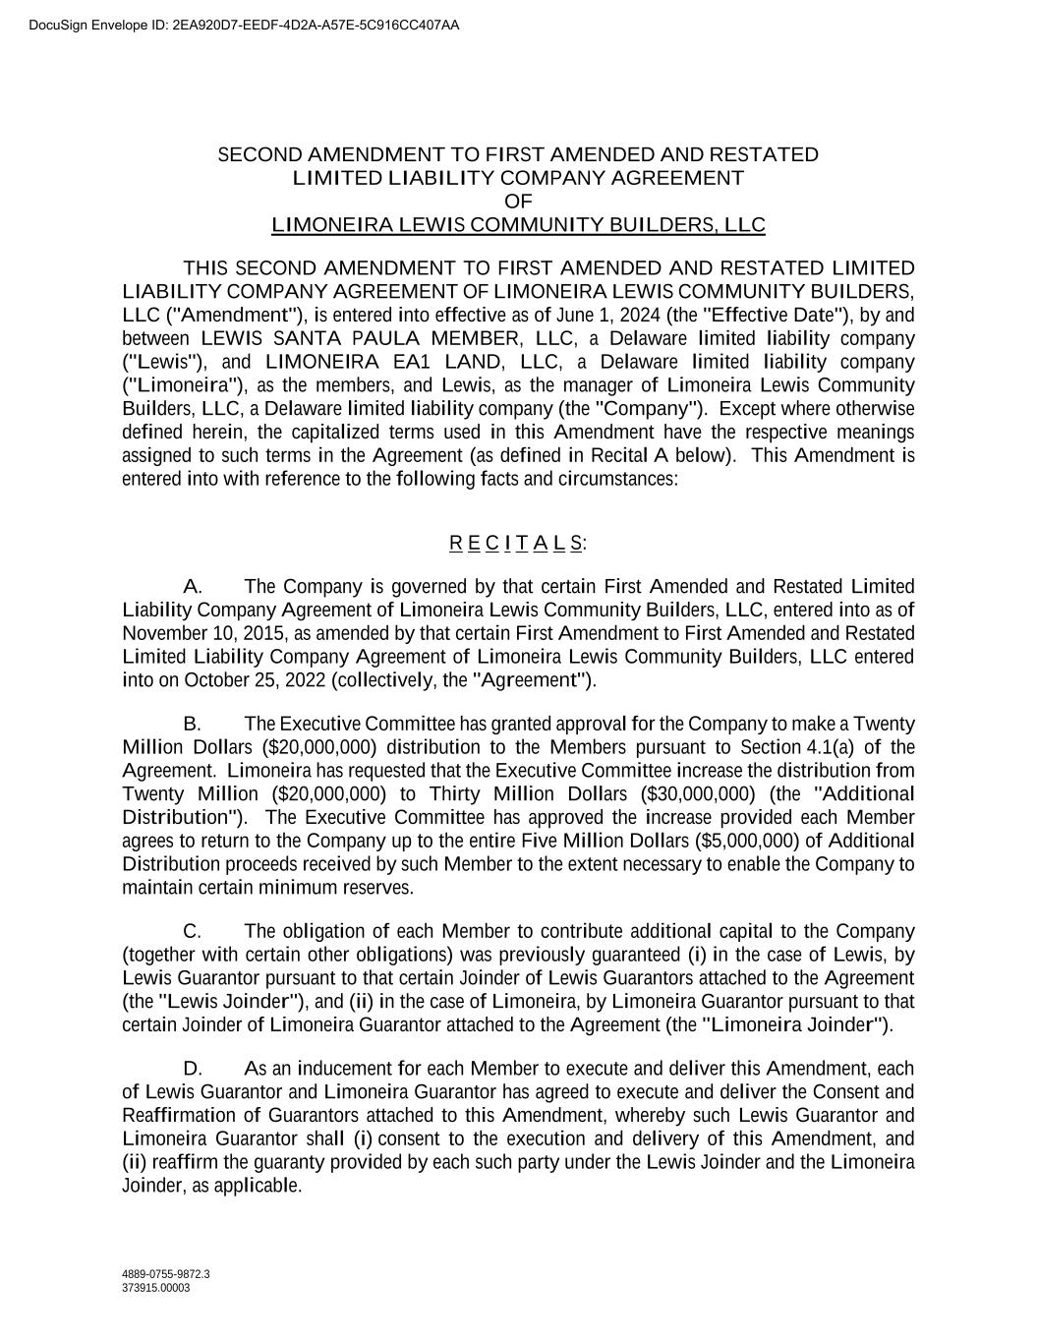
91
4889-0755-9872.3 373915.00003 SECOND AMENDMENT TO FIRST AMENDED AND RESTATED LIMITED LIABILITY COMPANY AGREEMENT OF LIMONEIRA LEWIS COMMUNITY BUILDERS, LLC THIS SECOND AMENDMENT TO FIRST AMENDED AND RESTATED LIMITED LIABILITY COMPANY AGREEMENT OF LIMONEIRA LEWIS COMMUNITY BUILDERS, LLC ("Amendment"), is entered into effective as of June 1, 2024 (the "Effective Date"), by and between LEWIS SANTA PAULA MEMBER, LLC, a Delaware limited liability company ("Lewis"), and LIMONEIRA EA1 LAND, LLC, a Delaware limited liability company ("Limoneira"), as the members, and Lewis, as the manager of Limoneira Lewis Community Builders, LLC, a Delaware limited liability company (the "Company"). Except where otherwise defined herein, the capitalized terms used in this Amendment have the respective meanings assigned to such terms in the Agreement (as defined in Recital A below). This Amendment is entered into with reference to the following facts and circumstances: R E C I T A L S: A. The Company is governed by that certain First Amended and Restated Limited Liability Company Agreement of Limoneira Lewis Community Builders, LLC, entered into as of November 10, 2015, as amended by that certain First Amendment to First Amended and Restated Limited Liability Company Agreement of Limoneira Lewis Community Builders, LLC entered into on October 25, 2022 (collectively, the "Agreement"). B. The Executive Committee has granted approval for the Company to make a Twenty Million Dollars ($20,000,000) distribution to the Members pursuant to Section 4.1(a) of the Agreement. Limoneira has requested that the Executive Committee increase the distribution from Twenty Million ($20,000,000) to Thirty Million Dollars ($30,000,000) (the "Additional Distribution"). The Executive Committee has approved the increase provided each Member agrees to return to the Company up to the entire Five Million Dollars ($5,000,000) of Additional Distribution proceeds received by such Member to the extent necessary to enable the Company to maintain certain minimum reserves. C. The obligation of each Member to contribute additional capital to the Company (together with certain other obligations) was previously guaranteed (i) in the case of Lewis, by Lewis Guarantor pursuant to that certain Joinder of Lewis Guarantors attached to the Agreement (the "Lewis Joinder"), and (ii) in the case of Limoneira, by Limoneira Guarantor pursuant to that certain Joinder of Limoneira Guarantor attached to the Agreement (the "Limoneira Joinder"). D. As an inducement for each Member to execute and deliver this Amendment, each of Lewis Guarantor and Limoneira Guarantor has agreed to execute and deliver the Consent and Reaffirmation of Guarantors attached to this Amendment, whereby such Lewis Guarantor and Limoneira Guarantor shall (i) consent to the execution and delivery of this Amendment, and (ii) reaffirm the guaranty provided by each such party under the Lewis Joinder and the Limoneira Joinder, as applicable. DocuSign Envelope ID: 2EA920D7-EEDF-4D2A-A57E-5C916CC407AA

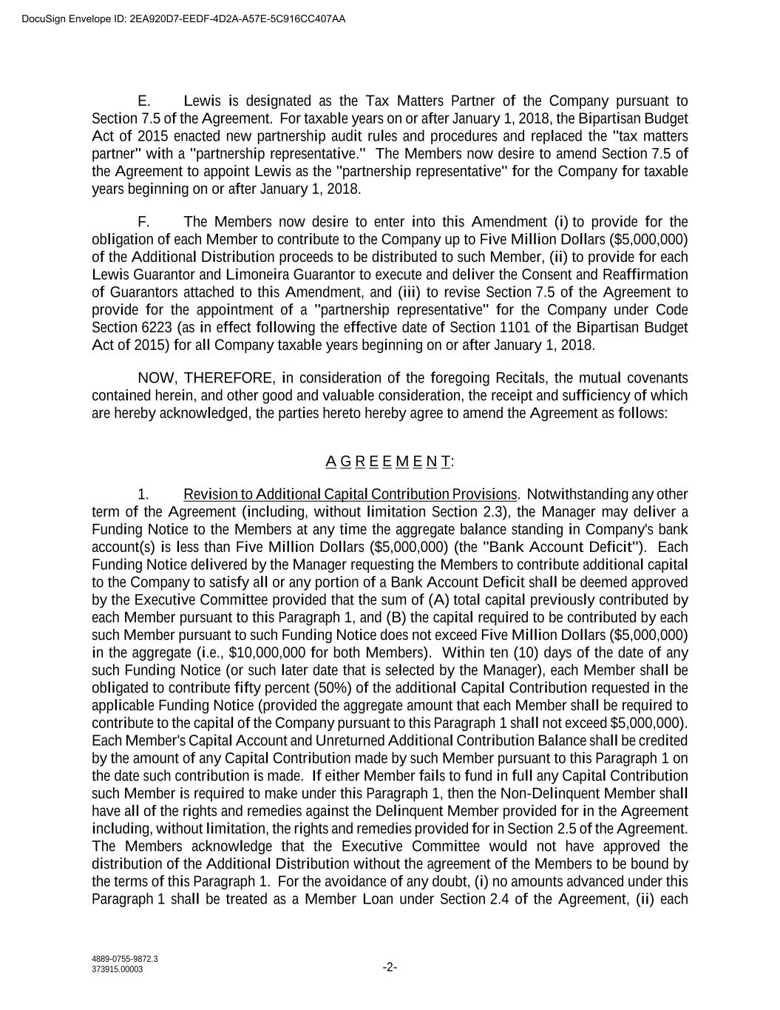
4889-0755-9872.3 373915.00003 -2- E. Lewis is designated as the Tax Matters Partner of the Company pursuant to Section 7.5 of the Agreement. For taxable years on or after January 1, 2018, the Bipartisan Budget Act of 2015 enacted new partnership audit rules and procedures and replaced the "tax matters partner" with a "partnership representative." The Members now desire to amend Section 7.5 of the Agreement to appoint Lewis as the "partnership representative" for the Company for taxable years beginning on or after January 1, 2018. F. The Members now desire to enter into this Amendment (i) to provide for the obligation of each Member to contribute to the Company up to Five Million Dollars ($5,000,000) of the Additional Distribution proceeds to be distributed to such Member, (ii) to provide for each Lewis Guarantor and Limoneira Guarantor to execute and deliver the Consent and Reaffirmation of Guarantors attached to this Amendment, and (iii) to revise Section 7.5 of the Agreement to provide for the appointment of a "partnership representative" for the Company under Code Section 6223 (as in effect following the effective date of Section 1101 of the Bipartisan Budget Act of 2015) for all Company taxable years beginning on or after January 1, 2018. NOW, THEREFORE, in consideration of the foregoing Recitals, the mutual covenants contained herein, and other good and valuable consideration, the receipt and sufficiency of which are hereby acknowledged, the parties hereto hereby agree to amend the Agreement as follows: A G R E E M E N T: 1. Revision to Additional Capital Contribution Provisions. Notwithstanding any other term of the Agreement (including, without limitation Section 2.3), the Manager may deliver a Funding Notice to the Members at any time the aggregate balance standing in Company's bank account(s) is less than Five Million Dollars ($5,000,000) (the "Bank Account Deficit"). Each Funding Notice delivered by the Manager requesting the Members to contribute additional capital to the Company to satisfy all or any portion of a Bank Account Deficit shall be deemed approved by the Executive Committee provided that the sum of (A) total capital previously contributed by each Member pursuant to this Paragraph 1, and (B) the capital required to be contributed by each such Member pursuant to such Funding Notice does not exceed Five Million Dollars ($5,000,000) in the aggregate (i.e., $10,000,000 for both Members). Within ten (10) days of the date of any such Funding Notice (or such later date that is selected by the Manager), each Member shall be obligated to contribute fifty percent (50%) of the additional Capital Contribution requested in the applicable Funding Notice (provided the aggregate amount that each Member shall be required to contribute to the capital of the Company pursuant to this Paragraph 1 shall not exceed $5,000,000). Each Member's Capital Account and Unreturned Additional Contribution Balance shall be credited by the amount of any Capital Contribution made by such Member pursuant to this Paragraph 1 on the date such contribution is made. If either Member fails to fund in full any Capital Contribution such Member is required to make under this Paragraph 1, then the Non-Delinquent Member shall have all of the rights and remedies against the Delinquent Member provided for in the Agreement including, without limitation, the rights and remedies provided for in Section 2.5 of the Agreement. The Members acknowledge that the Executive Committee would not have approved the distribution of the Additional Distribution without the agreement of the Members to be bound by the terms of this Paragraph 1. For the avoidance of any doubt, (i) no amounts advanced under this Paragraph 1 shall be treated as a Member Loan under Section 2.4 of the Agreement, (ii) each DocuSign Envelope ID: 2EA920D7-EEDF-4D2A-A57E-5C916CC407AA

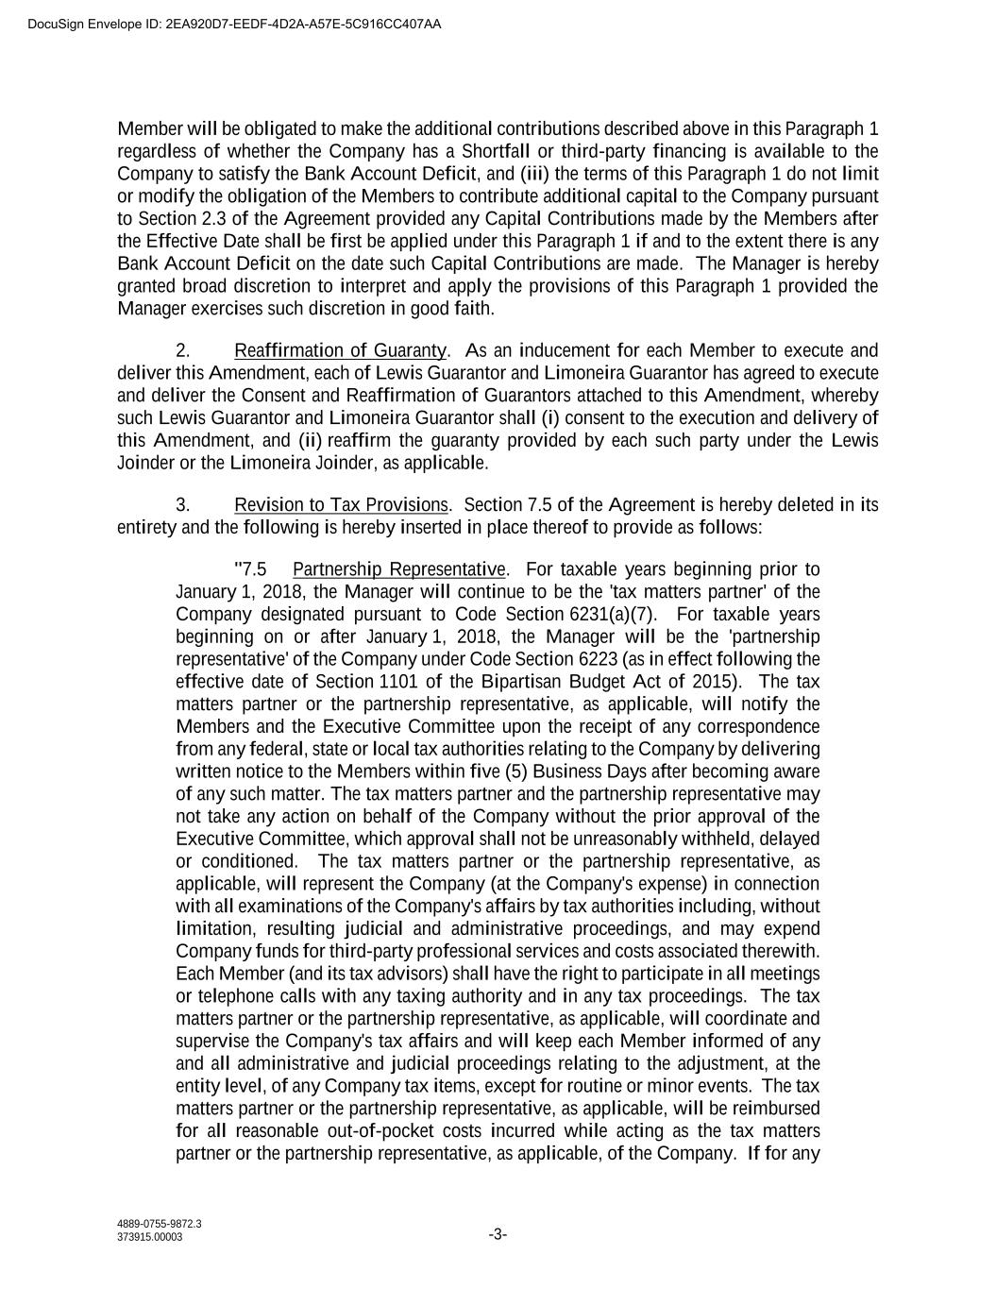
4889-0755-9872.3 373915.00003 -3- Member will be obligated to make the additional contributions described above in this Paragraph 1 regardless of whether the Company has a Shortfall or third-party financing is available to the Company to satisfy the Bank Account Deficit, and (iii) the terms of this Paragraph 1 do not limit or modify the obligation of the Members to contribute additional capital to the Company pursuant to Section 2.3 of the Agreement provided any Capital Contributions made by the Members after the Effective Date shall be first be applied under this Paragraph 1 if and to the extent there is any Bank Account Deficit on the date such Capital Contributions are made. The Manager is hereby granted broad discretion to interpret and apply the provisions of this Paragraph 1 provided the Manager exercises such discretion in good faith. 2. Reaffirmation of Guaranty. As an inducement for each Member to execute and deliver this Amendment, each of Lewis Guarantor and Limoneira Guarantor has agreed to execute and deliver the Consent and Reaffirmation of Guarantors attached to this Amendment, whereby such Lewis Guarantor and Limoneira Guarantor shall (i) consent to the execution and delivery of this Amendment, and (ii) reaffirm the guaranty provided by each such party under the Lewis Joinder or the Limoneira Joinder, as applicable. 3. Revision to Tax Provisions. Section 7.5 of the Agreement is hereby deleted in its entirety and the following is hereby inserted in place thereof to provide as follows: "7.5 Partnership Representative. For taxable years beginning prior to January 1, 2018, the Manager will continue to be the 'tax matters partner' of the Company designated pursuant to Code Section 6231(a)(7). For taxable years beginning on or after January 1, 2018, the Manager will be the 'partnership representative' of the Company under Code Section 6223 (as in effect following the effective date of Section 1101 of the Bipartisan Budget Act of 2015). The tax matters partner or the partnership representative, as applicable, will notify the Members and the Executive Committee upon the receipt of any correspondence from any federal, state or local tax authorities relating to the Company by delivering written notice to the Members within five (5) Business Days after becoming aware of any such matter. The tax matters partner and the partnership representative may not take any action on behalf of the Company without the prior approval of the Executive Committee, which approval shall not be unreasonably withheld, delayed or conditioned. The tax matters partner or the partnership representative, as applicable, will represent the Company (at the Company's expense) in connection with all examinations of the Company's affairs by tax authorities including, without limitation, resulting judicial and administrative proceedings, and may expend Company funds for third-party professional services and costs associated therewith. Each Member (and its tax advisors) shall have the right to participate in all meetings or telephone calls with any taxing authority and in any tax proceedings. The tax matters partner or the partnership representative, as applicable, will coordinate and supervise the Company's tax affairs and will keep each Member informed of any and all administrative and judicial proceedings relating to the adjustment, at the entity level, of any Company tax items, except for routine or minor events. The tax matters partner or the partnership representative, as applicable, will be reimbursed for all reasonable out-of-pocket costs incurred while acting as the tax matters partner or the partnership representative, as applicable, of the Company. If for any DocuSign Envelope ID: 2EA920D7-EEDF-4D2A-A57E-5C916CC407AA

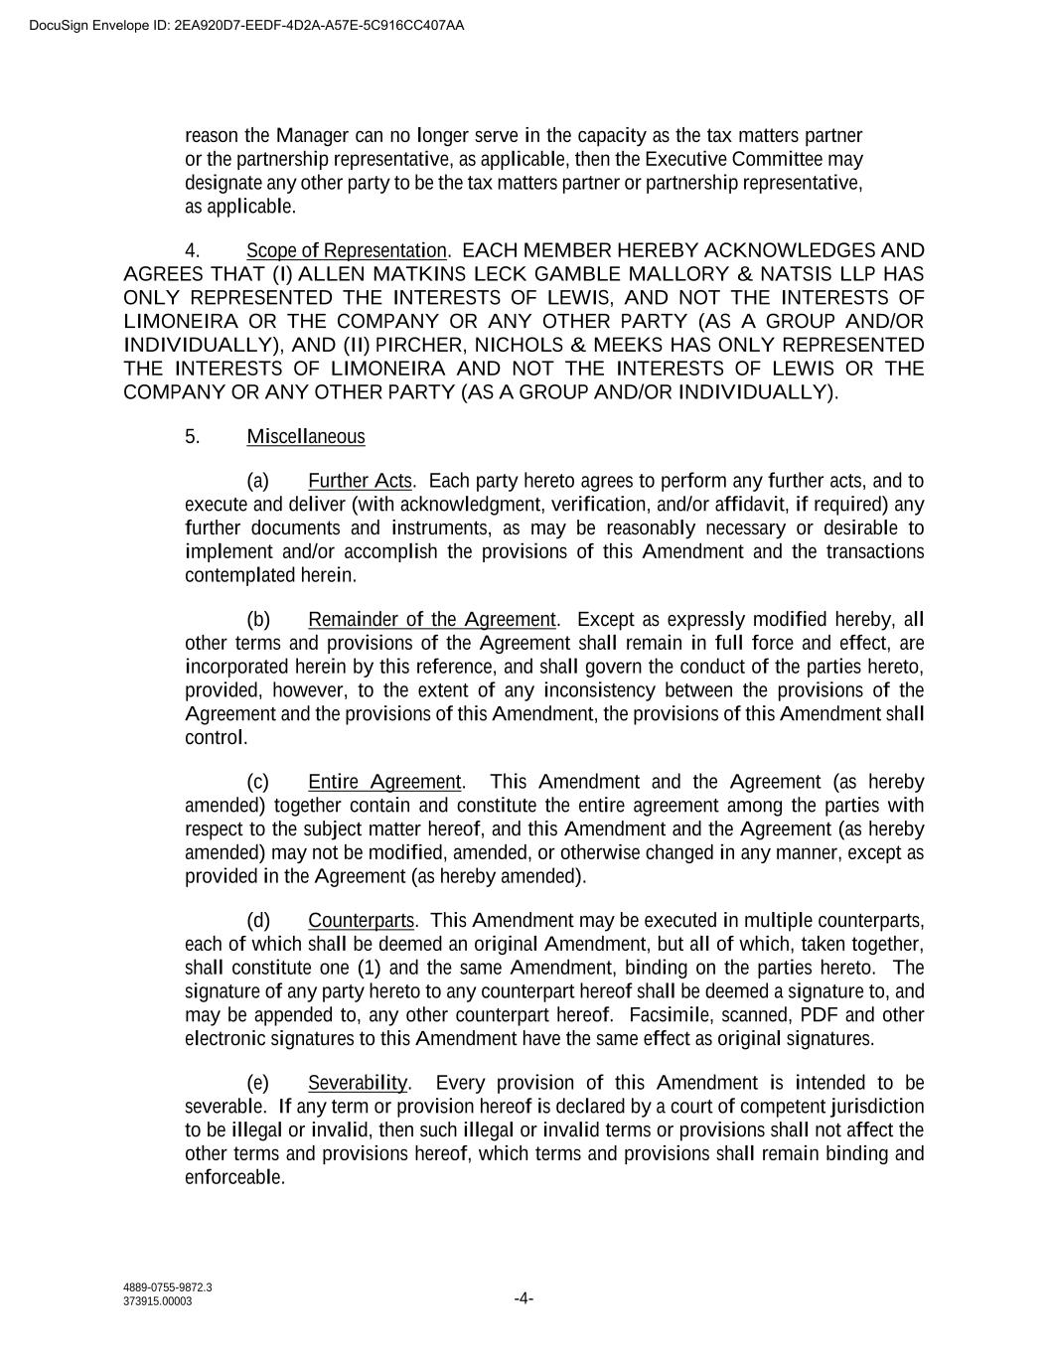
4889-0755-9872.3 373915.00003 -4- reason the Manager can no longer serve in the capacity as the tax matters partner or the partnership representative, as applicable, then the Executive Committee may designate any other party to be the tax matters partner or partnership representative, as applicable. 4. Scope of Representation. EACH MEMBER HEREBY ACKNOWLEDGES AND AGREES THAT (I) ALLEN MATKINS LECK GAMBLE MALLORY & NATSIS LLP HAS ONLY REPRESENTED THE INTERESTS OF LEWIS, AND NOT THE INTERESTS OF LIMONEIRA OR THE COMPANY OR ANY OTHER PARTY (AS A GROUP AND/OR INDIVIDUALLY), AND (II) PIRCHER, NICHOLS & MEEKS HAS ONLY REPRESENTED THE INTERESTS OF LIMONEIRA AND NOT THE INTERESTS OF LEWIS OR THE COMPANY OR ANY OTHER PARTY (AS A GROUP AND/OR INDIVIDUALLY). 5. Miscellaneous (a) Further Acts. Each party hereto agrees to perform any further acts, and to execute and deliver (with acknowledgment, verification, and/or affidavit, if required) any further documents and instruments, as may be reasonably necessary or desirable to implement and/or accomplish the provisions of this Amendment and the transactions contemplated herein. (b) Remainder of the Agreement. Except as expressly modified hereby, all other terms and provisions of the Agreement shall remain in full force and effect, are incorporated herein by this reference, and shall govern the conduct of the parties hereto, provided, however, to the extent of any inconsistency between the provisions of the Agreement and the provisions of this Amendment, the provisions of this Amendment shall control. (c) Entire Agreement. This Amendment and the Agreement (as hereby amended) together contain and constitute the entire agreement among the parties with respect to the subject matter hereof, and this Amendment and the Agreement (as hereby amended) may not be modified, amended, or otherwise changed in any manner, except as provided in the Agreement (as hereby amended). (d) Counterparts. This Amendment may be executed in multiple counterparts, each of which shall be deemed an original Amendment, but all of which, taken together, shall constitute one (1) and the same Amendment, binding on the parties hereto. The signature of any party hereto to any counterpart hereof shall be deemed a signature to, and may be appended to, any other counterpart hereof. Facsimile, scanned, PDF and other electronic signatures to this Amendment have the same effect as original signatures. (e) Severability. Every provision of this Amendment is intended to be severable. If any term or provision hereof is declared by a court of competent jurisdiction to be illegal or invalid, then such illegal or invalid terms or provisions shall not affect the other terms and provisions hereof, which terms and provisions shall remain binding and enforceable. DocuSign Envelope ID: 2EA920D7-EEDF-4D2A-A57E-5C916CC407AA

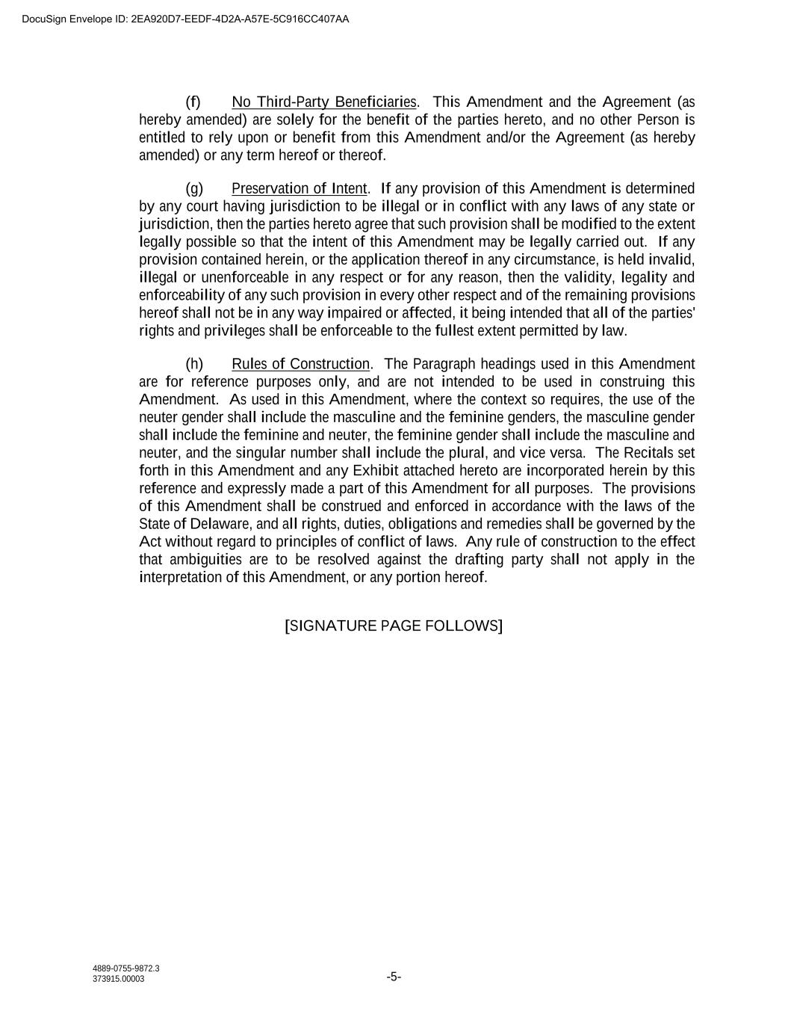
4889-0755-9872.3 373915.00003 -5- (f) No Third-Party Beneficiaries. This Amendment and the Agreement (as hereby amended) are solely for the benefit of the parties hereto, and no other Person is entitled to rely upon or benefit from this Amendment and/or the Agreement (as hereby amended) or any term hereof or thereof. (g) Preservation of Intent. If any provision of this Amendment is determined by any court having jurisdiction to be illegal or in conflict with any laws of any state or jurisdiction, then the parties hereto agree that such provision shall be modified to the extent legally possible so that the intent of this Amendment may be legally carried out. If any provision contained herein, or the application thereof in any circumstance, is held invalid, illegal or unenforceable in any respect or for any reason, then the validity, legality and enforceability of any such provision in every other respect and of the remaining provisions hereof shall not be in any way impaired or affected, it being intended that all of the parties' rights and privileges shall be enforceable to the fullest extent permitted by law. (h) Rules of Construction. The Paragraph headings used in this Amendment are for reference purposes only, and are not intended to be used in construing this Amendment. As used in this Amendment, where the context so requires, the use of the neuter gender shall include the masculine and the feminine genders, the masculine gender shall include the feminine and neuter, the feminine gender shall include the masculine and neuter, and the singular number shall include the plural, and vice versa. The Recitals set forth in this Amendment and any Exhibit attached hereto are incorporated herein by this reference and expressly made a part of this Amendment for all purposes. The provisions of this Amendment shall be construed and enforced in accordance with the laws of the State of Delaware, and all rights, duties, obligations and remedies shall be governed by the Act without regard to principles of conflict of laws. Any rule of construction to the effect that ambiguities are to be resolved against the drafting party shall not apply in the interpretation of this Amendment, or any portion hereof. [SIGNATURE PAGE FOLLOWS] DocuSign Envelope ID: 2EA920D7-EEDF-4D2A-A57E-5C916CC407AA

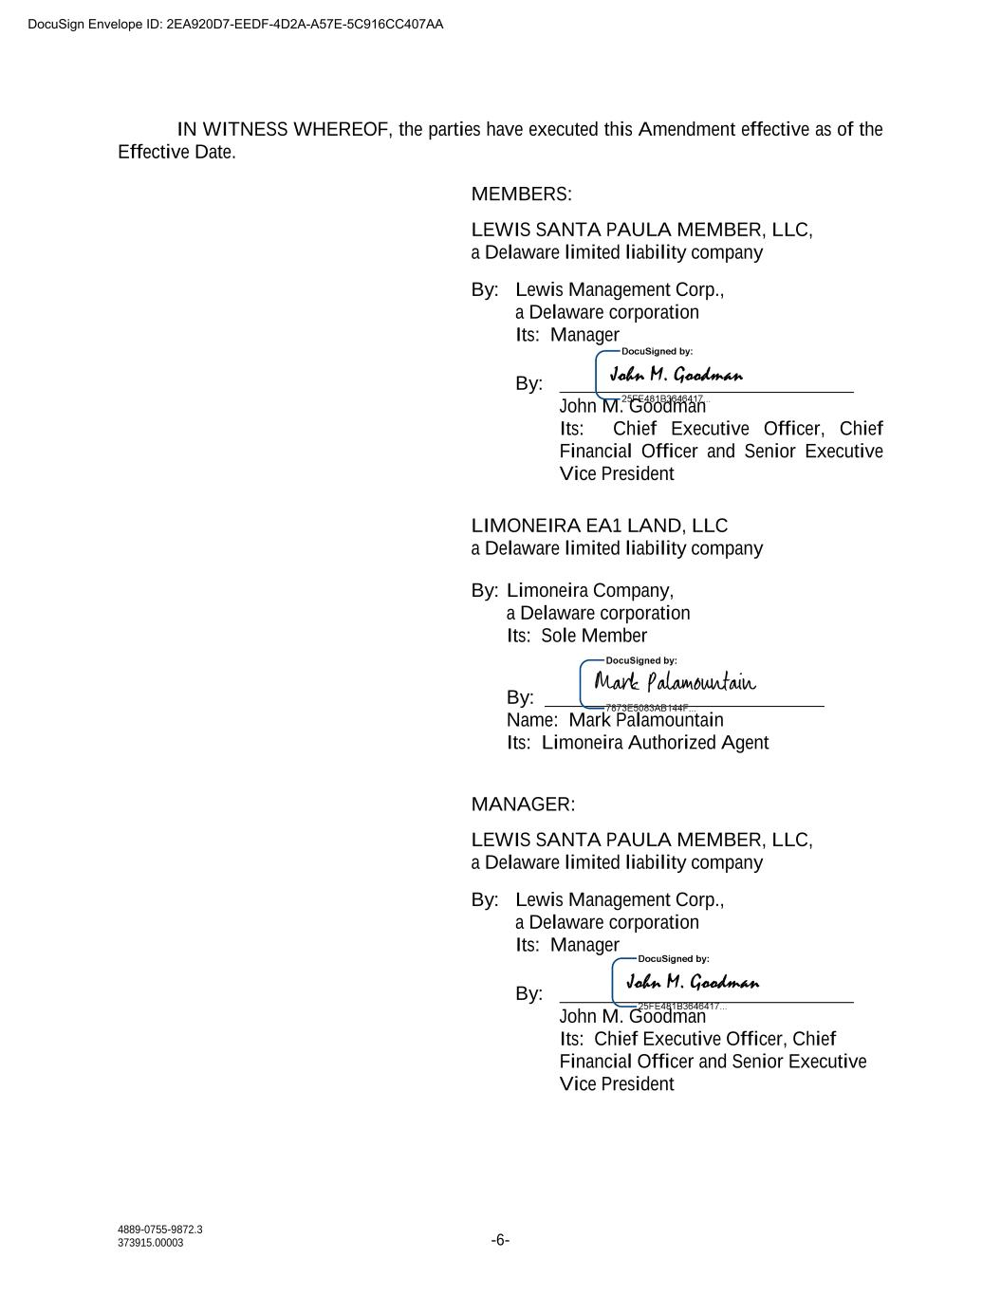
4889-0755-9872.3 373915.00003 -6- IN WITNESS WHEREOF, the parties have executed this Amendment effective as of the Effective Date. MEMBERS: LEWIS SANTA PAULA MEMBER, LLC, a Delaware limited liability company By: Lewis Management Corp., a Delaware corporation Its: Manager By: John M. Goodman Its: Chief Executive Officer, Chief Financial Officer and Senior Executive Vice President LIMONEIRA EA1 LAND, LLC a Delaware limited liability company By: Limoneira Company, a Delaware corporation Its: Sole Member By: Name: Mark Palamountain Its: Limoneira Authorized Agent MANAGER: LEWIS SANTA PAULA MEMBER, LLC, a Delaware limited liability company By: Lewis Management Corp., a Delaware corporation Its: Manager By: John M. Goodman Its: Chief Executive Officer, Chief Financial Officer and Senior Executive Vice President DocuSign Envelope ID: 2EA920D7-EEDF-4D2A-A57E-5C916CC407AA

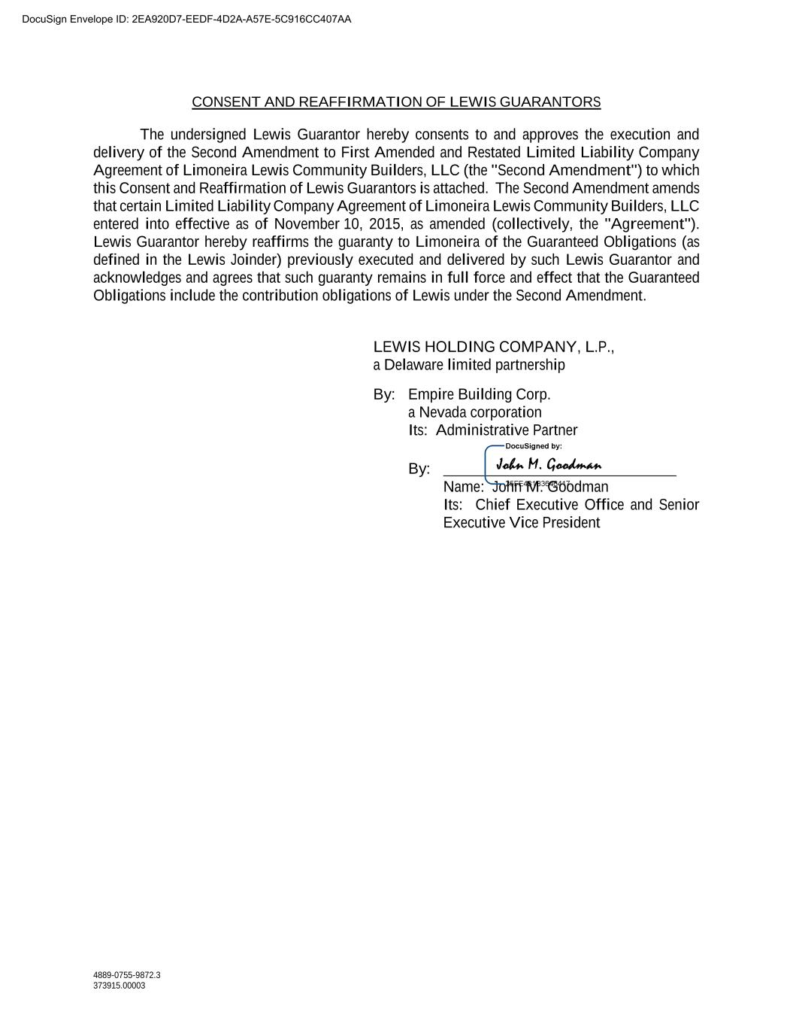
4889-0755-9872.3 373915.00003 CONSENT AND REAFFIRMATION OF LEWIS GUARANTORS The undersigned Lewis Guarantor hereby consents to and approves the execution and delivery of the Second Amendment to First Amended and Restated Limited Liability Company Agreement of Limoneira Lewis Community Builders, LLC (the "Second Amendment") to which this Consent and Reaffirmation of Lewis Guarantors is attached. The Second Amendment amends that certain Limited Liability Company Agreement of Limoneira Lewis Community Builders, LLC entered into effective as of November 10, 2015, as amended (collectively, the "Agreement"). Lewis Guarantor hereby reaffirms the guaranty to Limoneira of the Guaranteed Obligations (as defined in the Lewis Joinder) previously executed and delivered by such Lewis Guarantor and acknowledges and agrees that such guaranty remains in full force and effect that the Guaranteed Obligations include the contribution obligations of Lewis under the Second Amendment. LEWIS HOLDING COMPANY, L.P., a Delaware limited partnership By: Empire Building Corp. a Nevada corporation Its: Administrative Partner By: Name: John M. Goodman Its: Chief Executive Office and Senior Executive Vice President DocuSign Envelope ID: 2EA920D7-EEDF-4D2A-A57E-5C916CC407AA

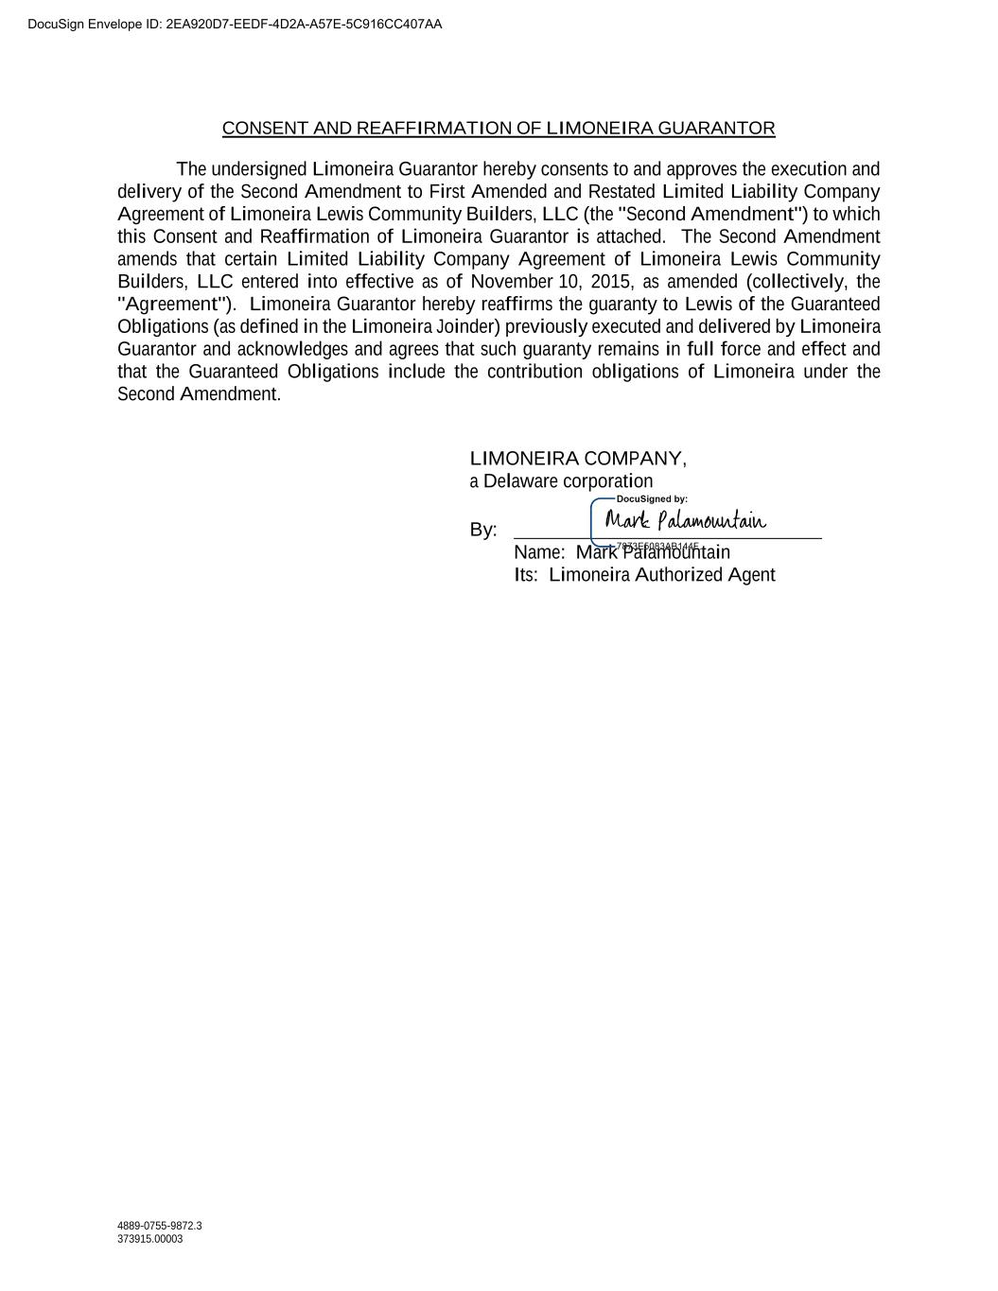
4889-0755-9872.3 373915.00003 CONSENT AND REAFFIRMATION OF LIMONEIRA GUARANTOR The undersigned Limoneira Guarantor hereby consents to and approves the execution and delivery of the Second Amendment to First Amended and Restated Limited Liability Company Agreement of Limoneira Lewis Community Builders, LLC (the "Second Amendment") to which this Consent and Reaffirmation of Limoneira Guarantor is attached. The Second Amendment amends that certain Limited Liability Company Agreement of Limoneira Lewis Community Builders, LLC entered into effective as of November 10, 2015, as amended (collectively, the "Agreement"). Limoneira Guarantor hereby reaffirms the guaranty to Lewis of the Guaranteed Obligations (as defined in the Limoneira Joinder) previously executed and delivered by Limoneira Guarantor and acknowledges and agrees that such guaranty remains in full force and effect and that the Guaranteed Obligations include the contribution obligations of Limoneira under the Second Amendment. LIMONEIRA COMPANY, a Delaware corporation By: Name: Mark Palamountain Its: Limoneira Authorized Agent DocuSign Envelope ID: 2EA920D7-EEDF-4D2A-A57E-5C916CC407AA

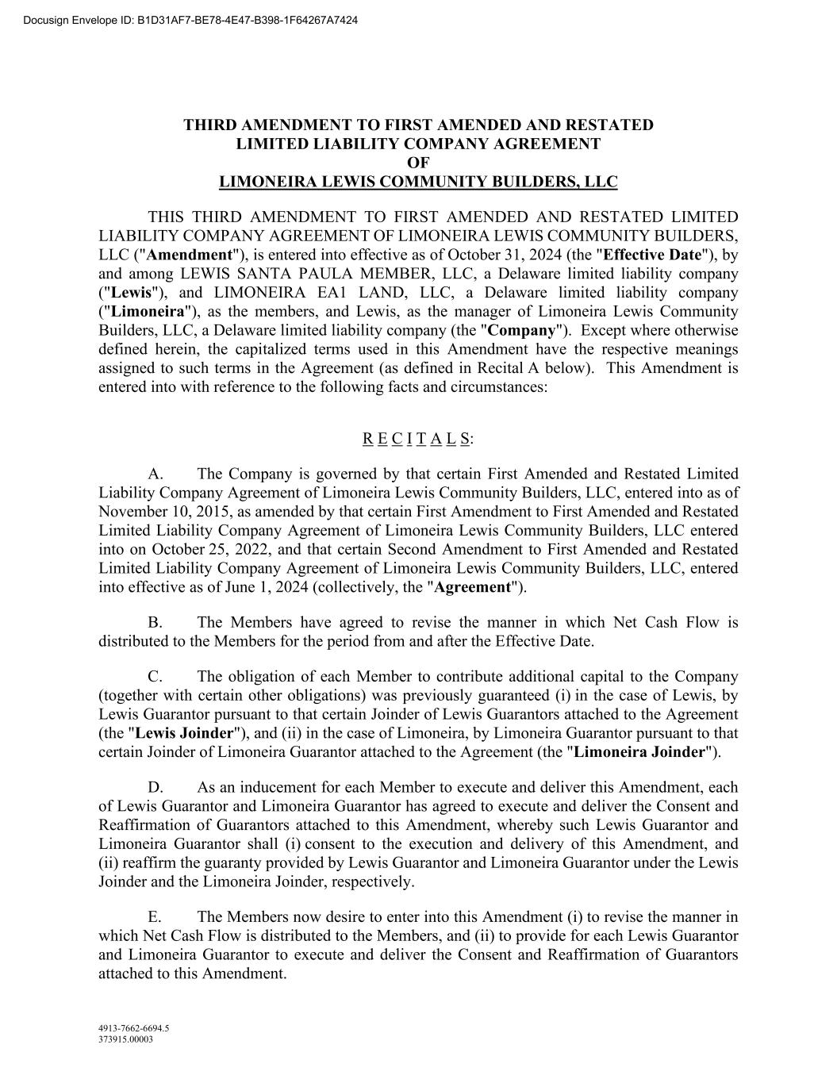
4913-7662-6694.5 373915.00003 THIRD AMENDMENT TO FIRST AMENDED AND RESTATED LIMITED LIABILITY COMPANY AGREEMENT OF LIMONEIRA LEWIS COMMUNITY BUILDERS, LLC THIS THIRD AMENDMENT TO FIRST AMENDED AND RESTATED LIMITED LIABILITY COMPANY AGREEMENT OF LIMONEIRA LEWIS COMMUNITY BUILDERS, LLC ("Amendment"), is entered into effective as of October 31, 2024 (the "Effective Date"), by and among LEWIS SANTA PAULA MEMBER, LLC, a Delaware limited liability company ("Lewis"), and LIMONEIRA EA1 LAND, LLC, a Delaware limited liability company ("Limoneira"), as the members, and Lewis, as the manager of Limoneira Lewis Community Builders, LLC, a Delaware limited liability company (the "Company"). Except where otherwise defined herein, the capitalized terms used in this Amendment have the respective meanings assigned to such terms in the Agreement (as defined in Recital A below). This Amendment is entered into with reference to the following facts and circumstances: R E C I T A L S: A. The Company is governed by that certain First Amended and Restated Limited Liability Company Agreement of Limoneira Lewis Community Builders, LLC, entered into as of November 10, 2015, as amended by that certain First Amendment to First Amended and Restated Limited Liability Company Agreement of Limoneira Lewis Community Builders, LLC entered into on October 25, 2022, and that certain Second Amendment to First Amended and Restated Limited Liability Company Agreement of Limoneira Lewis Community Builders, LLC, entered into effective as of June 1, 2024 (collectively, the "Agreement"). B. The Members have agreed to revise the manner in which Net Cash Flow is distributed to the Members for the period from and after the Effective Date. C. The obligation of each Member to contribute additional capital to the Company (together with certain other obligations) was previously guaranteed (i) in the case of Lewis, by Lewis Guarantor pursuant to that certain Joinder of Lewis Guarantors attached to the Agreement (the "Lewis Joinder"), and (ii) in the case of Limoneira, by Limoneira Guarantor pursuant to that certain Joinder of Limoneira Guarantor attached to the Agreement (the "Limoneira Joinder"). D. As an inducement for each Member to execute and deliver this Amendment, each of Lewis Guarantor and Limoneira Guarantor has agreed to execute and deliver the Consent and Reaffirmation of Guarantors attached to this Amendment, whereby such Lewis Guarantor and Limoneira Guarantor shall (i) consent to the execution and delivery of this Amendment, and (ii) reaffirm the guaranty provided by Lewis Guarantor and Limoneira Guarantor under the Lewis Joinder and the Limoneira Joinder, respectively. E. The Members now desire to enter into this Amendment (i) to revise the manner in which Net Cash Flow is distributed to the Members, and (ii) to provide for each Lewis Guarantor and Limoneira Guarantor to execute and deliver the Consent and Reaffirmation of Guarantors attached to this Amendment. Docusign Envelope ID: B1D31AF7-BE78-4E47-B398-1F64267A7424

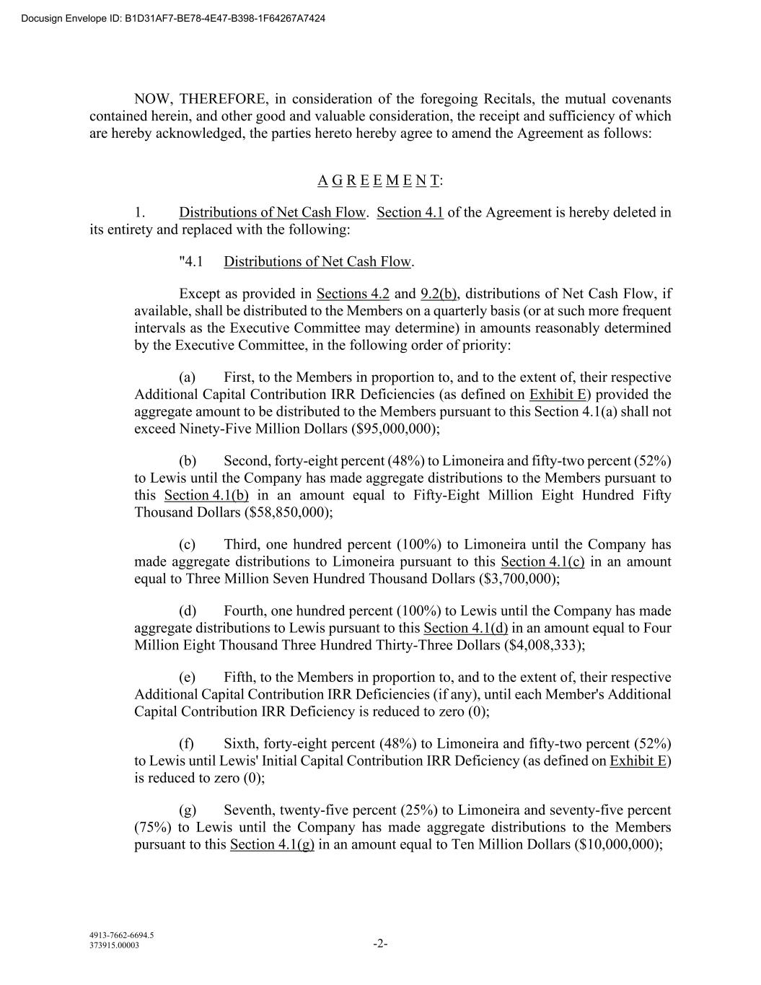
4913-7662-6694.5 373915.00003 -2- NOW, THEREFORE, in consideration of the foregoing Recitals, the mutual covenants contained herein, and other good and valuable consideration, the receipt and sufficiency of which are hereby acknowledged, the parties hereto hereby agree to amend the Agreement as follows: A G R E E M E N T: 1. Distributions of Net Cash Flow. Section 4.1 of the Agreement is hereby deleted in its entirety and replaced with the following: "4.1 Distributions of Net Cash Flow. Except as provided in Sections 4.2 and 9.2(b), distributions of Net Cash Flow, if available, shall be distributed to the Members on a quarterly basis (or at such more frequent intervals as the Executive Committee may determine) in amounts reasonably determined by the Executive Committee, in the following order of priority: (a) First, to the Members in proportion to, and to the extent of, their respective Additional Capital Contribution IRR Deficiencies (as defined on Exhibit E) provided the aggregate amount to be distributed to the Members pursuant to this Section 4.1(a) shall not exceed Ninety-Five Million Dollars ($95,000,000); (b) Second, forty-eight percent (48%) to Limoneira and fifty-two percent (52%) to Lewis until the Company has made aggregate distributions to the Members pursuant to this Section 4.1(b) in an amount equal to Fifty-Eight Million Eight Hundred Fifty Thousand Dollars ($58,850,000); (c) Third, one hundred percent (100%) to Limoneira until the Company has made aggregate distributions to Limoneira pursuant to this Section 4.1(c) in an amount equal to Three Million Seven Hundred Thousand Dollars ($3,700,000); (d) Fourth, one hundred percent (100%) to Lewis until the Company has made aggregate distributions to Lewis pursuant to this Section 4.1(d) in an amount equal to Four Million Eight Thousand Three Hundred Thirty-Three Dollars ($4,008,333); (e) Fifth, to the Members in proportion to, and to the extent of, their respective Additional Capital Contribution IRR Deficiencies (if any), until each Member's Additional Capital Contribution IRR Deficiency is reduced to zero (0); (f) Sixth, forty-eight percent (48%) to Limoneira and fifty-two percent (52%) to Lewis until Lewis' Initial Capital Contribution IRR Deficiency (as defined on Exhibit E) is reduced to zero (0); (g) Seventh, twenty-five percent (25%) to Limoneira and seventy-five percent (75%) to Lewis until the Company has made aggregate distributions to the Members pursuant to this Section 4.1(g) in an amount equal to Ten Million Dollars ($10,000,000); Docusign Envelope ID: B1D31AF7-BE78-4E47-B398-1F64267A7424

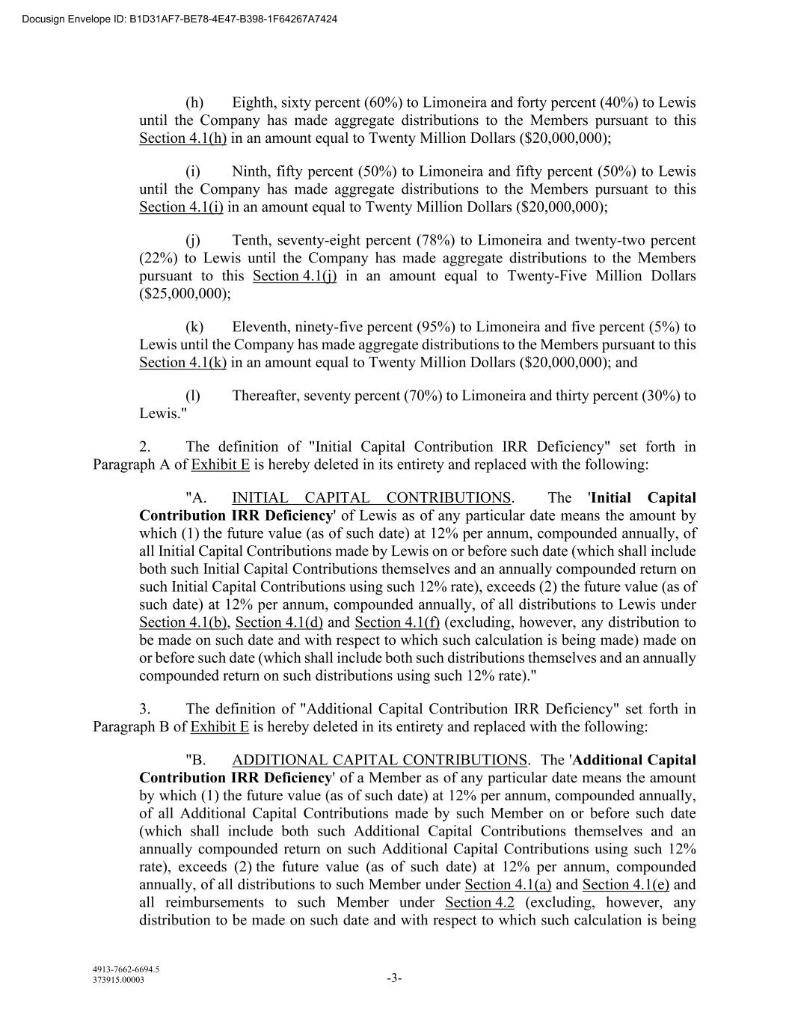
4913-7662-6694.5 373915.00003 -3- (h) Eighth, sixty percent (60%) to Limoneira and forty percent (40%) to Lewis until the Company has made aggregate distributions to the Members pursuant to this Section 4.1(h) in an amount equal to Twenty Million Dollars ($20,000,000); (i) Ninth, fifty percent (50%) to Limoneira and fifty percent (50%) to Lewis until the Company has made aggregate distributions to the Members pursuant to this Section 4.1(i) in an amount equal to Twenty Million Dollars ($20,000,000); (j) Tenth, seventy-eight percent (78%) to Limoneira and twenty-two percent (22%) to Lewis until the Company has made aggregate distributions to the Members pursuant to this Section 4.1(j) in an amount equal to Twenty-Five Million Dollars ($25,000,000); (k) Eleventh, ninety-five percent (95%) to Limoneira and five percent (5%) to Lewis until the Company has made aggregate distributions to the Members pursuant to this Section 4.1(k) in an amount equal to Twenty Million Dollars ($20,000,000); and (l) Thereafter, seventy percent (70%) to Limoneira and thirty percent (30%) to Lewis." 2. The definition of "Initial Capital Contribution IRR Deficiency" set forth in Paragraph A of Exhibit E is hereby deleted in its entirety and replaced with the following: "A. INITIAL CAPITAL CONTRIBUTIONS. The 'Initial Capital Contribution IRR Deficiency' of Lewis as of any particular date means the amount by which (1) the future value (as of such date) at 12% per annum, compounded annually, of all Initial Capital Contributions made by Lewis on or before such date (which shall include both such Initial Capital Contributions themselves and an annually compounded return on such Initial Capital Contributions using such 12% rate), exceeds (2) the future value (as of such date) at 12% per annum, compounded annually, of all distributions to Lewis under Section 4.1(b), Section 4.1(d) and Section 4.1(f) (excluding, however, any distribution to be made on such date and with respect to which such calculation is being made) made on or before such date (which shall include both such distributions themselves and an annually compounded return on such distributions using such 12% rate)." 3. The definition of "Additional Capital Contribution IRR Deficiency" set forth in Paragraph B of Exhibit E is hereby deleted in its entirety and replaced with the following: "B. ADDITIONAL CAPITAL CONTRIBUTIONS. The 'Additional Capital Contribution IRR Deficiency' of a Member as of any particular date means the amount by which (1) the future value (as of such date) at 12% per annum, compounded annually, of all Additional Capital Contributions made by such Member on or before such date (which shall include both such Additional Capital Contributions themselves and an annually compounded return on such Additional Capital Contributions using such 12% rate), exceeds (2) the future value (as of such date) at 12% per annum, compounded annually, of all distributions to such Member under Section 4.1(a) and Section 4.1(e) and all reimbursements to such Member under Section 4.2 (excluding, however, any distribution to be made on such date and with respect to which such calculation is being Docusign Envelope ID: B1D31AF7-BE78-4E47-B398-1F64267A7424

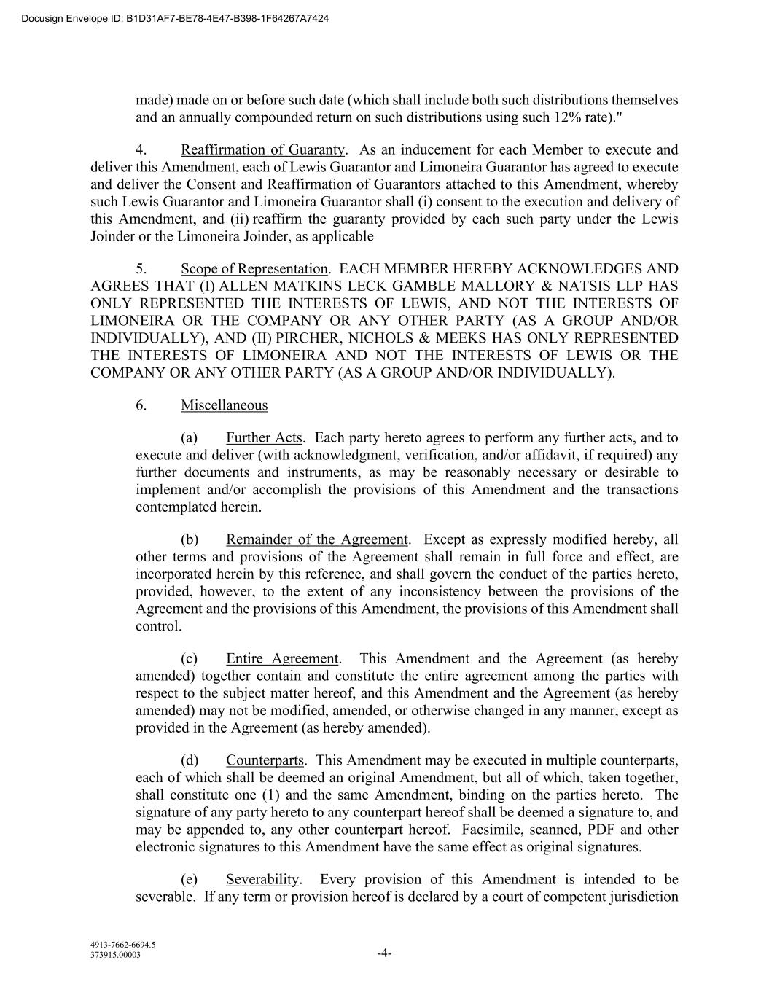
4913-7662-6694.5 373915.00003 -4- made) made on or before such date (which shall include both such distributions themselves and an annually compounded return on such distributions using such 12% rate)." 4. Reaffirmation of Guaranty. As an inducement for each Member to execute and deliver this Amendment, each of Lewis Guarantor and Limoneira Guarantor has agreed to execute and deliver the Consent and Reaffirmation of Guarantors attached to this Amendment, whereby such Lewis Guarantor and Limoneira Guarantor shall (i) consent to the execution and delivery of this Amendment, and (ii) reaffirm the guaranty provided by each such party under the Lewis Joinder or the Limoneira Joinder, as applicable 5. Scope of Representation. EACH MEMBER HEREBY ACKNOWLEDGES AND AGREES THAT (I) ALLEN MATKINS LECK GAMBLE MALLORY & NATSIS LLP HAS ONLY REPRESENTED THE INTERESTS OF LEWIS, AND NOT THE INTERESTS OF LIMONEIRA OR THE COMPANY OR ANY OTHER PARTY (AS A GROUP AND/OR INDIVIDUALLY), AND (II) PIRCHER, NICHOLS & MEEKS HAS ONLY REPRESENTED THE INTERESTS OF LIMONEIRA AND NOT THE INTERESTS OF LEWIS OR THE COMPANY OR ANY OTHER PARTY (AS A GROUP AND/OR INDIVIDUALLY). 6. Miscellaneous (a) Further Acts. Each party hereto agrees to perform any further acts, and to execute and deliver (with acknowledgment, verification, and/or affidavit, if required) any further documents and instruments, as may be reasonably necessary or desirable to implement and/or accomplish the provisions of this Amendment and the transactions contemplated herein. (b) Remainder of the Agreement. Except as expressly modified hereby, all other terms and provisions of the Agreement shall remain in full force and effect, are incorporated herein by this reference, and shall govern the conduct of the parties hereto, provided, however, to the extent of any inconsistency between the provisions of the Agreement and the provisions of this Amendment, the provisions of this Amendment shall control. (c) Entire Agreement. This Amendment and the Agreement (as hereby amended) together contain and constitute the entire agreement among the parties with respect to the subject matter hereof, and this Amendment and the Agreement (as hereby amended) may not be modified, amended, or otherwise changed in any manner, except as provided in the Agreement (as hereby amended). (d) Counterparts. This Amendment may be executed in multiple counterparts, each of which shall be deemed an original Amendment, but all of which, taken together, shall constitute one (1) and the same Amendment, binding on the parties hereto. The signature of any party hereto to any counterpart hereof shall be deemed a signature to, and may be appended to, any other counterpart hereof. Facsimile, scanned, PDF and other electronic signatures to this Amendment have the same effect as original signatures. (e) Severability. Every provision of this Amendment is intended to be severable. If any term or provision hereof is declared by a court of competent jurisdiction Docusign Envelope ID: B1D31AF7-BE78-4E47-B398-1F64267A7424

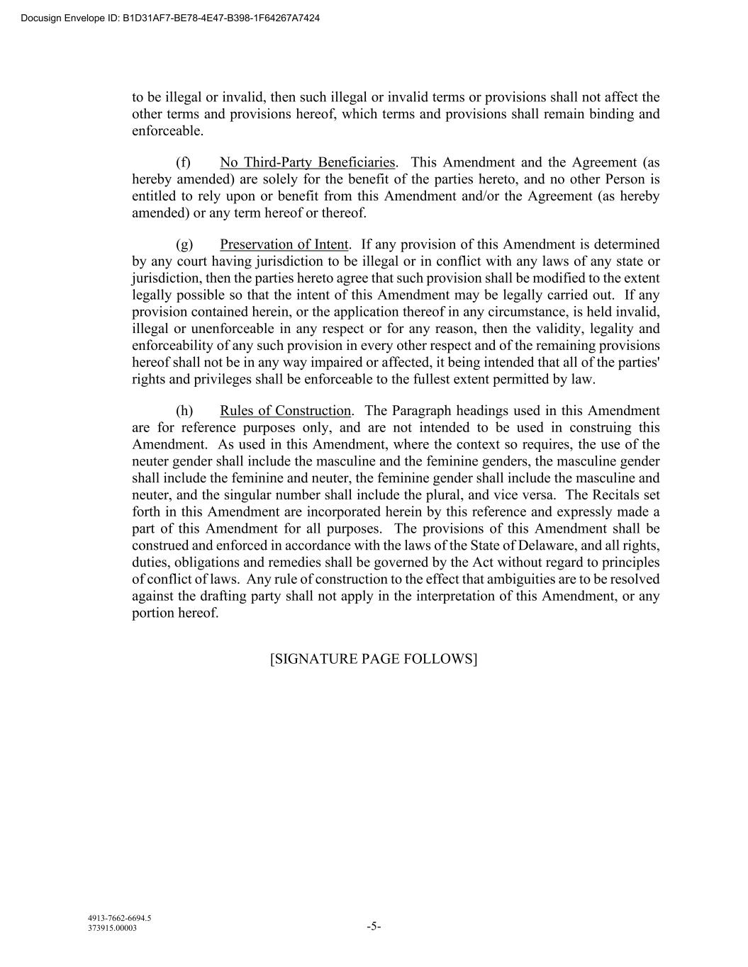
4913-7662-6694.5 373915.00003 -5- to be illegal or invalid, then such illegal or invalid terms or provisions shall not affect the other terms and provisions hereof, which terms and provisions shall remain binding and enforceable. (f) No Third-Party Beneficiaries. This Amendment and the Agreement (as hereby amended) are solely for the benefit of the parties hereto, and no other Person is entitled to rely upon or benefit from this Amendment and/or the Agreement (as hereby amended) or any term hereof or thereof. (g) Preservation of Intent. If any provision of this Amendment is determined by any court having jurisdiction to be illegal or in conflict with any laws of any state or jurisdiction, then the parties hereto agree that such provision shall be modified to the extent legally possible so that the intent of this Amendment may be legally carried out. If any provision contained herein, or the application thereof in any circumstance, is held invalid, illegal or unenforceable in any respect or for any reason, then the validity, legality and enforceability of any such provision in every other respect and of the remaining provisions hereof shall not be in any way impaired or affected, it being intended that all of the parties' rights and privileges shall be enforceable to the fullest extent permitted by law. (h) Rules of Construction. The Paragraph headings used in this Amendment are for reference purposes only, and are not intended to be used in construing this Amendment. As used in this Amendment, where the context so requires, the use of the neuter gender shall include the masculine and the feminine genders, the masculine gender shall include the feminine and neuter, the feminine gender shall include the masculine and neuter, and the singular number shall include the plural, and vice versa. The Recitals set forth in this Amendment are incorporated herein by this reference and expressly made a part of this Amendment for all purposes. The provisions of this Amendment shall be construed and enforced in accordance with the laws of the State of Delaware, and all rights, duties, obligations and remedies shall be governed by the Act without regard to principles of conflict of laws. Any rule of construction to the effect that ambiguities are to be resolved against the drafting party shall not apply in the interpretation of this Amendment, or any portion hereof. [SIGNATURE PAGE FOLLOWS] Docusign Envelope ID: B1D31AF7-BE78-4E47-B398-1F64267A7424

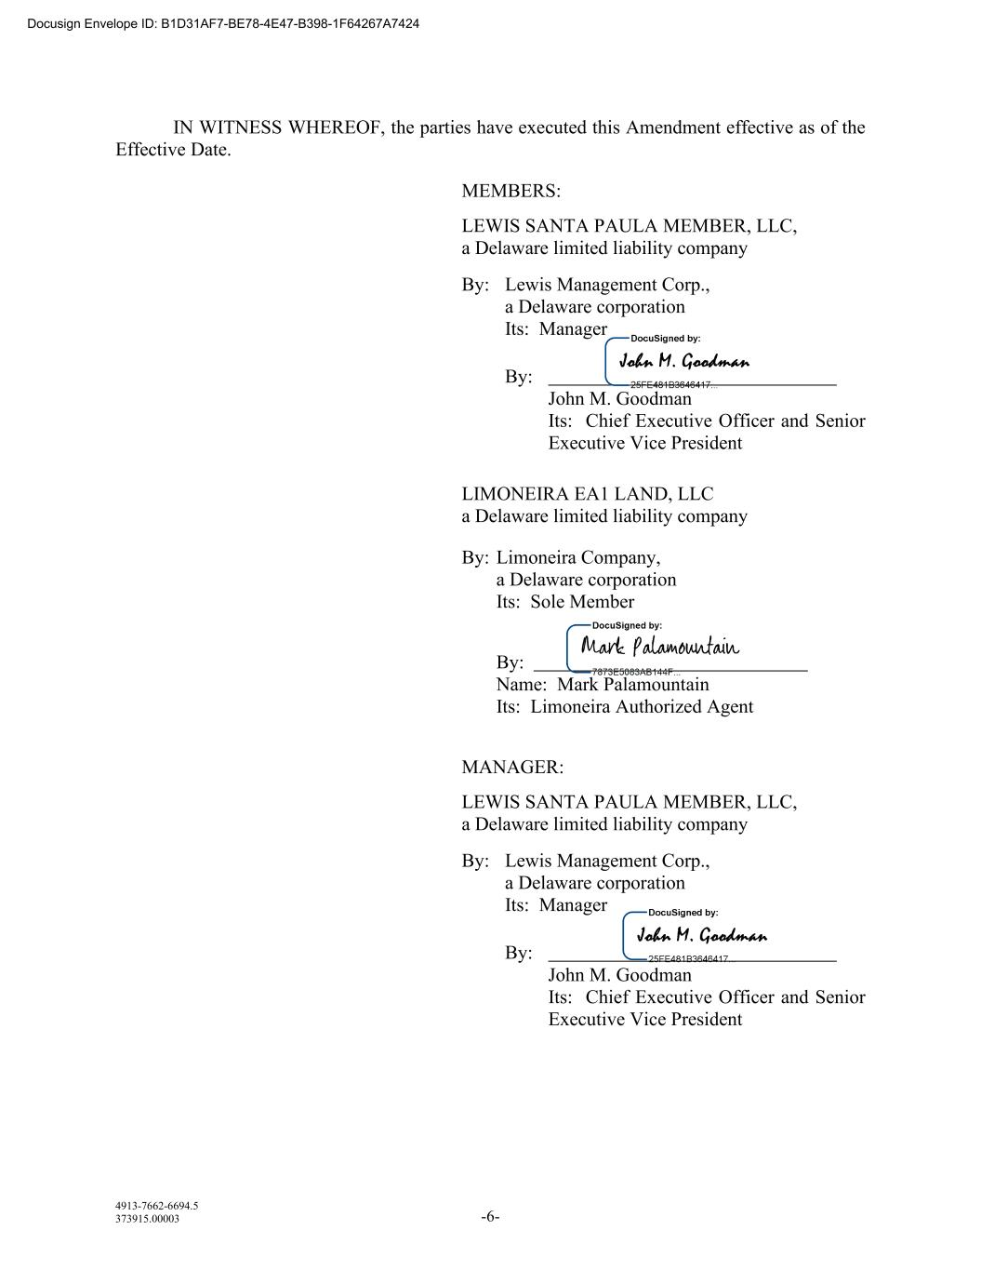
4913-7662-6694.5 373915.00003 -6- IN WITNESS WHEREOF, the parties have executed this Amendment effective as of the Effective Date. MEMBERS: LEWIS SANTA PAULA MEMBER, LLC, a Delaware limited liability company By: Lewis Management Corp., a Delaware corporation Its: Manager By: John M. Goodman Its: Chief Executive Officer and Senior Executive Vice President LIMONEIRA EA1 LAND, LLC a Delaware limited liability company By: Limoneira Company, a Delaware corporation Its: Sole Member By: Name: Mark Palamountain Its: Limoneira Authorized Agent MANAGER: LEWIS SANTA PAULA MEMBER, LLC, a Delaware limited liability company By: Lewis Management Corp., a Delaware corporation Its: Manager By: John M. Goodman Its: Chief Executive Officer and Senior Executive Vice President Docusign Envelope ID: B1D31AF7-BE78-4E47-B398-1F64267A7424

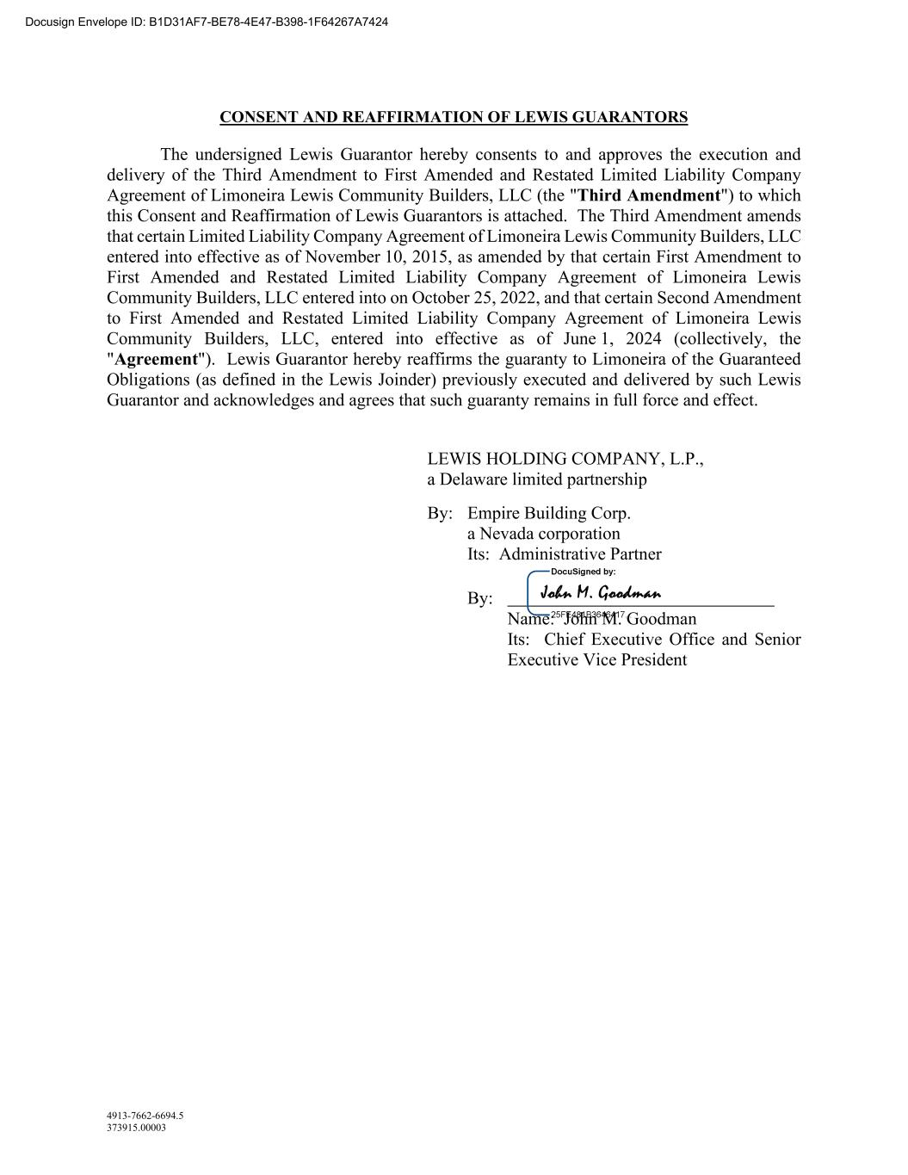
4913-7662-6694.5 373915.00003 CONSENT AND REAFFIRMATION OF LEWIS GUARANTORS The undersigned Lewis Guarantor hereby consents to and approves the execution and delivery of the Third Amendment to First Amended and Restated Limited Liability Company Agreement of Limoneira Lewis Community Builders, LLC (the "Third Amendment") to which this Consent and Reaffirmation of Lewis Guarantors is attached. The Third Amendment amends that certain Limited Liability Company Agreement of Limoneira Lewis Community Builders, LLC entered into effective as of November 10, 2015, as amended by that certain First Amendment to First Amended and Restated Limited Liability Company Agreement of Limoneira Lewis Community Builders, LLC entered into on October 25, 2022, and that certain Second Amendment to First Amended and Restated Limited Liability Company Agreement of Limoneira Lewis Community Builders, LLC, entered into effective as of June 1, 2024 (collectively, the "Agreement"). Lewis Guarantor hereby reaffirms the guaranty to Limoneira of the Guaranteed Obligations (as defined in the Lewis Joinder) previously executed and delivered by such Lewis Guarantor and acknowledges and agrees that such guaranty remains in full force and effect. LEWIS HOLDING COMPANY, L.P., a Delaware limited partnership By: Empire Building Corp. a Nevada corporation Its: Administrative Partner By: Name: John M. Goodman Its: Chief Executive Office and Senior Executive Vice President Docusign Envelope ID: B1D31AF7-BE78-4E47-B398-1F64267A7424

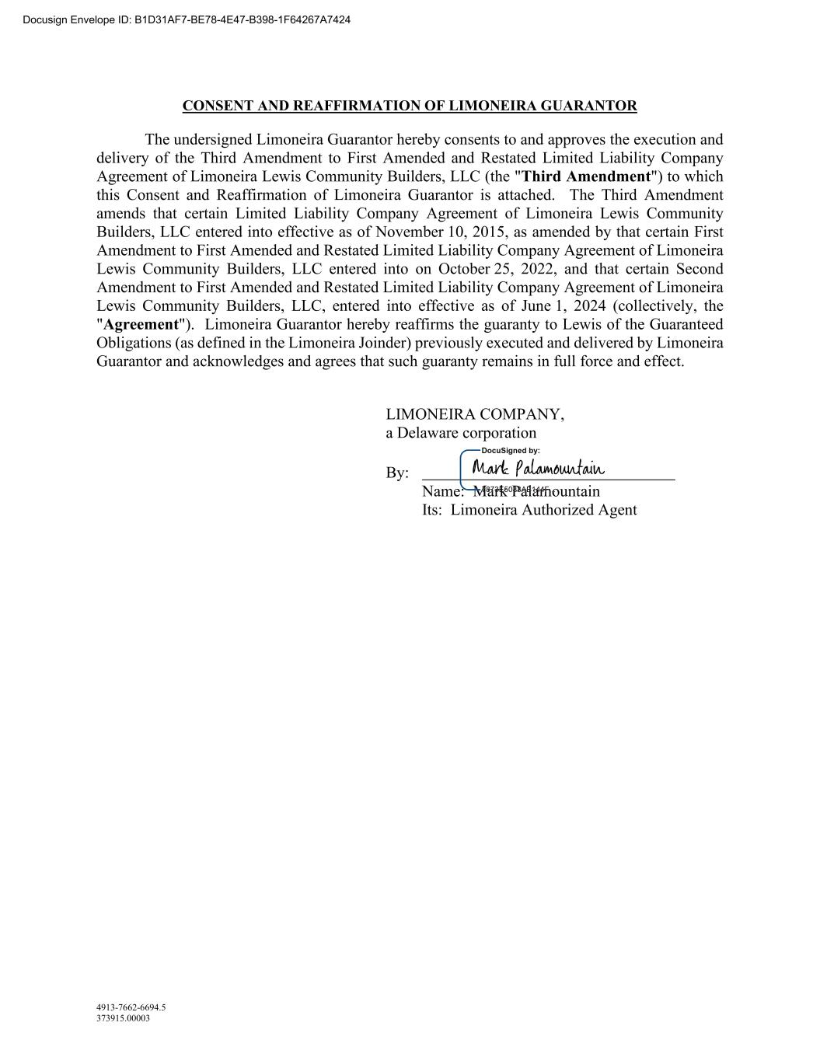
4913-7662-6694.5 373915.00003 CONSENT AND REAFFIRMATION OF LIMONEIRA GUARANTOR The undersigned Limoneira Guarantor hereby consents to and approves the execution and delivery of the Third Amendment to First Amended and Restated Limited Liability Company Agreement of Limoneira Lewis Community Builders, LLC (the "Third Amendment") to which this Consent and Reaffirmation of Limoneira Guarantor is attached. The Third Amendment amends that certain Limited Liability Company Agreement of Limoneira Lewis Community Builders, LLC entered into effective as of November 10, 2015, as amended by that certain First Amendment to First Amended and Restated Limited Liability Company Agreement of Limoneira Lewis Community Builders, LLC entered into on October 25, 2022, and that certain Second Amendment to First Amended and Restated Limited Liability Company Agreement of Limoneira Lewis Community Builders, LLC, entered into effective as of June 1, 2024 (collectively, the "Agreement"). Limoneira Guarantor hereby reaffirms the guaranty to Lewis of the Guaranteed Obligations (as defined in the Limoneira Joinder) previously executed and delivered by Limoneira Guarantor and acknowledges and agrees that such guaranty remains in full force and effect. LIMONEIRA COMPANY, a Delaware corporation By: Name: Mark Palamountain Its: Limoneira Authorized Agent Docusign Envelope ID: B1D31AF7-BE78-4E47-B398-1F64267A7424

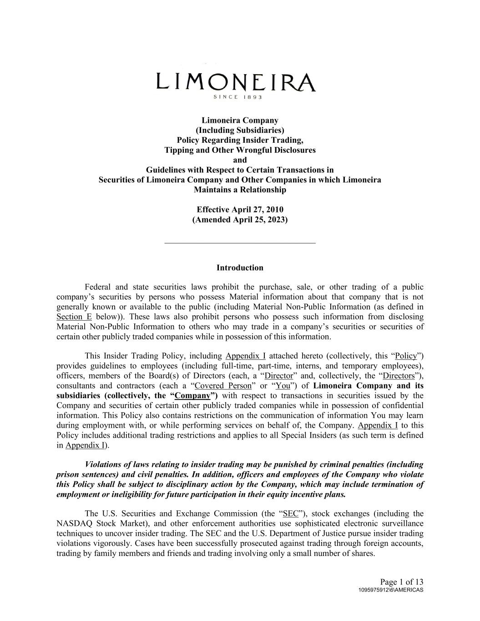
Page 1 of 13 1095975912\6\AMERICAS Limoneira Company (Including Subsidiaries) Policy Regarding Insider Trading, Tipping and Other Wrongful Disclosures and Guidelines with Respect to Certain Transactions in Securities of Limoneira Company and Other Companies in which Limoneira Maintains a Relationship Effective April 27, 2010 (Amended April 25, 2023) ___________________________________ Introduction Federal and state securities laws prohibit the purchase, sale, or other trading of a public company’s securities by persons who possess Material information about that company that is not generally known or available to the public (including Material Non-Public Information (as defined in Section E below)). These laws also prohibit persons who possess such information from disclosing Material Non-Public Information to others who may trade in a company’s securities or securities of certain other publicly traded companies while in possession of this information. This Insider Trading Policy, including Appendix I attached hereto (collectively, this “Policy”) provides guidelines to employees (including full-time, part-time, interns, and temporary employees), officers, members of the Board(s) of Directors (each, a “Director” and, collectively, the “Directors”), consultants and contractors (each a “Covered Person” or “You”) of Limoneira Company and its subsidiaries (collectively, the “Company”) with respect to transactions in securities issued by the Company and securities of certain other publicly traded companies while in possession of confidential information. This Policy also contains restrictions on the communication of information You may learn during employment with, or while performing services on behalf of, the Company. Appendix I to this Policy includes additional trading restrictions and applies to all Special Insiders (as such term is defined in Appendix I). Violations of laws relating to insider trading may be punished by criminal penalties (including prison sentences) and civil penalties. In addition, officers and employees of the Company who violate this Policy shall be subject to disciplinary action by the Company, which may include termination of employment or ineligibility for future participation in their equity incentive plans. The U.S. Securities and Exchange Commission (the “SEC”), stock exchanges (including the NASDAQ Stock Market), and other enforcement authorities use sophisticated electronic surveillance techniques to uncover insider trading. The SEC and the U.S. Department of Justice pursue insider trading violations vigorously. Cases have been successfully prosecuted against trading through foreign accounts, trading by family members and friends and trading involving only a small number of shares.

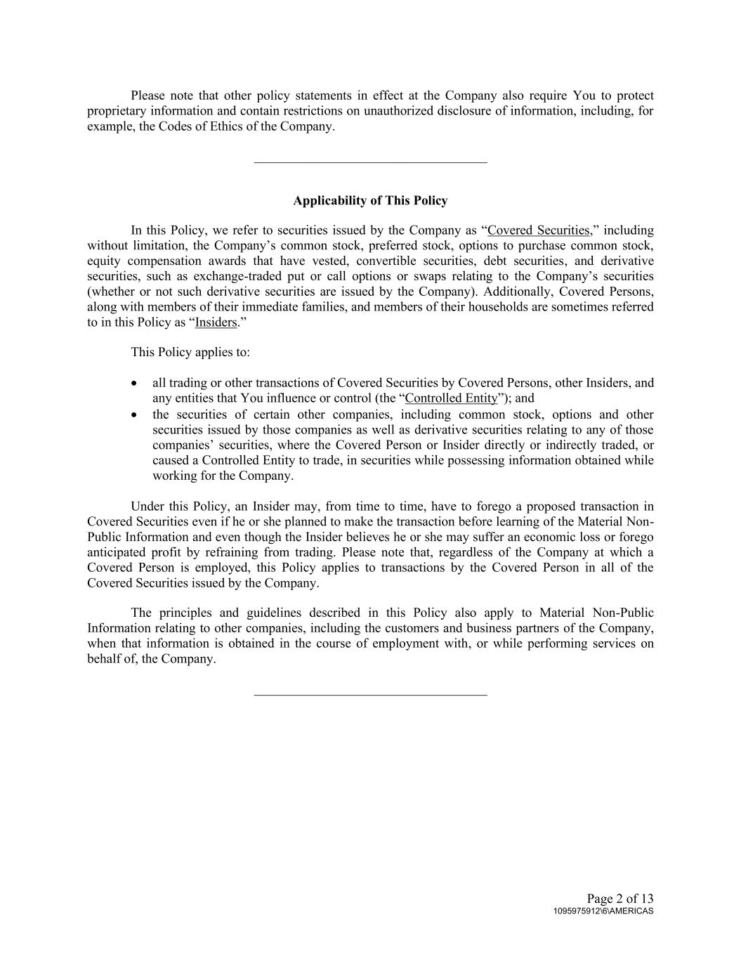
Page 2 of 13 1095975912\6\AMERICAS Please note that other policy statements in effect at the Company also require You to protect proprietary information and contain restrictions on unauthorized disclosure of information, including, for example, the Codes of Ethics of the Company. ___________________________________ Applicability of This Policy In this Policy, we refer to securities issued by the Company as “Covered Securities,” including without limitation, the Company’s common stock, preferred stock, options to purchase common stock, equity compensation awards that have vested, convertible securities, debt securities, and derivative securities, such as exchange-traded put or call options or swaps relating to the Company’s securities (whether or not such derivative securities are issued by the Company). Additionally, Covered Persons, along with members of their immediate families, and members of their households are sometimes referred to in this Policy as “Insiders.” This Policy applies to: • all trading or other transactions of Covered Securities by Covered Persons, other Insiders, and any entities that You influence or control (the “Controlled Entity”); and • the securities of certain other companies, including common stock, options and other securities issued by those companies as well as derivative securities relating to any of those companies’ securities, where the Covered Person or Insider directly or indirectly traded, or caused a Controlled Entity to trade, in securities while possessing information obtained while working for the Company. Under this Policy, an Insider may, from time to time, have to forego a proposed transaction in Covered Securities even if he or she planned to make the transaction before learning of the Material Non- Public Information and even though the Insider believes he or she may suffer an economic loss or forego anticipated profit by refraining from trading. Please note that, regardless of the Company at which a Covered Person is employed, this Policy applies to transactions by the Covered Person in all of the Covered Securities issued by the Company. The principles and guidelines described in this Policy also apply to Material Non-Public Information relating to other companies, including the customers and business partners of the Company, when that information is obtained in the course of employment with, or while performing services on behalf of, the Company. ___________________________________

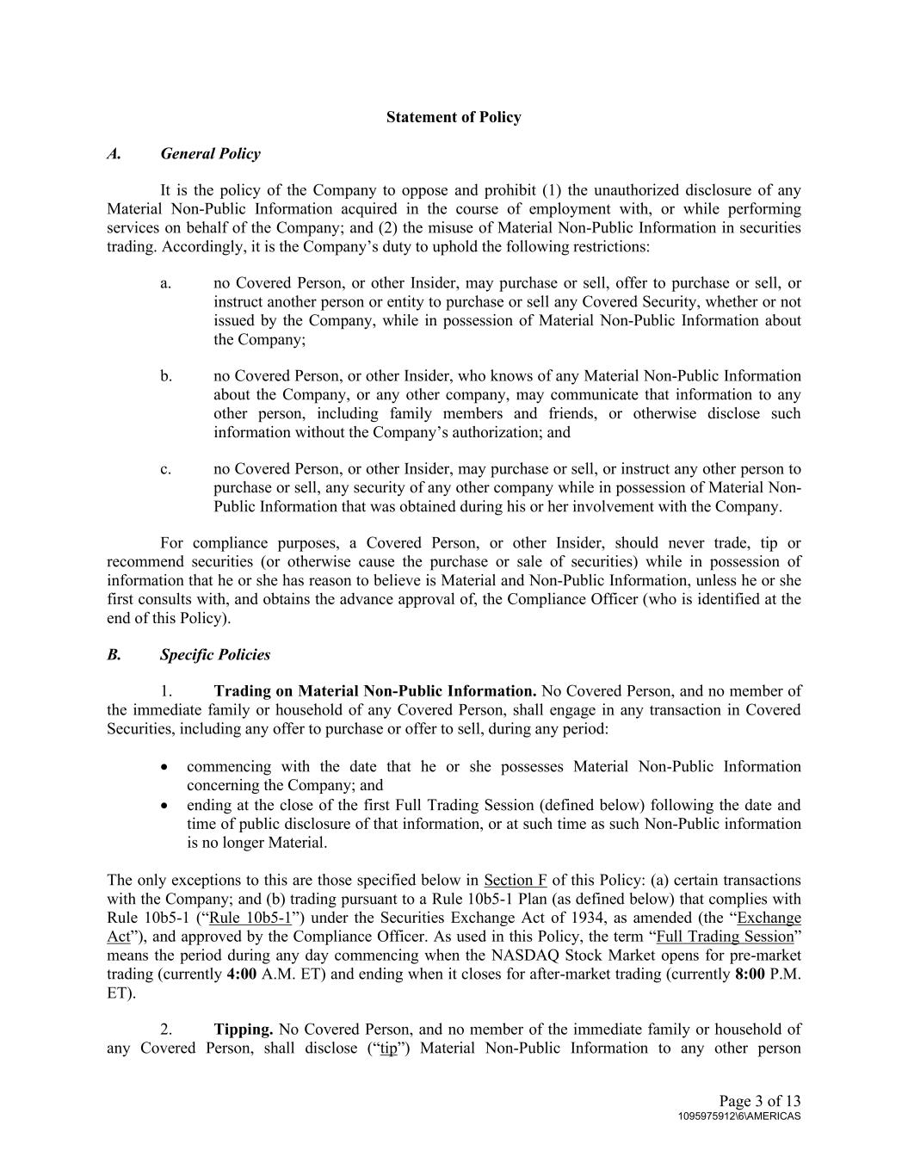
Page 3 of 13 1095975912\6\AMERICAS Statement of Policy A. General Policy It is the policy of the Company to oppose and prohibit (1) the unauthorized disclosure of any Material Non-Public Information acquired in the course of employment with, or while performing services on behalf of the Company; and (2) the misuse of Material Non-Public Information in securities trading. Accordingly, it is the Company’s duty to uphold the following restrictions: a. no Covered Person, or other Insider, may purchase or sell, offer to purchase or sell, or instruct another person or entity to purchase or sell any Covered Security, whether or not issued by the Company, while in possession of Material Non-Public Information about the Company; b. no Covered Person, or other Insider, who knows of any Material Non-Public Information about the Company, or any other company, may communicate that information to any other person, including family members and friends, or otherwise disclose such information without the Company’s authorization; and c. no Covered Person, or other Insider, may purchase or sell, or instruct any other person to purchase or sell, any security of any other company while in possession of Material Non- Public Information that was obtained during his or her involvement with the Company. For compliance purposes, a Covered Person, or other Insider, should never trade, tip or recommend securities (or otherwise cause the purchase or sale of securities) while in possession of information that he or she has reason to believe is Material and Non-Public Information, unless he or she first consults with, and obtains the advance approval of, the Compliance Officer (who is identified at the end of this Policy). B. Specific Policies 1. Trading on Material Non-Public Information. No Covered Person, and no member of the immediate family or household of any Covered Person, shall engage in any transaction in Covered Securities, including any offer to purchase or offer to sell, during any period: • commencing with the date that he or she possesses Material Non-Public Information concerning the Company; and • ending at the close of the first Full Trading Session (defined below) following the date and time of public disclosure of that information, or at such time as such Non-Public information is no longer Material. The only exceptions to this are those specified below in Section F of this Policy: (a) certain transactions with the Company; and (b) trading pursuant to a Rule 10b5-1 Plan (as defined below) that complies with Rule 10b5-1 (“Rule 10b5-1”) under the Securities Exchange Act of 1934, as amended (the “Exchange Act”), and approved by the Compliance Officer. As used in this Policy, the term “Full Trading Session” means the period during any day commencing when the NASDAQ Stock Market opens for pre-market trading (currently 4:00 A.M. ET) and ending when it closes for after-market trading (currently 8:00 P.M. ET). 2. Tipping. No Covered Person, and no member of the immediate family or household of any Covered Person, shall disclose (“tip”) Material Non-Public Information to any other person

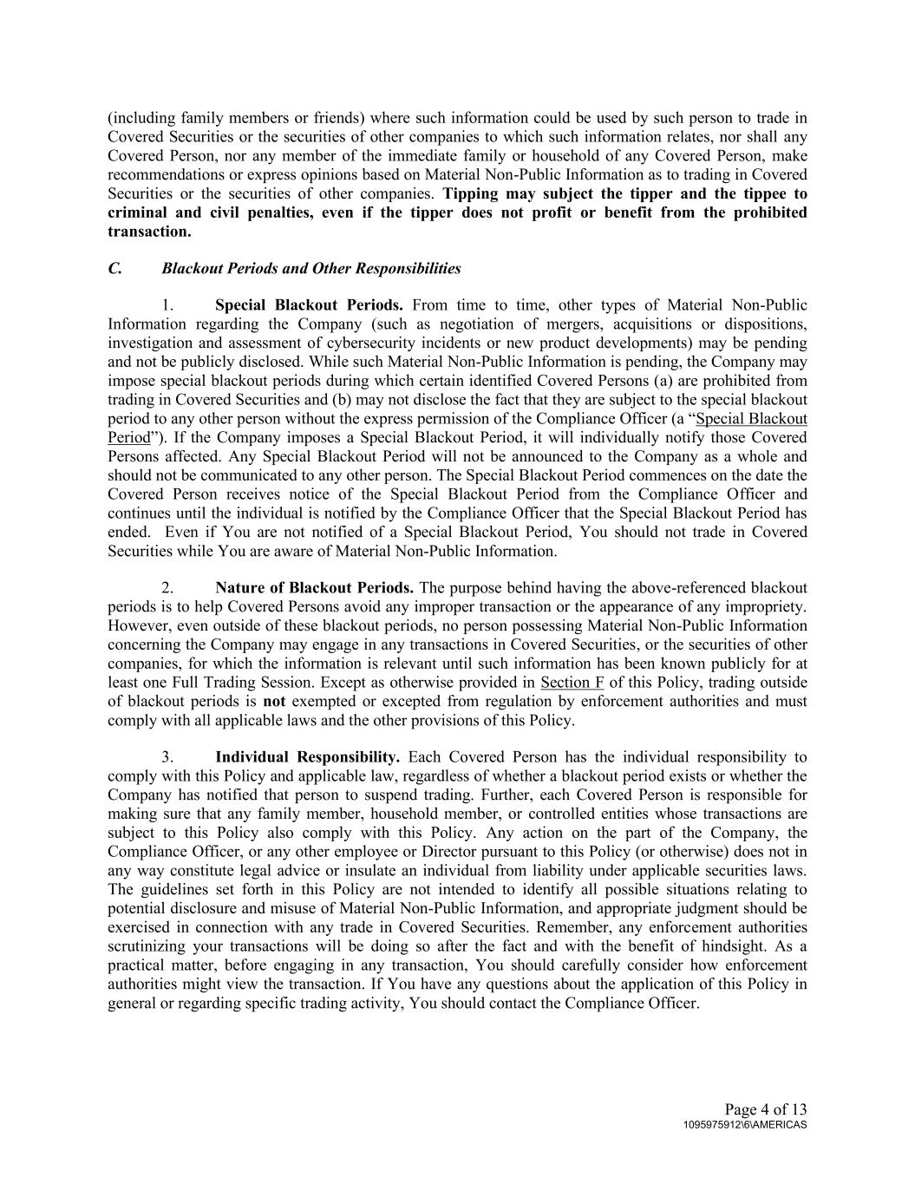
Page 4 of 13 1095975912\6\AMERICAS (including family members or friends) where such information could be used by such person to trade in Covered Securities or the securities of other companies to which such information relates, nor shall any Covered Person, nor any member of the immediate family or household of any Covered Person, make recommendations or express opinions based on Material Non-Public Information as to trading in Covered Securities or the securities of other companies. Tipping may subject the tipper and the tippee to criminal and civil penalties, even if the tipper does not profit or benefit from the prohibited transaction. C. Blackout Periods and Other Responsibilities 1. Special Blackout Periods. From time to time, other types of Material Non-Public Information regarding the Company (such as negotiation of mergers, acquisitions or dispositions, investigation and assessment of cybersecurity incidents or new product developments) may be pending and not be publicly disclosed. While such Material Non-Public Information is pending, the Company may impose special blackout periods during which certain identified Covered Persons (a) are prohibited from trading in Covered Securities and (b) may not disclose the fact that they are subject to the special blackout period to any other person without the express permission of the Compliance Officer (a “Special Blackout Period”). If the Company imposes a Special Blackout Period, it will individually notify those Covered Persons affected. Any Special Blackout Period will not be announced to the Company as a whole and should not be communicated to any other person. The Special Blackout Period commences on the date the Covered Person receives notice of the Special Blackout Period from the Compliance Officer and continues until the individual is notified by the Compliance Officer that the Special Blackout Period has ended. Even if You are not notified of a Special Blackout Period, You should not trade in Covered Securities while You are aware of Material Non-Public Information. 2. Nature of Blackout Periods. The purpose behind having the above-referenced blackout periods is to help Covered Persons avoid any improper transaction or the appearance of any impropriety. However, even outside of these blackout periods, no person possessing Material Non-Public Information concerning the Company may engage in any transactions in Covered Securities, or the securities of other companies, for which the information is relevant until such information has been known publicly for at least one Full Trading Session. Except as otherwise provided in Section F of this Policy, trading outside of blackout periods is not exempted or excepted from regulation by enforcement authorities and must comply with all applicable laws and the other provisions of this Policy. 3. Individual Responsibility. Each Covered Person has the individual responsibility to comply with this Policy and applicable law, regardless of whether a blackout period exists or whether the Company has notified that person to suspend trading. Further, each Covered Person is responsible for making sure that any family member, household member, or controlled entities whose transactions are subject to this Policy also comply with this Policy. Any action on the part of the Company, the Compliance Officer, or any other employee or Director pursuant to this Policy (or otherwise) does not in any way constitute legal advice or insulate an individual from liability under applicable securities laws. The guidelines set forth in this Policy are not intended to identify all possible situations relating to potential disclosure and misuse of Material Non-Public Information, and appropriate judgment should be exercised in connection with any trade in Covered Securities. Remember, any enforcement authorities scrutinizing your transactions will be doing so after the fact and with the benefit of hindsight. As a practical matter, before engaging in any transaction, You should carefully consider how enforcement authorities might view the transaction. If You have any questions about the application of this Policy in general or regarding specific trading activity, You should contact the Compliance Officer.

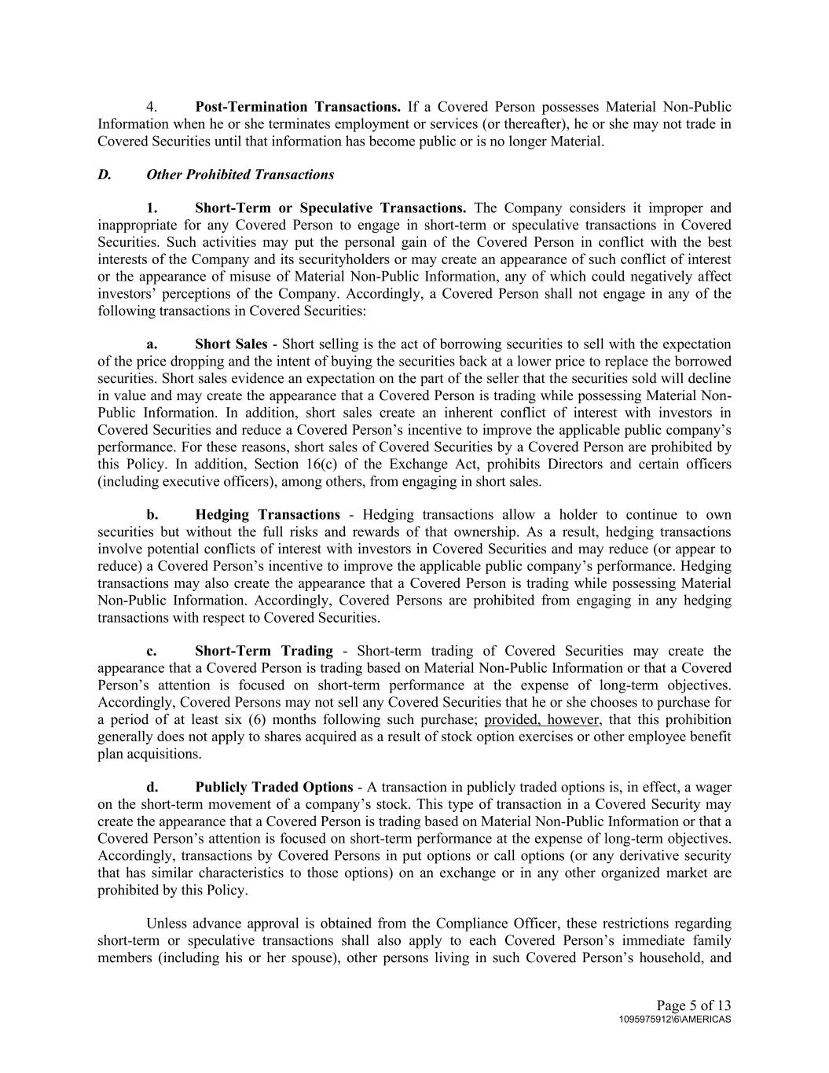
Page 5 of 13 1095975912\6\AMERICAS 4. Post-Termination Transactions. If a Covered Person possesses Material Non-Public Information when he or she terminates employment or services (or thereafter), he or she may not trade in Covered Securities until that information has become public or is no longer Material. D. Other Prohibited Transactions 1. Short-Term or Speculative Transactions. The Company considers it improper and inappropriate for any Covered Person to engage in short-term or speculative transactions in Covered Securities. Such activities may put the personal gain of the Covered Person in conflict with the best interests of the Company and its securityholders or may create an appearance of such conflict of interest or the appearance of misuse of Material Non-Public Information, any of which could negatively affect investors’ perceptions of the Company. Accordingly, a Covered Person shall not engage in any of the following transactions in Covered Securities: a. Short Sales - Short selling is the act of borrowing securities to sell with the expectation of the price dropping and the intent of buying the securities back at a lower price to replace the borrowed securities. Short sales evidence an expectation on the part of the seller that the securities sold will decline in value and may create the appearance that a Covered Person is trading while possessing Material Non- Public Information. In addition, short sales create an inherent conflict of interest with investors in Covered Securities and reduce a Covered Person’s incentive to improve the applicable public company’s performance. For these reasons, short sales of Covered Securities by a Covered Person are prohibited by this Policy. In addition, Section 16(c) of the Exchange Act, prohibits Directors and certain officers (including executive officers), among others, from engaging in short sales. b. Hedging Transactions - Hedging transactions allow a holder to continue to own securities but without the full risks and rewards of that ownership. As a result, hedging transactions involve potential conflicts of interest with investors in Covered Securities and may reduce (or appear to reduce) a Covered Person’s incentive to improve the applicable public company’s performance. Hedging transactions may also create the appearance that a Covered Person is trading while possessing Material Non-Public Information. Accordingly, Covered Persons are prohibited from engaging in any hedging transactions with respect to Covered Securities. c. Short-Term Trading - Short-term trading of Covered Securities may create the appearance that a Covered Person is trading based on Material Non-Public Information or that a Covered Person’s attention is focused on short-term performance at the expense of long-term objectives. Accordingly, Covered Persons may not sell any Covered Securities that he or she chooses to purchase for a period of at least six (6) months following such purchase; provided, however, that this prohibition generally does not apply to shares acquired as a result of stock option exercises or other employee benefit plan acquisitions. d. Publicly Traded Options - A transaction in publicly traded options is, in effect, a wager on the short-term movement of a company’s stock. This type of transaction in a Covered Security may create the appearance that a Covered Person is trading based on Material Non-Public Information or that a Covered Person’s attention is focused on short-term performance at the expense of long-term objectives. Accordingly, transactions by Covered Persons in put options or call options (or any derivative security that has similar characteristics to those options) on an exchange or in any other organized market are prohibited by this Policy. Unless advance approval is obtained from the Compliance Officer, these restrictions regarding short-term or speculative transactions shall also apply to each Covered Person’s immediate family members (including his or her spouse), other persons living in such Covered Person’s household, and

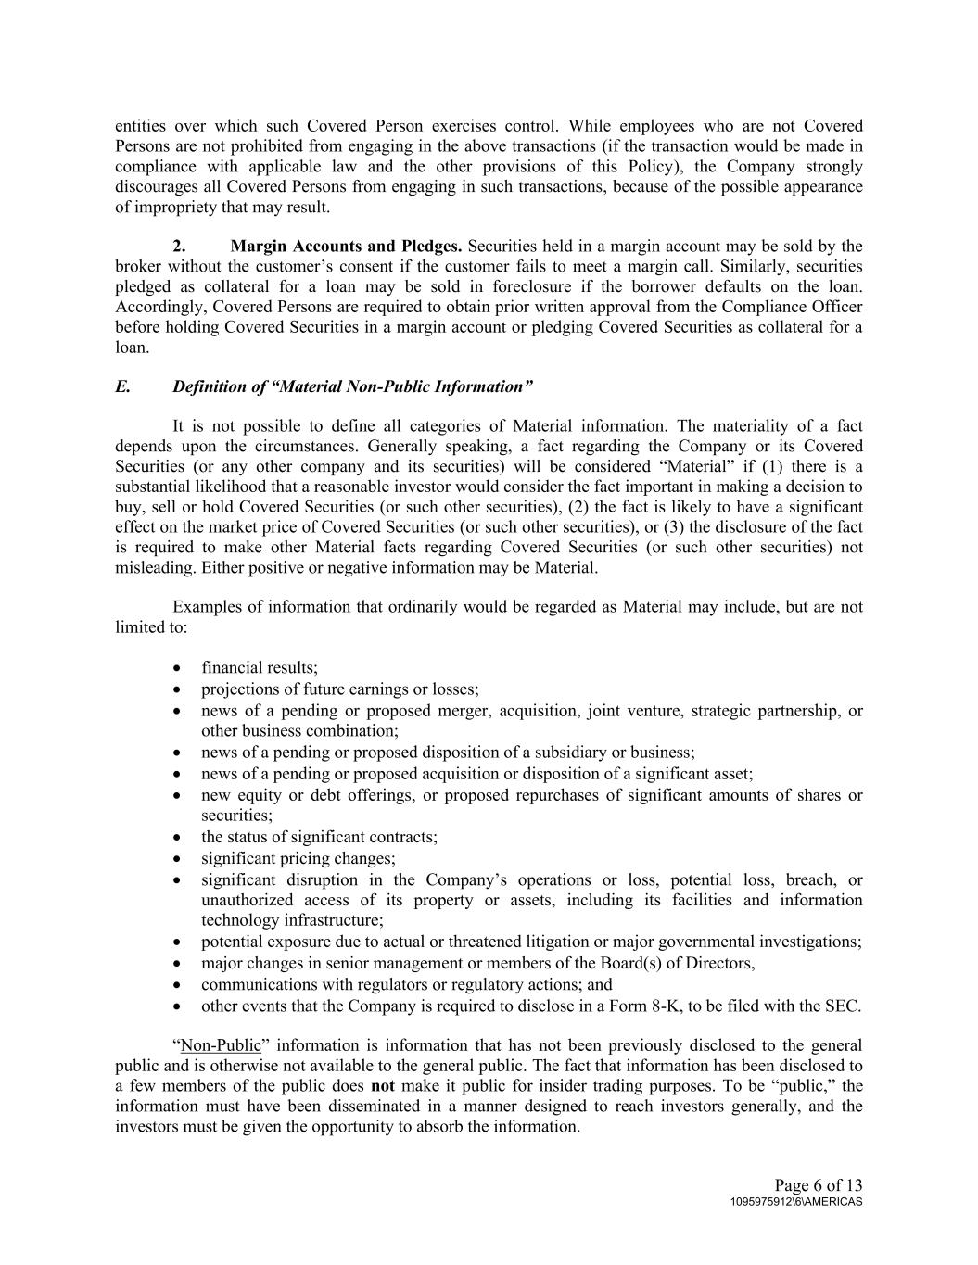
Page 6 of 13 1095975912\6\AMERICAS entities over which such Covered Person exercises control. While employees who are not Covered Persons are not prohibited from engaging in the above transactions (if the transaction would be made in compliance with applicable law and the other provisions of this Policy), the Company strongly discourages all Covered Persons from engaging in such transactions, because of the possible appearance of impropriety that may result. 2. Margin Accounts and Pledges. Securities held in a margin account may be sold by the broker without the customer’s consent if the customer fails to meet a margin call. Similarly, securities pledged as collateral for a loan may be sold in foreclosure if the borrower defaults on the loan. Accordingly, Covered Persons are required to obtain prior written approval from the Compliance Officer before holding Covered Securities in a margin account or pledging Covered Securities as collateral for a loan. E. Definition of “Material Non-Public Information” It is not possible to define all categories of Material information. The materiality of a fact depends upon the circumstances. Generally speaking, a fact regarding the Company or its Covered Securities (or any other company and its securities) will be considered “Material” if (1) there is a substantial likelihood that a reasonable investor would consider the fact important in making a decision to buy, sell or hold Covered Securities (or such other securities), (2) the fact is likely to have a significant effect on the market price of Covered Securities (or such other securities), or (3) the disclosure of the fact is required to make other Material facts regarding Covered Securities (or such other securities) not misleading. Either positive or negative information may be Material. Examples of information that ordinarily would be regarded as Material may include, but are not limited to: • financial results; • projections of future earnings or losses; • news of a pending or proposed merger, acquisition, joint venture, strategic partnership, or other business combination; • news of a pending or proposed disposition of a subsidiary or business; • news of a pending or proposed acquisition or disposition of a significant asset; • new equity or debt offerings, or proposed repurchases of significant amounts of shares or securities; • the status of significant contracts; • significant pricing changes; • significant disruption in the Company’s operations or loss, potential loss, breach, or unauthorized access of its property or assets, including its facilities and information technology infrastructure; • potential exposure due to actual or threatened litigation or major governmental investigations; • major changes in senior management or members of the Board(s) of Directors, • communications with regulators or regulatory actions; and • other events that the Company is required to disclose in a Form 8-K, to be filed with the SEC. “Non-Public” information is information that has not been previously disclosed to the general public and is otherwise not available to the general public. The fact that information has been disclosed to a few members of the public does not make it public for insider trading purposes. To be “public,” the information must have been disseminated in a manner designed to reach investors generally, and the investors must be given the opportunity to absorb the information.

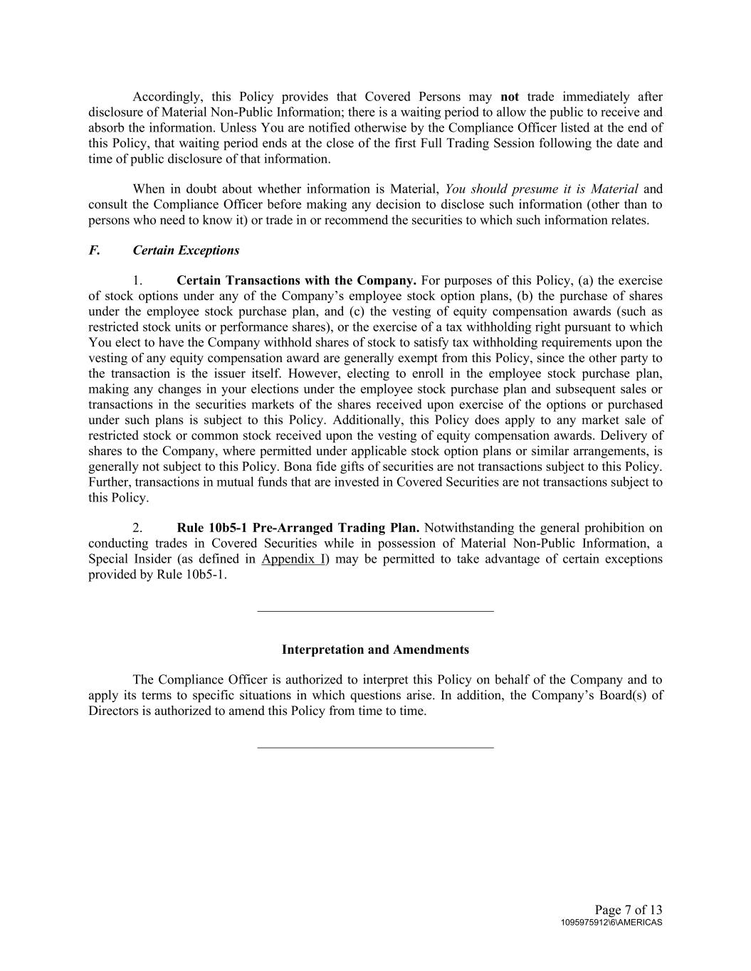
Page 7 of 13 1095975912\6\AMERICAS Accordingly, this Policy provides that Covered Persons may not trade immediately after disclosure of Material Non-Public Information; there is a waiting period to allow the public to receive and absorb the information. Unless You are notified otherwise by the Compliance Officer listed at the end of this Policy, that waiting period ends at the close of the first Full Trading Session following the date and time of public disclosure of that information. When in doubt about whether information is Material, You should presume it is Material and consult the Compliance Officer before making any decision to disclose such information (other than to persons who need to know it) or trade in or recommend the securities to which such information relates. F. Certain Exceptions 1. Certain Transactions with the Company. For purposes of this Policy, (a) the exercise of stock options under any of the Company’s employee stock option plans, (b) the purchase of shares under the employee stock purchase plan, and (c) the vesting of equity compensation awards (such as restricted stock units or performance shares), or the exercise of a tax withholding right pursuant to which You elect to have the Company withhold shares of stock to satisfy tax withholding requirements upon the vesting of any equity compensation award are generally exempt from this Policy, since the other party to the transaction is the issuer itself. However, electing to enroll in the employee stock purchase plan, making any changes in your elections under the employee stock purchase plan and subsequent sales or transactions in the securities markets of the shares received upon exercise of the options or purchased under such plans is subject to this Policy. Additionally, this Policy does apply to any market sale of restricted stock or common stock received upon the vesting of equity compensation awards. Delivery of shares to the Company, where permitted under applicable stock option plans or similar arrangements, is generally not subject to this Policy. Bona fide gifts of securities are not transactions subject to this Policy. Further, transactions in mutual funds that are invested in Covered Securities are not transactions subject to this Policy. 2. Rule 10b5-1 Pre-Arranged Trading Plan. Notwithstanding the general prohibition on conducting trades in Covered Securities while in possession of Material Non-Public Information, a Special Insider (as defined in Appendix I) may be permitted to take advantage of certain exceptions provided by Rule 10b5-1. ___________________________________ Interpretation and Amendments The Compliance Officer is authorized to interpret this Policy on behalf of the Company and to apply its terms to specific situations in which questions arise. In addition, the Company’s Board(s) of Directors is authorized to amend this Policy from time to time. ___________________________________

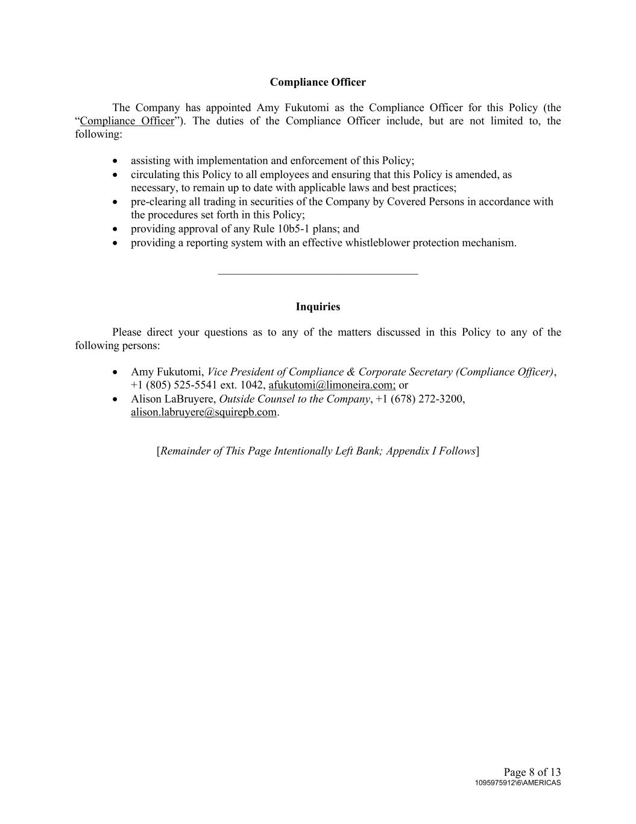
Page 8 of 13 1095975912\6\AMERICAS Compliance Officer The Company has appointed Amy Fukutomi as the Compliance Officer for this Policy (the “Compliance Officer”). The duties of the Compliance Officer include, but are not limited to, the following: • assisting with implementation and enforcement of this Policy; • circulating this Policy to all employees and ensuring that this Policy is amended, as necessary, to remain up to date with applicable laws and best practices; • pre-clearing all trading in securities of the Company by Covered Persons in accordance with the procedures set forth in this Policy; • providing approval of any Rule 10b5-1 plans; and • providing a reporting system with an effective whistleblower protection mechanism. ___________________________________ Inquiries Please direct your questions as to any of the matters discussed in this Policy to any of the following persons: • Amy Fukutomi, Vice President of Compliance & Corporate Secretary (Compliance Officer), +1 (805) 525-5541 ext. 1042, afukutomi@limoneira.com; or • Alison LaBruyere, Outside Counsel to the Company, +1 (678) 272-3200, alison.labruyere@squirepb.com. [Remainder of This Page Intentionally Left Bank; Appendix I Follows]

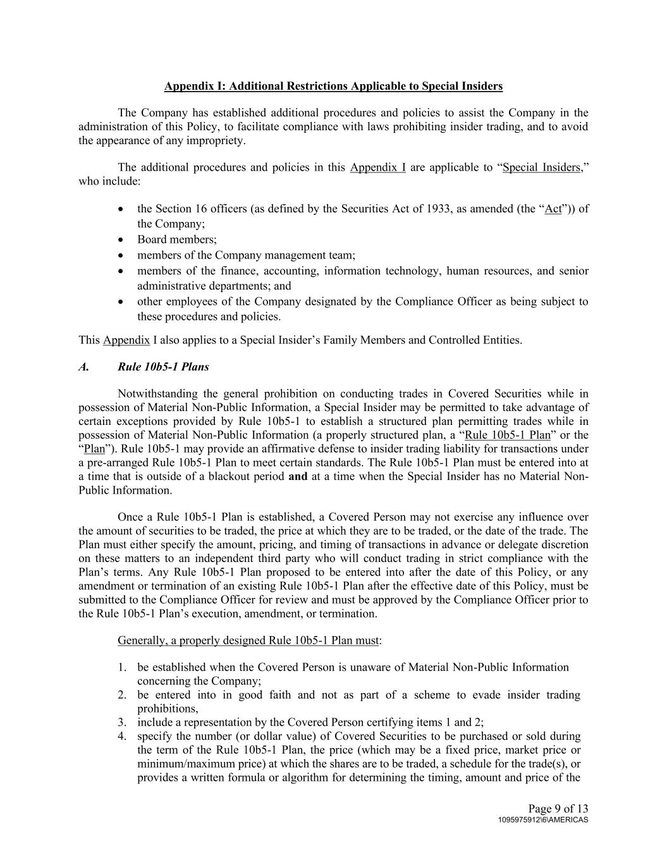
Page 9 of 13 1095975912\6\AMERICAS Appendix I: Additional Restrictions Applicable to Special Insiders The Company has established additional procedures and policies to assist the Company in the administration of this Policy, to facilitate compliance with laws prohibiting insider trading, and to avoid the appearance of any impropriety. The additional procedures and policies in this Appendix I are applicable to “Special Insiders,” who include: • the Section 16 officers (as defined by the Securities Act of 1933, as amended (the “Act”)) of the Company; • Board members; • members of the Company management team; • members of the finance, accounting, information technology, human resources, and senior administrative departments; and • other employees of the Company designated by the Compliance Officer as being subject to these procedures and policies. This Appendix I also applies to a Special Insider’s Family Members and Controlled Entities. A. Rule 10b5-1 Plans Notwithstanding the general prohibition on conducting trades in Covered Securities while in possession of Material Non-Public Information, a Special Insider may be permitted to take advantage of certain exceptions provided by Rule 10b5-1 to establish a structured plan permitting trades while in possession of Material Non-Public Information (a properly structured plan, a “Rule 10b5-1 Plan” or the “Plan”). Rule 10b5-1 may provide an affirmative defense to insider trading liability for transactions under a pre-arranged Rule 10b5-1 Plan to meet certain standards. The Rule 10b5-1 Plan must be entered into at a time that is outside of a blackout period and at a time when the Special Insider has no Material Non- Public Information. Once a Rule 10b5-1 Plan is established, a Covered Person may not exercise any influence over the amount of securities to be traded, the price at which they are to be traded, or the date of the trade. The Plan must either specify the amount, pricing, and timing of transactions in advance or delegate discretion on these matters to an independent third party who will conduct trading in strict compliance with the Plan’s terms. Any Rule 10b5-1 Plan proposed to be entered into after the date of this Policy, or any amendment or termination of an existing Rule 10b5-1 Plan after the effective date of this Policy, must be submitted to the Compliance Officer for review and must be approved by the Compliance Officer prior to the Rule 10b5-1 Plan’s execution, amendment, or termination. Generally, a properly designed Rule 10b5-1 Plan must: 1. be established when the Covered Person is unaware of Material Non-Public Information concerning the Company; 2. be entered into in good faith and not as part of a scheme to evade insider trading prohibitions, 3. include a representation by the Covered Person certifying items 1 and 2; 4. specify the number (or dollar value) of Covered Securities to be purchased or sold during the term of the Rule 10b5-1 Plan, the price (which may be a fixed price, market price or minimum/maximum price) at which the shares are to be traded, a schedule for the trade(s), or provides a written formula or algorithm for determining the timing, amount and price of the

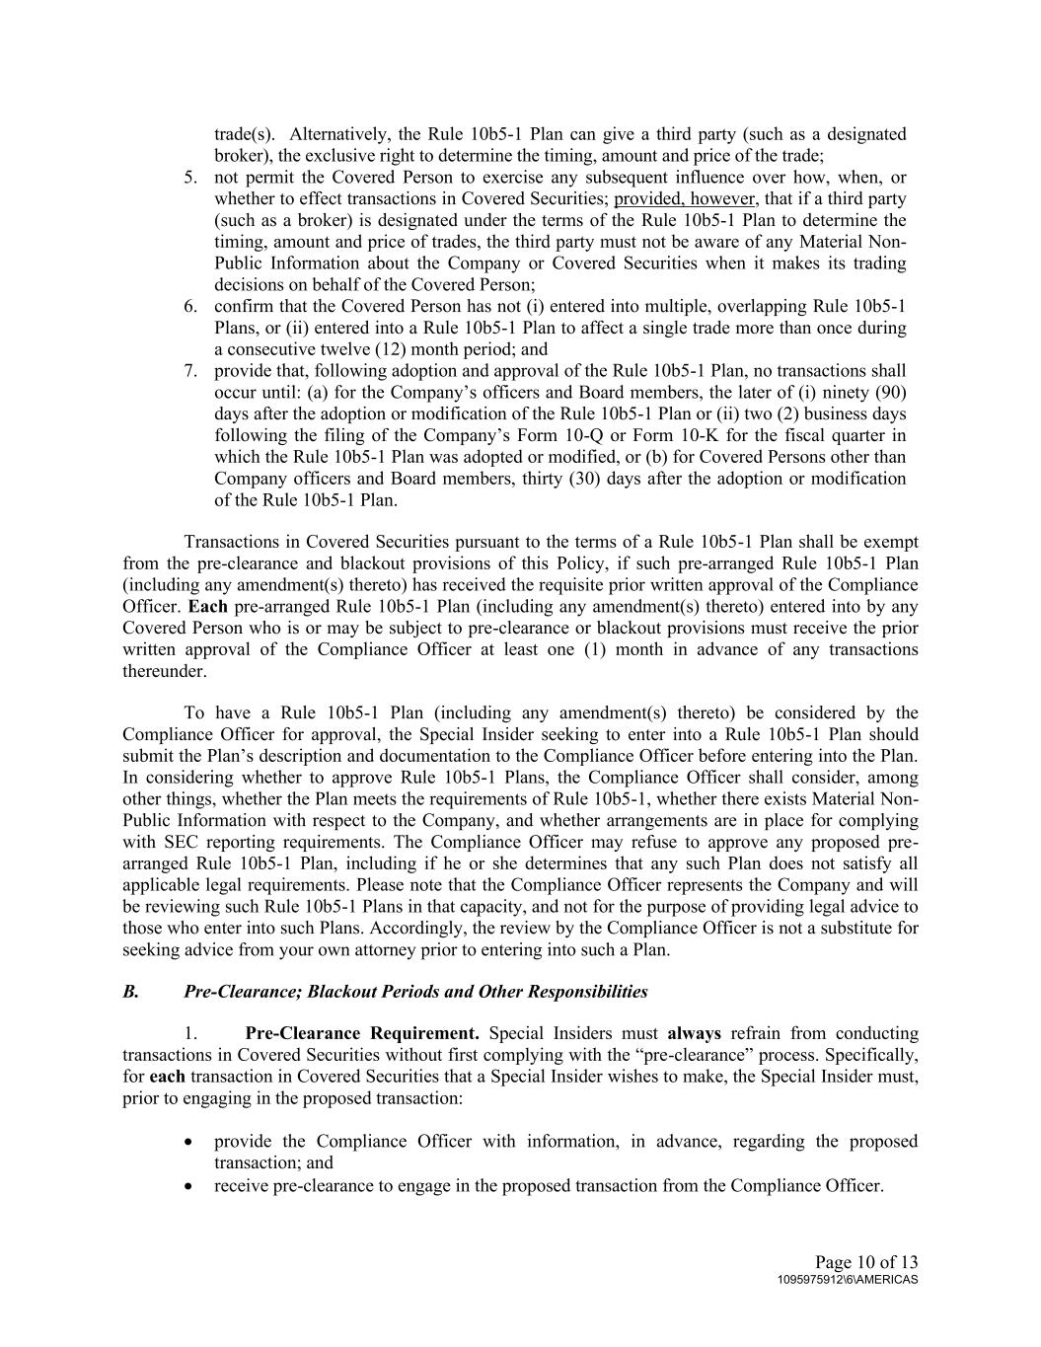
Page 10 of 13 1095975912\6\AMERICAS trade(s). Alternatively, the Rule 10b5-1 Plan can give a third party (such as a designated broker), the exclusive right to determine the timing, amount and price of the trade; 5. not permit the Covered Person to exercise any subsequent influence over how, when, or whether to effect transactions in Covered Securities; provided, however, that if a third party (such as a broker) is designated under the terms of the Rule 10b5-1 Plan to determine the timing, amount and price of trades, the third party must not be aware of any Material Non- Public Information about the Company or Covered Securities when it makes its trading decisions on behalf of the Covered Person; 6. confirm that the Covered Person has not (i) entered into multiple, overlapping Rule 10b5-1 Plans, or (ii) entered into a Rule 10b5-1 Plan to affect a single trade more than once during a consecutive twelve (12) month period; and 7. provide that, following adoption and approval of the Rule 10b5-1 Plan, no transactions shall occur until: (a) for the Company’s officers and Board members, the later of (i) ninety (90) days after the adoption or modification of the Rule 10b5-1 Plan or (ii) two (2) business days following the filing of the Company’s Form 10-Q or Form 10-K for the fiscal quarter in which the Rule 10b5-1 Plan was adopted or modified, or (b) for Covered Persons other than Company officers and Board members, thirty (30) days after the adoption or modification of the Rule 10b5-1 Plan. Transactions in Covered Securities pursuant to the terms of a Rule 10b5-1 Plan shall be exempt from the pre-clearance and blackout provisions of this Policy, if such pre-arranged Rule 10b5-1 Plan (including any amendment(s) thereto) has received the requisite prior written approval of the Compliance Officer. Each pre-arranged Rule 10b5-1 Plan (including any amendment(s) thereto) entered into by any Covered Person who is or may be subject to pre-clearance or blackout provisions must receive the prior written approval of the Compliance Officer at least one (1) month in advance of any transactions thereunder. To have a Rule 10b5-1 Plan (including any amendment(s) thereto) be considered by the Compliance Officer for approval, the Special Insider seeking to enter into a Rule 10b5-1 Plan should submit the Plan’s description and documentation to the Compliance Officer before entering into the Plan. In considering whether to approve Rule 10b5-1 Plans, the Compliance Officer shall consider, among other things, whether the Plan meets the requirements of Rule 10b5-1, whether there exists Material Non- Public Information with respect to the Company, and whether arrangements are in place for complying with SEC reporting requirements. The Compliance Officer may refuse to approve any proposed pre- arranged Rule 10b5-1 Plan, including if he or she determines that any such Plan does not satisfy all applicable legal requirements. Please note that the Compliance Officer represents the Company and will be reviewing such Rule 10b5-1 Plans in that capacity, and not for the purpose of providing legal advice to those who enter into such Plans. Accordingly, the review by the Compliance Officer is not a substitute for seeking advice from your own attorney prior to entering into such a Plan. B. Pre-Clearance; Blackout Periods and Other Responsibilities 1. Pre-Clearance Requirement. Special Insiders must always refrain from conducting transactions in Covered Securities without first complying with the “pre-clearance” process. Specifically, for each transaction in Covered Securities that a Special Insider wishes to make, the Special Insider must, prior to engaging in the proposed transaction: • provide the Compliance Officer with information, in advance, regarding the proposed transaction; and • receive pre-clearance to engage in the proposed transaction from the Compliance Officer.

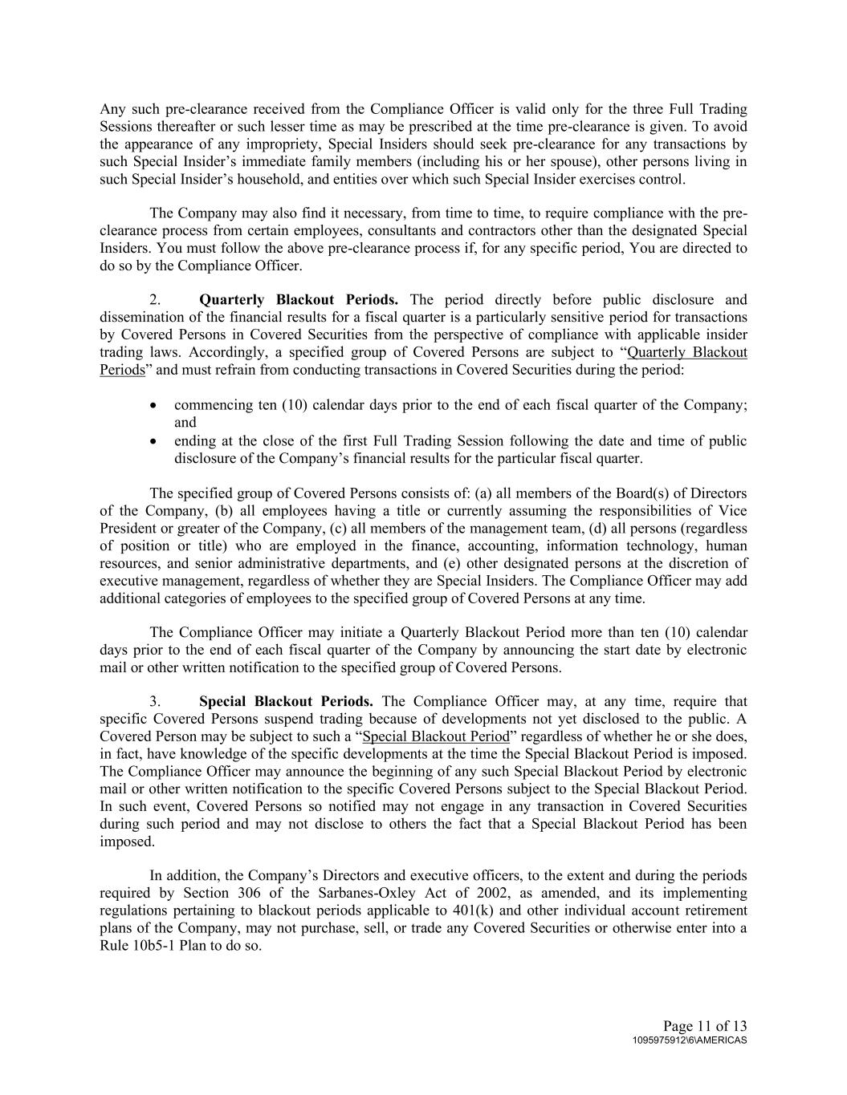
Page 11 of 13 1095975912\6\AMERICAS Any such pre-clearance received from the Compliance Officer is valid only for the three Full Trading Sessions thereafter or such lesser time as may be prescribed at the time pre-clearance is given. To avoid the appearance of any impropriety, Special Insiders should seek pre-clearance for any transactions by such Special Insider’s immediate family members (including his or her spouse), other persons living in such Special Insider’s household, and entities over which such Special Insider exercises control. The Company may also find it necessary, from time to time, to require compliance with the pre- clearance process from certain employees, consultants and contractors other than the designated Special Insiders. You must follow the above pre-clearance process if, for any specific period, You are directed to do so by the Compliance Officer. 2. Quarterly Blackout Periods. The period directly before public disclosure and dissemination of the financial results for a fiscal quarter is a particularly sensitive period for transactions by Covered Persons in Covered Securities from the perspective of compliance with applicable insider trading laws. Accordingly, a specified group of Covered Persons are subject to “Quarterly Blackout Periods” and must refrain from conducting transactions in Covered Securities during the period: • commencing ten (10) calendar days prior to the end of each fiscal quarter of the Company; and • ending at the close of the first Full Trading Session following the date and time of public disclosure of the Company’s financial results for the particular fiscal quarter. The specified group of Covered Persons consists of: (a) all members of the Board(s) of Directors of the Company, (b) all employees having a title or currently assuming the responsibilities of Vice President or greater of the Company, (c) all members of the management team, (d) all persons (regardless of position or title) who are employed in the finance, accounting, information technology, human resources, and senior administrative departments, and (e) other designated persons at the discretion of executive management, regardless of whether they are Special Insiders. The Compliance Officer may add additional categories of employees to the specified group of Covered Persons at any time. The Compliance Officer may initiate a Quarterly Blackout Period more than ten (10) calendar days prior to the end of each fiscal quarter of the Company by announcing the start date by electronic mail or other written notification to the specified group of Covered Persons. 3. Special Blackout Periods. The Compliance Officer may, at any time, require that specific Covered Persons suspend trading because of developments not yet disclosed to the public. A Covered Person may be subject to such a “Special Blackout Period” regardless of whether he or she does, in fact, have knowledge of the specific developments at the time the Special Blackout Period is imposed. The Compliance Officer may announce the beginning of any such Special Blackout Period by electronic mail or other written notification to the specific Covered Persons subject to the Special Blackout Period. In such event, Covered Persons so notified may not engage in any transaction in Covered Securities during such period and may not disclose to others the fact that a Special Blackout Period has been imposed. In addition, the Company’s Directors and executive officers, to the extent and during the periods required by Section 306 of the Sarbanes-Oxley Act of 2002, as amended, and its implementing regulations pertaining to blackout periods applicable to 401(k) and other individual account retirement plans of the Company, may not purchase, sell, or trade any Covered Securities or otherwise enter into a Rule 10b5-1 Plan to do so.

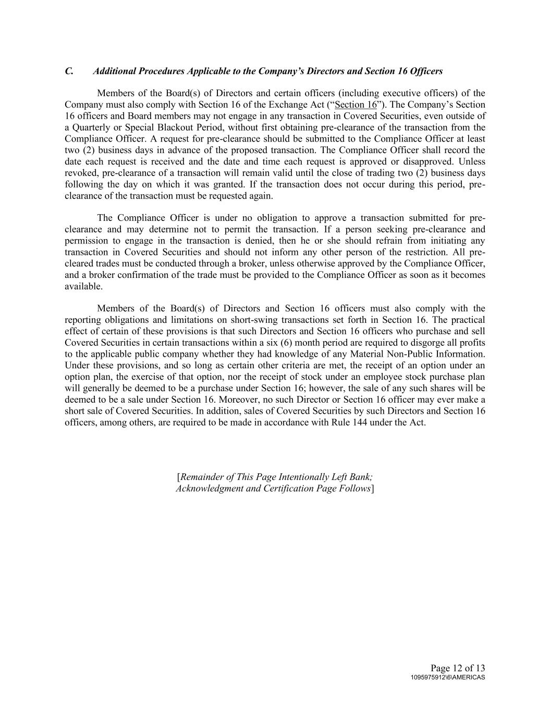
Page 12 of 13 1095975912\6\AMERICAS C. Additional Procedures Applicable to the Company’s Directors and Section 16 Officers Members of the Board(s) of Directors and certain officers (including executive officers) of the Company must also comply with Section 16 of the Exchange Act (“Section 16”). The Company’s Section 16 officers and Board members may not engage in any transaction in Covered Securities, even outside of a Quarterly or Special Blackout Period, without first obtaining pre-clearance of the transaction from the Compliance Officer. A request for pre-clearance should be submitted to the Compliance Officer at least two (2) business days in advance of the proposed transaction. The Compliance Officer shall record the date each request is received and the date and time each request is approved or disapproved. Unless revoked, pre-clearance of a transaction will remain valid until the close of trading two (2) business days following the day on which it was granted. If the transaction does not occur during this period, pre- clearance of the transaction must be requested again. The Compliance Officer is under no obligation to approve a transaction submitted for pre- clearance and may determine not to permit the transaction. If a person seeking pre-clearance and permission to engage in the transaction is denied, then he or she should refrain from initiating any transaction in Covered Securities and should not inform any other person of the restriction. All pre- cleared trades must be conducted through a broker, unless otherwise approved by the Compliance Officer, and a broker confirmation of the trade must be provided to the Compliance Officer as soon as it becomes available. Members of the Board(s) of Directors and Section 16 officers must also comply with the reporting obligations and limitations on short-swing transactions set forth in Section 16. The practical effect of certain of these provisions is that such Directors and Section 16 officers who purchase and sell Covered Securities in certain transactions within a six (6) month period are required to disgorge all profits to the applicable public company whether they had knowledge of any Material Non-Public Information. Under these provisions, and so long as certain other criteria are met, the receipt of an option under an option plan, the exercise of that option, nor the receipt of stock under an employee stock purchase plan will generally be deemed to be a purchase under Section 16; however, the sale of any such shares will be deemed to be a sale under Section 16. Moreover, no such Director or Section 16 officer may ever make a short sale of Covered Securities. In addition, sales of Covered Securities by such Directors and Section 16 officers, among others, are required to be made in accordance with Rule 144 under the Act. [Remainder of This Page Intentionally Left Bank; Acknowledgment and Certification Page Follows]

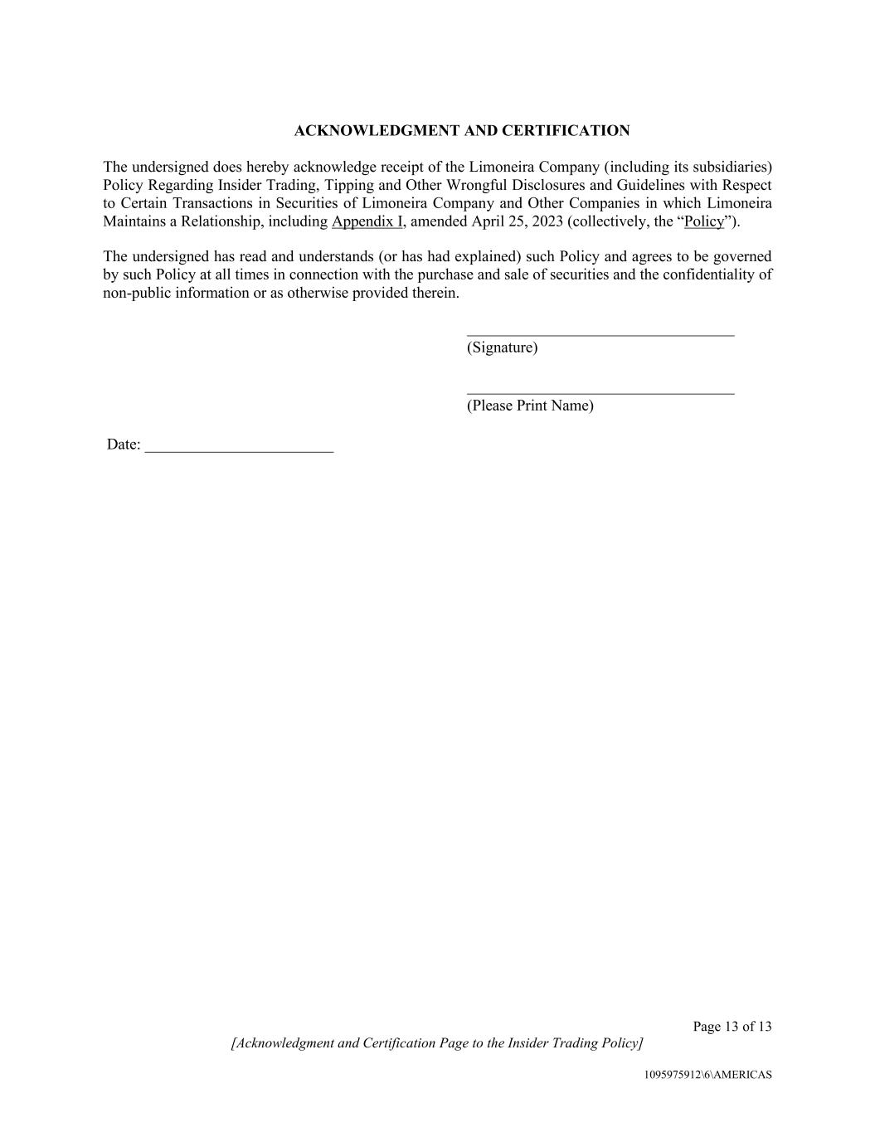
Page 13 of 13 [Acknowledgment and Certification Page to the Insider Trading Policy] 1095975912\6\AMERICAS ACKNOWLEDGMENT AND CERTIFICATION The undersigned does hereby acknowledge receipt of the Limoneira Company (including its subsidiaries) Policy Regarding Insider Trading, Tipping and Other Wrongful Disclosures and Guidelines with Respect to Certain Transactions in Securities of Limoneira Company and Other Companies in which Limoneira Maintains a Relationship, including Appendix I, amended April 25, 2023 (collectively, the “Policy”). The undersigned has read and understands (or has had explained) such Policy and agrees to be governed by such Policy at all times in connection with the purchase and sale of securities and the confidentiality of non-public information or as otherwise provided therein. __________________________________ (Signature) __________________________________ (Please Print Name) Date: ________________________

Exhibit 21.1

List of Subsidiaries of Limoneira Company |  |  |  |  |  | State of Incorporation/Organization
Associated Citrus Packers, Inc. |  |  |  |  |  | Arizona
Limoneira EA1 Land LLC |  |  |  |  |  | Delaware
Limoneira EA2 LLC |  |  |  |  |  | Delaware
Limoneira International Division, LLC |  |  |  |  |  | California
Limoneira Lewis Community Builders, LLC |  |  |  |  |  | Delaware
LLCB II, LLC |  |  |  |  |  | Delaware
Windfall Investors, LLC |  |  |  |  |  | California
Limoneira Chile SpA |  |  |  |  |  | Chile
Fruticola Pan de Azucar S.A. |  |  |  |  |  | Chile
Agricola San Pablo SpA |  |  |  |  |  | Chile
Limoneira Argentina S.A.U. |  |  |  |  |  | Argentina
Trapani Fresh Consorcio de Cooperacion |  |  |  |  |  | Argentina
Limoneira Holland B.V. |  |  |  |  |  | Holland

Exhibit 23.1

Consent of Independent Registered Public Accounting Firm

We consent to the incorporation by reference in Registration Statement Nos. 333-171934 and 333-263794 on Form S-8 of our reports dated December 23, 2024, relating to the financial statements of Limoneira Company and the effectiveness of Limoneira Company’s internal control over financial reporting appearing in this Annual Report on Form 10-K for the year ended October 31, 2024.

/s/ Deloitte & Touche LLP

Los Angeles, California
December 23, 2024

Exhibit 23.2

Consent of Independent Registered Public Accounting Firm

We consent to the incorporation by reference in the following Registration Statements:

(1)Registration Statement (Form S-8 No. 333-171934) pertaining to the Limoneira Company 2010 Omnibus Incentive Plan, and
(2)Registration Statement (Form S-8 No. 333-263794) pertaining to the Limoneira Company 2022 Omnibus Incentive Plan;

of our report dated December 18, 2024, with respect to the financial statements of Limoneira Lewis Community Builders, LLC included in this Annual Report (Form 10-K) of Limoneira Company for the year ended October 31, 2024.

/s/ Ernst & Young LLP

Irvine, California
December 23, 2024

Exhibit 31.1

Certification of the Principal Executive Officer
Pursuant to Exchange Act Rule 13a-14(a) and 15d-14(a)

I, Harold S. Edwards, certify that:

1. I have reviewed this Annual Report on Form 10-K of Limoneira Company (the “Registrant”);

2. Based on my knowledge, this report does not contain any untrue statement of a material fact or omit to state a material fact necessary to make the statements made, in light of the circumstances under which such statements were made, not misleading with respect to the period covered by this report;

3. Based on my knowledge, the financial statements, and other financial information included in this report, fairly present in all material respects the financial condition, results of operations and cash flows of the Registrant as of, and for, the periods presented in this report;

4. The Registrant’s other certifying officer and I are responsible for establishing and maintaining disclosure controls and procedures (as defined in Exchange Act Rules 13a-15(e) and 15d-15(e)) and internal control over financial reporting (as defined in Exchange Act Rules 13a-15(f) and 15d- 15(f)) for the Registrant and have:

(a) designed such disclosure controls and procedures, or caused such disclosure controls and procedures to be designed under our supervision, to ensure that material information relating to the Registrant, including its consolidated subsidiaries, is made known to us by others within those entities, particularly during the period in which this report is being prepared;

(b) designed such internal control over financial reporting, or caused such internal control over financial reporting to be designed under our supervision, to provide reasonable assurance regarding the reliability of financial reporting and the preparation of financial statements for external purposes in accordance with generally accepted accounting principles;

(c) evaluated the effectiveness of the Registrant’s disclosure controls and procedures and presented in this report our conclusions about the effectiveness of the disclosure controls and procedures, as of the end of the period covered by this report based on such evaluation; and

(d) disclosed in this report any change in the Registrant’s internal control over financial reporting that occurred during the Registrant’s fourth quarter that has materially affected, or is reasonably likely to materially affect, the Registrant’s internal control over financial reporting; and

5. The Registrant’s other certifying officer and I have disclosed, based on our most recent evaluation of internal control over financial reporting, to the Registrant’s auditors and the audit committee of the Registrant’s board of directors (or persons performing the equivalent functions):

(a) all significant deficiencies and material weaknesses in the design or operation of internal control over financial reporting which are reasonably likely to adversely affect the Registrant’s ability to record, process, summarize and report financial information; and

(b) any fraud, whether or not material, that involves management or other employees who have a significant role in the Registrant’s internal control over financial reporting.

December 23, 2024 |  |  |  |  |  | /s/ Harold S. Edwards
 |  |  |  |  |  | Harold S. Edwards,
 |  |  |  |  |  | Director, President and Chief Executive Officer
 |  |  |  |  |  | (Principal Executive Officer)

Exhibit 31.2

Certification of the Principal Financial Officer
Pursuant to Exchange Act Rule 13a-14(a) and 15d-14(a)

I, Mark Palamountain, certify that:

1. I have reviewed this Annual Report on Form 10-K of Limoneira Company (the “Registrant”);

2. Based on my knowledge, this report does not contain any untrue statement of a material fact or omit to state a material fact necessary to make the statements made, in light of the circumstances under which such statements were made, not misleading with respect to the period covered by this report;

3. Based on my knowledge, the financial statements, and other financial information included in this report, fairly present in all material respects the financial condition, results of operations and cash flows of the Registrant as of, and for, the periods presented in this report;

4. The Registrant’s other certifying officer and I are responsible for establishing and maintaining disclosure controls and procedures (as defined in Exchange Act Rules 13a-15(e) and 15d-15(e)) and internal control over financial reporting (as defined in Exchange Act Rules 13a-15(f) and 15d- 15(f)) for the Registrant and have:

(a) designed such disclosure controls and procedures, or caused such disclosure controls and procedures to be designed under our supervision, to ensure that material information relating to the Registrant, including its consolidated subsidiaries, is made known to us by others within those entities, particularly during the period in which this report is being prepared;

(b) designed such internal control over financial reporting, or caused such internal control over financial reporting to be designed under our supervision, to provide reasonable assurance regarding the reliability of financial reporting and the preparation of financial statements for external purposes in accordance with generally accepted accounting principles;

(c) evaluated the effectiveness of the Registrant’s disclosure controls and procedures and presented in this report our conclusions about the effectiveness of the disclosure controls and procedures, as of the end of the period covered by this report based on such evaluation; and

(d) disclosed in this report any change in the Registrant’s internal control over financial reporting that occurred during the Registrant’s fourth quarter that has materially affected, or is reasonably likely to materially affect, the Registrant’s internal control over financial reporting; and
5. The Registrant’s other certifying officer and I have disclosed, based on our most recent evaluation of internal control over financial reporting, to the Registrant’s auditors and the audit committee of the Registrant’s board of directors (or persons performing the equivalent functions):

(a) all significant deficiencies and material weaknesses in the design or operation of internal control over financial reporting which are reasonably likely to adversely affect the Registrant’s ability to record, process, summarize and report financial information; and

(b) any fraud, whether or not material, that involves management or other employees who have a significant role in the Registrant’s internal control over financial reporting.

December 23, 2024 |  |  |  |  |  | /s/ Mark Palamountain
 |  |  |  |  |  | Mark Palamountain,
 |  |  |  |  |  | Executive Vice President, Chief Financial Officer and Treasurer
 |  |  |  |  |  | (Principal Financial and Accounting Officer)

Exhibit 32.1

Certification of the Principal Executive Officer
Pursuant to Section 906 of the Sarbanes-Oxley Act of 2002 (18 U.S.C. 1350)

In connection with the Annual Report on Form 10-K for the fiscal year ended October 31, 2024 (the “Report”) of Limoneira Company (the “Registrant”), as filed with the Securities and Exchange Commission on the date hereof, I, Harold S. Edwards, Director, President and Chief Executive Officer of the Registrant, hereby certify that:
(1) The Report fully complies with the requirements of Section 13(a) or 15(d) of the Securities Exchange Act of 1934, as amended; and
(2) The information contained in the Report fairly presents, in all material respects, the financial condition and results of operations of the Registrant.
December 23, 2024 |  |  |  |  |  | /s/ Harold S. Edwards
 |  |  |  |  |  | Harold S. Edwards,
 |  |  |  |  |  | Director, President and Chief Executive Officer
 |  |  |  |  |  | (Principal Executive Officer)

Exhibit 32.2

Certification of the Principal Financial Officer
Pursuant to Section 906 of the Sarbanes-Oxley Act of 2002 (18 U.S.C. 1350)

In connection with the Annual Report on Form 10-K for the fiscal year ended October 31, 2024 (the “Report”) of Limoneira Company (the “Registrant”), as filed with the Securities and Exchange Commission on the date hereof, I, Mark Palamountain, Executive Vice President, Chief Financial Officer and Treasurer of the Registrant, hereby certify that:
(1) The Report fully complies with the requirements of Section 13(a) or 15(d) of the Securities Exchange Act of 1934, as amended; and
(2) The information contained in the Report fairly presents, in all material respects, the financial condition and results of operations of the Registrant.
December 23, 2024 |  |  |  |  |  | /s/ Mark Palamountain
 |  |  |  |  |  | Mark Palamountain,
 |  |  |  |  |  | Executive Vice President, Chief Financial Officer and Treasurer
 |  |  |  |  |  | (Principal Financial and Accounting Officer)

Exhibit 97

LIMONEIRA COMPANY
AMENDED AND RESTATED CLAWBACK POLICY

1.Purpose. This Clawback Policy (this “Policy”) has been adopted by the Board of Directors (the “Board”) of Limoneira Company (the “Company”) to provide for the recovery of certain erroneously awarded Incentive Compensation (defined below) in the event the Company is required to prepare an Accounting Restatement (defined below). This Policy amends and restates, and replaces in its entirety, the Policy Regarding Recoupment of Incentive Compensation, dated October 26, 2022. This Policy is intended to comply with, and shall be interpreted in accordance with, Section 10D of the Securities Exchange Act of 1934, as amended (the “Exchange Act”), Exchange Act Rule 10D-1, and Nasdaq Stock Market Listing Rule 5608 (“Rule 5608”).

2.Definitions. For purposes of this Policy, the following terms shall have the meanings set forth below:

a.“Accounting Restatement” shall mean an accounting restatement due to the material noncompliance of the Company with any financial reporting requirement under the securities laws, including any required accounting restatement to correct an error in previously issued financial statements that is material to the previously issued financial statements, or that would result in a material misstatement if the error were corrected in the current period or left uncorrected in the current period.

b.“Erroneously Awarded Compensation” shall mean the amount of Incentive Compensation Received by an Executive Officer during a Recovery Period that exceeds the amount of Incentive Compensation the Executive Officer otherwise would have Received had such Incentive Compensation been determined based on the restated amounts. For Incentive Compensation based on stock price or total shareholder return, where the amount of Erroneously Awarded Compensation is not subject to mathematical recalculation directly from the information in the applicable Accounting Restatement, the amount of Erroneously Awarded Compensation must be based on a reasonable estimate of the effect of the Accounting Restatement on the stock price or total shareholder return upon which such Incentive Compensation was Received. The amount of Erroneously Awarded Compensation shall be computed without regard to any taxes paid.

c.“Executive Officer” shall mean a current or former executive officer of the Company, within the meaning of and as determined in accordance with Section 10D of the Exchange Act, Exchange Act Rule 10D-1, and Rule 5608.

d.“Financial Reporting Measures” shall mean measures that are determined and presented in accordance with the accounting principles used in preparing the Company's financial statements, and any measures that are derived wholly or in part from such measures. Stock price and total shareholder return are also Financial Reporting Measures. A Financial Reporting Measure need not be presented in the Company’s financial statements or included in a filing with the SEC.

e.“Incentive Compensation” shall mean any compensation that is granted, earned, or vested based wholly or in part upon the attainment of a Financial Reporting Measure.

f.Incentive Compensation shall be deemed “Received” in the Company’s fiscal period during which the Financial Reporting Measure specified in the Incentive Compensation award is attained, even if the payment or grant of the Incentive Compensation occurs after the end of that period.

g.“Recovery Period” shall mean (1) the three completed fiscal years of the Company immediately preceding the Restatement Date and (2) any transition period (that results from a change in the Company’s fiscal year) within or immediately following those three
- 1 -
1098283557\2\AMERICAS
completed fiscal years that is within the scope of the recovery period described in Rule 5608.

h.“Restatement Date” shall mean the date the Company is required to prepare an Accounting Restatement. Such date shall be the earlier of (1) the date the Board, a committee of the Board, or the officer(s) of the Company authorized to take such action if Board action is not required, concludes, or reasonably should have concluded, that the Company is required to prepare an Accounting Restatement, or (2) the date a court, regulator, or other legally authorized body directs the Company to prepare an Accounting Restatement.

i.“SEC” shall mean the U.S. Securities and Exchange Commission.

3.Recovery of Erroneously Awarded Compensation.

a.In the event the Company is required to prepare an Accounting Restatement, the Administrator shall review all Incentive Compensation Received by any Executive Officer during the applicable Recovery Period to determine if any Erroneously Awarded Compensation has been Received, and the Company shall recover, reasonably promptly, any Erroneously Awarded Compensation.

b.The Company may affect the recovery by requiring repayment, reimbursement or return of Incentive Compensation previously paid, seeking recovery of any gain realized on the vesting, exercise, settlement, sale, transfer or other disposition of any equity-based awards, cancelling outstanding vested or unvested awards, cancelling or offsetting the recouped amount from any compensation otherwise owed by the Company to the Executive Officer or from any future compensation, and/or any other means or combination of means or remedial or recovery action permitted by law as determined by the Administrator in its sole discretion.

c.Except as set forth in Section 4, in no event may the Company seek to recover an amount that is less than the Erroneously Awarded Compensation owed by an Executive Officer.

d.This Policy applies to all Incentive Compensation Received by a person (1) after beginning service as an Executive Officer; (2) who served as an Executive Officer at any time during the performance period for that Incentive Compensation; (3) while the Company has a class of securities listed on a national securities exchange or a national securities association; and (4) during the Recovery Period. For the avoidance of doubt, this Policy shall apply to all such Executive Officers who Received Erroneously Awarded Compensation during the applicable Recovery Period, regardless of whether any misconduct occurred or an Executive Officer was responsible for the preparation of the Company’s financial statements. Further, the Company’s obligation to recover Erroneously Awarded Compensation is not dependent on if or when restated financial statements are filed.

4.Exceptions to Recovery of Erroneously Awarded Compensation. The Company shall recover Erroneously Awarded Compensation in accordance with this Policy except to the extent that the conditions set forth in Exchange Act Rule 10D-1 and Rule 5608 are met, and the Company’s Compensation Committee, or in the absence of an independent compensation committee, a majority of the independent directors serving on the Board, has made a determination that recovery would be impracticable in accordance with Exchange Act Rule 10D-1 and Rule 5608.

- 2 -
1098283557\2\AMERICAS
5.Records. The Company shall maintain documentation relating to the Administrator’s review process, including any computation of the restated amounts or the Erroneously Awarded Compensation. Further, if the amount of Erroneously Awarded Compensation is determined pursuant to the second sentence of Section 2(b), the Company shall maintain documentation of any estimated Erroneously Awarded Compensation and provide such documentation to Nasdaq.

6.Indemnification Prohibition. Under no circumstances shall the Company indemnify any Executive Officer against, or provide insurance coverage for, the loss of any Erroneously Awarded Compensation or any claims relating to the Company’s enforcement of its rights under this Policy. Further, the Company shall not enter into any agreement that exempts any Incentive Compensation from the application of this Policy or that waives the Company’s right to recover any Erroneously Awarded Compensation. This Policy shall supersede any such agreement (whether entered into before, on, or after the Effective Date).

7.Administration. This Policy shall be administered, interpreted and enforced by the Board, or, if so designated by the Board, by any Board committee to which such authority may be delegated (the “Administrator”). The Administrator has full power and authority to interpret and construe this Policy and to make all determinations that it deems necessary, appropriate or advisable for the administration of this Policy, subject to and unless otherwise provided in this Policy or in Exchange Act Rule 10D-1 or Rule 5608. Any determinations made by the Administrator in good faith pursuant to this Policy or otherwise made in accordance with this Policy, Section 10D of the Exchange Act, Exchange Act Rule 10D-1 and Rule 5608. shall be final and binding on all affected individuals.

8.Other Agreements; Other Recoupment Rights. The Board intends that this Policy will be applied to the fullest extent of the law. The Board may require that any employment agreement, award agreement, or similar agreement entered into on or after the Effective Date shall, as a condition to the grant of any benefit thereunder, require an Executive Officer to agree to abide by the terms of this Policy. Any right of recoupment under this Policy is in addition to, and not in lieu of, any other remedies or rights of recoupment that may be available to the Company under applicable law or pursuant to the terms of any similar additional policy adopted by the Company to supplement this Policy; any similar or other policy or provision in any employment agreement, award terms, award agreement or similar agreement; any compensation, incentive, or severance plan or policy; and any other remedies at law or in equity available to the Company.

9.Effective Date. This Policy shall be effective as of November 1, 2023 (the “Effective Date”). The terms of this Policy shall apply to any Incentive Compensation that is Received by Executive Officers on or after the Effective Date, even if such Incentive Compensation was approved, awarded, granted, or paid to Executive Officers prior to the Effective Date.

10.Severability. If any provision of this Policy is determined to be unenforceable or invalid under any applicable law, such provision shall be applied to the maximum extent permitted by applicable law and shall automatically be deemed amended in a manner consistent with its objectives to the extent necessary to conform to any limitations required under applicable law.

11.Successors. This Policy shall be binding and enforceable against all Executive Officers and their beneficiaries, heirs, executors, administrators, or other legal representatives.

12.Amendment; Termination. The Board may amend this Policy from time to time in its discretion and shall amend this Policy as it deems necessary, including when it determines that it is legally required by, or to comply with, any federal securities laws, regulations adopted by the SEC, or any rules or standards adopted by a national securities exchange on which the Company’s securities are listed. The Board may terminate this Policy at any time.
- 3 -
1098283557\2\AMERICAS
Notwithstanding anything contrary herein, no amendment or termination of this Policy shall be effective if such amendment or termination would cause the Company to violate any federal securities laws, SEC rules, or rules of any national securities exchange on which the Company’s securities are listed.

**********

Approved by the Board: October 30, 2023

Effective: November 1, 2023

- 4 -
1098283557\2\AMERICAS

FORM OF
CLAWBACK POLICY ACKNOWLEDGMENT

I, the undersigned, for good and valuable consideration, the receipt and sufficiency of which is hereby acknowledged, and intending to be legally bound, acknowledge and agree to the following:

1.I have received and reviewed a copy of the Amended and Restated Clawback Policy (as the same may be amended, restated, supplemented or otherwise modified from time to time, the “Policy”) of Limoneira Company (the “Company”).

2.As of the Effective Date of the Policy (or, if later than the Effective Date of the Policy, the date I became an Executive Officer of the Company), and not the date of my execution of this Acknowledgment, I am, and will continue to be, fully bound by, and subject to, all of the terms and conditions of the Policy during and after my employment with the Company.

3.I will abide by the terms of the Policy and Company determinations under the Policy. In the event it is determined by the Company that any amounts granted, awarded, earned or paid to me must be forfeited or reimbursed to the Company under the Policy, I will promptly take any action necessary to effectuate such forfeiture and/or reimbursement. Incentive Compensation (as defined in the Policy), including under awards that were granted or made to me prior to the Policy Effective Date, is subject to the Policy to the extent provided therein. This includes cash and equity. In the event of any inconsistency between the Policy and the terms of any employment or severance agreement, plan or policy to which I am a party or in which I participate, or the terms of any compensation plan, program, award or agreement under which any compensation has been granted, awarded, earned, or paid, the terms of the Policy shall govern and such agreement, plan, policy or program shall be deemed to have been amended to the extent necessary to give full effect to the Policy.

_______________________________________
Signature

_______________________________________
Print Name

_______________________________________
Date

- 5 -
1098283557\2\AMERICAS

Exhibit 99.1

LIMONEIRA LEWIS COMMUNITY BUILDERS, LLC
(a Delaware Limited Liability Company)

Financial Statements

October 31, 2024

LIMONEIRA LEWIS COMMUNITY BUILDERS, LLC

(a Delaware Limited Liability Company)

Table of Contents
Report of Independent Registered Public Accounting Firm |  |  | 1
Financial Statements
Balance Sheets |  |  | 4
Statements of Operations |  |  | 5
Statements of Members’ Capital |  |  | 6
Statements of Cash Flows |  |  | 7
Notes to Financial Statements |  |  | 8

Report of Independent Registered Public Accounting Firm

To the Members of Limoneira Lewis Community Builders, LLC

Opinion on the Financial Statements

We have audited the accompanying balance sheets of Limoneira Lewis Community Builders, LLC (the Company) as of October 31, 2024 and 2023, the related statements of operations, members’ capital and cash flows for each of the three years in the period ended October 31, 2024, and the related notes (collectively referred to as the “financial statements”). In our opinion, the financial statements present fairly, in all material respects, the financial position of the Company at October 31, 2024 and 2023, and the results of its operations and its cash flows for each of the three years in the period ended October 31, 2024, in conformity with U.S. generally accepted accounting principles.

Basis for Opinion

These financial statements are the responsibility of the Company's management. Our responsibility is to express an opinion on the Company’s financial statements based on our audits. We are a public accounting firm registered with the Public Company Accounting Oversight Board (United States) (PCAOB) and are required to be independent with respect to the Company in accordance with the U.S. federal securities laws and the applicable rules and regulations of the Securities and Exchange Commission and the PCAOB.

We conducted our audits in accordance with the standards of the PCAOB and in accordance with auditing standards generally accepted in the United States of America. Those standards require that we plan and perform the audit to obtain reasonable assurance about whether the financial statements are free of material misstatement, whether due to error or fraud. The Company is not required to have, nor were we engaged to perform, an audit of its internal control over financial reporting. As part of our audits we are required to obtain an understanding of internal control over financial reporting but not for the purpose of expressing an opinion on the effectiveness of the Company’s internal control over financial reporting. Accordingly, we express no such opinion.

Our audits included performing procedures to assess the risks of material misstatement of the financial statements, whether due to error or fraud, and performing procedures that respond to those risks. Such procedures included examining, on a test basis, evidence regarding the amounts and disclosures in the financial statements. Our audits also included evaluating the accounting principles used and significant estimates made by management, as well as evaluating the overall presentation of the financial statements. We believe that our audits provide a reasonable basis for our opinion.

Critical Audit Matters

The critical audit matters communicated below are matters arising from the current period audit of the financial statements that were communicated or required to be communicated to the audit committee and that: (1) relate to accounts or disclosures that are material to the financial statements and (2) involved our especially challenging, subjective or complex judgments. The communication of critical audit matters does not alter in any way our opinion on the financial statements, taken as a whole, and we are not, by communicating the critical audit matters below, providing separate opinions on the critical audit matters or on the accounts or disclosures to which they relate.

 |  |  |  |  |  | Land Sales Revenue Recognition
Description of the Matter |  |  |  |  |  | For the year ended October 31, 2024, the Company’s revenues from land sales totaled $87.1 million. As more fully described in Note 2 to the financial statements, the Company evaluates each of its land sale contracts to identify the related performance obligations, determines and allocates the overall transaction price to the identified performance obligations, and recognizes revenue based on the extent to which the performance obligations have been satisfied. The Company also evaluates the terms of variable consideration attributable to each land sale contract, including factors indicating the need to constrain the amount of revenue to be recognized, and evaluates any other unique contract terms which may otherwise impact revenue recognition under Accounting Standards Codification Topic 606, Revenue from Contracts with Customers (ASC 606).  Auditing the Company’s recognition and measurement of land sales revenue is especially challenging because the application of the ASC 606 revenue recognition model to land sale transactions is complex and involves significant judgments related to the identification of performance obligations within the context of each contract; the determination of overall transaction price, including estimates of variable consideration and determining the need to constrain the amount of revenue to be recognized; and evaluation of any unique contract terms which could impact revenue recognition.
How We Addressed the Matter in Our Audit |  |  |  |  |  | To test the land sales revenue recognized by the Company, our audit procedures included, among others, testing each land sale transaction and assessing the methodologies and evaluating the significant judgments used by the Company in applying the ASC 606 revenue recognition model to its land sales contracts. We tested each land sale transactions in the current year through inspection of the terms of the purchase and sale agreements and other relevant agreements, inspection of closing statements, vouching of significant cash proceeds received, and recalculation of revenue recognized. We evaluated the methodology utilized and significant judgments made by management in the application of the ASC 606 revenue recognition model to each land sale transaction, including: the identification of performance obligations within the context of each contract; the determination of the overall transaction price, including variable consideration, and related judgments involved in determining whether to constrain revenue related to variable consideration; and the evaluation of any unique contract terms and related impact on the overall recognition or measurement of revenue. We also performed inquiries of operational personnel outside the accounting function to corroborate our inquiries of management and to identify any contrary information toward the satisfaction of performance obligations and overall recognition and measurement of revenue within the ASC 606 model.

 |  |  |  |  |  | Project Budgeting and Cost of Land Sales
Description of the Matter |  |  |  |  |  | As discussed in Note 2 to the financial statements, cost of land sales is determined based on an allocation of costs to individual land parcels sold based on specific identification, if practicable, or an allocation based on a method which approximates relative fair value. Costs allocated to land parcels sold include actual development costs incurred and estimates of future development costs, including common costs and amenities within the project. For purposes of allocating development costs, estimates of future sales prices and development costs reflected in the project budget are reevaluated throughout the year, with adjustments being allocated prospectively to the remaining parcels available for sale.  Auditing the Company’s cost of land sales is especially challenging as it involves significant management estimation related to projecting future development costs (including estimated reimbursements) and land sales prices and involves judgment and complexity in applying the appropriate costing methodology to each land sale.
How We Addressed the Matter in Our Audit |  |  |  |  |  | To test cost of land sales recorded by the Company, our audit procedures included, among others, evaluating management’s methodology for estimating future development costs and land sales prices associated with the project and allocating such costs to individual land sales, as well as evaluating the underlying data and assumptions used by management. We tested projected future sales prices by comparing against actual historical sales and evaluating underlying assumptions against market data. We tested projected future development costs by comparing against development obligations in contractual agreements to determine completeness and accuracy, comparing cost projections to historical actuals for similar work performed at the project, and comparing projected costs to current commitments in place on a sample basis. We also evaluated changes in budgeted revenue and cost amounts from previous periods for reasonableness relative to changes in the project development and other factors. Further, we performed inquiries with operational personnel outside the accounting function to corroborate information obtained from management and inspected evidence of the project’s physical condition to compare overall status of the development to information reflected in the project budget.

/s/ Ernst & Young LLP

We have served as the Company’s auditor since 2016.

Irvine, California
December 18, 2024

LIMONEIRA LEWIS COMMUNITY BUILDERS, LLC
(a Delaware Limited Liability Company)

Balance Sheets
(in thousands)
 |  |  | October 31,
 |  |  | 2024 |  |  |  |  |  | 2023
Assets
Land held for development and sale |  |  | $ | 67,282 |  |  |  |  | $ | 105,979
Cash and cash equivalents |  |  | 66,851 |  |  |  |  |  | 12,863
Restricted cash |  |  | — |  |  |  |  |  | 1,011
Due from affiliates (Note 7) |  |  | 3,444 |  |  |  |  |  | 3,378
Refundable deposits and other assets |  |  | 1,557 |  |  |  |  |  | 1,072
Contract assets |  |  | 2,526 |  |  |  |  |  | 636
Total assets |  |  | $ | 141,660 |  |  |  |  | $ | 124,939
Liabilities and members’ capital
Unsecured line of credit (Note 5) |  |  | $ | — |  |  |  |  | $ | —
Accounts payable and accrued expenses |  |  | 8,985 |  |  |  |  |  | 5,424
Unearned revenue |  |  | 6,322 |  |  |  |  |  | 1,627
Due to affiliates (Note 7) |  |  | 154 |  |  |  |  |  | 53
 |  |  | 15,461 |  |  |  |  |  | 7,104
Commitments and contingencies (Note 8)
Members’ capital:
Limoneira EA1 Land, LLC |  |  | 63,581 |  |  |  |  |  | 58,282
Lewis Santa Paula Member, LLC |  |  | 62,618 |  |  |  |  |  | 59,553
 |  |  | 126,199 |  |  |  |  |  | 117,835
Total liabilities and members’ capital |  |  | $ | 141,660 |  |  |  |  | $ | 124,939

See accompanying notes.

4

LIMONEIRA LEWIS COMMUNITY BUILDERS, LLC
(a Delaware Limited Liability Company)

Statements of Operations
(in thousands)

 |  |  | Year Ended October 31,
 |  |  | 2024 |  |  |  |  |  | 2023 |  |  |  |  |  | 2022
Revenues:
Land sales |  |  | $ | 87,100 |  |  |  |  | $ | 30,933 |  |  |  |  | $ | 2,500
Cost of sales:
Cost of land sales |  |  | (50,358) |  |  |  |  |  | (18,660) |  |  |  |  |  | —
Gross profit |  |  | 36,742 |  |  |  |  |  | 12,273 |  |  |  |  |  | 2,500
Sales and marketing expenses |  |  | 328 |  |  |  |  |  | 301 |  |  |  |  |  | 553
General and administrative expenses |  |  | 138 |  |  |  |  |  | 208 |  |  |  |  |  | 138
Other (income) expense |  |  | (2,088) |  |  |  |  |  | (6) |  |  |  |  |  | —
Net income |  |  | $ | 38,364 |  |  |  |  | $ | 11,770 |  |  |  |  | $ | 1,809

See accompanying notes.

5

LIMONEIRA LEWIS COMMUNITY BUILDERS, LLC
(a Delaware Limited Liability Company)

Statements of Members’ Capital
(in thousands)
 |  |  | Limoneira EA1 Land, LLC |  |  |  |  |  | Lewis  Santa Paula Member, LLC |  |  |  |  |  | Total  Members' Capital
Balance at October 31, 2021 |  |  | $ | 51,416 |  |  |  |  | $ | 52,840 |  |  |  |  | $ | 104,256
Contributions |  |  | — |  |  |  |  |  | — |  |  |  |  |  | —
Net income |  |  | 1,015 |  |  |  |  |  | 794 |  |  |  |  |  | 1,809
Balance at October 31, 2022 |  |  | 52,431 |  |  |  |  |  | 53,634 |  |  |  |  |  | 106,065
Contributions |  |  | — |  |  |  |  |  | — |  |  |  |  |  | —
Net income |  |  | 5,851 |  |  |  |  |  | 5,919 |  |  |  |  |  | 11,770
Balance at October 31, 2023 |  |  | 58,282 |  |  |  |  |  | 59,553 |  |  |  |  |  | 117,835
Contributions |  |  | — |  |  |  |  |  | — |  |  |  |  |  | —
Distributions |  |  | (15,005) |  |  |  |  |  | (14,995) |  |  |  |  |  | (30,000)
Net income |  |  | 20,304 |  |  |  |  |  | 18,060 |  |  |  |  |  | 38,364
Balance at October 31, 2024 |  |  | $ | 63,581 |  |  |  |  | $ | 62,618 |  |  |  |  | $ | 126,199

See accompanying notes.

LIMONEIRA LEWIS COMMUNITY BUILDERS, LLC
6

(a Delaware Limited Liability Company)

Statements of Cash Flows
(in thousands)
 |  |  | Year ended October 31,
 |  |  | 2024 |  |  |  |  |  | 2023 |  |  |  |  |  | 2022
Operating activities
Net income |  |  | $ | 38,364 |  |  |  |  | $ | 11,770 |  |  |  |  | $ | 1,809
Adjustments to reconcile net income to net cash provided by
(used in) operating activities:
Changes in operating assets and liabilities:
Land held for development and sale |  |  | 38,737 |  |  |  |  |  | 6,242 |  |  |  |  |  | (13,270)
Due from affiliates |  |  | (66) |  |  |  |  |  | — |  |  |  |  |  | 2,393
Refundable deposits and other assets |  |  | (485) |  |  |  |  |  | (448) |  |  |  |  |  | 391
Contract assets |  |  | (1,890) |  |  |  |  |  | (453) |  |  |  |  |  | 378
Accounts payable and accrued expenses |  |  | 3,561 |  |  |  |  |  | (460) |  |  |  |  |  | 1,227
Unearned revenue |  |  | 4,695 |  |  |  |  |  | 1,627 |  |  |  |  |  | —
Due to affiliates |  |  | 101 |  |  |  |  |  | (94) |  |  |  |  |  | 96
Net cash provided by (used in) operating activities |  |  | 83,017 |  |  |  |  |  | 18,184 |  |  |  |  |  | (6,976)
Financing activities
Distributions to Members |  |  | (30,000) |  |  |  |  |  | — |  |  |  |  |  | —
Borrowings from line of credit |  |  | — |  |  |  |  |  | 11,100 |  |  |  |  |  | 11,400
Principal repayments on line of credit |  |  | — |  |  |  |  |  | (15,600) |  |  |  |  |  | (6,900)
Payment of deferred loan costs |  |  | (40) |  |  |  |  |  | (70) |  |  |  |  |  | —
Net cash (used in) provided by financing activities |  |  | (30,040) |  |  |  |  |  | (4,570) |  |  |  |  |  | 4,500
Net increase (decrease) in cash, cash equivalents and
restricted cash |  |  | 52,977 |  |  |  |  |  | 13,614 |  |  |  |  |  | (2,476)
Cash, cash equivalents and restricted cash – beginning |  |  | 13,874 |  |  |  |  |  | 260 |  |  |  |  |  | 2,736
Cash, cash equivalents and restricted cash – ending |  |  | $ | 66,851 |  |  |  |  | $ | 13,874 |  |  |  |  | $ | 260
Supplemental disclosure of cash flow information
Cash paid for interest (including amounts capitalized to
the Project) |  |  | $ | 131 |  |  |  |  | $ | 946 |  |  |  |  | $ | 164
The following table provides a reconciliation of cash, cash equivalents and restricted cash reported within the consolidated balance sheets that sum to the total of the same amounts shown in the consolidated statements of cash flows.
 |  |  | Year ended October 31,
 |  |  | 2024 |  |  |  |  |  | 2023 |  |  |  |  |  | 2022
Cash and cash equivalents |  |  | $ | 66,851 |  |  |  |  | $ | 12,863 |  |  |  |  | $ | 260
Restricted cash |  |  | — |  |  |  |  |  | 1,011 |  |  |  |  |  | —
Cash, cash equivalents and restricted cash |  |  | $ | 66,851 |  |  |  |  | $ | 13,874 |  |  |  |  | $ | 260

See accompanying notes.

LIMONEIRA LEWIS COMMUNITY BUILDERS, LLC
7

(a Delaware Limited Liability Company)

Notes to Financial Statements

October 31, 2024

1.Organization

Organization and Business

Limoneira Lewis Community Builders, LLC (“Limoneira Lewis” or the “Company”), a Delaware Limited Liability Company, is a joint venture between Lewis Santa Paula Member, LLC (“Lewis”) and Limoneira EA1 Land, LLC (“Limoneira”) (together, the “Members”) for the primary purpose of developing a 501 acre area of land in Santa Paula, California into residential properties (the “Project”). Limoneira Lewis was formed on November 3, 2015 and began operations on November 10, 2015 in conjunction with the contribution of land and related entitlements for an agreed-upon value of $40,000,000 by Limoneira (the “Property”) to the Company and a concurrent assignment of a 50% interest in the Company to Lewis for $20,000,000 cash consideration, which were reflected as initial capital contributions from the Members. Initial capital contributions of the Members also included the value of certain pre-formation development costs and expenses (“Pre-Assignment Expenses”) incurred by Limoneira of $1,374,279 and Lewis of $217,774.

The terms of the Company are governed pursuant to the Limited Liability Company Agreement, as amended (the “LLC Agreement”). Each Member’s liability is limited pursuant to the Delaware Limited Liability Company Act. The term of the Company shall continue until the Company is dissolved pursuant to the provisions of the LLC Agreement.

Lewis is the designated manager of the Company (“Manager”) and manages the business activities of the Company pursuant to the terms of the LLC Agreement through an affiliated entity, Lewis Management Corp., a California Corporation (the “Manager Affiliate”). All major decisions, as defined by the LLC Agreement, are decided by an executive committee consisting of two representatives each from Lewis and Limoneira.

Capital contributions are made by the Members for funding of Project Costs pursuant to terms of the LLC Agreement. Through October 31, 2024, the Members’ capital contributions include the Members’ initial capital contributions representing the value of the contributed property and Pre-Assignment Expenses and additional contributions totaling $82,799,000 in the aggregate.

On March 3, 2008, Limoneira entered into a Development Agreement with the City of Santa Paula (the “City”) to develop the property which was transferred to the Company on November 10, 2015. The Development Agreement was amended and restated on February 26, 2015, and further amended through March 23, 2024. The amended Development Agreement currently provides for up to 2,050 total residential units (inclusive of units planned for development on land held outside the Company), approximately 8.3 acres for educational facilities, and approximately 225 acres of park, green space, open space, and agricultural land.

LIMONEIRA LEWIS COMMUNITY BUILDERS, LLC
8
(a Delaware Limited Liability Company)

Notes to Financial Statements (continued)
1.Organization (continued)

Distributions

Pursuant to the LLC Agreement, as amended by the Members effective during the period ended October 31, 2024, distributions of Net Cash Flow, as defined, shall be distributed to the Members in the following order of priority (using terms as defined in the LLC Agreement):

(a)First, to the Members in proportion to, and to the extent of, their respective Additional Capital Contribution IRR Deficiencies, representing a 12% return, compounded annually, provided the aggregate amount to be distributed to the Members pursuant to this Section 4.1(a) shall not exceed Ninety-Five Million Dollars ($95,000,000);

(b)Second, forty-eight percent (48%) to Limoneira and fifty-two percent (52%) to Lewis until the Company has made aggregate distributions to the Members pursuant to this Section 4.1(b) in an amount equal to Fifty-Eight Million Eight Hundred Fifty Thousand Dollars ($58,850,000);

(c)Third, one hundred percent (100%) to Limoneira until the Company has made aggregate distributions to Limoneira pursuant to this Section 4.1(c) in an amount equal to Three Million Seven Hundred Thousand Dollars ($3,700,000);

(d)Fourth, one hundred percent (100%) to Lewis until the Company has made aggregate distributions to Lewis pursuant to this Section 4.1(d) in an amount equal to Four Million Eight Thousand Three Hundred Thirty-Three Dollars ($4,008,333);

(e)Fifth, to the Members in proportion to, and to the extent of, their respective Additional Capital Contribution IRR Deficiencies (if any), until each Member's Additional Capital Contribution IRR Deficiency is reduced to zero (0), representing a 12% return, compounded annually;

(f)Sixth, forty-eight percent (48%) to Limoneira and fifty-two percent (52%) to Lewis until Lewis' Initial Capital Contribution IRR Deficiency is reduced to zero (0), representing a 12% return, compounded annually;

(g)Seventh, twenty-five percent (25%) to Limoneira and seventy-five percent (75%) to Lewis until the Company has made aggregate distributions to the Members pursuant to this Section 4.1(g) in an amount equal to Ten Million Dollars ($10,000,000);

(h)Eighth, sixty percent (60%) to Limoneira and forty percent (40%) to Lewis until the Company has made aggregate distributions to the Members pursuant to this Section 4.1(h) in an amount equal to Twenty Million Dollars ($20,000,000);

(i)Ninth, fifty percent (50%) to Limoneira and fifty percent (50%) to Lewis until the Company has made aggregate distributions to the Members pursuant to this Section 4.1(i) in an amount equal to Twenty Million Dollars ($20,000,000);

(j)Tenth, seventy-eight percent (78%) to Limoneira and twenty-two percent (22%) to Lewis until the Company has made aggregate distributions to the Members pursuant to this Section 4.1(j) in an amount equal to Twenty-Five Million Dollars ($25,000,000);
LIMONEIRA LEWIS COMMUNITY BUILDERS, LLC
9
(a Delaware Limited Liability Company)

Notes to Financial Statements (continued)
1.Organization (continued)

Distributions (continued)

(k)Eleventh, ninety-five percent (95%) to Limoneira and five percent (5%) to Lewis until the Company has made aggregate distributions to the Members pursuant to this Section 4.1(k) in an amount equal to Twenty Million Dollars ($20,000,000); and

(l)Thereafter, seventy percent (70%) to Limoneira and thirty percent (30%) to Lewis.

Pursuant to the LLC Agreement, as amended, distributions of Net Cash Flow may also be affected by certain Net Cash Flow Override provisions based on the status of an affiliated joint venture project between the Members formed in September 2022, LLCB II (Note 7). Pursuant to these provisions, if either (i) LLCB II is dissolved prior to the date (if any) that LLCB II obtains the Site Specific Entitlements, as defined, or (ii) there is a Material Adverse Impact, as defined, after LLCB II obtains the Site Specific Entitlements, then the first $4,000,000 of Net Cash Flow of the Company available for distribution to the Members shall be distributed to Lewis prior to any other distributions being made to the Members under the distribution priorities above. The LLC Agreement also states that Lewis shall have the right to elect to dissolve LLCB II in accordance with the terms of the operating agreement of LLCB II thereby triggering the application of these Net Cash Flow Override provisions without regard to any fiduciary or other duties owed to Limoneira other than the covenant of good faith and fair dealing.

Allocations of Income and Loss

Net income and loss each period is allocated to the Members in respect of how such income or loss would affect related cash distributions that would be made to the Members if the Company were to be liquidated as of the reporting date and proceeds equal to the book value of members’ capital were to be distributed pursuant to the cash distribution priorities of the LLC Agreement. The allocations of income and loss reflected herein assume that no Net Cash Flow Override provisions have been triggered as of the reporting date.

2. Summary of Significant Accounting Policies

Basis of Presentation

The accompanying financial statements have been prepared in conformity with accounting principles generally accepted in the United States (“GAAP”). All references to authoritative accounting literature in the Company’s financial statements were referenced in accordance with the Financial Accounting Standards Board (“FASB”) Accounting Standards Codification (“ASC”), which is the single source of authoritative nongovernmental GAAP in the United States.

Acreage, square footage, number of units or lots, and other similar non-financial measures included in these notes to the financial statements are presented on an unaudited basis.

LIMONEIRA LEWIS COMMUNITY BUILDERS, LLC
10
(a Delaware Limited Liability Company)

Notes to Financial Statements (continued)
2. Summary of Significant Accounting Policies (continued)

Cash and Cash Equivalents

All highly liquid investments with a remaining maturity of three months or less when purchased are considered to be cash equivalents. As of October 31, 2023, restricted cash balances of $1,011,000 relate to contractual escrow holdbacks for remaining seller improvements to be completed by the Company related to one of the previous year land sales. The seller improvements were completed during the year ended October 31, 2024, and all restricted amounts were released. No other cash balances held by the Company during the periods presented were legally restricted as to use.

Financial instruments that potentially subject the Company to concentrations of credit risk consist of demand deposits with a financial institution. The Company’s cash balances from time to time exceed federally insurable limits. However, the Company believes there is minimal credit risk relative to its cash balances.

Land Held for Development and Sale and Cost of Land Sales

Land held for development and sale consists of unimproved land and costs related to improvements including infrastructure and other capitalizable project costs. Capitalized costs include direct and indirect land costs, development and construction costs, direct labor, real estate taxes, and interest related to development and construction. Capitalized costs also include prepaid insurance policies and other similar costs which do not extend beyond the projected development period of the related project components.

Cost of land sales is determined based on an allocation of costs to individual land parcels sold based on specific identification, if practicable, or an allocation based on a method which approximates relative fair value in accordance with ASC 970, Real Estate - General. Costs allocated to land parcels sold include actual development costs incurred and estimates of future development costs, including common costs and amenities within the Project. For purposes of allocating development costs, estimates of future sales prices and development costs reflected in the project budget are reevaluated throughout the year, with adjustments being allocated prospectively to the remaining parcels available for sale. Due to uncertainties in the estimation process and other factors beyond our control, actual development costs could differ from those estimated.

Land held for development and sale is carried at cost. The Company tests its land held for development and sale for impairment in accordance with ASC 360, Property, Plant and Equipment, whenever events or changes in circumstances indicate that the carrying value of its project may not be recoverable. Such events or changes in circumstances may include, among others, a significant adverse change in the business climate that could affect the value of the project, an accumulation of costs significantly in excess of the amount originally expected, or current period operating or cash flow loss combined with a history of operating or cash flow losses or a forecast that demonstrates continuing losses.

LIMONEIRA LEWIS COMMUNITY BUILDERS, LLC
11
(a Delaware Limited Liability Company)

Notes to Financial Statements (continued)
2. Summary of Significant Accounting Policies (continued)

Land Held for Development and Sale and Cost of Land Sales (continued)

If such indicators of impairment are identified, the project is tested for recoverability by comparing the carrying amount of the asset to the undiscounted future net cash flows expected to be generated from the project. If the carrying value of the project is determined to not be recoverable, an impairment charge is recognized equal to the amount by which the carrying value exceeds its estimated fair value. Fair value is determined based on estimated future cash flows discounted for inherent risks associated with the project, or other valuation techniques.

Revenue Recognition

Land sale transactions are made pursuant to contracts under which the Company typically has a performance obligation to deliver specified land parcels to the buyer when closing conditions are met. The Company evaluates each land sale contract to determine its performance obligations under the contract, including whether there is a distinct promise to perform post-closing land development work that is material within the context of the contract, and uses objective criteria to determine the completion of the applicable performance obligations, whether at a point in time or over time. Revenues from land sales are recognized when the Company has satisfied the performance obligations within the sales contract. Under its land sale contracts, the Company typically receives an initial cash deposit from the buyer at the time the contract is executed and receives the remaining fixed price consideration, through a third-party escrow agent, at closing when title and control of the land transfers to the buyer.

In instances where the Company has one or more performance obligations to perform land development work after the closing date, a portion of the transaction price under the land sale contract is allocated to such performance obligations and is recognized as revenue over time based upon the estimated progress toward the satisfaction of the related performance obligation, which is generally measured based on costs incurred relative to the total costs expected to satisfy the performance obligation.

The Company’s land sales contracts to homebuilders also generally provide for additional variable consideration in the form of a master-planned community benefit fee (or otherwise titled fee) based on a percentage of the sales prices of homes built and sold on the land (“price participation”) as well as the ability to receive future profit participation payments on profitability above specified thresholds achieved on sales of the homes by the homebuilder (“profit participation”). The Company’s performance obligations related to these amounts are generally satisfied as of or in advance of when such price and profit participation payments are received, which may result in the recognition of a contract asset for the estimated future variable consideration expected to be received. In determining the amount of revenue to recognize related to price and profit participation, the Company estimates the total variable consideration it expects to receive utilizing the expected value approach and constrains the amount to be recognized to the extent such variable consideration is subject to a risk of significant revenue reversal. The Company considers various factors in determining whether a constraint is necessary, including its experience to date and degree to which the variable consideration is susceptible to factors outside its influence. The amount and timing of revenue and cash flows related to price and profit participation payments are impacted by the ultimate timing and sales prices of homes sold by homebuilders.

LIMONEIRA LEWIS COMMUNITY BUILDERS, LLC
12
(a Delaware Limited Liability Company)

Notes to Financial Statements (continued)
2. Summary of Significant Accounting Policies (continued)

Revenue Recognition (continued)

The Company's land sales contracts may also contain other forms of variable consideration including adjustments to transaction price based on specified factors, such as the final cost of development obligations assumed by the customer in the transaction. To the extent the Company expects it will have to refund a portion of consideration received from a customer, it records a refund liability based on the expected amount to be refunded to the customer.

The Company also evaluates the terms of anti-speculation or similar clauses contained in its land sales contracts which may provide the Company the contingent right to repurchase such land if the buyer fails to comply with provisions of the sales contract to determine whether the customer under its contracts has obtained control of the land in determining satisfaction of the related performance obligation.

Deposits received under customer contracts prior to closing of land sales, or other payments received under a contract for which related performance obligation is not yet complete, represent contract liabilities and are recorded as unearned revenue. Contract assets are recognized to the extent revenues are recorded but the related amounts are not yet receivable under the terms of the contract. Trade receivables are recorded to the extent amounts are receivable from the customer and the Company’s right to the consideration is no longer conditional. Contract assets and trade receivables are evaluated for impairment or collectability in accordance with respective guidance.

Line of Credit

The Company’s line of credit was recorded at amortized cost. Loan costs associated with obtaining or extending the line of credit were deferred and recognized as a component of interest cost over the term of the line of credit and presented as a reduction of the line of credit balance on the accompanying balance sheets. In periods where there were no balances outstanding on the line of credit, unamortized loan costs were reclassified to other assets. Interest costs are capitalized to the Project during periods in which development activities are ongoing. The line of credit was terminated during the year ending October 31, 2024.

Income Taxes

As a limited liability company, the Company is subject to certain minimal taxes and fees; however, no provision for income taxes has been made in the accompanying financial statements as the Members are individual responsible for reporting their respective share of the Company’s income or loss.

Based on its evaluation under ASC 740, Income Taxes, the Company has concluded that there are no significant tax positions requiring recognition in its financial statements, nor has the Company been assessed interest or penalties by any tax jurisdictions.

LIMONEIRA LEWIS COMMUNITY BUILDERS, LLC
13
(a Delaware Limited Liability Company)

Notes to Financial Statements (continued)
2. Summary of Significant Accounting Policies (continued)

Other Income and Expenses

Other income and expenses are recorded in the period earned or incurred. Selling costs and costs related to marketing of the community are generally recorded to sales and marketing expenses as incurred. Interest income on the Company cash accounts is recorded as earned.

Comprehensive Income and Loss

For all periods presented, comprehensive income is the same as net income reported for the respective period.

Use of Estimates

The preparation of these financial statements in accordance with generally accepted accounting principles requires management to make estimates and assumptions that affect the reported amounts of assets and liabilities and the revenues and expenses for the periods presented. Actual amounts and results could differ from those estimates.

3. Land Held for Development and Sale

Activity related to the Company’s land held for development and sale for the years ended October 31, 2024 and 2023 is as follows:

 |  |  | 2024 |  |  |  |  |  | 2023
Beginning balance |  |  | $ | 105,979,000 |  |  |  |  | $ | 112,221,000
Additional costs incurred |  |  | 16,471,000 |  |  |  |  |  | 17,453,000
CFD and other reimbursements1 |  |  | (4,810,000) |  |  |  |  |  | (5,035,000)
Cost of land sales |  |  | (50,358,000) |  |  |  |  |  | (18,660,000)
Ending balance |  |  | $ | 67,282,000 |  |  |  |  | $ | 105,979,000

1 Represents reimbursements from CFDs (Note 8), the City of Santa Paula or other third parties.

No impairment charges were recorded related to land held for development and sale through October 31, 2024.

LIMONEIRA LEWIS COMMUNITY BUILDERS, LLC
14
(a Delaware Limited Liability Company)

Notes to Financial Statements (continued)
3.Land Held for Development and Sale (continued)

During the year ended October 31, 2024, the Company closed on the sale of 554 lots in a single land sale transaction with a homebuilder and recognized total land sale revenues of $87,100,000 including price and profit participation revenues. During the year ended October 31, 2023, the Company closed on the sale of 121 lots in land sale transactions with two homebuilders and recognized total land sale revenues of $30,933,000, including price and profit participation revenues. During the year ended October 31, 2022, there were no new land sale transactions. Land sales revenues recognized during the year ended October 31, 2022, primarily related to profit participation amounts recognized on land sale transactions which had closed in previous periods.

Included in land sales revenues for the years ended October 31, 2024, 2023 and 2022 were price participation revenues of $4,409,000, $1,160,000 and $27,000. As of October 31, 2024 and 2023 $2,526,000 and $537,000 of contract assets were recorded representing estimated future variable consideration to be received related to price participation revenues. Additionally, land sales revenues for the years ended October 31, 2024, 2023 and 2022 included revenues from profit participation arrangements totaling $0, $1,381,000 and $2,473,000. Of these amounts, $99,000 was receivable as of October 31, 2023 and included in contract assets on the accompanying balance sheets, which was subsequently collected.

As of October 31, 2024 and 2023, there were $3,576,000 and $39,000, respectively, in refund liabilities which were classified in accounts payable and accrued liabilities on the accompanying balance sheet related to variable consideration amounts received by the Company which were expected to be returned or otherwise for which a revenue constraint was applied as a result of uncertainty as to whether such amounts would need to be returned.

As of October 31, 2024, unearned revenue of $6,322,000 represents the remaining contract liability for certain specified post-close seller development obligations related to the land sale transaction that closed during the year ended October 31, 2024. The original aggregate amount of the transaction price allocated to these development obligations was $7,840,000. The Company currently estimates that these development obligations will be completed over a period through 2026. During the periods presented, the Company did not have any other contracts with customers or related performance obligations with an original expected duration of greater than one year. As of October 31, 2023, unearned revenue of $1,627,000 represented remaining contract liabilities for certain specified post-close seller development obligations related to the land sale transactions that closed during the year ended October 31, 2023, which were completed and recognized during the year ended October 31, 2024.

As of October 31, 2024 and 2023, the Company had no deposits related to future lot sale transactions.

LIMONEIRA LEWIS COMMUNITY BUILDERS, LLC
15
(a Delaware Limited Liability Company)

Notes to Financial Statements (continued)
4.Accounts Payable and Accrued Liabilities

Accounts payable and accrued liabilities includes the following as of October 31, 2024 and 2023:

 |  |  | 2024 |  |  |  |  |  | 2023
Trade accounts payable |  |  | $ | 1,514,000 |  |  |  |  | $ | 56,000
Retentions payable |  |  | 1,282,000 |  |  |  |  |  | 1,550,000
Refund liabilities |  |  | 3,576,000 |  |  |  |  |  | 39,000
Accrued liabilities |  |  | 2,613,000 |  |  |  |  |  | 3,779,000
 |  |  | $ | 8,985,000 |  |  |  |  | $ | 5,424,000

5. Line of Credit

In February 2018, the Company entered into an unsecured revolving line of credit facility with a third-party lender to provide development financing for the Project. The Company exercised its available one-year extension option on the line of credit, which reduced the maximum borrowing amount from $45,000,000 to $35,000,000 and extended the maturity to February 22, 2024. Upon its maturity, the Company entered into a short-term extension of the line of credit through its final maturity on August 22, 2024. The line of credit bore interest, payable monthly, at an annual rate of the BSBY Daily Floating Rate plus 2.85%, plus an unused commitment fee of 0.20% per year, payable quarterly.

As of October 31, 2023, the Company had outstanding borrowings of $0 under the line of credit. Unamortized loan costs totaling $22,000 as of October 31, 2023 were classified as other assets as the line of credit had no outstanding borrowings as of that date. Loan costs amortized as interest costs during the years ended October 31, 2024 and 2023 totaled $62,000 and $48,000, respectively, all of which were capitalized to the Project. During the years ended October 31, 2024, 2023 and 2022, the Company recorded interest and unused commitment fees on the line of credit of $40,000, $1,012,000 and $164,000, respectively, all of which were capitalized to the Project.

The line of credit was guaranteed by Limoneira and certain owners of Lewis. The loan also required compliance with certain financial covenants, including liquid asset and tangible net worth requirements of the guarantors, all of which were in compliance through the termination date.

LIMONEIRA LEWIS COMMUNITY BUILDERS, LLC
16
(a Delaware Limited Liability Company)

Notes to Financial Statements (continued)
6.Fair Value Disclosures

ASC Topic 820, Fair Value Measurement, provides a framework for measuring fair value and has established a fair value hierarchy which prioritizes the inputs used in measuring fair value. The hierarchy is summarized as follows:

Level 1 – Fair value determined based on quoted prices in active markets for identical assets.

Level 2 – Fair value determined using significant observable inputs, such as those principally derived from or corroborated by observable market data, by correlation or other means.

Level 3 – Fair value determined using significant unobservable inputs, such as pricing models, discounted cash flows, or similar techniques.

GAAP requires the measurement of certain financial instruments at fair value on a recurring basis, and certain other financial and non-financial assets at fair value on a nonrecurring basis. Additionally, GAAP requires fair value disclosures for certain assets and liabilities.

There were no recurring or nonrecurring fair value measurements made in the periods presented in the accompanying financial statements through October 31, 2024. Additionally, there were no financial liabilities held as of October 31, 2024 or 2023 other than accounts payable and other accrued liabilities in the ordinary course of business whose fair values approximated cost.

7. Related Party Transactions

Cost Reimbursements to Members

The Company reimburses for approved costs and expenses incurred by the Manager and Limoneira, or their affiliates, on behalf of the Company, including for employees providing services in conjunction with development activities for the Project. For the years ended October 31, 2024, 2023 and 2022, $2,145,000, $1,812,000 and $1,925,000, respectively, of such costs were incurred by the Members on behalf of the Company, all of which were capitalized to the Project. During the years ended October 31, 2024, 2023 and 2022, certain additional reimbursable employee costs of $46,000, $56,000, and $89,000, respectively, were incurred by the Company for employees of the Manager providing services for the Project which were recorded as sales and marketing expenses. As of October 31, 2024 and 2023, $154,000 and $53,000, respectively, of such cost reimbursements remained payable by the Company to the Members, which are included in due to affiliates on the accompanying balance sheets.

During the years ended October 31, 2024, 2023 and 2022, the Company received $4,810,000, $0 and $14,108,000, respectively, in total CFD reimbursement proceeds (Note 8).

Retained Land and Infrastructure Cost Reimbursements

In conjunction with Limoneira’s initial contribution of land to the Company, certain additional land (referred to as the “Retained Land”) was legally conveyed to the Company for which Limoneira retained beneficial ownership. The land was transferred back to Limoneira in August 2018 for no consideration upon recording of a revised tract map that subdivided the Retained Property as a legal parcel.
LIMONEIRA LEWIS COMMUNITY BUILDERS, LLC
17
(a Delaware Limited Liability Company)

Notes to Financial Statements (continued)
7. Related Party Transactions (continued)

Retained Land and Infrastructure Cost Reimbursements (continued)

Limoneira has agreed to reimburse the Company for certain allocated infrastructure costs incurred by the Company which benefit the Retained Property and certain adjacent real property owned by Limoneira commonly referred to as East Area 2, as defined in the Retained Property Development Agreement between the Company and Limoneira. As of October 31, 2024 and 2023, estimated such reimbursements from Limoneira totaled $3,444,000 and $3,378,000, respectively, which is classified as due from affiliates on the accompanying balance sheet and is net of related future CFD proceeds attributable to Limoneira.

On September 28, 2022, affiliates of Lewis and Limoneira formed a new joint venture (“LLCB II”) to acquire the Retained Property from Limoneira for the intended purpose of pursuing entitlements and developing multifamily residential units.

Leasing Transactions with Related Parties

The Company has agreed to lease two offices from Limoneira in two office buildings in Santa Paula, California. The leases are month-to-month leases at a rate of $472 and $1,350 per month and may be terminated by either party with 30 days’ notice.

8. Commitments and Contingencies

The Company’s commitments and contingencies include the usual litigation and obligations incurred by real estate owners, developers and operators in the normal course of business, none of which, in the opinion of management, are expected to have a material adverse effect on the Company’s financial position or results of operations.

Although there can be no assurance, the Company is not aware of any material environmental liability that could have a material adverse effect on its financial condition or results of operations. However, identification of contamination affecting the Project, changes in applicable environmental laws and regulations, the uses and conditions of properties in the vicinity of the Project, the activities of entities who may purchase from the Company land within the project and other environmental conditions of which the Company is unaware with respect to the Project could result in future environmental liabilities.

Limoneira is required to transfer sufficient groundwater production and/or water rights to the City to allow the Company to satisfy the requirements of the Development Agreement and any other groundwater protection and/or water rights required by the City or other governmental agency in connection with existing or future entitlements for the Project.

LIMONEIRA LEWIS COMMUNITY BUILDERS, LLC
18
(a Delaware Limited Liability Company)

Notes to Financial Statements (continued)
8. Commitments and Contingencies (continued)

Currently, there are no guarantees by any of the Members or their affiliates in place on any of the obligations of the Company. The Company is also required to complete development obligations related to the Project pursuant to the Development Agreement as well as pursuant to the terms of contracts with individual homebuilders and other parties, including providing performance bonds for certain improvement obligations. As of October 31, 2024, the Company had $21.9 million of performance bonds outstanding. If any such performance bonds are called, the Company would be obligated to reimburse the issuer of the performance bond. The Company does not believe that a material amount of any currently outstanding performance bonds will be called. As of October 31, 2024, the Company had remaining commitments to subcontractors or other parties related to its land development activities totaling $24.4 million.

The Company expects to be reimbursed for certain infrastructure costs it incurs related to the Project from the proceeds of bonds to be issued from one or more community facilities districts (“CFDs”). Through October 31, 2024, the Company had received $37,160,000 in net CFD reimbursements. As of October 31, 2024, there were $40,000,000 in total bonds issued and outstanding by the CFDs associated with the Project. These bond obligations are not recorded as liabilities of the Company as the estimated payments associated with the bonds are not fixed and determinable. Additionally, the Company is not liable to satisfy shortfalls in annual debt service obligations and has not pledged assets or provided other credit enhancements in support of the bond obligations.

During 2023, a lawsuit was filed against the Company pertaining to an alleged personal injury claim occurring on the site of the Project, which was settled during 2024.

9. Subsequent Events

The Company has evaluated events subsequent to October 31, 2024 through December 18, 2024, the date the financial statements were available to be issued, for their impact on the financial statements and disclosures.

19

